**Install AR Package**

Create a New Project, choose Universal 3D

Go to Window 🡪Package Manager 🡪 Unity Registry 🡪 type AR

Choose AR Foundation 🡪 Install

Choose Google ARCore XR Plug In 🡪 Install

Choose Apple AR Kit XR 🡪 Install

Close the Package Manager Window

**Main Scene Setting**

In the hierarchy window, delete the main camera

Right click 🡪 choose XR 🡪 choose XR Origin (Mobile AR)

Right click 🡪 choose AR session

**Project Setting**

Go to Edit 🡪 choose project settings 🡪choose graphics

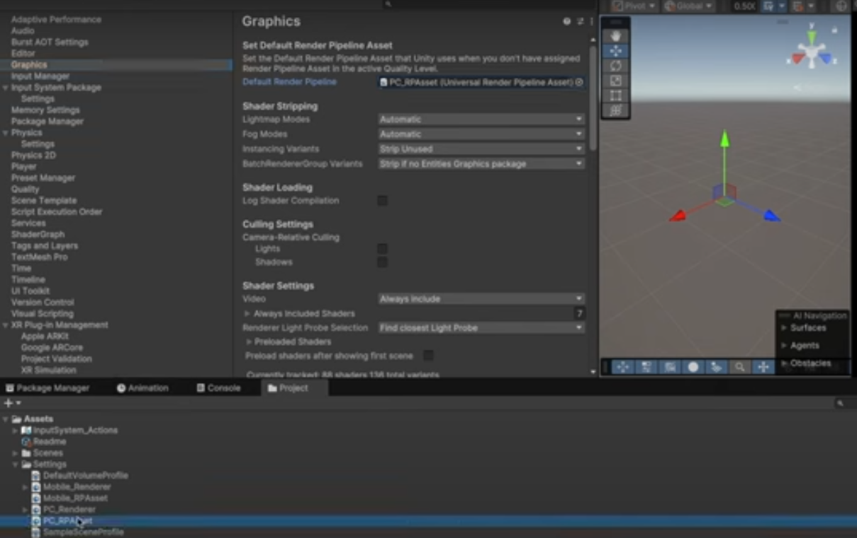

Go to Default Render Pipeline

Click PC Renderer at Assets panel

At Inspector Window 🡪 Click Add Renderer Feature 🡪 Add Background Renderer

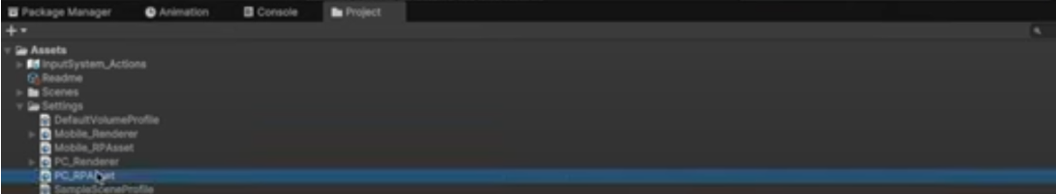

Click Mobile Renderer at Assets panel

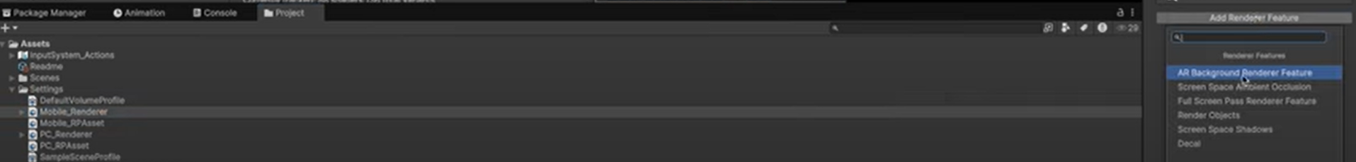

At Inspector Window 🡪 Click Add Renderer Feature 🡪 Add Background Renderer

Go back to project settings

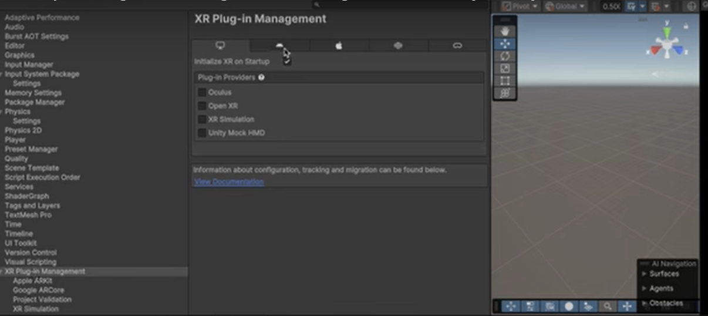

Go to XR Plug-in Management 🡪 Click android 🡪 click Google ARCore

Then 🡪 Click IOS platform (apple) 🡪 Click Apple ARKit

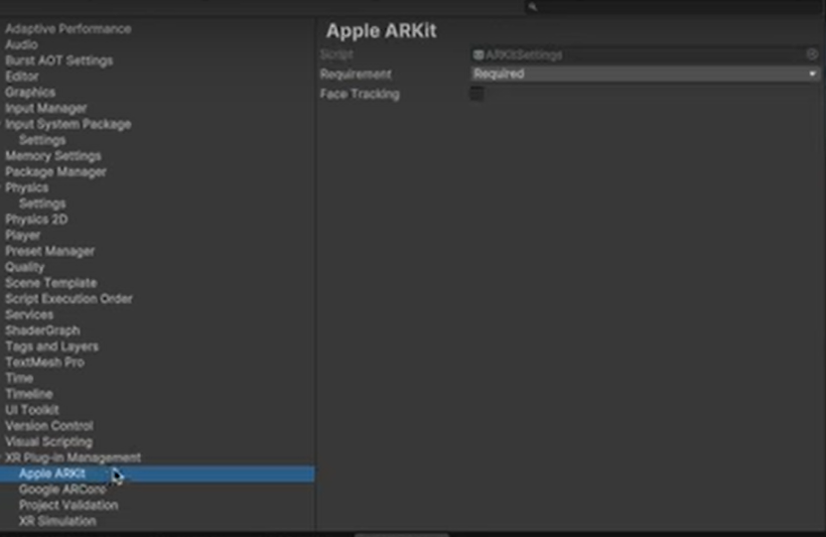

Select Apple ARKit 🡪 Find Requirement, click required

Select Google ARCore 🡪 Find Requirement, click required



Go to Player

Type your Product Name

Then, go to graphics API, remove vulkan

Scroll down until you find minimum API level 🡪 choose API level 24

Scroll down until you find ARMM 64 🡪 click the check box

Close project setting windows

**(Before that, you have to make sure your phone is in developer mode, check in the youtube, how to set your android phone to developer mode ) Connect your android with your laptop.**

**Switch Platform**

**Go to File 🡪 select Build Profile 🡪 Find Android 🡪 switch platform Android to active.   
Follow all the instructions given until, the unity logo is displayed in the android screen**