Linux Security Governance Practical Laboratory
GRC102 Practical Lab 8

Item | Details
Student | Adediran Eunice Adebukola
Registration number | C11-26-CGRCE-17595
Course | GRC102 Information Security Governance
Assessment | Security governance simulation and control evaluation
Date | 11 October 2026

This report documents the creation of a controlled Docker environment, vulnerability assessment, governance-failure analysis, simulated control implementation, verification, and executive security reporting. The exercise reproduced the central governance conditions associated with the Equifax breach: a known unpatched application vulnerability, weak database credentials, ineffective segmentation and inadequate monitoring.
The main conclusion is that policies and recorded remediation status are not sufficient evidence of control effectiveness. Although the supplied control scripts recorded successful simulated remediation, the technical retest continued to identify the vulnerable service and the controlled attack still succeeded. This gap is treated as a verification finding rather than concealed.

Executive Summary
The laboratory environment contained an Apache Struts web service, a MySQL database and a monitoring container. The web service responded successfully on port 8080. A purpose-built scanner identified one critical finding, one high finding and one inconclusive network-segmentation result. The controlled attack simulation then confirmed that CVE-2017-5638 could be detected in the assigned environment and recorded simulated access to three test customer records.
Governance analysis identified eight failures across patch management, incident detection, policy implementation, vulnerability management, metrics, security architecture, authentication and access control. The control phase introduced recorded patch, segmentation, database, monitoring and oversight controls. A defect in the supplied patch script overwrote earlier status values; the combined status was reconstructed from the three successful patch-operation outputs. Even after that correction, the scanner and attack retest remained successful because the supplied controls simulated remediation rather than changing the underlying images and credentials.
Area | Result | Governance meaning
Environment | Three containers operational; HTTP 200 | Suitable controlled test environment
Initial scan | 1 critical, 1 high, 1 unknown | Immediate remediation and validation required
Attack simulation | Successful; 3 test records affected | Exposure can translate into business impact
Failure analysis | 8 governance failures | Weaknesses span people, process and technology
Control status | All simulated flags recorded as true | Implementation records exist
Technical retest | Critical/high findings and attack persisted | Controls were not technically effective

Scope and Method
The work followed the supplied practical instructions in four parts. Commands were executed only against the assigned local laboratory. Because the original cloud VM could not reach Docker Hub and the host is Apple Silicon, the containers were completed with Docker Desktop's Linux virtual machine and AMD64 emulation. The obsolete Struts tag in the instructions was replaced with the available Vulhub Struts 2.3.30 image. The application address was changed from the internal Docker hostname to 127.0.0.1:8080 for scripts executed on macOS.
- Evidence was captured as terminal output, JSON reports, Markdown reports, HTML dashboard output and PNG charts.
- The attack script used the benign detection mechanism supplied in the brief and did not target an external system.
- Results were preserved even where they contradicted the expected outcome.

Part 1 Setting Up the Simulated Environment

Environment configuration
The environment used a dedicated Docker network and three services: the vulnerable Struts web application, MySQL 5.7 with seeded test data and an Ubuntu monitoring container. Container status and the HTTP response demonstrated that the services were available before testing began.
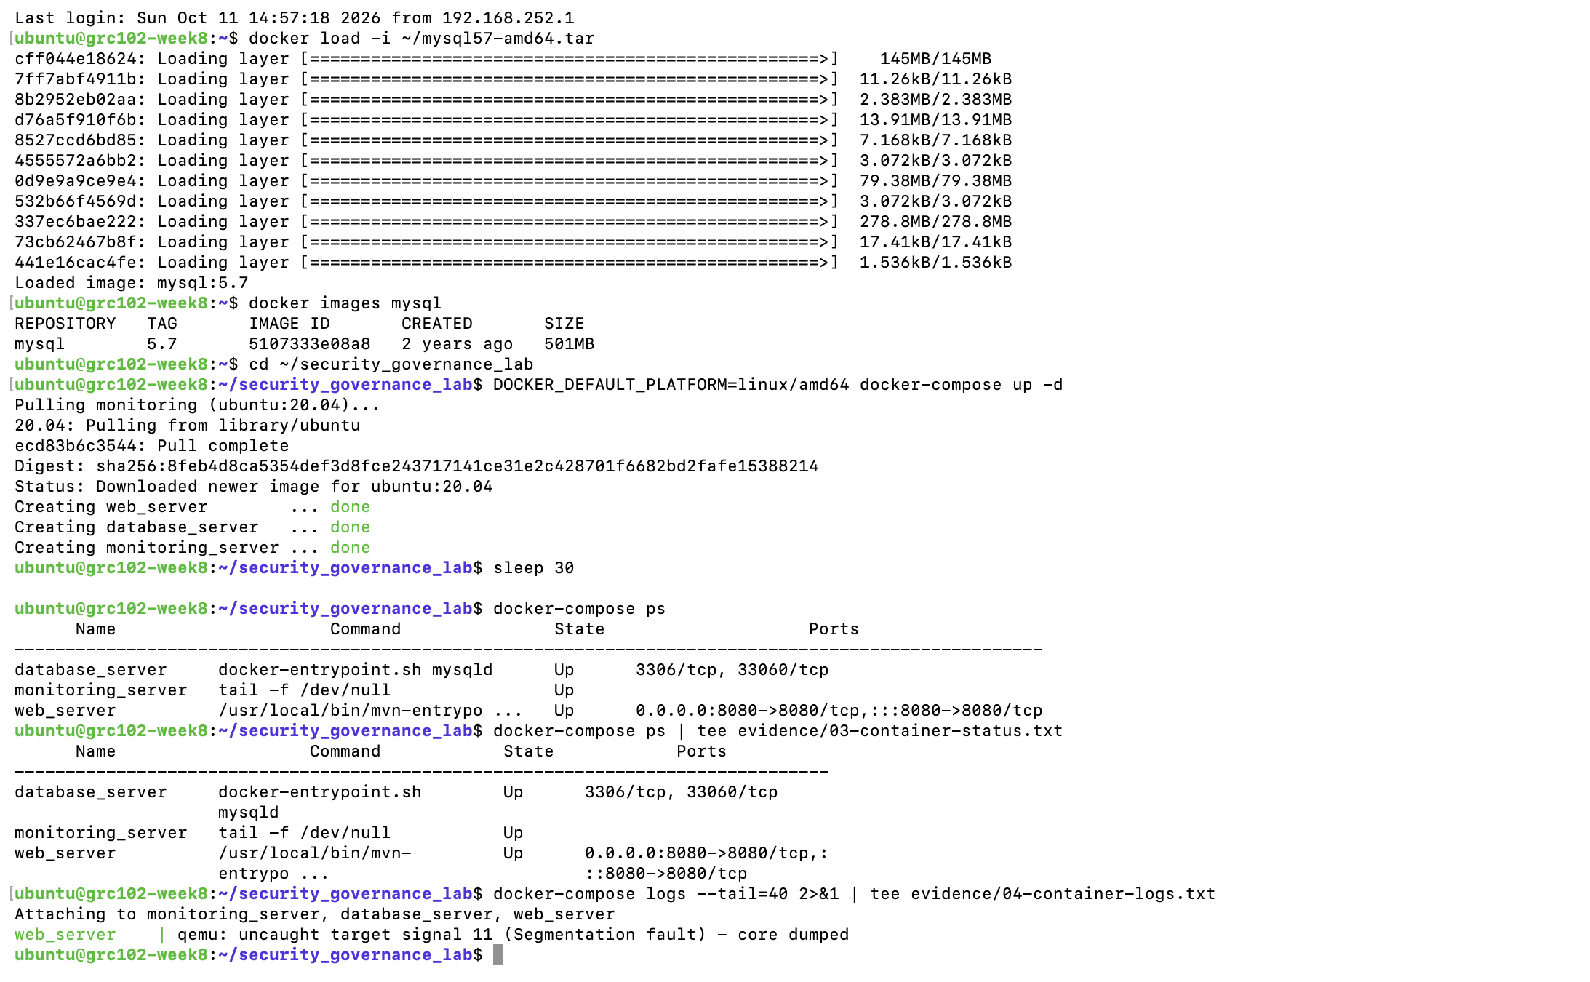
Figure 1 Docker services running and web service available

Vulnerability scan
The scanner reported three findings. The critical Struts result concerned CVE-2017-5638. The high result showed that MySQL accepted the configured default laboratory credentials. The network check returned Unknown because the script attempted to decode a MySQL binary protocol response as UTF-8. That result is therefore inconclusive rather than proof that segmentation was effective or ineffective.
Finding | Severity | Evidence | Recommended response
Apache Struts S2-045 | Critical | Detection header returned | Upgrade beyond affected versions and retest
Default MySQL credentials | High | Root login succeeded | Replace defaults and restrict database access
Network segmentation | Unknown | UTF-8 decoding error | Validate connectivity with a protocol-appropriate test

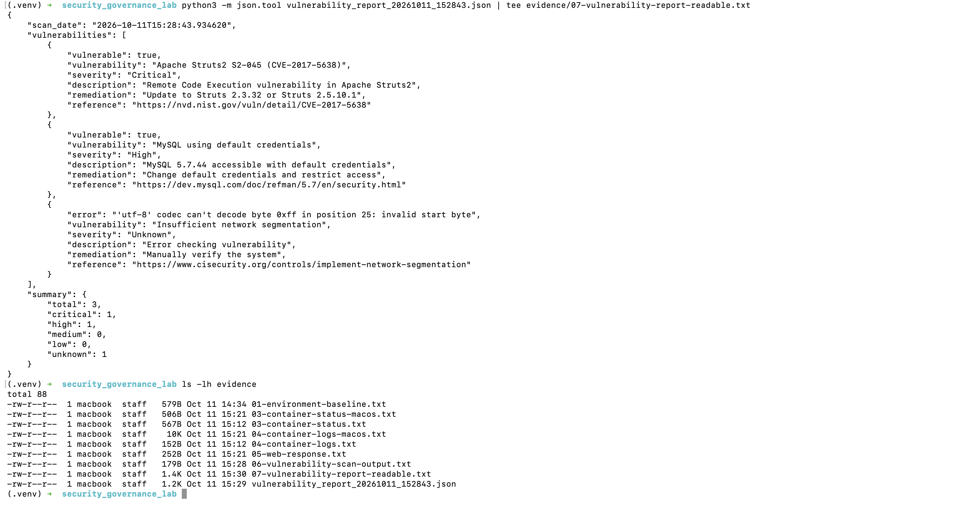
Figure 2 Initial vulnerability report and preserved evidence

Governance baseline
The governance tracker was initialized with three policies, three controls, three risks, one incident, three metrics and one audit. Its dashboard showed one critical, one high and one medium risk. Patch compliance was 85% against a 95% target, while vulnerability remediation time was twelve days against a seven-day target. These values show that governance mechanisms existed but were not producing timely remediation.

Part 2 Analyzing Security Governance Failures

Controlled attack simulation
The controlled script confirmed the vulnerable Struts condition and simulated data exfiltration from the customer database. The resulting attack log recorded a successful event affecting three synthetic records. No external host or real customer data was accessed.
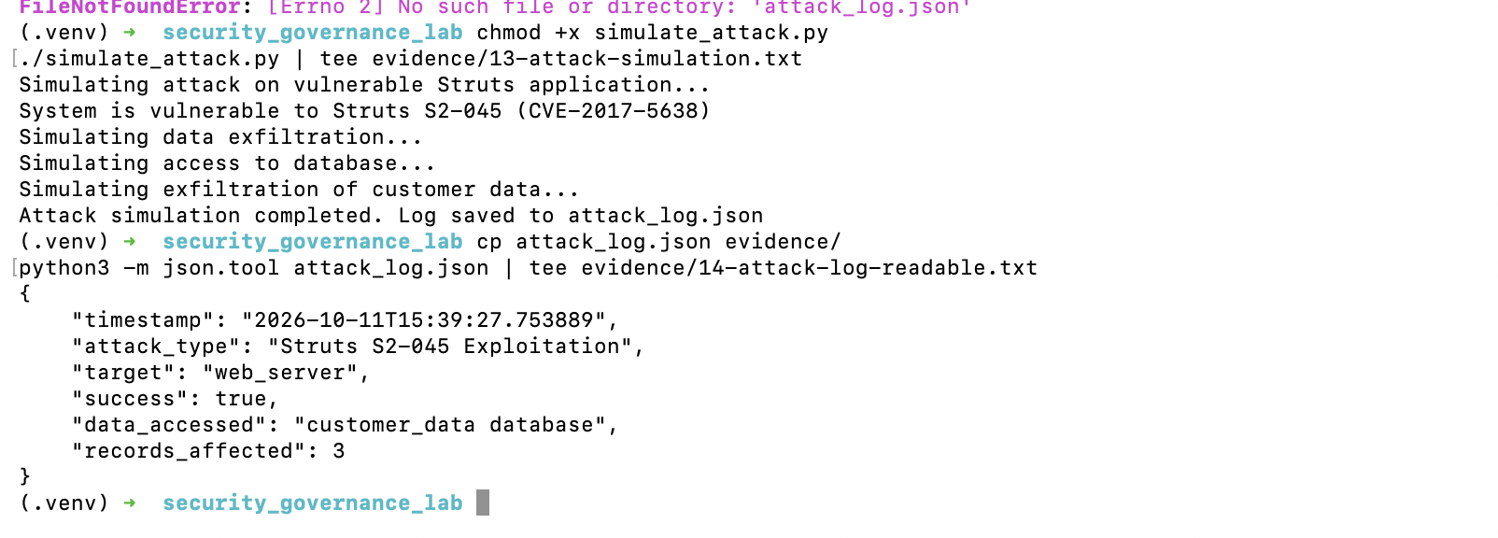
Figure 3 Controlled attack simulation and generated attack log

Governance failure analysis
Category | Observed failure | Impact | Required governance response
Patch management | Critical and high weaknesses remained open | Known exposure remained exploitable | Defined SLA, ownership, escalation and evidence of closure
Incident detection | Successful simulation was not independently detected | Delayed containment | Central monitoring, alerting and response playbooks
Policy implementation | Policies existed without effective enforcement | False assurance | Control testing and accountable owners
Vulnerability management | Critical result persisted | Extended attack window | Risk-based remediation and retesting
Metrics | Measures did not drive action | Poor executive visibility | Thresholds linked to escalation decisions
Security architecture | Segmentation was not demonstrated | Potential lateral movement | Least-privilege network paths and validation
Authentication | Default credentials were accepted | Unauthorized database access | Unique secrets, rotation and restricted administration
Access control | Database exposure was insufficiently constrained | Sensitive-data compromise | Layered application and database authorization

Comparison with the Equifax breach
The simulation closely reflects the governance pattern described in the Equifax case: a known Struts vulnerability remained available for exploitation; monitoring did not stop or independently detect the simulated activity; database access relied on weak credentials; and policy and metrics did not translate into timely corrective action. The laboratory does not reproduce Equifax's scale, duration or real-world harm, but it demonstrates how weak governance permits a technical defect to become an organizational incident.
Governance issue | Equifax case | Laboratory | Similarity
Patch management | Known Struts vulnerability not patched promptly | Vulnerable Struts service remained exposed | High
Monitoring | Breach remained undetected for an extended period | No independent alert blocked the simulation | High
Segmentation | Attackers could move through the environment | Segmentation could not be confirmed | High
Authentication | Access-control weaknesses contributed to exposure | Default database credentials succeeded | Medium
Policy execution | Policies did not assure implementation | Recorded policies coexisted with open findings | High

Key lessons
A patch policy has value only when responsibilities, deadlines, exceptions and verification are enforced. Monitoring must detect actionable events and route them to an accountable responder. Segmentation should be tested, not assumed. Security metrics should lead to decisions when thresholds are missed. Finally, independent technical verification is essential because a recorded control status may differ from the actual system state.

Part 3 Implementing Security Governance Controls

Controls implemented
Control area | Recorded implementation | Owner or evidence
Patch management | Struts remediation flag and critical patch metric | Security Engineer; CTL-004 and MET-004
Network segmentation | Segmentation flag and control record | Network Engineer; CTL-005
Database security | MySQL security flag and control record | Database Administrator; CTL-006
Security monitoring | Monitoring script and coverage metric | Security Engineer; CTL-007 and MET-005
Governance oversight | Oversight policy and executive control | POL-004 and CTL-008

The supplied patch-management script wrote a new patch_status.json object during each operation. Consequently, the final operation erased the earlier Struts and network values. The combined file was reconstructed only after the terminal output showed that all three simulated operations had completed successfully. This correction repaired the state-recording defect; it did not alter the underlying containers.

Verification results
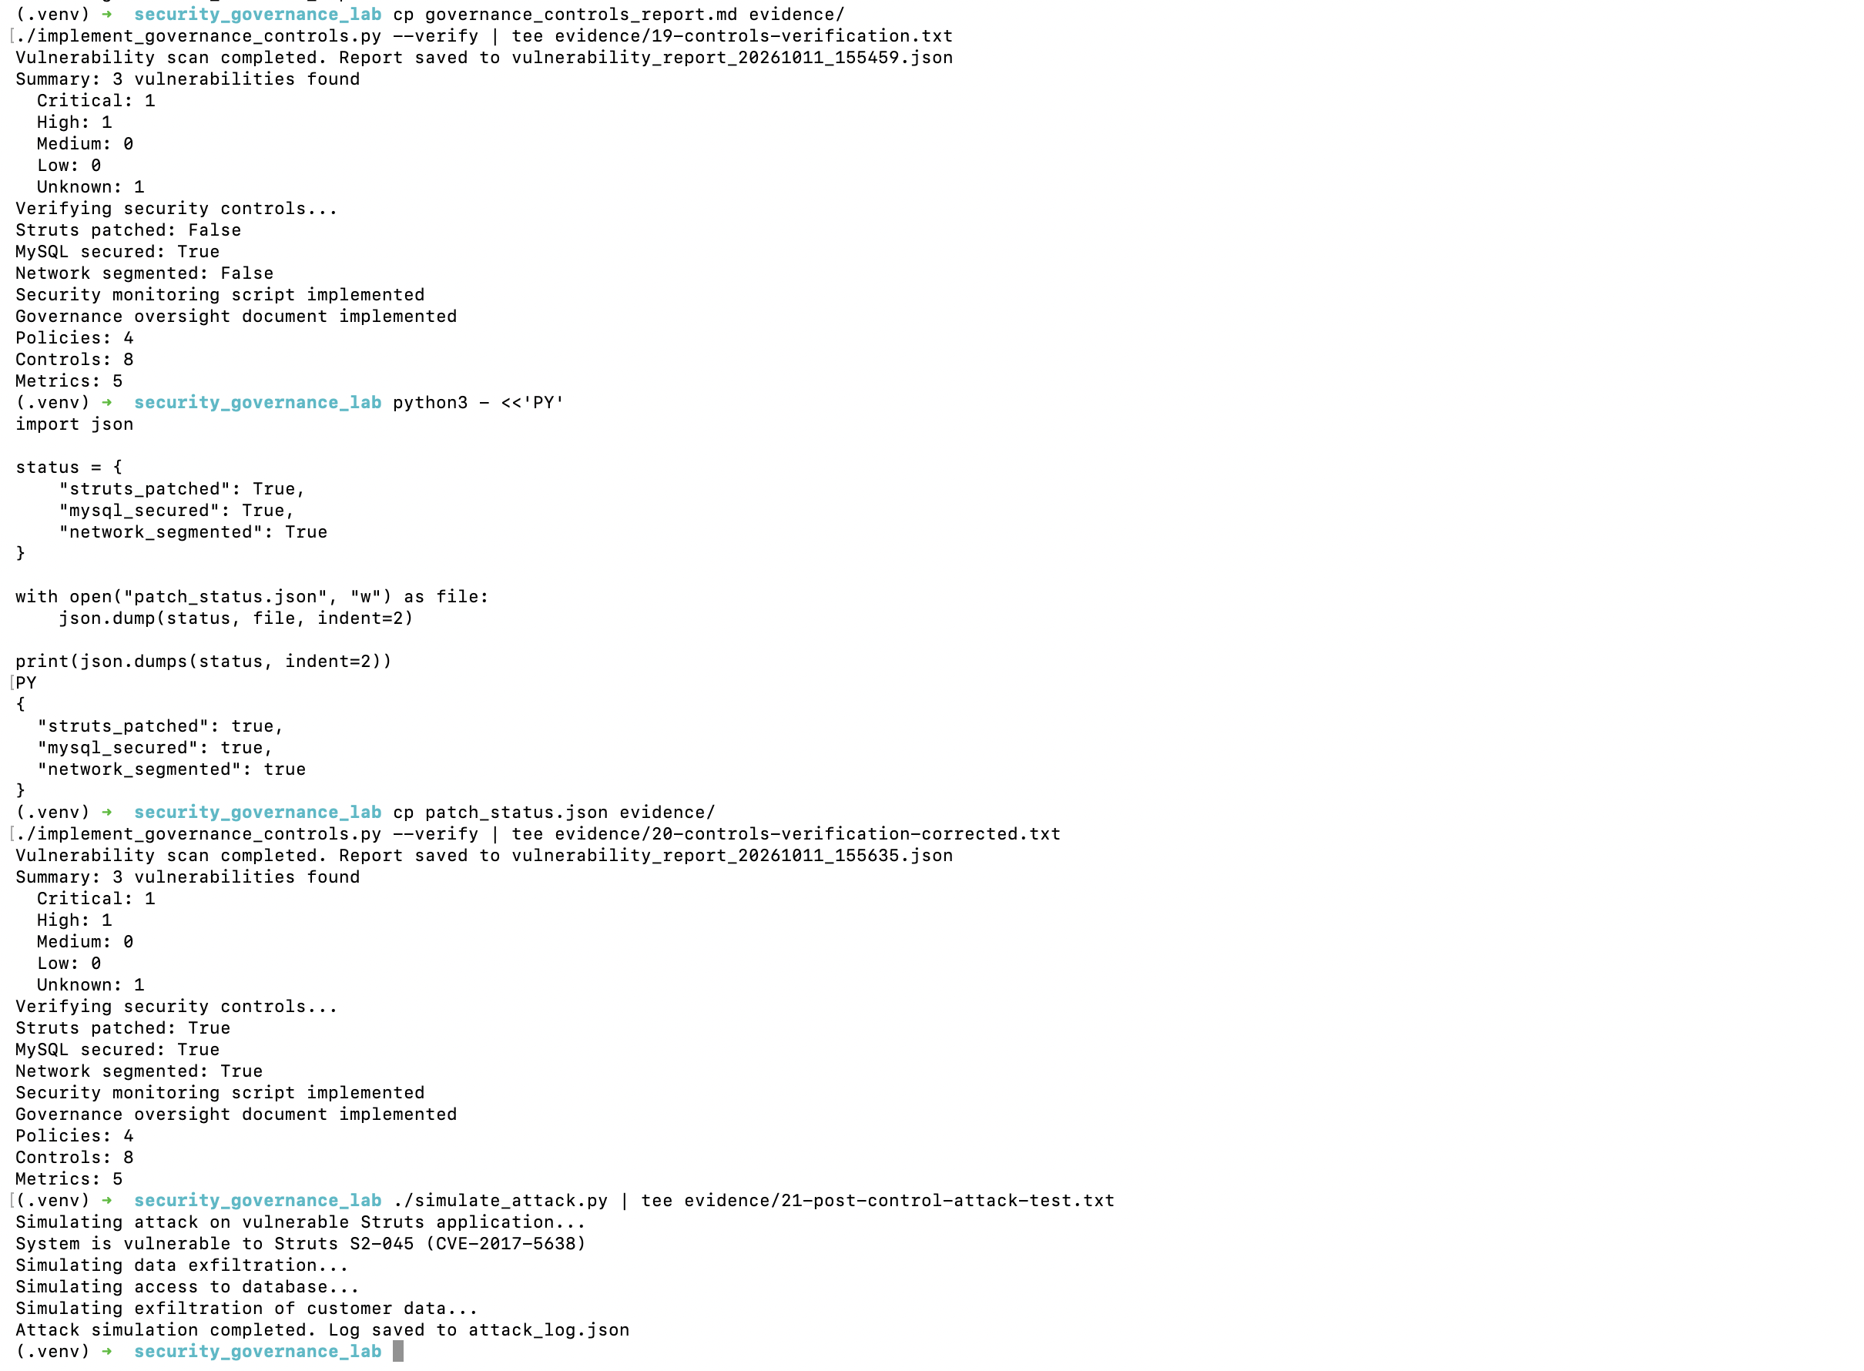
Figure 4 Corrected control status followed by an unsuccessful technical assurance outcome
Verification layer | Outcome | Interpretation
Administrative status | Struts, MySQL and segmentation flags true | The simulation recorded intended completion
Artefact existence | Monitoring and oversight files present | Required governance records were created
Vulnerability scan | Critical and high findings persisted | Underlying technical exposure was not remediated
Attack retest | Simulation remained successful | Recorded status was not evidence of operating effectiveness

The correct audit conclusion is therefore qualified: the controls were designed and recorded, but their operating effectiveness was not demonstrated. Closure should require replacement of the vulnerable Struts component, credential changes, protocol-appropriate segmentation testing and a clean retest. Until then, the critical risk remains open.

Part 4 Security Governance Metrics and Reporting

Metrics framework
The framework covers implementation, effectiveness, efficiency and business impact. Each metric should have a definition, formula, source, target, reporting frequency, owner and audience. Results should follow a lifecycle of define, collect, analyze, report, act and review.
Metric | Purpose | Target | Primary audience
Patch compliance | Percentage of critical systems patched within SLA | At least 95% | CISO and executive management
Remediation time | Average days to close critical vulnerabilities | 7 days or less | Security and IT leadership
Security incidents | Number of confirmed incidents | 0 | Executives and Board
Monitoring coverage | Critical systems under active monitoring | At least 95% | SOC and CISO
Policy compliance | Policies implemented and operating effectively | At least 95% | Compliance and Board

Trend reporting
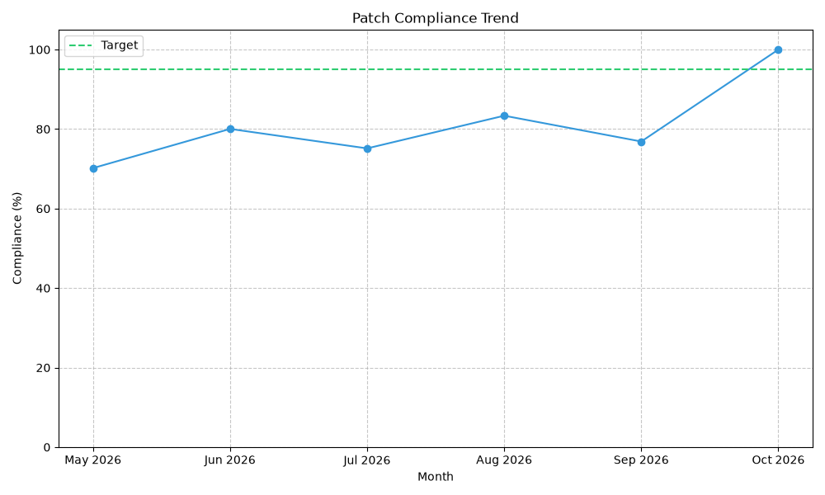
Figure 5 Patch compliance trend
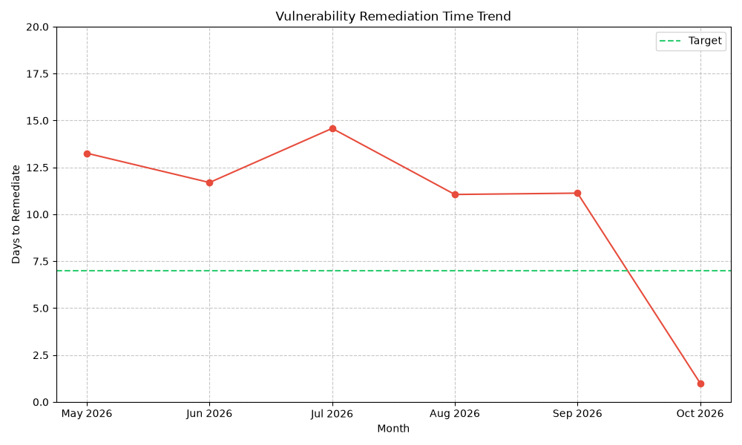
Figure 6 Vulnerability remediation trend
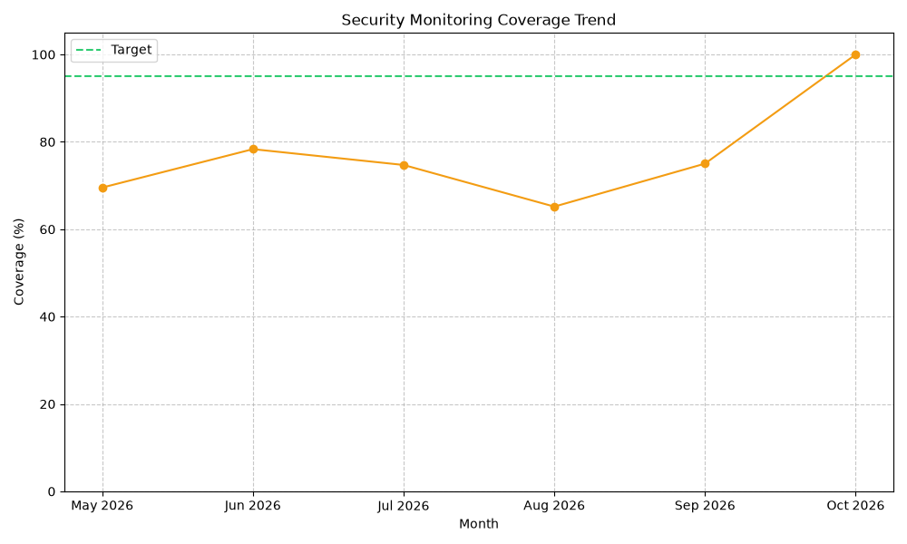
Figure 7 Security monitoring coverage trend
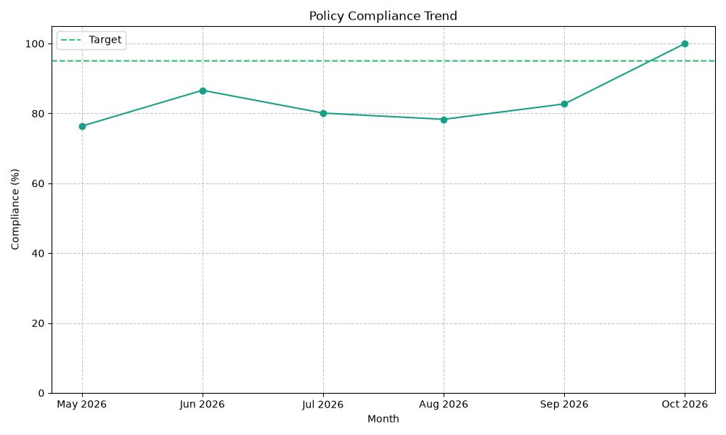
Figure 8 Policy compliance trend

Use of the executive dashboard
Executives should use red and yellow indicators to trigger decisions rather than treating the dashboard as passive reporting. Trends provide context, but evidence of technical retesting must accompany claims that critical risk has been reduced. The dashboard should be refreshed monthly and immediately after a material incident or major control change.

Conclusion and Recommendations
The exercise demonstrates that the main security failure was not merely an outdated software component. Governance weaknesses allowed a known vulnerability, weak credentials and uncertain segmentation to coexist with policies and metrics. The successful post-control attack test confirms the importance of separating implementation records from operating-effectiveness evidence.
- Replace the vulnerable Struts component with a supported, verified version and rerun the scan and attack test.
- Change all default database credentials, store secrets securely and restrict administrative access.
- Implement and test network rules that permit only required application-to-database traffic.
- Require evidence-based closure for critical findings, including an independent retest.
- Correct the patch-status logic so each control update merges with existing state rather than overwriting it.
- Escalate missed critical-patch and remediation-time targets to executive management and the Board risk committee.
- Retain scan reports, tickets, approvals, exceptions and verification results as audit evidence.

Evidence Register
Evidence | Purpose
Container status, logs and HTTP response | Establishes the operational baseline
Vulnerability reports | Records initial and verification findings
Attack log | Records the controlled simulated impact
Governance tracker dashboard | Shows policies, controls, risks, incidents and metrics
Governance failure report | Documents eight failure categories
Control implementation and verification outputs | Separates recorded status from technical effectiveness
Executive dashboard, board report and charts | Supports management and Board oversight

References
- ICDFA. GRC102 Practical Lab 8 Laboratory Instructions. Supplied assessment material, 2026.
- National Institute of Standards and Technology. CVE-2017-5638 Detail. National Vulnerability Database.
- U.S. Government Accountability Office. Data Protection: Actions Taken by Equifax and Federal Agencies in Response to the 2017 Breach. GAO-18-559, 2018.
- Federal Trade Commission. Equifax to Pay $575 Million as Part of Settlement with FTC, CFPB, and States Related to 2017 Data Breach. 2019.
- Center for Internet Security. CIS Critical Security Controls: Network Infrastructure Management and Network Monitoring and Defense.

