**User-guide for Running CAMDT GUI**

-Prepared by Eunjin Han[1] at IRI, Columbia University –

(August, 2016)

**1. Run “CAMDT_2016_0802.py”.**

You can adjust size of the pot-up window if you cannot see the full contents of the CAMDT-GUI as shown in Figure 1.

**1) Simulation setup**

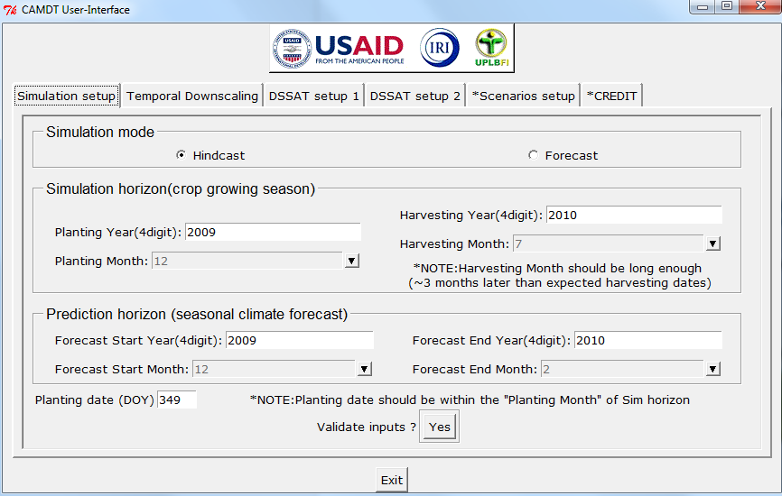

<Figure 1>

On the first page “Simulation setup”, you can set up simulation mode and crop growing period.

First, there are two simulation options: Hindcast and Forecast. The Hindcast mode can be used to run the crop simulation model (DSSAT) for past events (i.e., for the period when observed weather data are available). The Forecast mode can be selected for more operational purposes for the coming season (i.e., when observed weather data is not fully available for whole crop growing season).

Next, *Simulation horizon (crop growing season)* section is to designate a crop growing period by typing/selecting a planting year/month and harvesting year/month. Note that if you type an invalid number for planting/harvesting year (i.e., not 4 digit number such as 209 instead of 2009), the EntryField (blank box) would remain in red to indicate that there is an error in the format of your input. The user-defined planting month should include planting date. For example, in Figure 1, the planting DOY, 349(December 14) corresponds to the planting month (December, 2009). Typical rice growing period in the Philippines is three months and thus approximate harvesting month would be March, 2010 in Figure 1. However, when we generate *N* weather realizations based on Seasonal Climate Forecast (SCF) (see Figure 2), some weather realizations representing dry weather may give water stress delaying crop growth, which results in delayed harvest time. Therefore, it is always recommended to give enough time (longer than actual growing period) for harvest month in Figure 1 so that DSSAT can finish simulations even for extremely delayed growths. For instance, you can put harvest month as July, 2010 rather than actual harvesting month (e.g., March, 2010). If you put harvest month as March, 2010, DSSAT may generate error-message for some simulations when crop maturity is delayed to April.

*Prediction horizon (seasonal climate forecast)* section is to specify the period for which SCF is released. Typically IRI seasonal climate forecast is provided for a trimester with different lead time. However, in CAMDT the prediction horizon can be set for 2~6 month period. It is meaningless to put the prediction horizon beyond the crop growing season (simulation horizon) designated in the previous step. As shown in Figure 2, the *prediction horizon* can be set for DJF or JFM or FMA depending on when you run the CAMDT. For instance, when you run the CAMDT on February 5th, 2010, you would set up the *prediction horizon* from February to April. In this case, observed weather data will be used to run the DSSAT until January 31, and then temporally downscaled *N* weather realizations will be used to run DSSAT for FMA season (see Figure 2). Weather conditions beyond the SCF (e.g., May in Figure 2) are generated based on climatology because no SCF information is available for this period.

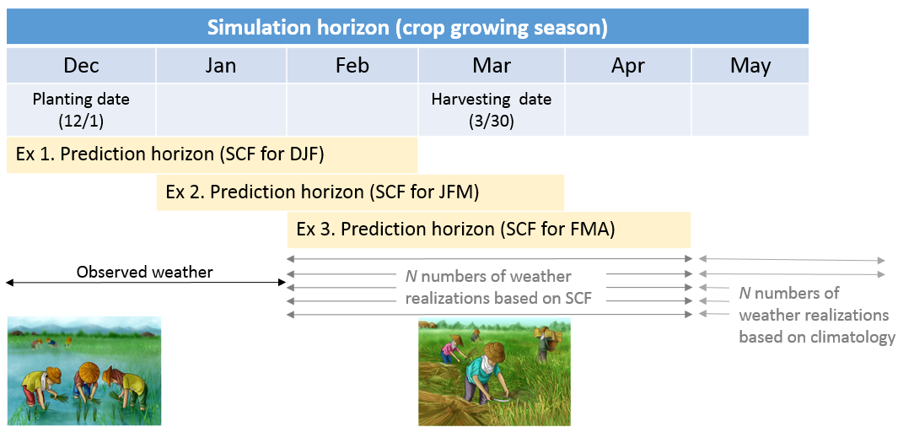

<Figure 2>

Lastly, planting date should be provided in DOY (Day of Year) format. Again, this planting date should match with the planting month in the previous *Simulation horizon* section. If you want to check if all your inputs are correct, click the “Yes” button next to “Validate inputs?”. This button will check if there are any mismatches among the inputs. For example, if you put planting month and harvesting month as 2009/12 and 2009/7 respectively, you will get a pop-up error message in Figure 3(a). Once you fix the mistake in harvesting month 2009/7 to 2010/7, you will get a message shown in Figure 3(b).

|  |  |
| --- | --- |
| (a) | (b) |
|  |  |

<Figure 3>

**2) Temporal Downscaling.**

Most of the publically accessible seasonal climate forecasts (SCF) by the NOAA-Climate Prediction Center, IRI or the UK Met Office are released in the format of tercile probability: below-, near- and above-normal probability as shown in Figure 4. Therefore, the tercile-based SCF should be converted to daily weather sequences to force the DSSAT simulations. This temporal downscaling process can be set up in “Temporal Downscaling” page on the CAMDT in Figure 5.

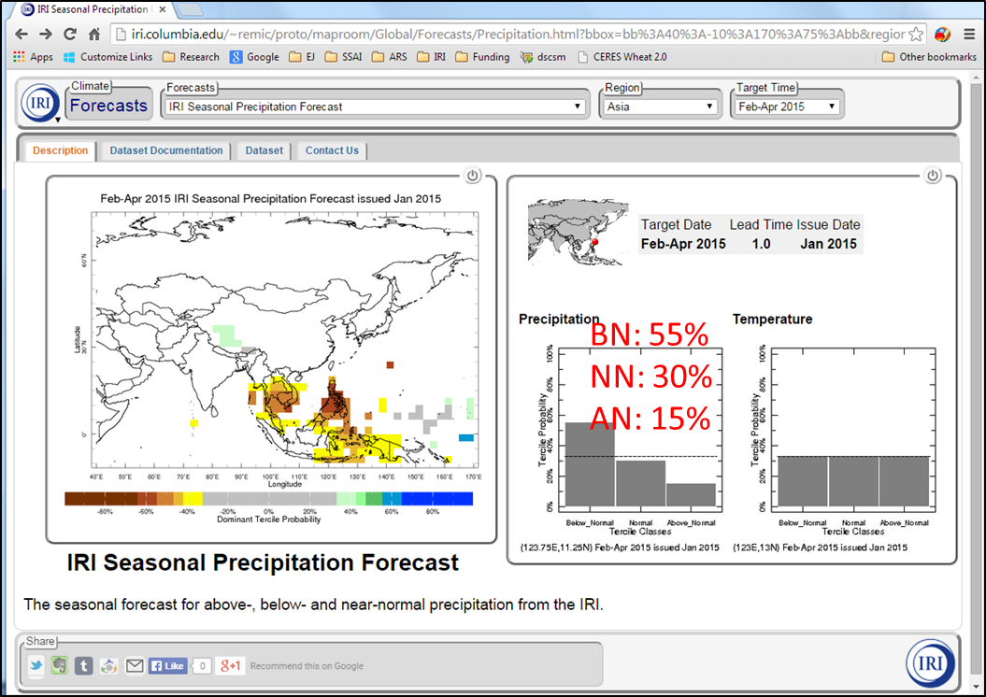

<Figure 4>

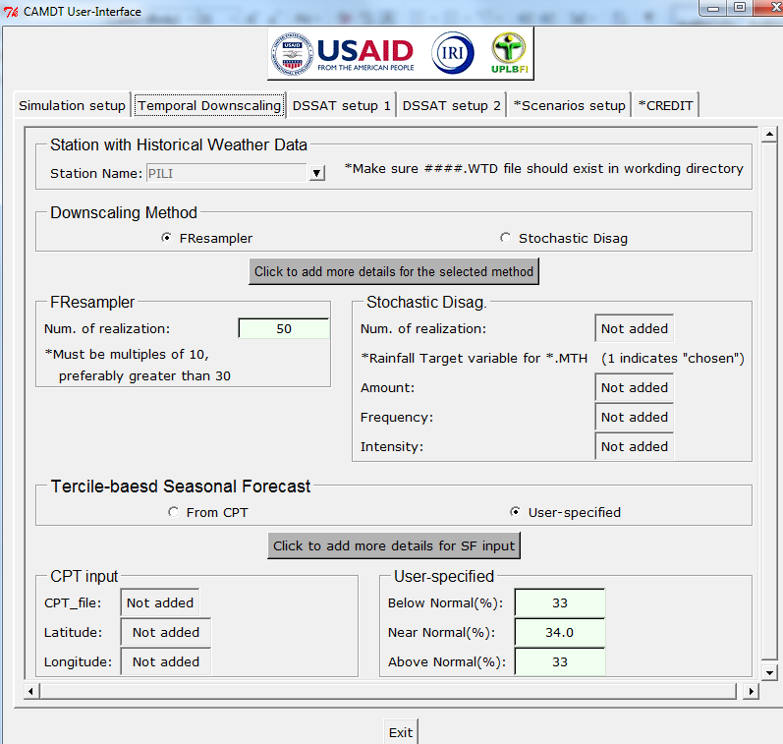

<Figure 5>

The temporal downscaling process requires a long-term weather record to be used for parameterization of the *Stochastic Disag* method and to serve as a sampling pool for the *FResampler* method. The first step is to select a weather station which has long-term daily weather data and is closest to the area/fields of interest. The weather station has an ID which consists of exactly 4 characters (e.g., PILI in Figure 5). The long-term daily weather data should be contained in a text file of which name is same as the station ID. That is, for the PILI station in Figure 5, you should have PILI.WTD file as shown in Figure 6. The *.WTD file has similar format to the DSSAT weather input file (*.WTH) shown in Figure 7. The *.WTD file contains all historical daily weather (SRad, Tmin, Tmax and rainfall) data in ONE file while each *.WTH file contains only one-year data (i.e., PILI**75**01.WTH has data for the year of 1975 and PILI**76**01.WTH for 1976 and so on). Note that both *.WTD and *.WTH files are format-sensitive and therefore location of each column and number of spaces should be carefully checked in advance. In addition, since the DSSAT does not allow any missing data, **you should fill the missing values in advance before running the CAMDT (i.e., *.WTD should not have any missing values such as -99)**. Since the *.WTD is the main input file for the temporal downscaling, the file should be found in the main working directory which will be set up in Figure 21. In this exercise, PILI.WTD should be in the folder “~\GUI_test_2016”

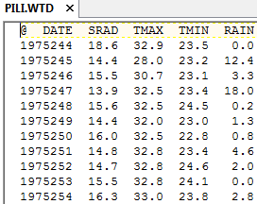  
<Figure 6>

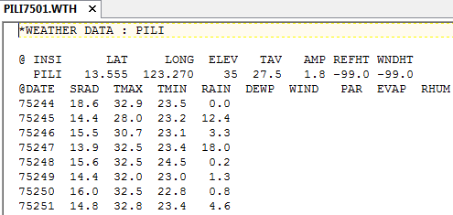

<Figure 7>

There are two temporal downscaling methods available in CAMDT: *Stochastic Disag* and *FResampler* method. The *Stochastic Disag* method is a conditional weather generator designed for the stochastic disaggregation of monthly rainfall into daily realizations. Model parameters of the *Stochastic Disag* are estimated by running *EstimatePrm.exe* with arguments *.CLI and *.WTD files. Command for running *EstimatePrm.exe* is hidden behind the CAMDT, but you should make sure both *.CLI and *.WTD files are prepared in advance under the working directory. An example of *.CLI file is shown in Figure 8 for the PILI station. The *.CLI file provides only geo-location of the weather station to the parameter estimation program. Therefore, the information within the red box in Figure 8 is only necessary. Next step for the parameter estimation is to determine monthly target information (again, *Stochastic Disag* basically generates daily weather realizations from monthly rainfall). You can choose different monthly targets: one of the rainfall characteristics (rainfall amount, frequency, intensity), or combination of two characteristics (e.g., amount & frequency), but not the three at the same time. When you select the *Stochastic Disag* method andclicks the button “Click to add more details for the selected method” in Figure 5, a pop-up window appears so that you can select monthly targets (Figure 9 (a)). In addition, you can specify how many weather realizations would be created. The larger number of realizations is the better to fully represent uncertainties from the SCF. Typically 100 realization is reasonable while at least 30 realizations are recommended. The selected monthly target(s) and number of realizations are copied to the main CAMDT window. The selected monthly targets are indicated as “1” and non-selected one(s) are as “0” as shown in Figure 9(b).

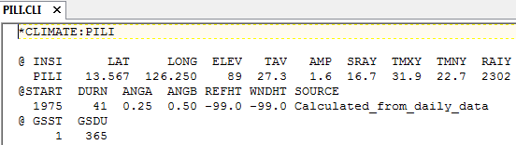

<Figure 8>

|  |  |
| --- | --- |
| (a) | (b) |
|  | |

<Figure 9>

The second downscaling method, *FResampler* creates weather realizations by sampling historical records based on tercile-based SCF. It samples a seasonal chunk of daily weather data that includes SRad, Tmin, Tmax and rainfall with replacement. Unlike the *Stochastic Disag,* the *FResampler* method does not requires any further information except number of realizations in running it. Note that number of realization should be multiples of 10. When you select the *FResampler* method andclicks the button “Click to add more details for the selected method” in Figure 5, a simple pop-up window (Figure 10) appears so as for you to determine number of realizations. Again, your input is copied to the main window.

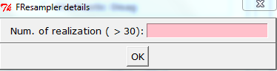

<Figure 10>

Tercile-based SCF can be typed directly by a user or taken from a CPT output (text) file. If you selects “user-specified” radio button and clicks “Click to add more details for SF input”, a pop-up window appears to provide probabilities of below- and above-normal (Figure 11). If you select “From CPT” option, another pop-up window appears to provide latitude and longitude of the target location and specify CPT output file (Figure 12). The CPT (Climate Predictability Tool) is a software package developed by IRI “*for constructing a seasonal climate forecast model, performing model validation, and producing forecasts given updated data”* (http://iri.columbia.edu/our-expertise/climate/tools/cpt/)*.* The CPT produces tailored SCFs for the whole Philippines (latitude: 5~10N, longitude: 117~126W) in a text output file. Figure 13 shows an example of CPT output text file for OND of 2009. Based on the user-specified geo-location, the CAMDT extracts probabilities of BN, NN and AN from the chosen text file. Again, your inputs on the pop-up window are copied to the main window.

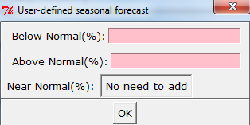

<Figure 11>

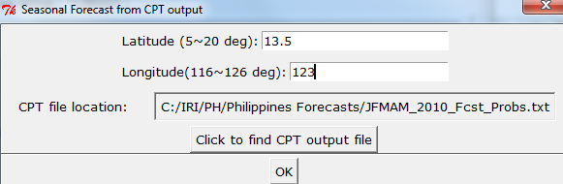

<Figure 12>

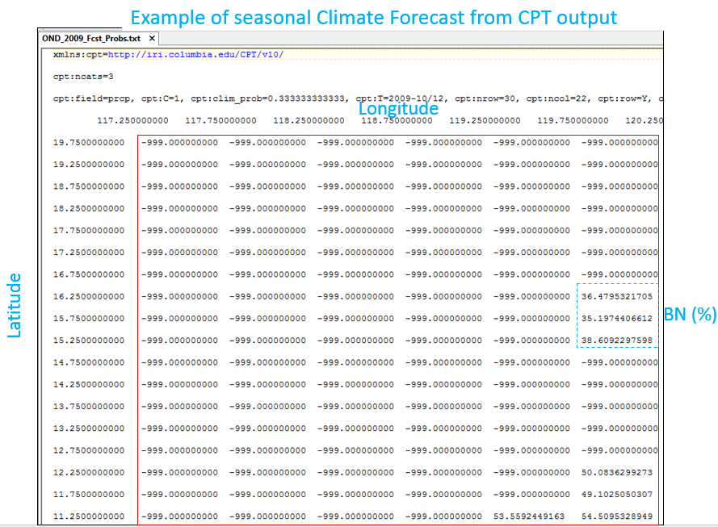

<Figure 13>

**3) DSSAT Setup**

Next step is to provide crop management inputs for DSSAT on “DSSAT setup 1” and “DSSAT setup 2” pages (Figure 14 and 17). These inputs will be used to fill out the DSSAT-experimental file (*.RIX or *.SNX) shown in Figure 15. The DSSAT-experimental file called File-X can contain much more information such as initial soil condition, tillage, management options etc. However, in CAMDT, inputs from the user were simplified as much as possible so that the user is not overwhelmed by too much options.

First, since the current version of CAMDT focus on rice, there are two planting methods available: dry seed or transplanting (Figure 14). Planting details can be typed in the next section where some default values are already given for guidance.

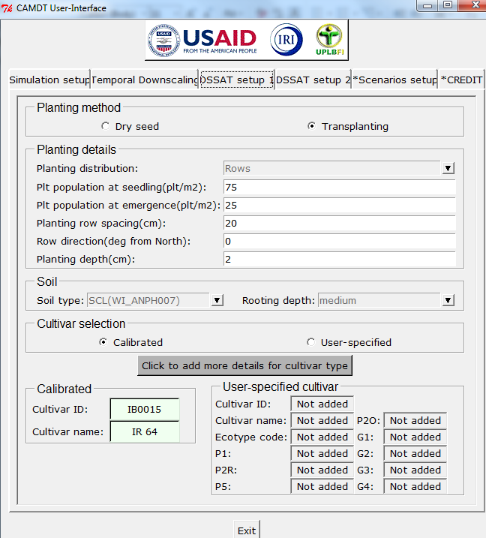

<Figure 14>

Soil physical or chemical characteristics are critical factors for crop growth. Due the unavailability of soil database from the Bicol region in the Philippines, a few soil profiles extracted from WISE (World Inventory of Soil Emission Potentials) soil database (WI.SOL) were added on CAMDT. More soil profiles from WI.SOL can be added to the CAMDT by simply modifying Python script (see *CAMDT_Python_user_guide.docx* for details). For each available soil profile, you can set up different rooting depths (shallow, medium or deep).

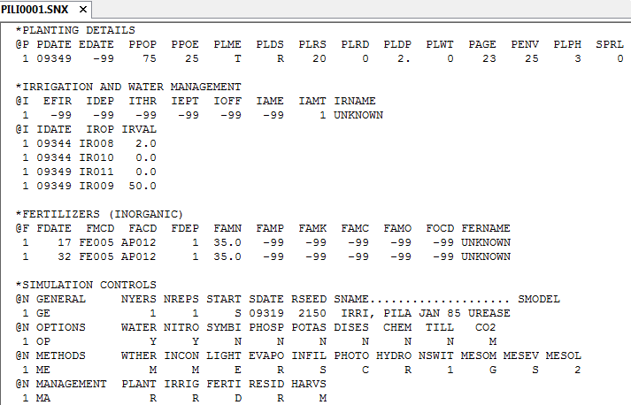

<Figure 15>

In DSSAT-CERES-Rice, crop growths are simulated using genetic coefficients defined in Table 1. These coefficients have different values for each rice variety and should be carefully calibrated before model simulation using field experiment data. The DSSAT 4.5 version has genetic coefficients calibrated for a number of rice varieties. In CAMDT, three calibrated rice cultivars (IR54, 58, 64) from *RICER45.CUL* file were added. In addition, we calibrated two new varieties using field experiment data at PhilRice Central Experiment Station, Muñoz, Nueva Ecija in the Philippines: inbred PSB Rc82 (110 days to maturity) and hybrid Mestiso 20 (111 days to maturity). In total those five cultivars are available for DSSAT simulation in the current version of CAMTD (Figure 16(a)), but again additional cultivars from *RICER45.CUL* file can be easily added by modifying Python script of the CAMDT. If you want to simulate using the given cultivars, “Calibrated” option should be chosen under the “Cultivar selection” group (Figure 14). Once you click “Click to add more details for cultivar type” button, a new pop-up window appears for you to select a cultivar type as shown in Figure 16(a). In case you are an expert of DSSAT and has your own calibrated parameters for a certain cultivar, you can add newly calibrated parameters by selecting “User-specified” option under “Cultivar selection” group and clicking “Click to add more details for cultivar type” button in Figure 14. Then new coefficients can be directly typed on the new window (Figure 16(b)) and these coefficients will be written into *RICER45.CUL* file under the working directory.

<Table 1. The Genetic Coefficient for DSSAT Rice Model>

|  |  |
| --- | --- |
| **Coefficients** | **Definition** |
| P1 | Time period (expressed as growing degree days [GDD] in oC above a base temperature of 9 oC) from seedling emergence during which the rice plant is not responsive to changes in photoperiod. This period is also referred to as the basic vegetative phase of the plant. |
| P20 | Critical photoperiod or the longest day length (in hours) at which the development occurs at a maximum rate. At values higher than P20 developmental rate is slowed, hence there is delay due to longer day lengths. |
| P2R | Extent to which phasic development leading to panicle initiation is delayed (expressed as GDD in oC) for each hour increase in photoperiod above P20. |
| P5 | Time period in GDD oC from beginning of grain filling (3 to 4 days after flowering) to physiological maturity with a base temperature of 9oC. |
| G1 | Potential spikelet number coefficient as estimated from the number of spikelets per g of main culm dry weight (less lead blades and sheaths plus spikes) at anthesis. A typical value is 55. |
| G2 | Single grain weight (g) under ideal growing conditions, i.e. nonlimiting light, water, nutrients, and absence of pests and diseases. |
| G3 | Tillering coefficient (scaler value) relative to IR64 cultivar under ideal conditions. A higher tillering cultivar would have coefficient greater than 1.0. |
| G4 | Temperature tolerance coefficient. Usually 1.0 for varieties grown in normal environments. G4 for japonica type rice growing in a warmer environment would be 1.0 or greater. Likewise, theG4 value for indica type rice in very cool environments or season would be less than 1.0. |

|  |  |
| --- | --- |
| (a) | (b) |
|  |  |

<Figure 16>

The “DSSAT setup 2” page in Figure 17 is to get user’s inputs for fertilizer and irrigation applications. First, you should select if fertilizer would be applied (by selecting “Fertilization” button) or not (by selecting “No Fertilization” button). If “Fertilization” was selected, you can give more detailed inputs (fertilizer material, amount and application methods) by clicking the button “Click to add more details for fertilizer”. Again, for simplicity, the CAMDT allows fertilizer application up to maximum three times. Figure 18 shows an example of how to fill out the Fertilizer Application section. Once you fill out the pop-up window, the inputs will be copied to the main window. Note that you also should type “number of fertilizer applications” on the blank box in the “Fertilizer application” group.

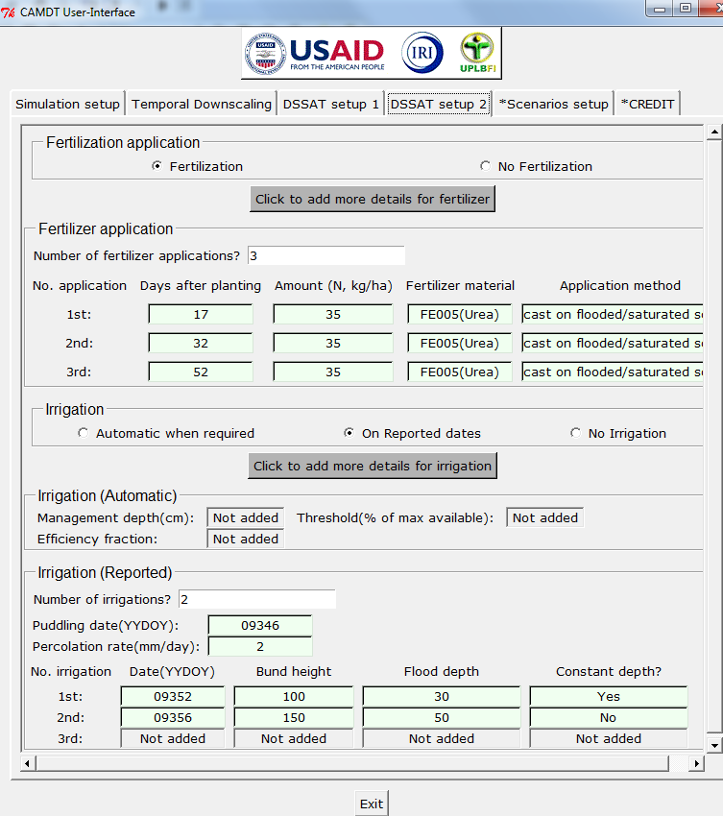

<Figure 17>

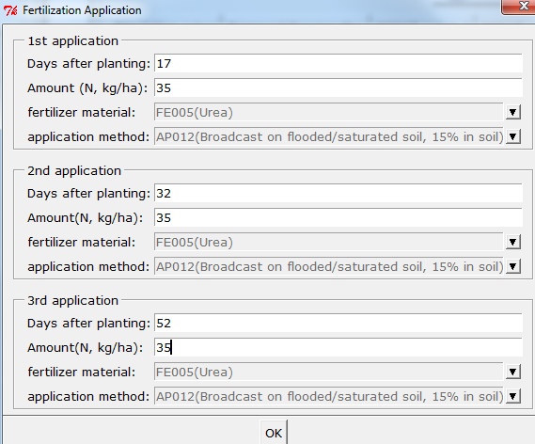

<Figure 18>

Next, an irrigation option need to be chosen. There are three options available: 1) Automatic when required, 2) On Reported dates, 3) No Irrigation. The first option, “Automatic when required” can be used to simulate crop growth with no water stress by triggering irrigation whenever soil water content drops down below a certain threshold (% of maximum available water in soil). Three inputs shown in Figure 19 are required when “Automatic when required” is selected on the main window in Figure 17.

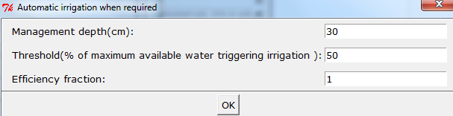

<Figure 19>

More realistic irrigation applications can be possible with the option “On Reported dates”. Since we assume “lowland” rice, initial puddling is assumed and related information (puddling date, and percolation rate) is required (Figure 20). For the rest of irrigation, you need to provide irrigation date, bund height, flood depth and if the flood depth would be constant or not. If you check “yes” to the question, “Constant flood depth?” (as shown in Figure 20), the DSSAT assumes the flood depth maintains constant flood depth until next irrigation record. Otherwise (when “No” is chosen), regular irrigation concept is applied. Once you click “ok” button of the pop-up window, all the inputs you provided will be copied to the main window. Do not forget to type “Number of Irrigations” on the main window in Figure 17.

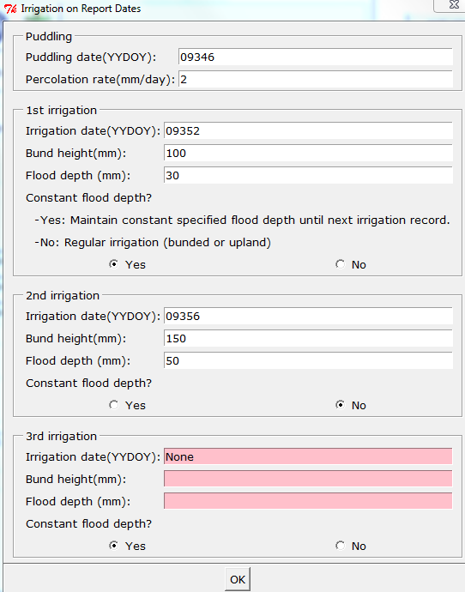

<Figure 20>

**4) Scenario Setup**

Now we are ready to set up “what-if” scenario(s) and run DSSAT for the scenarios. On “Scenarios setup” page in Figure 21, first, you need to designate a working directory where all required input files are located. The list of necessary input files is shown in Table 2. Please make sure all those input files are saved in the working directory. Once you click “Click to select a working directory” button, a new pop-up window will appear so that you can select a folder. New folders which contain simulation result for each scenario will be created under the working directory you designated. **Note: the working directory SHOULD NOT have any spaces.**

**For example, “C:\Users\eunjin han\Documents\CMDT” will result in an error due to the space in the name of “eunjin han” folder. Therefore, make a folder name as “eunjin_han” instead of “eunijn han”.**

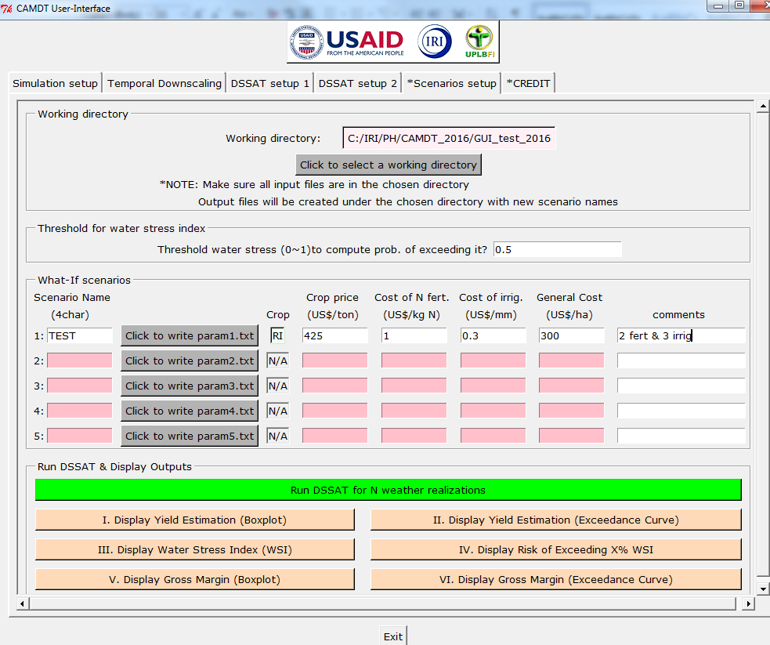

<Figure 21>

<Table 2. Required input files for CAMDT>

|  |  |  |
| --- | --- | --- |
| Category | File name/type |  |
| Executables | CAMDT_PH_exe.exe | to get user's input from the CAMDT and to run temporal downscaling and DSSAT |
| FResampler_Colombia.exe | to run a temporal downscaling method - *FResampler* |
| predictWTD_Colombia.exe | to link a temporal downscaling method (*Dis Ag*) with seasonal climate forecast |
| Disag.exe | to run a temporal downscaling method - *DisAg* |
| EstimatePrm.exe | to estimate parameters for *DisAg* |
| exportPHNT.exe | to convert outputs from *DisAg* to weather input files for DSSAT |
| dscsm045.exe | DSSAT 4.5 executable |
| minpt040.exe | auxiliary file to run DSSAT |
| DSSAT_AnalysisTool.exe | to post-process DSSAT output to extract yield and water stress index |
| input related to weather station | *.CLI (e.g., PILI.CLI) | need to run *DisAg* |
| *.WTD (e.g., PILI.WTD) | long-term daily weather data |
| DSSAT input files | RICER045.CUL | contains genetic coefficients for rice growth simulation |
| RICER045.SPE | Contains species coefficients for rice growth simulation |
| WI.SOL | DSSAT soil input file |
| *.WTH(e.g., PILI0101.WTH) | yearly weather input files for DSSAT (need to run DSSAT with observed weather) |

Next, you need to define threshold to compute water stress. Water stress (WS) is defined as (1– ETact/ETcrop), where ETcrop is potential daily root water uptake (demand of the atmosphere) and ETact is actual transpiration due to soil moisture constraint. Therefore, WS=1 means the highest stress while WS=0 means no stress. Since we run *N* numbers of simulations with different *N* weather realizations downscaled from a SCF, we will get *N* different WS values after all simulations. Using the WS results, we can calculate probability of exceeding a certain WS value. For instance, when you set the threshold as 0.5, the CAMDT will count how many WSIs are greater than 0.5 out of total simulation results. If there are 30 WSs greater than 0.5 on a certain DAP (Days after planting) out of 100 realizations, the probability of exceeding 50% level water stress on that day is 30% given a SCF. The result, 30% can be interpreted as “risk index”. This approach shows the “risk” of having passing the threshold at that day of year. High WS at critical growth stages is potentially lethal for crops.

Now, let’s move to the next box, “What-If scenarios” in Figure 21 to make a name of the scenario. **The scenario name should be exactly 4 characters** (any combination of letters and numbers are fine). Once you click the button “Click to write param1.txt” next to the scenario name box, “Crop” box will turn to green with “RI” (rice). Once you click the button “Click to write param1.txt”, the CAMDT will create a text file, “param_####.txt” where #### is the scenario name you typed. This text file contains all information which you provided on the pages of CAMDT user-interface (from “Simulation setup” to “Scenario setup” pages). This “param_####.txt” is the main input file to the *CAMDT_PH_exe.exe* which is the actual core program to run the temporal downscaling and the DSSAT. You can run *CAMDT_PH_exe.exe* by typing a command line on your MS-Dos window as shown in Figure 22. Instead of doing this, however, you can click the green button, “Run DSSAT for N weather realizations” within “Run DSSAT & Display Outputs” box of the CAMDT. Then MS-Dos window will show progress of the temporal downscaling and the DSSAT simulation (Figure 23).

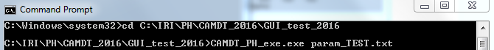<Figure 22>

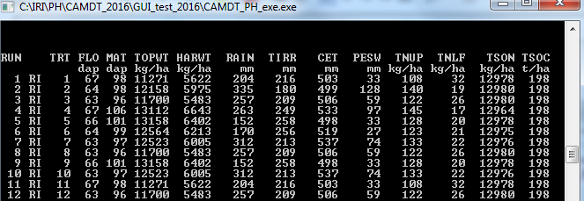<Figure 23>

Once all simulations ran successfully, you should be able to find a new folder “####_output” (in this exercise “TEST_output”) under your working directory as shown in Figure 24. The folder contains all the DSSTA output files (*.OUT) as well as some additional post-processed files (AveStress.txt, YIELD.txt and PgtTHRESHPct.txt). For more information about DSSAT output, please refer to DSSAT documentation.

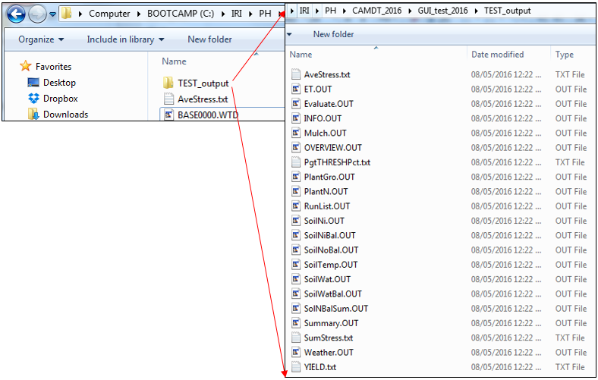<Figure 24>

The CAMDT helps the user to display some of interesting outputs (predicted yields, water stress and gross margin) easily. To display output variables, you can click the buttons in orange (from “I. Display Yield Estimation (Boxplot)” to “VI. Display Gross Margin (Exceedance Curve)”) in Figure 21. The first two buttons, “I. Display Yield Estimation (Boxplot)” and “II. Display Yield Estimation (Exceedance Curve)” are to display predicted yields in two different ways (using boxplot and exceedance curve). A box plot is used to display the distribution of quantitative data. The box shows the quartiles of the dataset while the whiskers extend to show the rest of the distribution, except for points that are determined to be “outliers”. From the boxplot, you can have an idea of median (indicated by the red line in the middle of the notch) and mean (indicated by the extended red line in Figure 25(a)). The notch in Figure 25(a) displays a confidence interval around the median (typically 95% confidence interval) and the blue box shows an interquartile (i.e., 50% of data) between the 1st (i.e., 25th percentile) and 3rd (i.e., 75th percentile) quartiles. The two black bars indicates low/upper whiskers. The green dot is the simulated yield using observed weather. This green dot can be used as a reference to check how the SCF we used was accurate compared to actual weather condition during the target season. In 2010, El Niño resulted in a drier weather in JFM and a drier SCF 39.73% BN, 39.2% NN and 20.45% AN was forecasted. Therefore the green dot show very low yield compared to the forecasted yields from climatology (33% AN, 34%NN and 33% BN we set in Figure 5).

The yield exceedance curve in Figure 25(b) shows the full distribution of the predicted yields using the weather realizations downscaled from the given SCF. Exceedance probability (P) is computed as P = m × (n + 1)-1, where m is the rank of a forecasted yield (m=1 is the largest value) and n is the total number of simulated years (yields). Uncertainties in forecasted yields are reflected in the spread of the exceedance curve or size of the interquartile of the boxplot. Again the green dotted line in Figure 25(b) is from the observed weather.

|  |  |
| --- | --- |
| (a) | (b) |
|  |  |

<Figure 25>

Next two buttons, “III. Display Average Water Stress (WS)” and “IV. Display Risk of Exceeding X% WS” were to display average water stress and risk of water stress during the crop growth. In this exercise, since we set up regular flooding depth (not constant flooding depth) for the second irrigation (by selecting “No” in Figure 20), water stress happened around the DAT=100 (Figure 26(a)). However, because the water stress was minimal (less than 0.06) and it happened during the maturity stage, there was no serious yield loss due to water stress. There are also risks of exceeding 50% of water stress around DAP=100 (Figure 26(b)).

|  |  |
| --- | --- |
| (a) | (b) |
|  |  |

<Figure 26>

Expected gross margins can be also calculated once a user provides an expected crop price [$ ton-1], cost for fertilizer [$ kg-1 N], cost for irrigation [$ mm-1], the general cost [$ ha-1]. The general cost includes the cost of buying seeds, labor and/or maintaining/renting tools or machines. If we assume expected rice price = 425 [$ ton-1], cost for fertilizer =1[$ kg-1 N], cost for irrigation =0.3 [$ mm-1] and general cost=300 [$ ha-1], the expected gross margins are calculated for all predicted yields and distribution of them are displayed in Figure 27(a) and (b) using a boxplot and exceedance curve same as yield distribution.

|  |  |
| --- | --- |
| (a) | (b) |
|  |  |

<Figure 27>

In this excise, we tried only one scenario. However, If you want to make another scenario (say by changing the planting date), you can simply go back to the page you want to make a change, make changes whatever you want and then type a new scenario name on the second line in Figure 21. If you click “Click to write param2.txt” button, the newly updated information will be saved into another “param_####.txt” file. You can create up to 5 different scenarios for comparison.

For example, by running CAMDT with three different planting dates, you can find an optimal planting date as shown in Figure 28.

|  |  |
| --- | --- |
| (a)  (b)  (c)  (d) |  |
|  |  |

<Figure 28>

1. Contact info: [eunjin@iri.columbia.edu](mailto:eunjin@iri.columbia.edu)