Default of Credit Card Clients Dataset
Default Payments of Credit Card Clients in Taiwan from 2005

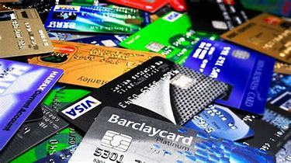

by

Eunna Park
Raheleh Bahrami Khodababandeh

Big Data Solution Architecture

in

Applied Computer Science & Information Technology

Conestoga College
Waterloo, Ontario

Introduction

Background
Credit card is a slab of plastic which is issued by financial organization in order to allow the cardholders borrow funds from bank to make their purchases (goods/services) and do the payment later, plus interest in some circumstances. In Fact, if customer pay back the borrowed fund in full balance within the “grace period” of 25-30 days, they do not have to pay any interest. However, if they do not pay it back in that time period, they should pay interest on top the borrowed money. It is important for the financial institution to have a prediction about their customers behavior regarding their credit card payment in order to decrease the chance of fraud and risk.

Purpose
The overall purpose of this paper is to predicate the likelihood of default payment base on different demographic variables. Also, to investigate which variables are the strongest predictors of default payment. The dataset we are using for this project contains information on demographic factors, bill statements of credit card, and history of payment for clients in Taiwan from April 2005 to September 2005. This project adopts the dataset from Kaggle website, and the link is provided in the references.

Objective & Deliverables
As mentioned, the specific objective of this project is to check the likelihood of defaulting next payment based on some factors and predict the behaviour of the customers regarding their credit card payment. Hopefully, the results provide useful insight to the financial institution about their customers payment behaviour and preferences.

Structure of the project
This project is organized into three chapters. Chapter one introduces the background, purpose, objective, and deliverables. Chapter two reviews the variables and data transformation. Chapter three explains the development of the research model. Chapter four reports the results of the study. Below is the steps we follow to come up with the appropriate model and result.
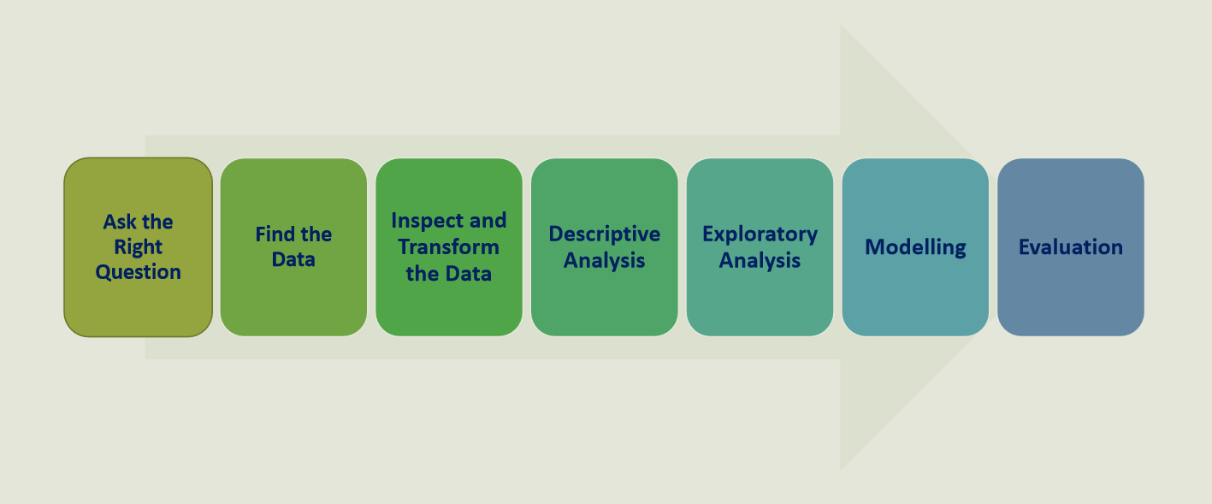

Data Analysis

Variables
The dataset used in this analysis has 25 variables and the survey was done with around 3000 customers payment history. Data from sample used to draw inferences about population and the goal of this chapter is to provide an overview of factors which may affect consumers credit card payment behavior.
variables
ID | ID of each client
LIMIT_BAL | Amount of given credit in NT dollars (includes individual and family/supplementary credit
SEX | Gender (1=male, 2=female)
EDUCATION | (1=graduate school, 2=university, 3=high school, 4=others, 5=unknown, 6=unknown)
MARRIAGE | Marital status (1=married, 2=single, 3=others)
AGE | Age in years
PAY_0 | Repayment status in September, 2005 (-1=pay duly, 1=payment delay for one month, 2=payment delay for two months, … 8=payment delay for eight months, 9=payment delay for nine months and above)
PAY_2 | Repayment status in August, 2005 (scale same as above)
PAY_3 | Repayment status in July, 2005 (scale same as above)
PAY_4 | Repayment status in June, 2005 (scale same as above)
PAY_5 | Repayment status in May, 2005 (scale same as above)
PAY_6 | Repayment status in April, 2005 (scale same as above)
BILL_AMT1 | Amount of bill statement in September, 2005 (NT dollar)
BILL_AMT2 | Amount of bill statement in August, 2005 (NT dollar)
BILL_AMT3 | Amount of bill statement in July, 2005 (NT dollar)
BILL_AMT4 | Amount of bill statement in June, 2005 (NT dollar)
BILL_AMT5 | Amount of bill statement in May, 2005 (NT dollar)
BILL_AMT6 | Amount of bill statement in April, 2005 (NT dollar)
PAY_AMT1 | Amount of previous payment in September, 2005 (NT dollar)
PAY_AMT2 | Amount of previous payment in August, 2005 (NT dollar)
PAY_AMT3 | Amount of previous payment in July, 2005 (NT dollar)
PAY_AMT4 | Amount of previous payment in June, 2005 (NT dollar)
PAY_AMT5 | Amount of previous payment in May, 2005 (NT dollar)
PAY_AMT6 | Amount of previous payment in April, 2005 (NT dollar)
default.payment.next.month | Default payment (1=yes, 0=no)

Import libraries and read the dataset from csv file
In this project we are using Python as the tool for analysing the dataset. In this part, the libraries needed for the analysis imported to the Python in order to read and analyze the dataset and transform any variables that are required to conduct the in Python.

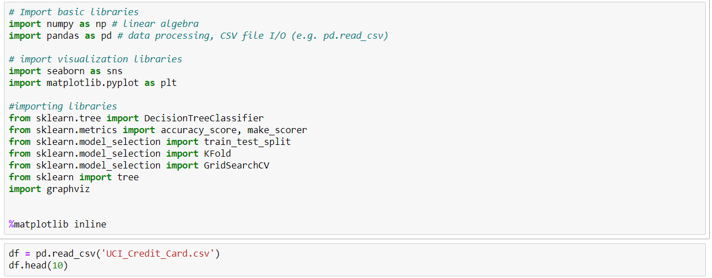
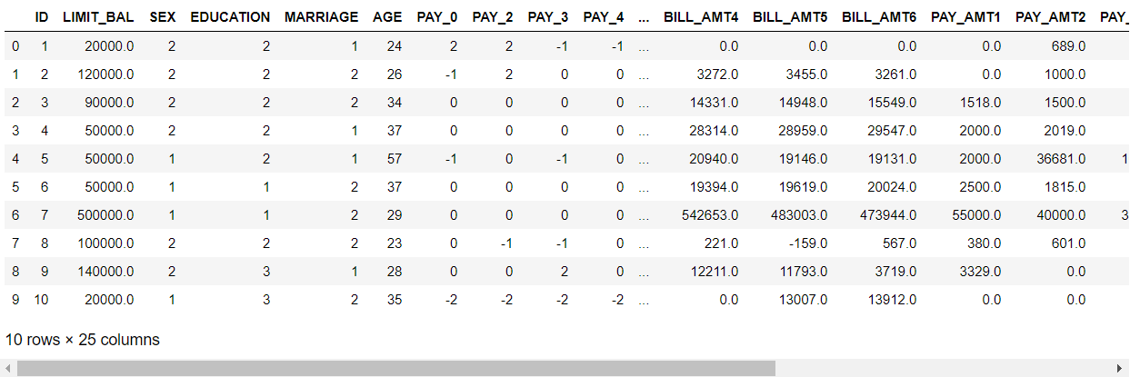

Data Transformation
The first step in any data analysis is to know the dataset and check for accuracy and reliability. In this step variables were checked to find type of the variable and check for any missing or anomalous data.

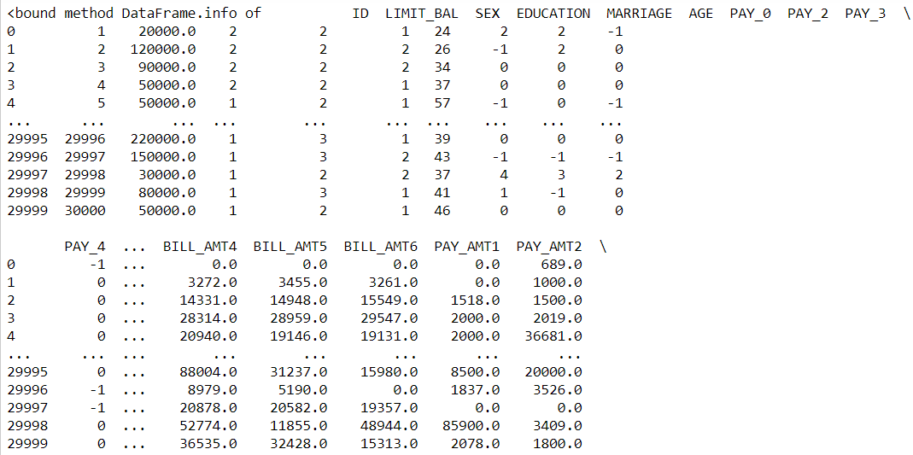
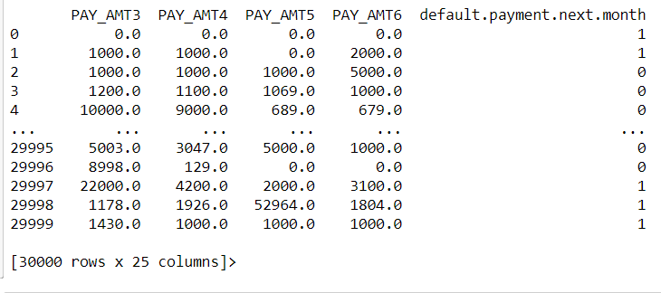

Descriptive Analysis
Here a descriptive data analysis was created to summarize, organize, and simplify the dataset and make it easily to understand. In this summarizing calculation for mean, min, max, and quartiles had been done for the variables.
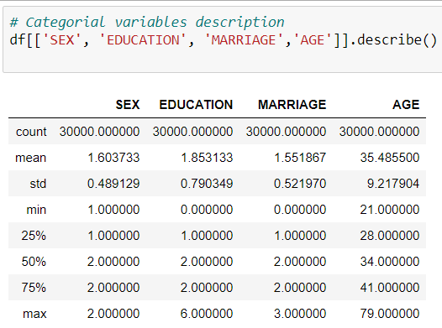

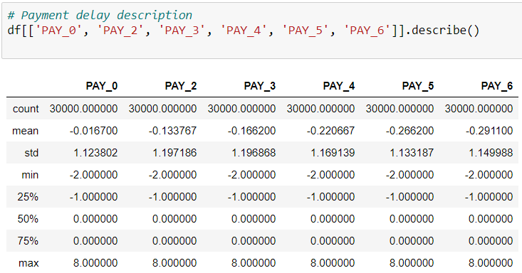
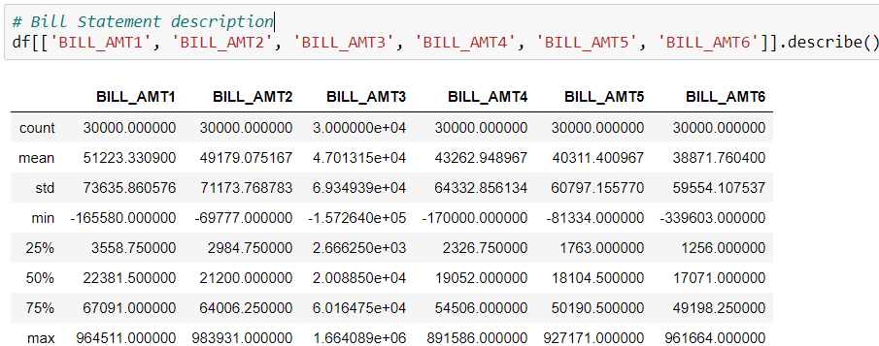
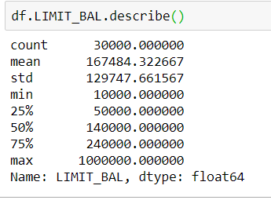

Renaming the columns for the easier interpretation & data cleaning
In this part, we recognized that the dataset did not labeled properly, so we have decided to rename the columns for easier interpretation.

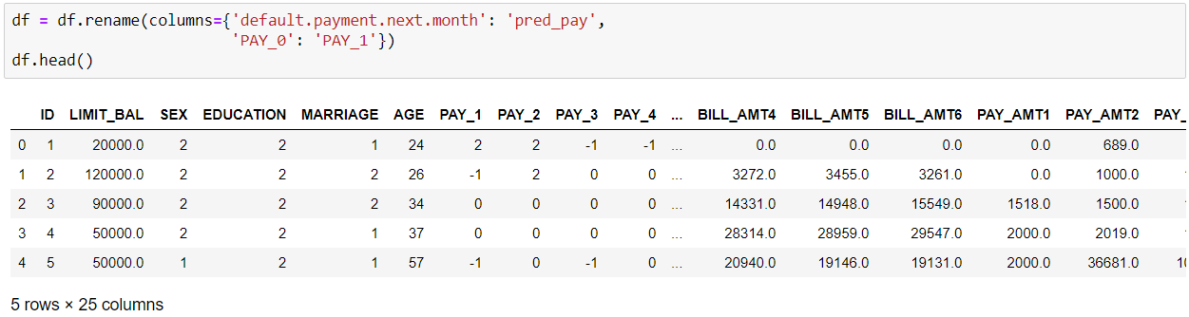
Checking the total observation in pre_pay:

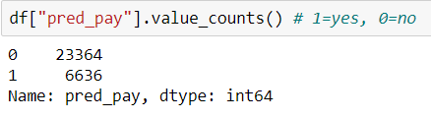

Checking the columns in the dataset after name change:
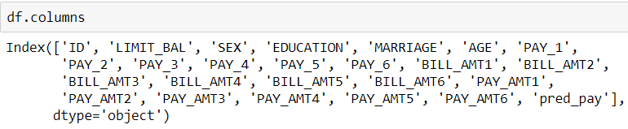
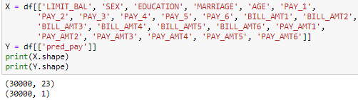
Data cleaning:
Age has too wide range, so make clustering as age groups.
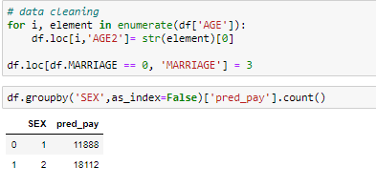

Exploratory Analysis
In this step coding have been done to have Exploratory Analysis for analyzing data sets and summarize its main characteristics. Also, we want to have idea about outliers and to know how to deal with them.

Gender:
Frequency of the not having payment for the next month is higher in female than in men.
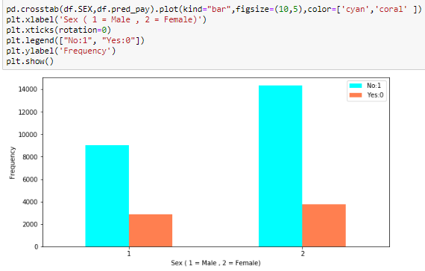

Education:
The result shows that most of the customers have graduate degree and there are some outlier in education, howeve; we decided to keep them for now to see their result at the end.
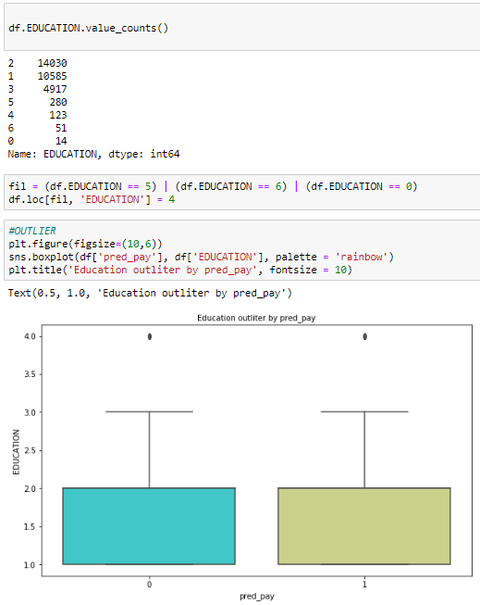
Marriage:
The result shows the frequency of not having payment for the next month is higher for singles than the marriages, which kind of make sence.
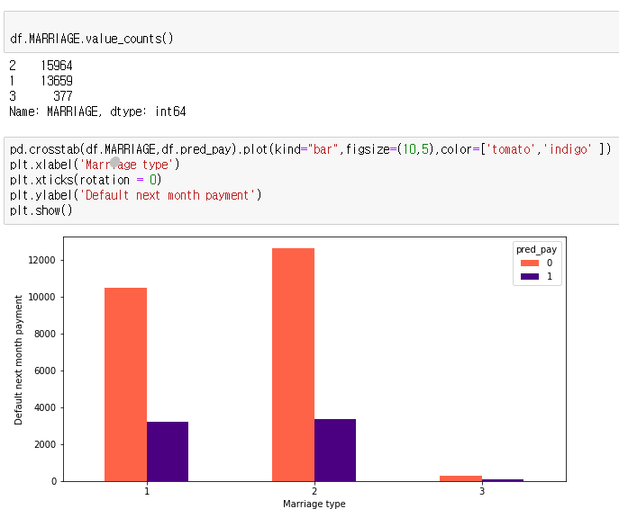

Age:
Result shows that most of the customers are in the mid age customers and they are more likely to do the next month payment than the younger one. However; the chance of doing payment decrease by increase in age.
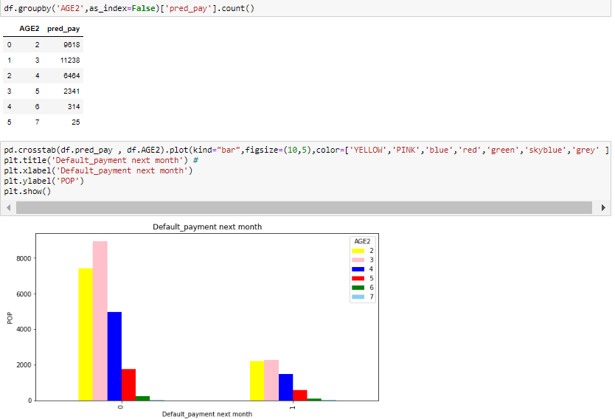
In Scatter plot, I have expected that there are closly related between age and limit balance, but many percentage of people have similar limit balance.

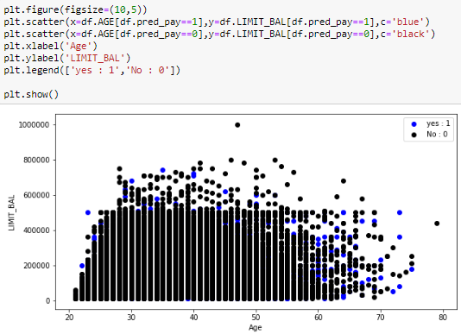

Model development
The purpose of this chapter is to design a predictive model which helps us in predicting the likelihood of defaulting next payment based on all other factors. For choosing a model for a dataset with predicting numeric, we should consider whether accuracy is important to us or the speed. Decision Tree and Liner Regression models are good when speed is our priority. Random Forest, Neural Network, Gradient Boosting Regression are useful while accuracy is important. The first model that we used in this project is Decision Tree which is a flowchart-like structure. In decision model, each internal node represents a “test” on an attribute, each branch shows the outcome of the test, and each leaf node represents a class label, and finally the paths from root to leaf represent classification rules. (Brid, R. 2018)

Decision Tree Model
The first step is to split the df into train and test, and to make sure they are not communicating during the training. Here we will train on 90% of the data and test on the remaining 10%.

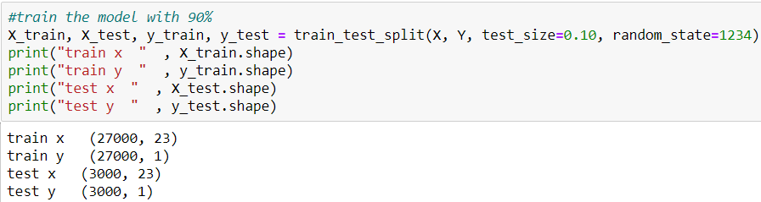

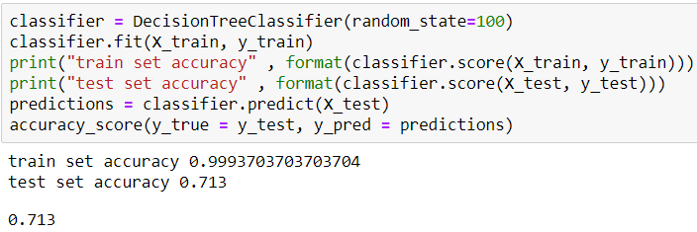

To get accuracy score, tried to divide the gotten. I was not shown partitial outrcomes.
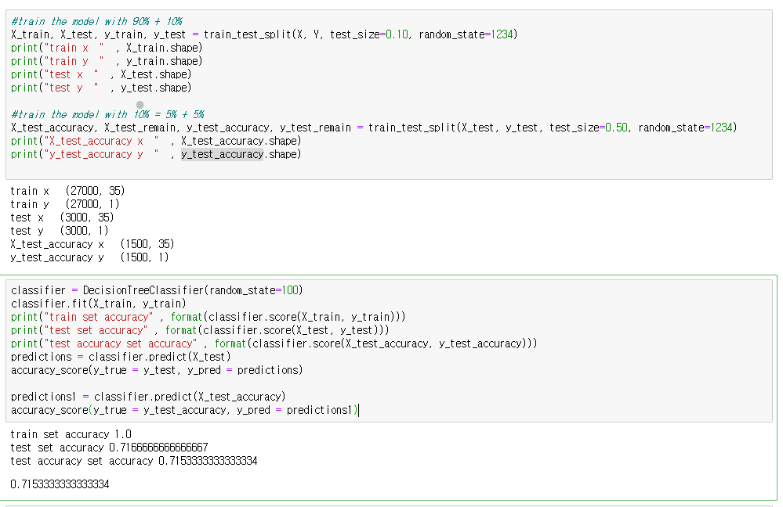

The result shows 71% accuracy for the random choice of the parameters which in not reliable. So, we had decided to do more adjustment in order to have higher score. Use GridSearchCV and classify the parameters and check the result base on that.

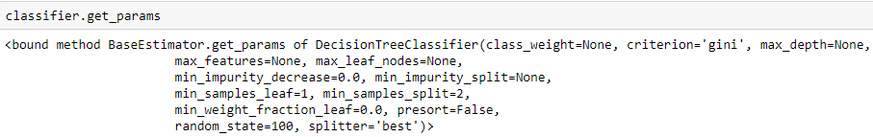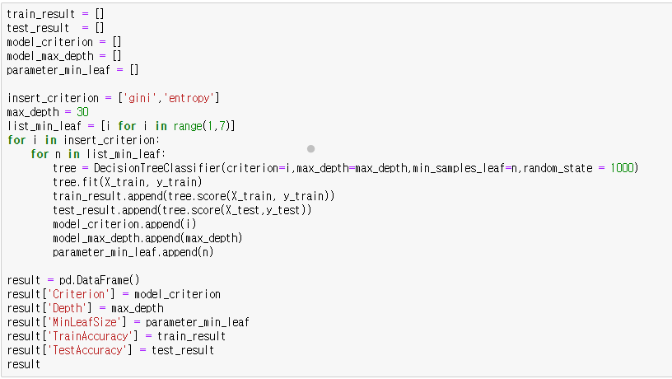
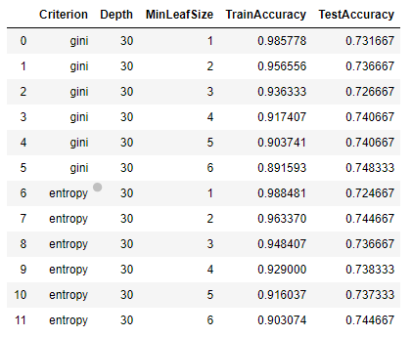

We used melt function for visualizing the result and find accuracy of test and train.
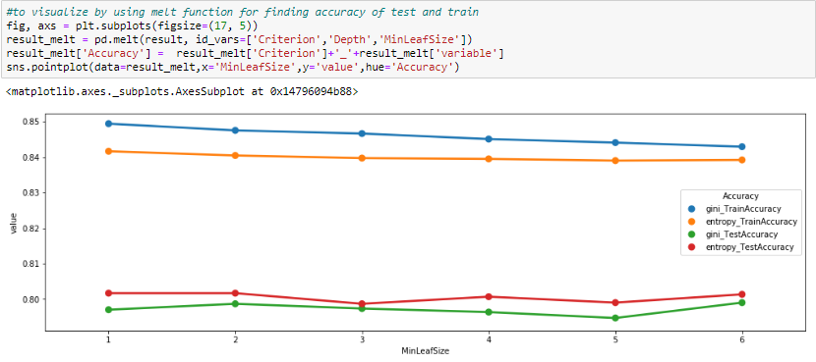
The above chart shows that the Entopy model fits better. The accuracy is a little bit higher, but still low for our purpose.
train set accuracy 0.8712962962962963
test set accuracy 0.795 (5% data)

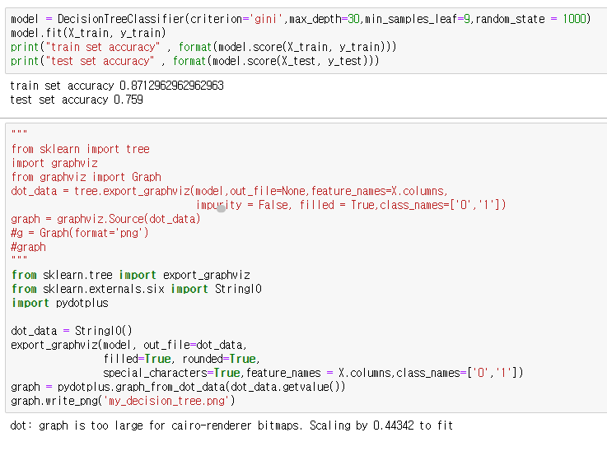
The downloaded image of tree will be attached with all files.
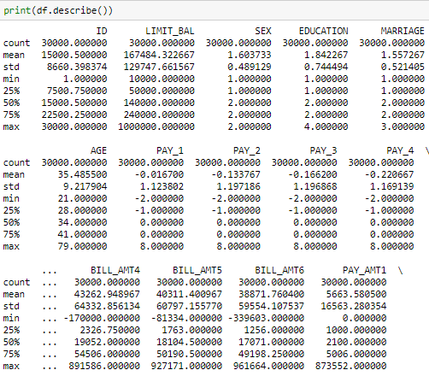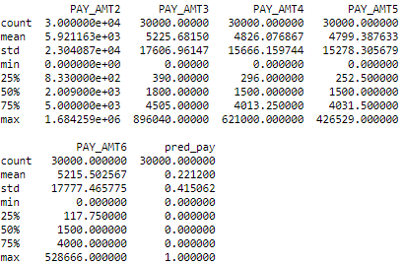

The result of the Decision Tree shows that even though we have used GridSearchCV, the accuracy got better but still it is around the 80% and can not be a good predictive model for our dataset. So, we have decided to move forward and try another model.

TensorFlow which is kind of A Neural Network

Neural Network algorithm has 3 layers, input layer, hidden layer, output layer. for making input data that we need in this step, we are using dummy value as binary variables.
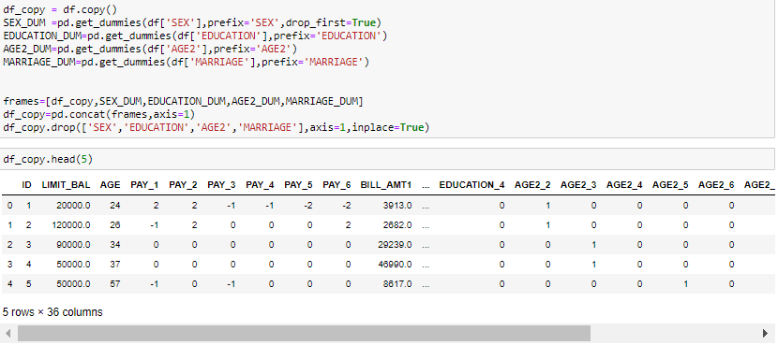
We have tried to drop null value for improvement of accuracy
, but it did not discovered.
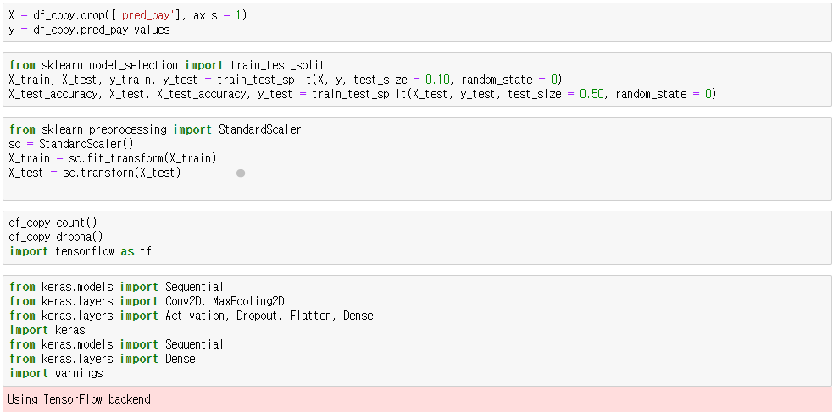
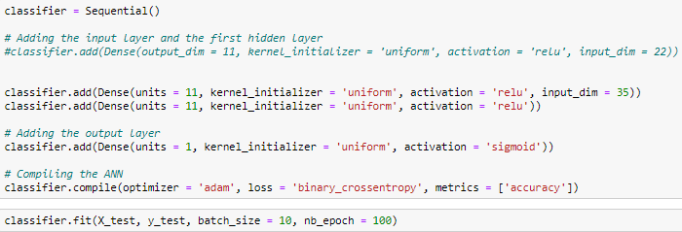

Test Data (5/100)
C:\Users\maiji\Anaconda3\lib\site-packages\ipykernel_launcher.py:1: UserWarning: The `nb_epoch` argument in `fit` has been renamed `epochs`.
"""Entry point for launching an IPython kernel.
Epoch 1/100
1500/1500 [==============================] - 0s 212us/step - loss: 0.6020 - accuracy: 0.7880
Epoch 2/100
1500/1500 [==============================] - 0s 132us/step - loss: 0.4907 - accuracy: 0.7887
…..
1500/1500 [==============================] - 0s 129us/step - loss: 0.3083 - accuracy: 0.8720
Epoch 96/100
1500/1500 [==============================] - 0s 126us/step - loss: 0.3076 - accuracy: 0.8700
Epoch 97/100
1500/1500 [==============================] - 0s 153us/step - loss: 0.3079 - accuracy: 0.8713
Epoch 98/100
1500/1500 [==============================] - 0s 148us/step - loss: 0.3059 - accuracy: 0.8687
Epoch 99/100
1500/1500 [==============================] - 0s 146us/step - loss: 0.3055 - accuracy: 0.8680
Epoch 100/100
1500/1500 [==============================] - 0s 144us/step - loss: 0.3055 - accuracy: 0.8693
Out[40]:
<keras.callbacks.callbacks.History at 0x26548155c48>

Train Data(90/100)
Epoch 1/100
1290/28500 [>.............................] - ETA: 3s - loss: 0.5403 - accuracy: 0.7853
C:\Users\maiji\Anaconda3\lib\site-packages\ipykernel_launcher.py:1: UserWarning: The `nb_epoch` argument in `fit` has been renamed `epochs`.
"""Entry point for launching an IPython kernel.
Epoch 97/100
28500/28500 [==============================] - 3s 120us/step - loss: 0.4198 - accuracy: 0.8229
Epoch 98/100
28500/28500 [==============================] - 3s 118us/step - loss: 0.4197 - accuracy: 0.8233
Epoch 99/100
28500/28500 [==============================] - 4s 124us/step - loss: 0.4200 - accuracy: 0.8234
Epoch 100/100
28500/28500 [==============================] - 4s 127us/step - loss: 0.4197 - accuracy: 0.8233
Out[41]:
<keras.callbacks.callbacks.History at 0x2654815bc48>

Finally, after the tensor flow was executed, we can draw conductions which are 82% accuracy in train part and 87% of accuracy in test data.

Acknowledgements
We would like to thank you professor Norbet Mika for all your patience, encouragement and support which helped us in completion of this project. Norbet, thanks for giving us the opportunity to study in the field that we have always been interested in and for being a welcome source of advice during this time. We have learned a lot from you, but the best lesson is to always be patient, just like you.

References
Uci. (2016, November 3). Default of Credit Card Clients Dataset. Retrieved from https://www.kaggle.com/uciml/default-of-credit-card-clients-dataset
Lichman, M. (2013). UCI Machine Learning Repository [http://archive.ics.uci.edu/ml]. Irvine, CA: University of California, School of Information and Computer Science
Marsh, D. (2020). PROG8430 – Data Analysis, Modeling and Algorithms- Lecture 06 – Multiple Linear Regression [PowerPoint slides]. Retrieved April 16, 2020 from eConestoga.
Brid, R. (2018, October 26). Decision Trees - A simple way to visualize a decision. Retrieved April 17, 2020, from https://medium.com/greyatom/decision-trees-a-simple-way-to-visualize-a-decision-dc506a403aeb

Share to WhatsApptalk a lot about the science side of data analysis and BI: the calculations and algorithms needed to perform complex queries. Sure, a big part of BI is math, but making sense of data – planning how to structure your analysis at one end, and interpreting the results at the other – is very much an art form, too.

