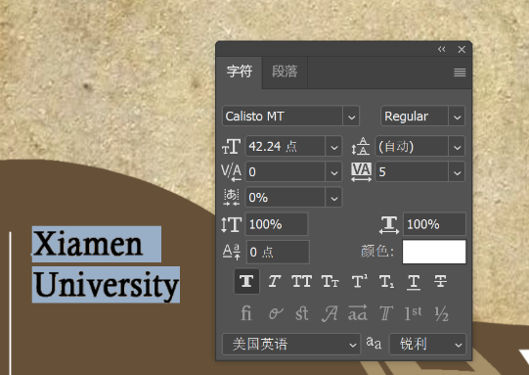
Xiamen
University

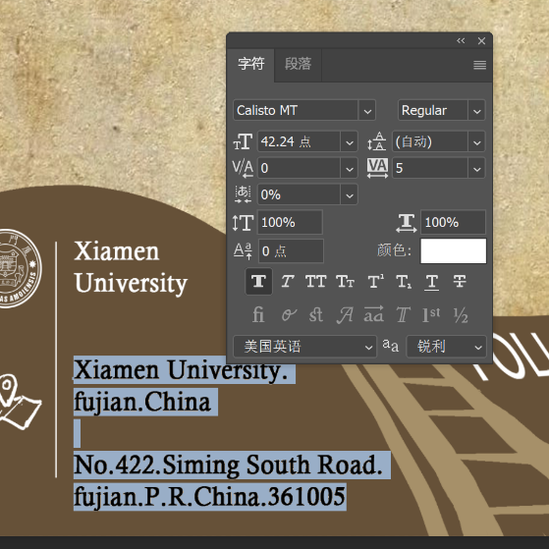
Xiamen University.
Fujian. China
No.422.Siming South Road.
fujian.P.R.China.361005

contact us

igem_xmu@163.com

