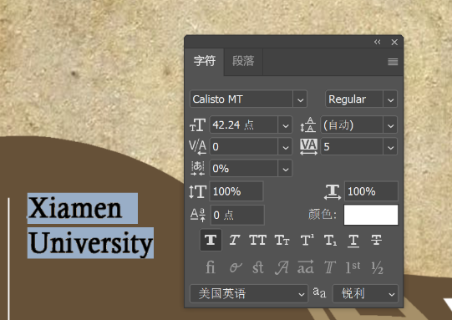

Xiamen University

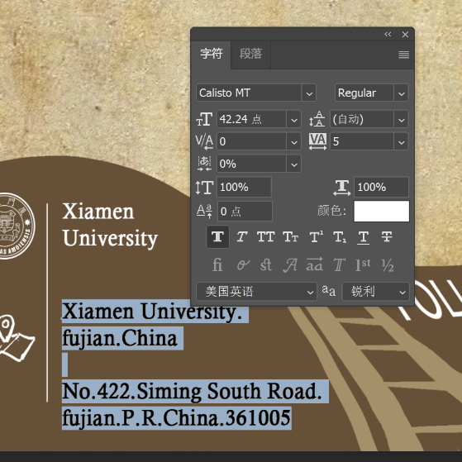

Xiamen University.Fujian. ChinaNo.422.Siming South Road.fujian.P.R.China.361005

contact us

igem_xmu@163.com