**Artificial Intelligence**



DT228/3 – Artificial Intelligence

**Eurico Carajote**

## Code:

In my code I’ve only made a few changes, I made the program modular so that I can just input my parameters for different questions, I’ve also implemented my predict functions, one for a singular output and one for an array of outputs, in addition to this my cost function is running as a cross entropy function. In the following screen shot there is also my code to write my output and predict statement into a csv file using pandas.

Modularity:

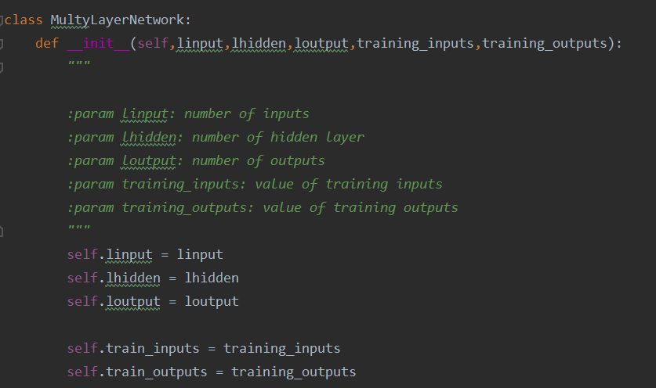

Predict Functions:

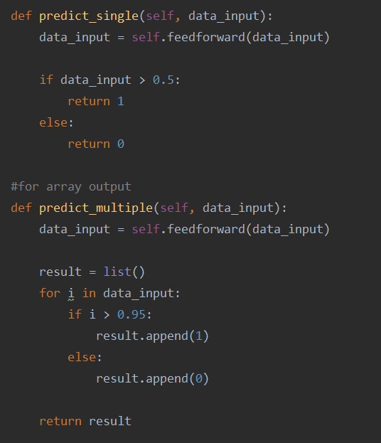

cross entropy function:



Output to csv:

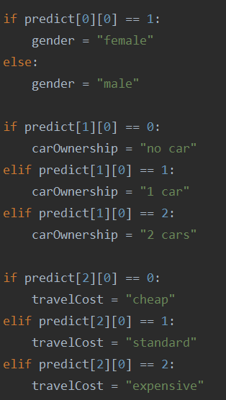 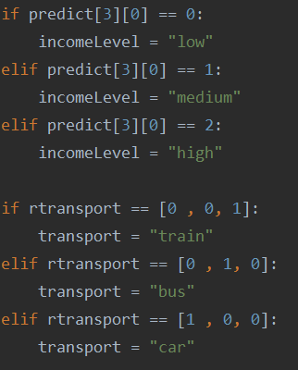

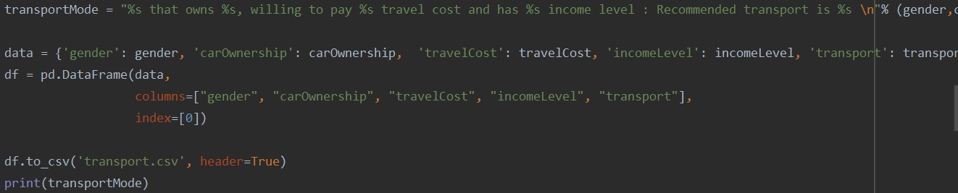

Output in Jupyter Notebook:



Output in csv:

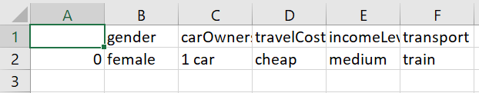

## Problem 1:

Ephocs: 2000

Eta: 2.0

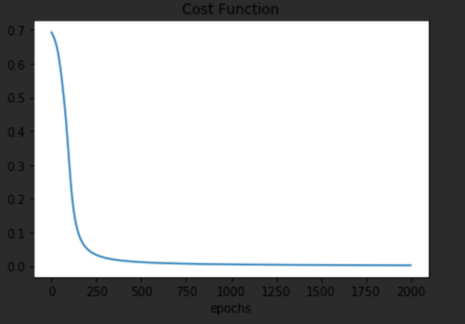

Ephocs: 2000

Eta: 11.0

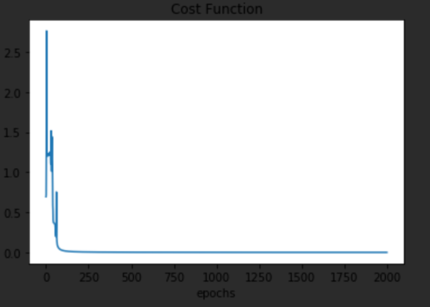

## Problem 2:

Ephocs: 2000

Eta: 2.0

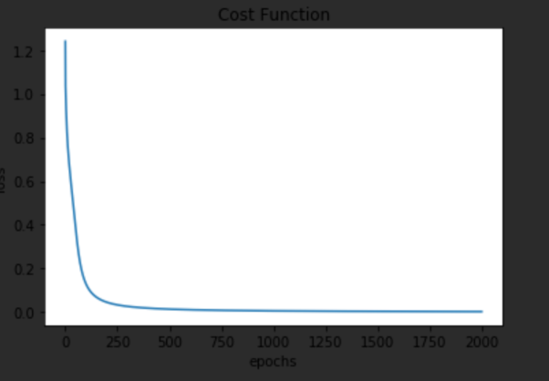

Ephocs: 2000

Eta: 50.0

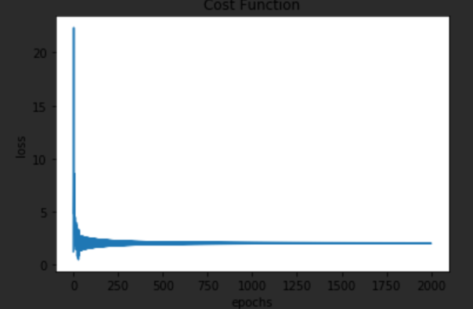

## Problem 3:

Ephocs: 2000

Eta: 2.0

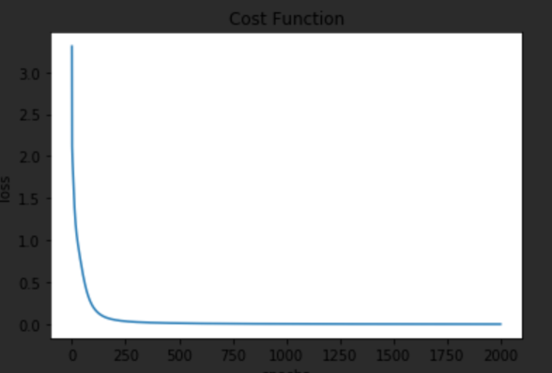

Ephocs: 2000

Eta: 11.0

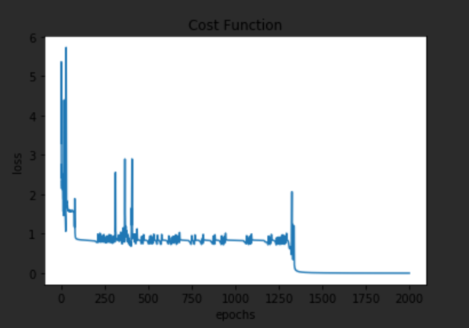

## Problem 4:

Ephocs: 5000

Eta: 0.05

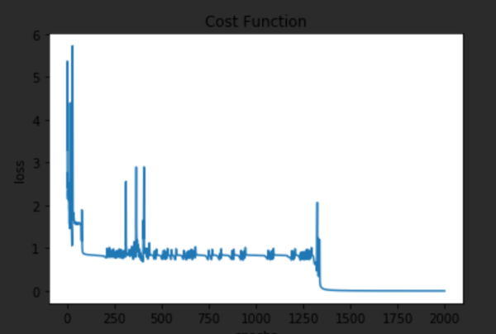

Ephocs: 5000

Eta: 11.00

