**Part 2 – YouTube**

**1 – Encoding error for UTF-8**

I believe the files with Aramaic alphabet was getting error to read in UTF-8 code.

For this assignment, the encoding= "ISO-8859–1" will be satisfactory to reach the objectives of this assignment.

However, it is necessary to validate if the encoding= "ISO-8859–1" can be used as standard, if necessary further analysis in the text file.

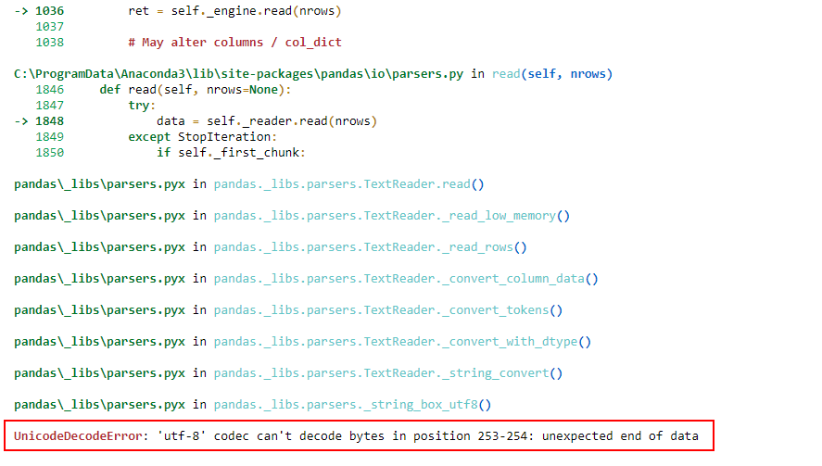

Solution: encoding= "ISO-8859–1"

**2 – Error to load data into Postgres database**

One of the approaches was to deploy the data automatically into the database. However, it was not possible because of the error below:

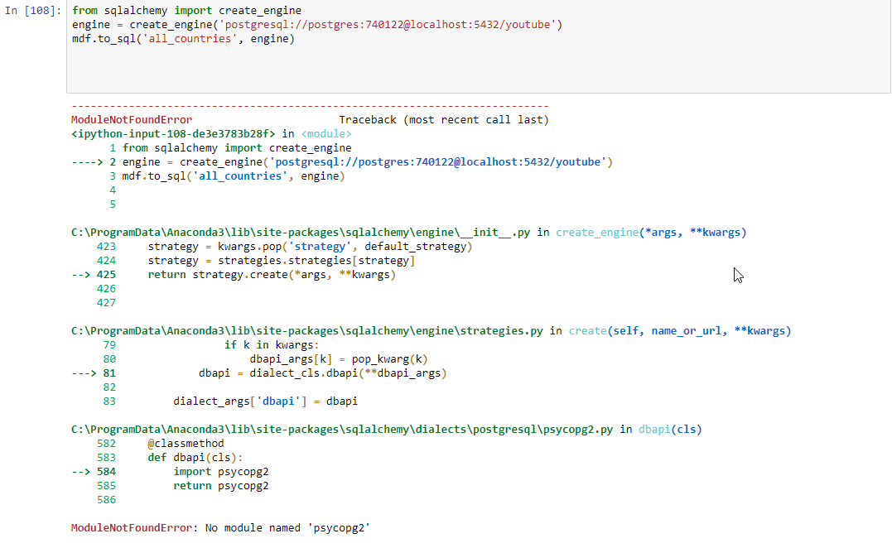

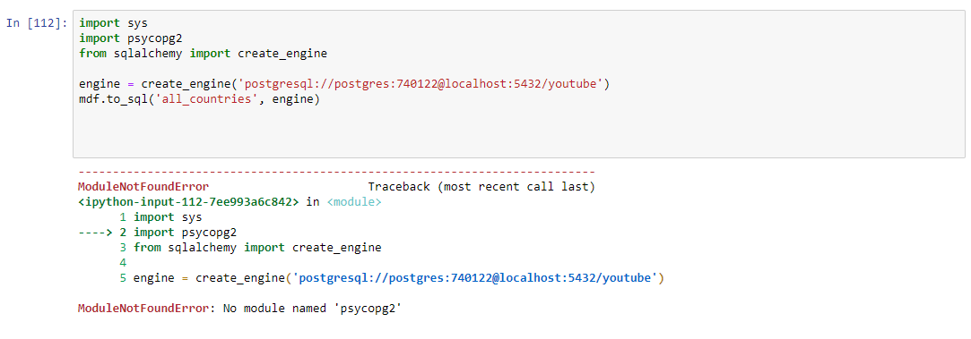

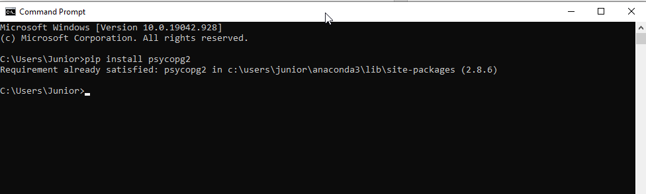

I have the package installed, but I do not know why I could not write on the database. It is necessary to further investigation to solve this problem.

**3 – Null Category investigation**

Null Values. Further investigation must analyse if the NULL category is correct.

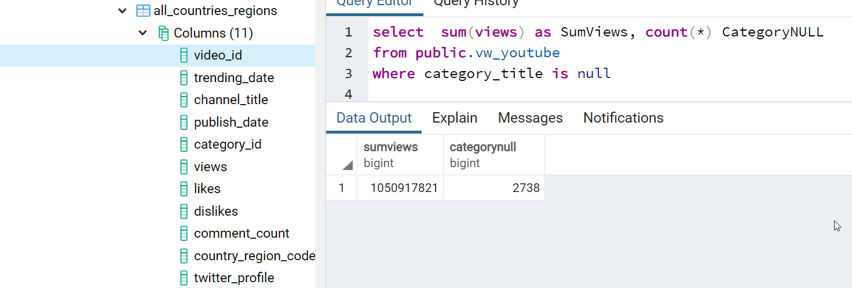

Executing some investigation on category 29, and there isn't category 29 on the JSON file for Canada.

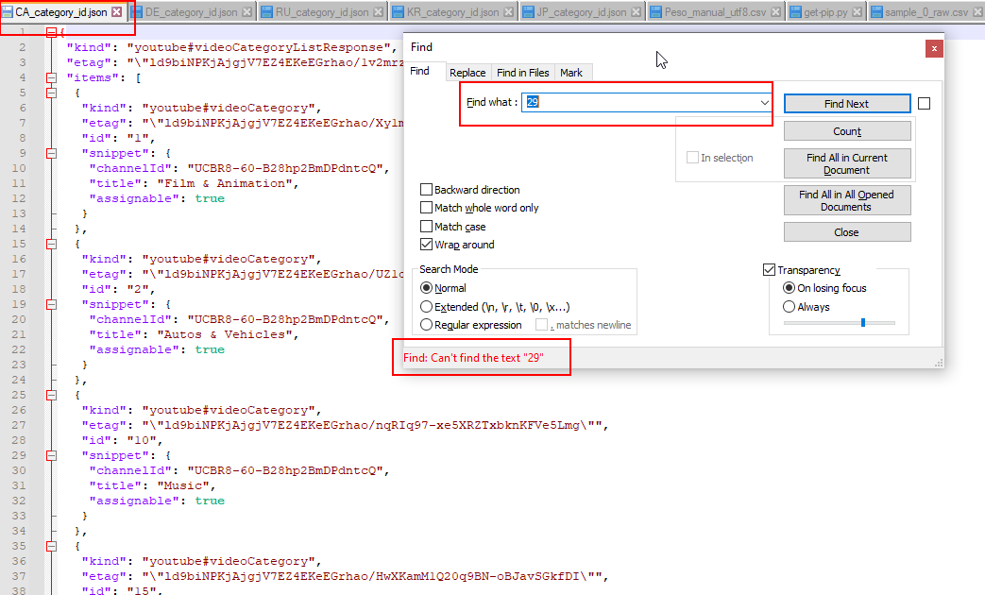

Sample of Category 29:

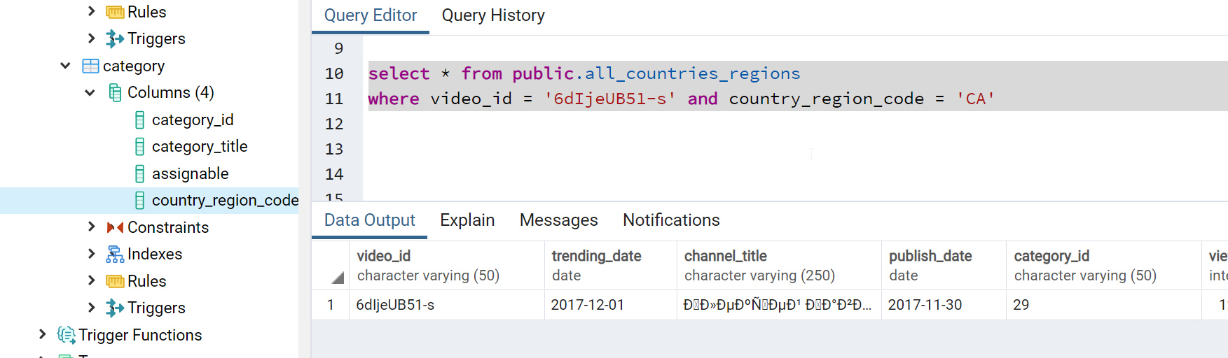

If we search for this video_id, the category is null on the view.

Because there isn't category 29 in the JSON file as said previously.

**4 – Date**

There is a problem with the data set. Because there are no data for some days:

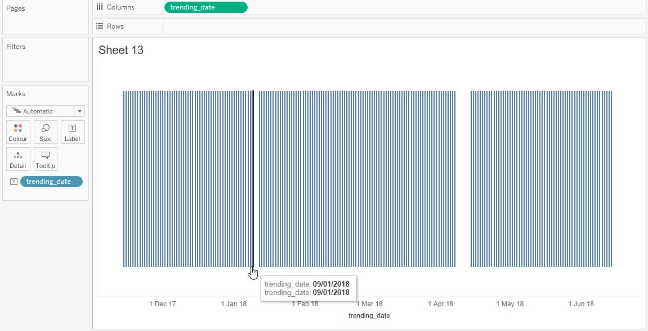

It is necessary to validate what would be the approach with these days without data.