**Some notes of the assignment**

**Part 1 – Airline**

**1 – Transforming field**

I was trying to transform DepTime format from **hhmm** to **hh:mm**.

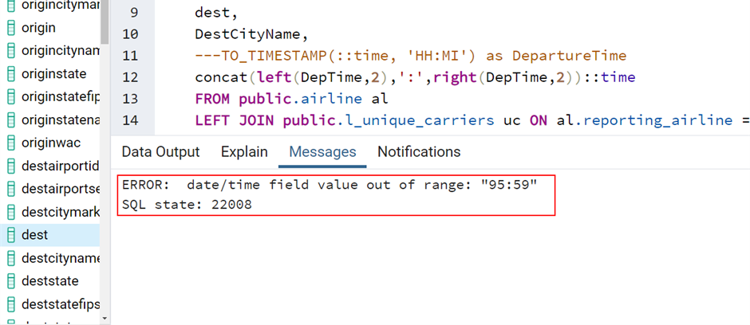

I found another solution later after retrieving the data for the SFO-LAX route.

**2 – Change colour Pallete configuration**

The Twitter colour palette on the file Preferences.tps on My Tableau Repository folder

