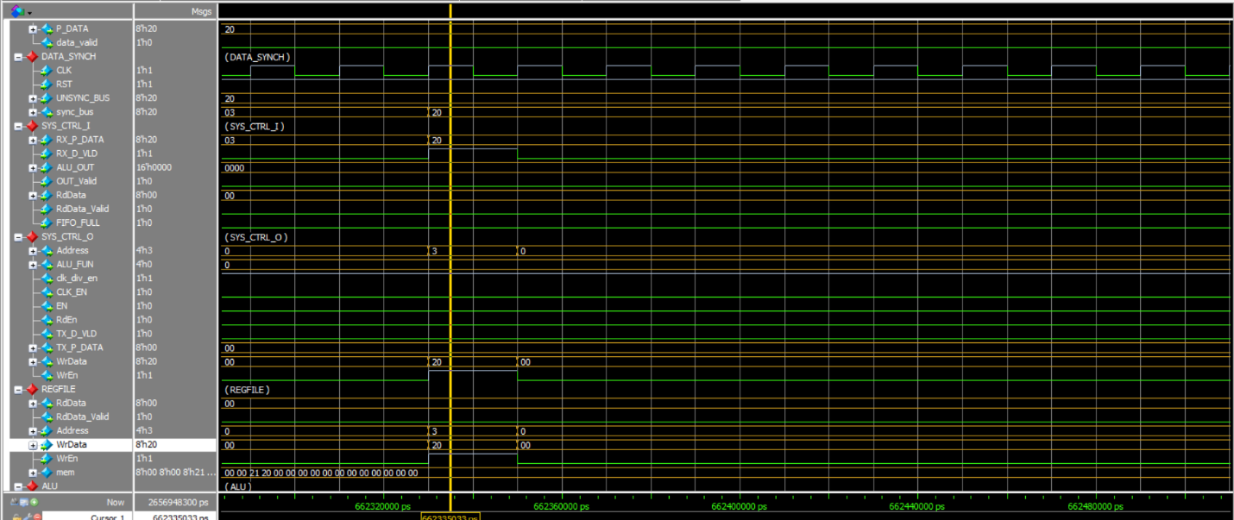

Figure 1: Writing the DIV_RATIO

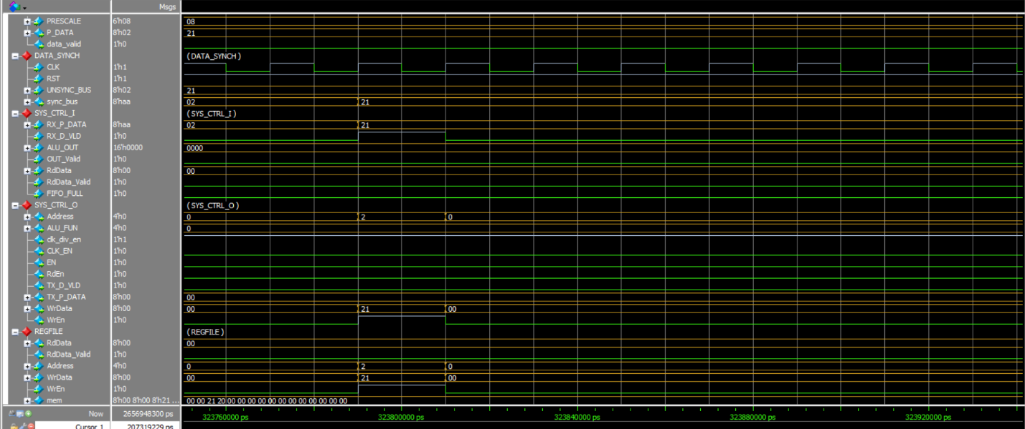

Figure 2: Writing the Prescale

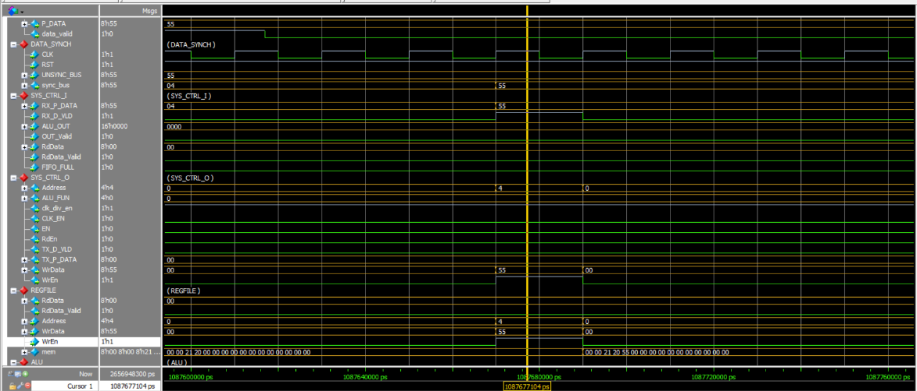

Figure 3: Writing 0x55

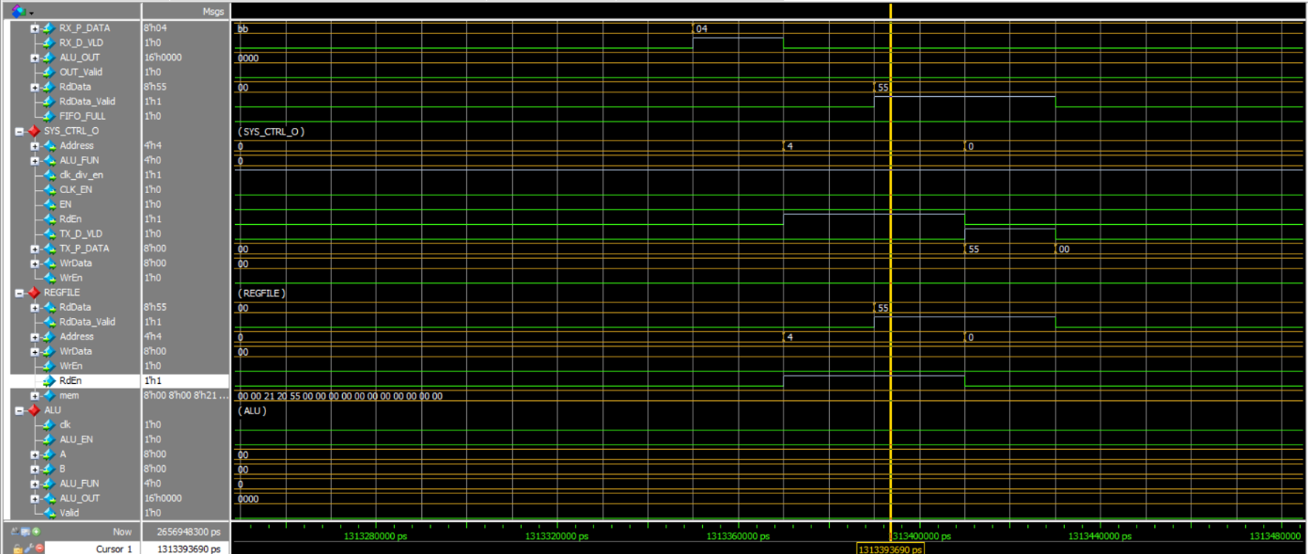

Figure 4: Reading 0x55

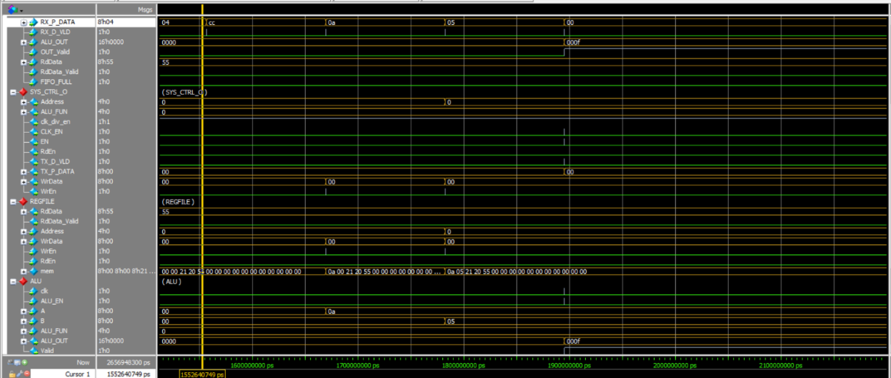

Figure 5: Sending the ALU Ops 0xa and 0x5 with Op ADD 000

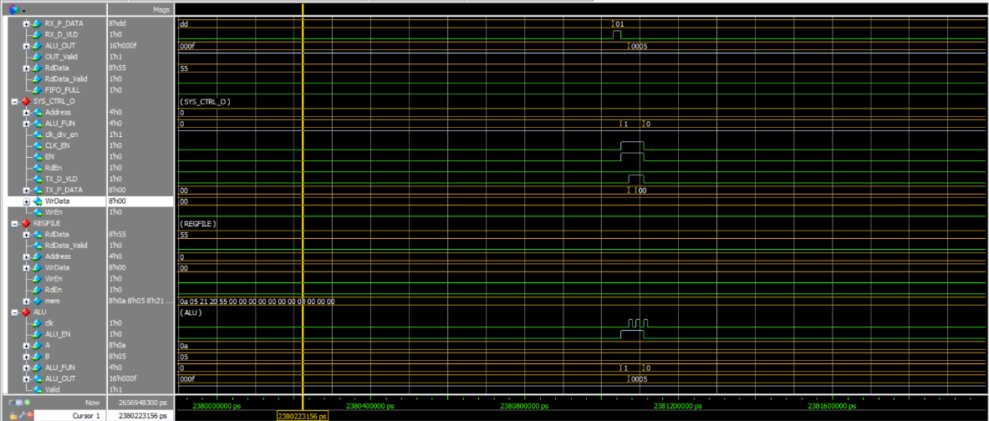

Figure 6: Sending the ALU NoOp Command with SUB 0x01

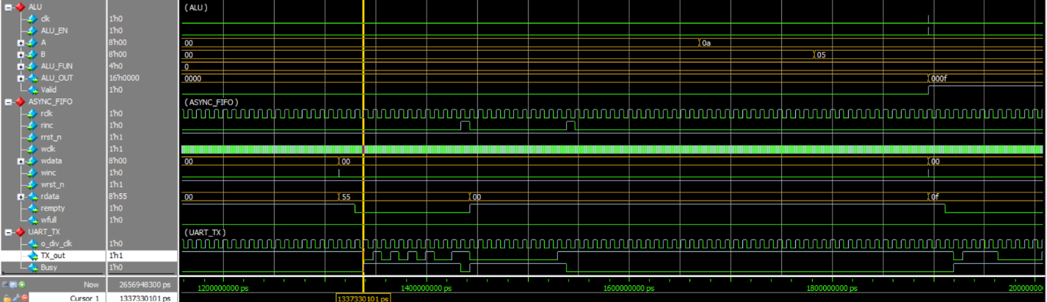

Figure 7: TX_OUT

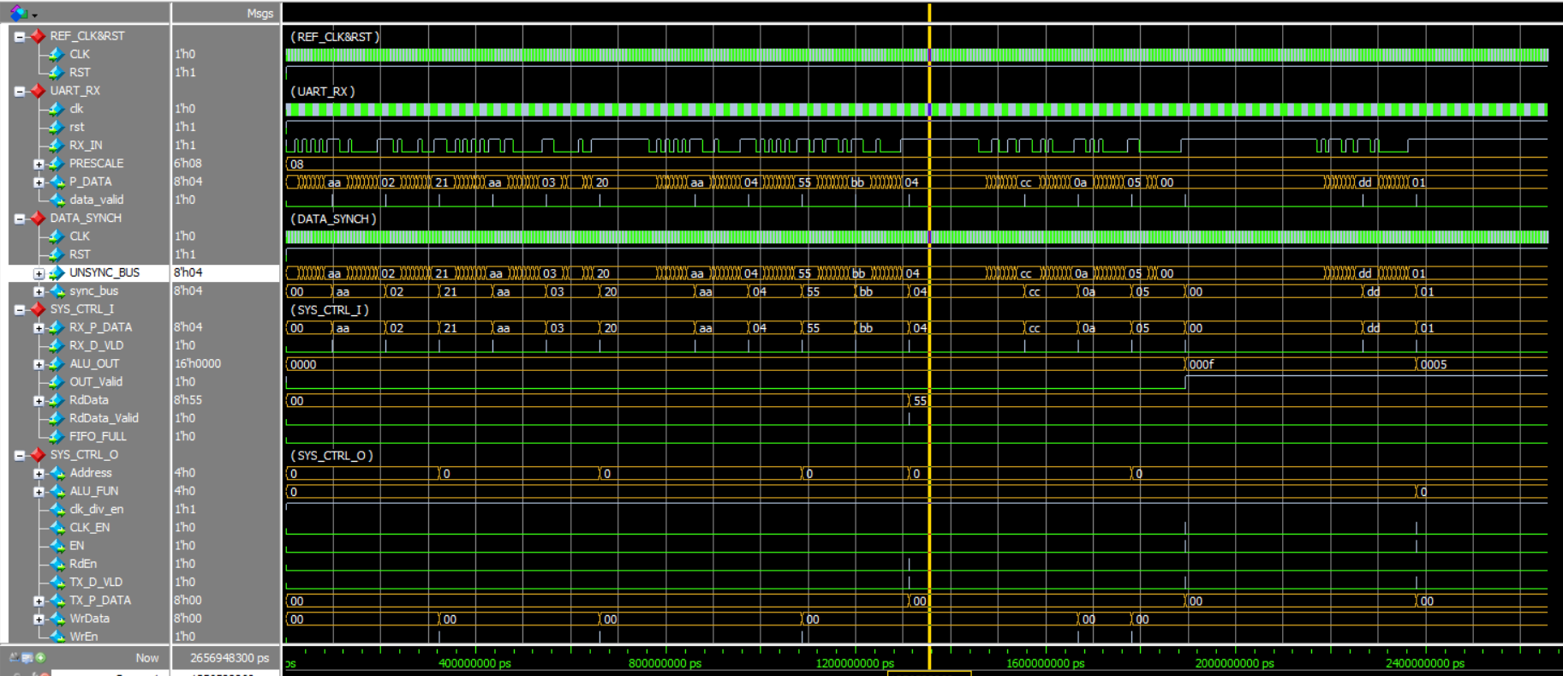

Figure 8: Full Waveform Part I

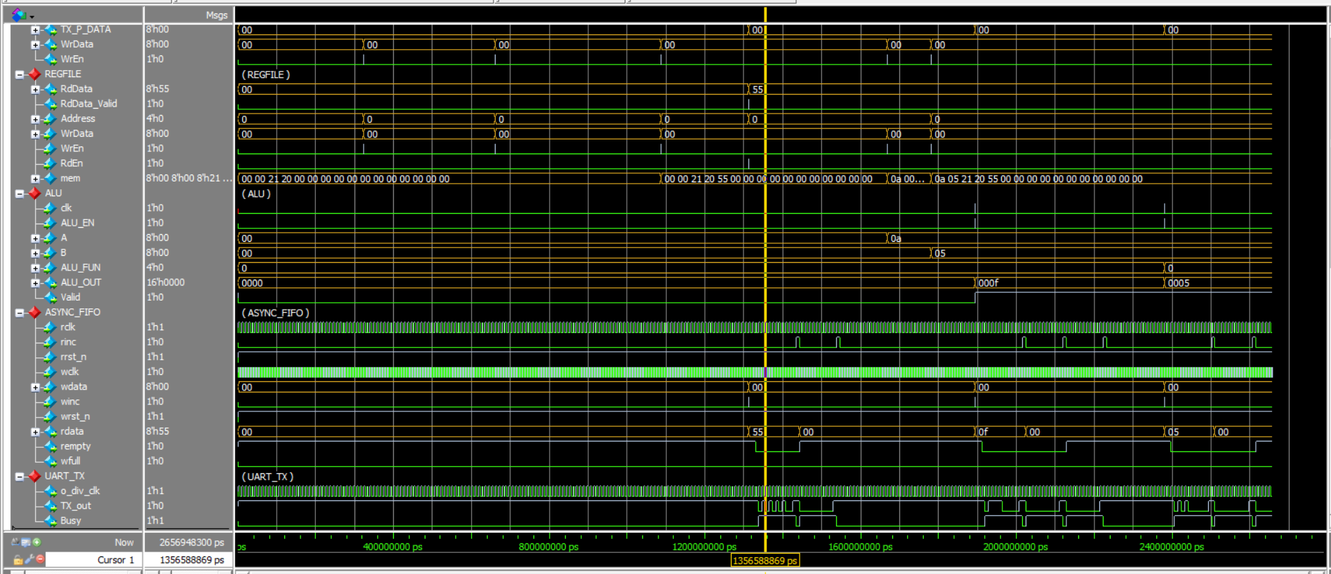

Figure 9: Full Waveform Part II

