VERSION CHECK
 | Version | Content | Date | Processed by | Translation
Specification | 1.0 | New document | 15.12.2011 | KSamkova
 | 1.1 | Document reworked according to new requirements | 13.02.2012 | KSamkova
 | 1.2 | Added process scheme and other minor changes | 20.03.2012 | KSamkova
 | 1.3 | Document reworked according to the implementation, design suggestions added | 19.05.2012 | KSamkova
 | 1.4 | Screenshots replaced with new ones, added function double click on user group, warning message changed | 29.05.2012 | KSamkova
 | 1.5 | ES logo replaced with GK logo | 31.05.2012 | KSamkova
 | 1.6 | Log Viewer added | 07.08.2012 | KSamkova
 | 1.7 | Cleanup process added | 06.09.2012 | KSamkova
 | 1.8 | Locking process, saving favourite links, GUI changes | 19.10.2012 | KSamkova
 | 1.9 | Small improvements | 01.11.2012 | KSamkova
 | 1.10 | Edits in newly added features | 05.12.2012 | KSamkova
 | 1.11 | Small edits in locking | 19.12.2012 | KSamkova
 | 1.12 | Small adjustments | 12.02.2012 | KSamkova
 | 1.13 | Changes in new implementation documented | 19.02.2012 | KSamkova
 | 1.14 | Added captions to Cleaner mask | 22.02.2012 | KSamkova
 | 1.15 | Added description of the lists in the Settings mask, based on the implemented functionality | 06.03.2013 | AKabela
 | 1.16 | GUI changes, Mailing, Clean rights procedure, multiple LDAP support, some screenshots replaced with new ones | 25.7.2013 | OHavlicek
 | 1.17 | Adjustments in text and pictures. |  | RAdamec

SVN Access Tool

Introduction
The new SVN Access tool is a web application. Some old features were removed and a new functionality was added. The main differences to the old system are:
- The tool contains user friendly GUI for editing the access rights to SVN.
- Changes to access list are also protected by authentication that determines who has rights to change access rights and who doesn’t.

Specification

Features
The tool is accessible through a web application after login (a login mask is shown when the tool starts). It contains following features:
- Switch between all available repositories.
- Visualization of the directory tree and possibility of browsing it and searching in it.
- View of the access list after clicking on a particular directory.
- View of the rights of particular users / groups, creating new local user groups.
- Possibility to manually enter a path to particular directory in edit field.
- Loading groups from Active Directory which is a central database of employees and employee groups and for example when an employee leaves the company he will automatically disappear from the list.
- Adding and removing groups and users for particular tree levels.
- Authorization overview – who can edit access rights in particular parts of the tree.
- The rights will be inherited from the root node to its children if this is not disabled by special feature (checkbox ‘disable inheritance’). Usage of the string ‘* = r’ is not supported anymore. The string “* =” provides the possibility of disabling inheritance.
- An automatic cleanup of redundant information (e.g. when there are a selected user and a group he belongs to in the same directory, the user will be deleted but his rights remain the same) is done while saving the made changes.
- Possibility of locking the directories.
- Possibility of adding the particular locations to favourites for easier access and automatic saving of the most visited locations.
- All dialogs with buttons “OK” and “Cancel” will also function for keyboard buttons: Enter as OK and Esc as Cancel.
- Maintenance of the list of Active Directory servers
- Possibility of e-mailing about changes of the rights to repositories and LDAP groups.
The tool also generates / updates the overall access.list file that contains the list of paths of all directories and corresponding user rights.

Authorization levels
These authorization levels are meant for working with SVN Access tool. They have different purpose than the rights to the repository (SVN). Each user has an authorization level which restricts what can he use and do after logging into the Access tool using the log-in mask at the start of the application. Levels and corresponding rights are as following:
- View only – user with this authorization level can browse the tree but he cannot view any files, just the directories. He can also see the access rights (to find out who can for example give him some rights or save a file in a particular directory). All users should be able to have this right to see who can give them rights to SVN etc
- Editing – user with these rights is able to edit the access list – add and remove users and user groups
- Administrator – complete rights including the possibility of changing the settings
Rights to SVN can also be of three types:
- Read only (R) – user can only view and download the content of the repository
- Write (W) – user can read and commit new versions and new files to the repository
- Modify (M) – user can edit the access lists of people to the given repositories

Process Scheme
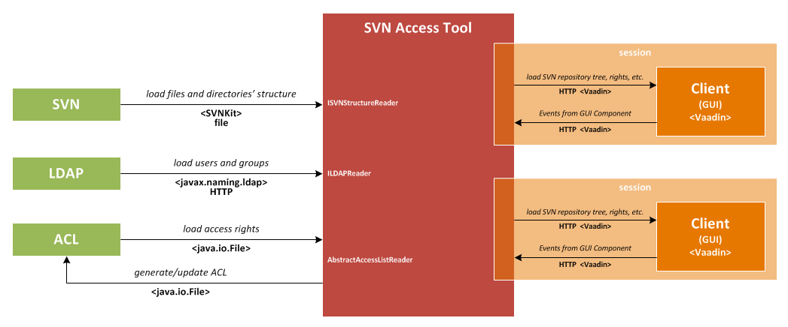

GUI

Login dialog
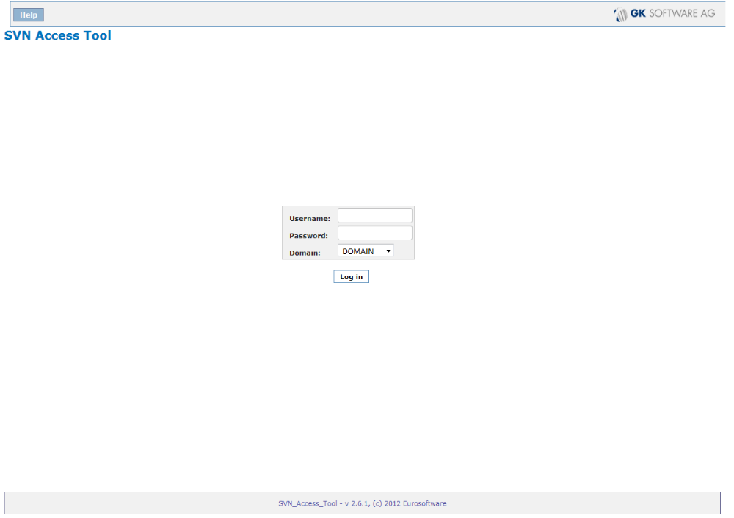
Mask
GUI-element | Content
Edit field (Username) | Username of the user who wants to log in
Edit field (Password) | Password for the access to the tool
Combo box | Domain to which user wants to log in

Buttons
Caption | Action | Enabled
Log in | Confirm entered data | Always
Help | Download documentation about SVN Access Tool | Always

Login failed
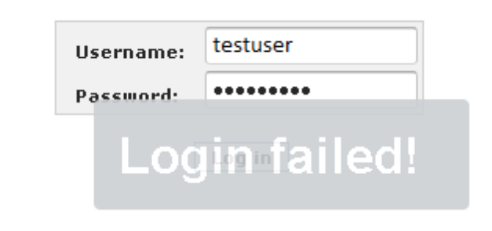
Mask
GUI-element | Content
Text | “Login failed!”

Main window
On the following picture is a scheme of the web tool for SVN access rights view and editing. Particular parts and their functionality are described below.
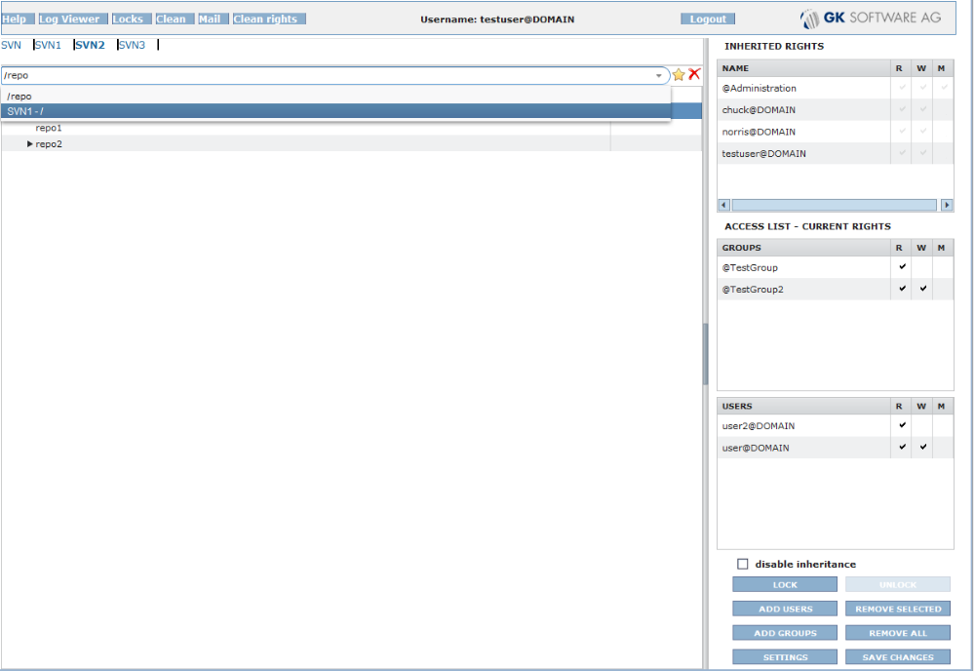

Mask
GUI-element | Content
Header | Logged username, Eurosoftware logo
Menu | List of the available repositories
Edit field | Address of the current directory / entering different address
Tree view | View of the selected repository / path to directory. After changes, focus remains on the last edited directory, doesn’t roll to the root.
Text | Logged user and his login name
Table - Inherited rights | Non-editable list of the access rights that are inherited from parent directories – for better overview and information
Access list – groups | List of groups with rights in the currently selected directory– inserted groups are marked with red colour– changed fields are marked with red colour, deleted are struck through and grey. Sorted alphabetically.
Access list – users | List of users with rights in the currently selected directory – inserted users are marked with red colour– changed fields are marked with red colour, deleted are struck through and grey. Sorted alphabetically.
Access rights R/W/M | Detailed information about the given rights to specific users / groups (Read/Write/Modify) – changed fields are marked with red colour
Checkbox “disable inheritance” | If this checkbox is selected access data will not be inherited from this directory to its children. Shown just for admin users

Buttons
Caption | Action | Enabled
Help | Download documentation about SVN Access Tool | 1,2,3
Locks | View the list of active locks | 3
Log Viewer | Tool for the log viewing | 1,2,3
Clean | Removal of the redundant and unnecessary data | 3
Mail | Mail settings | 1,2,3
Clean Rights | Function for deleting the selected types of rights | 2,3
Logout | Logout the user | 1,2,3
Star | Put the current location to favourites | 1,2,3
Rollout arrow | Rollout the favourites / most used locations | 1,2,3
Cross | Delete the current location from favourites | 1,2,3
LOCK (Ctrl+L) | Lock the directory tree | 2,3
UNLOCK (Ctrl+U) | Unlock the directory tree | 2,3
ADD USER (Alt+U) | Add user to the access list | 2,3
ADD GROUP (Alt+G) | Add group to the access list | 2,3
REMOVE SELECTED (Alt+R) | Remove the selected users/groups | 2,3
REMOVE ALL (Alt+A) | Remove all entries from the access list | 2,3
SETTINGS (Alt+S) | Enter the window with program settings | 3
SAVE CHANGES (Ctrl+S) | Save changes that were done in the access rights | 2,3 – when some rights were changed directly

All buttons are enabled for admin users(level 3). Users of levels 1 and 2 have only some of them enabled (see the table above).
Selected repository is highlighted in bold font.
Update of the access list according to the selected directory should be performed also when user is browsing the tree with cursor buttons, not only whit mouse-browsing.
Selection of more than 1 user or group can be done by holding the CTRL button and selecting more users during that (multi-select).
Changed items are coloured in red - inserted user and its rights, mark for rights that were added (R/W/M) and if a right was removed, the used character is changed from “” to “” and also marked with red colour.
Users that were deleted are struck through and in grey colour.
Header line contains ES logo that should be possible to be changed simply or just load the file logo.png from some specified folder where it could be replaced by other picture. Button “Help” will download PDF file containing this specification from given address (will be specified in a property). It should be possible to view/download this PDF file. “Log Viewer” is entered by pressing the button with the same caption and this function is described further in its own chapter.
Multiselect allows to select more than one directory for access rights changes. Changed directories are marked with dark-red dot and their superior directories with light-red dot (so that users can be able to find easily the changed directories in case of tree closing). See the following picture:

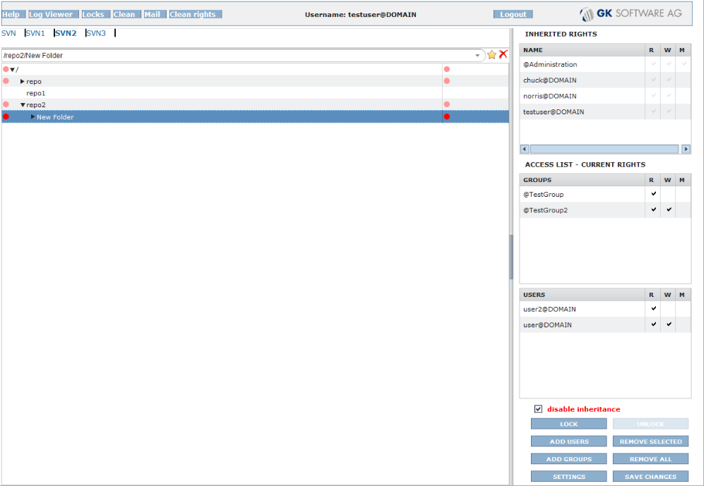

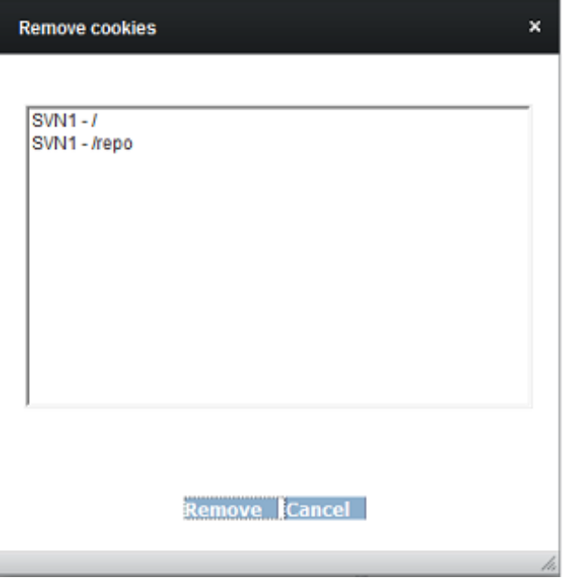
Remove Cookies

Mask
GUI-element | Content
List Box | List of all available favourite / most used locations

Buttons
Caption | Action | Enabled
Remove | Remove the selected locations from cookies (Favourites / most used) | Always
Cancel | Go to the previous screen without changes | Always

Log Viewer
For authorized person:
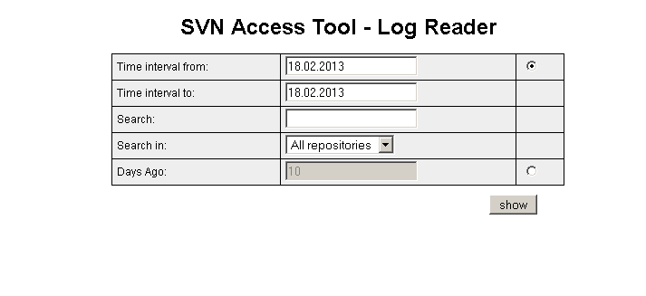
Mask
GUI-element | Content
Text | “SVN Access Tool – Log Reader”
Radio buttons | For the selection between entering the time interval or amount of days to the past from “To”
Edit field | “Time interval from:” yyyy-mm-dd
Edit field | “Time interval to:” yyyy-mm-dd
Edit field | “Search:”
Rollout list | „Search in:“ Contains a list of repositories for which the user has right to search in their logs. Access allowed only for administrators, users with “M” right in the root directory or owners of the repository.
Edit field | “Days Ago:”

Buttons
Caption | Action | Enabled
show | Shows logs according to entered filter | Always

For non-authorized person:

GUI-element | Content
Text | “SVN Access Tool – Log Reader”
Text | “You have no rights to see this content!”

Info Message (Confirmation)
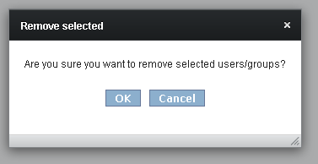
or
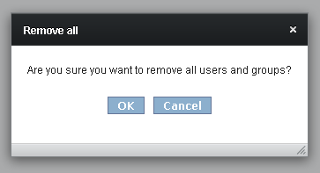

Mask
GUI-element | Content
Text | “Are you sure you want to remove selected users/groups?”  or  “Are you sure you want to remove all users and groups?”

Buttons
Caption | Action | Enabled
Cancel | Cancel the action | Always
OK | Confirm the action (removing of the selected/all users and groups) | Always

Add users/groups
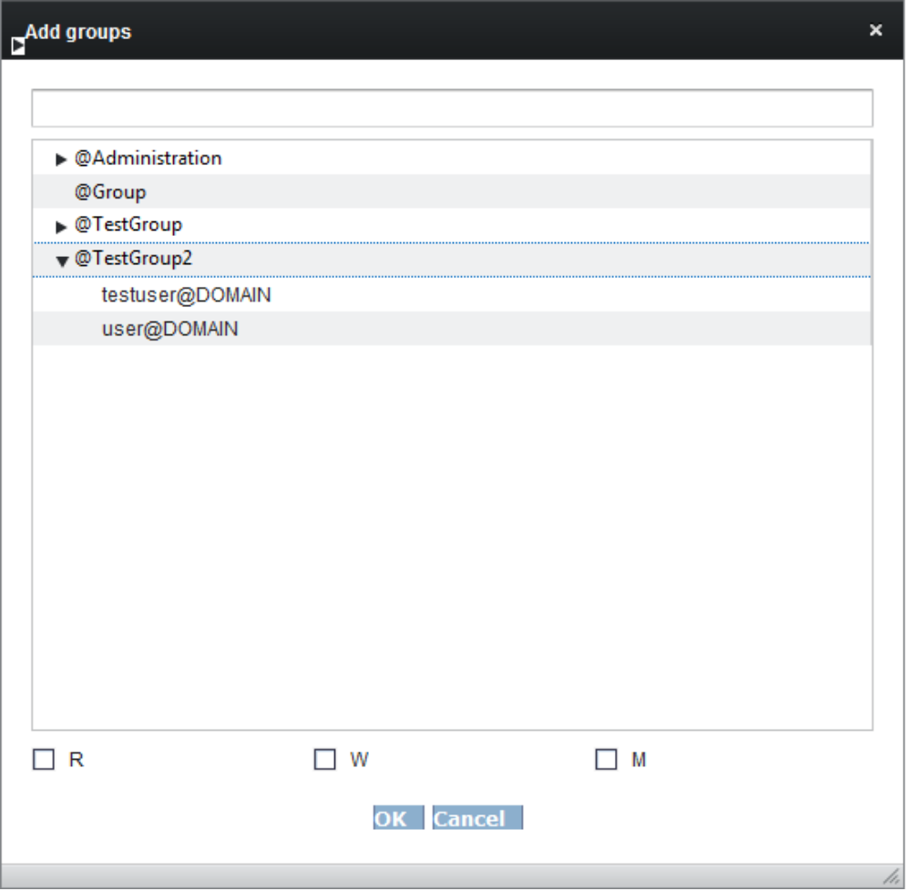
Mask
GUI-element | Content
Edit field | Filter users according to entered string
Check boxes | Selection of given rights (Read/Write/Modify)
List box | List of all users or groups
Buttons
Caption | Action | Enabled
Cancel | Go back without changes | Yes
OK | Confirm the selection | After the user/group selection and at least one check box checked. Focus is on this button

This window is for the “Add Groups” action. Similar window appears for the “Add Users” action, the only difference is in the caption of the window (“Add Users”/”Add Groups”) and in the content of the list.
Adding of groups is shown hierarchically including single users. It allows adding of rights for both users and user groups.
It is also possible to immediately filter branches according to their names or user names. Sub-trees that don’t contain the searched entry are filtered out.
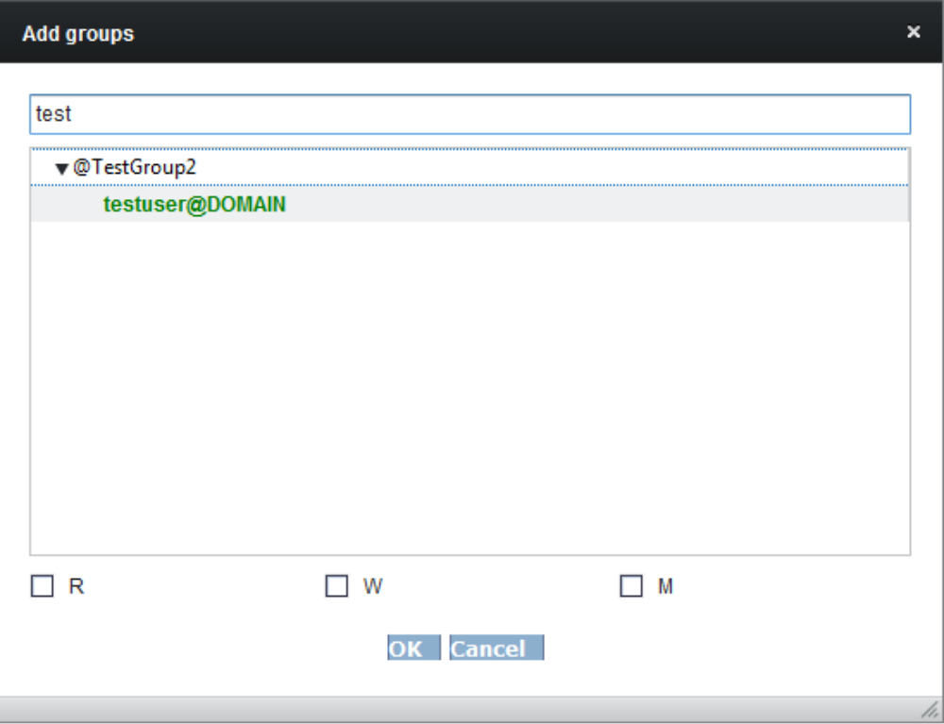

Warning Message “No rights selected”
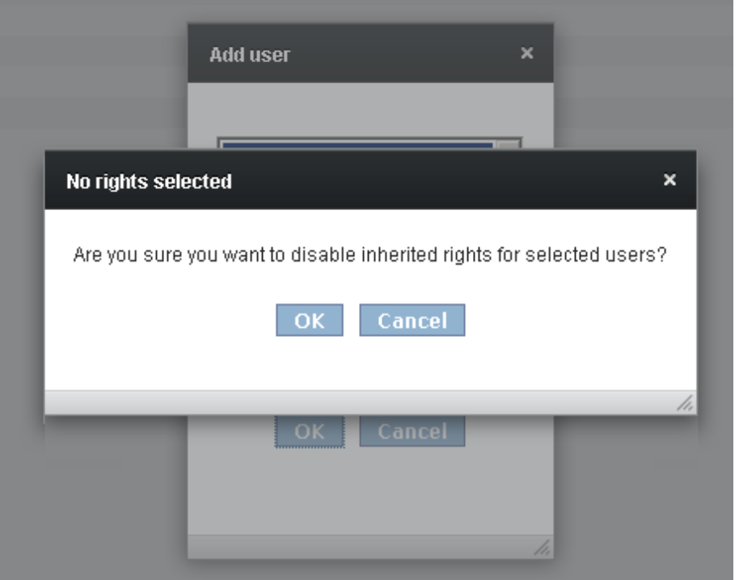
Mask
GUI-element | Content
Caption | “No rights selected!
Text | “Are you sure you want to disable inherited rights for selected user?”

Buttons
Caption | Action | Enabled
Cancel | Go back without changes | Yes
OK | Disable inherited rights for selected users | Yes

Users
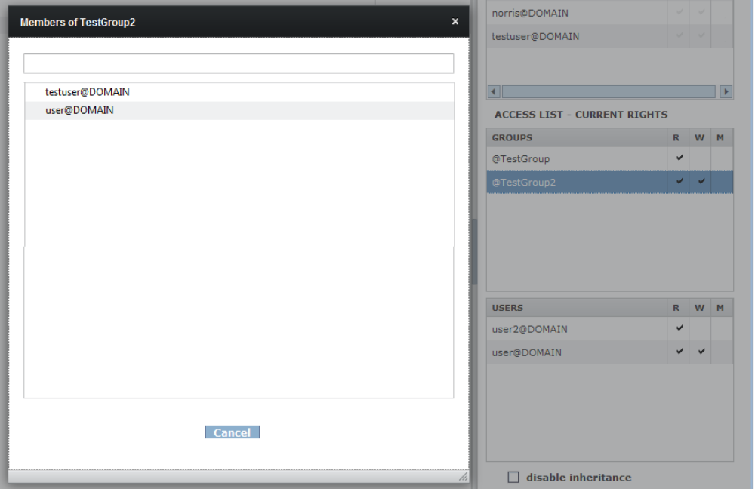
Mask
GUI-element | Content
List box | List of all users/groups from the selected group
Edit field | Direct filtering of the shown entries

Buttons
Caption | Action | Enabled
Cancel | Go back | Yes

After double click on the group in “inherited groups” or list of groups a tree that belongs to the selected group is shown. Functionality of filtering is the same as for user/group selection.
Lists of the given rights contain tooltips for showing the whole name in case of small window.

Locked Tree Part
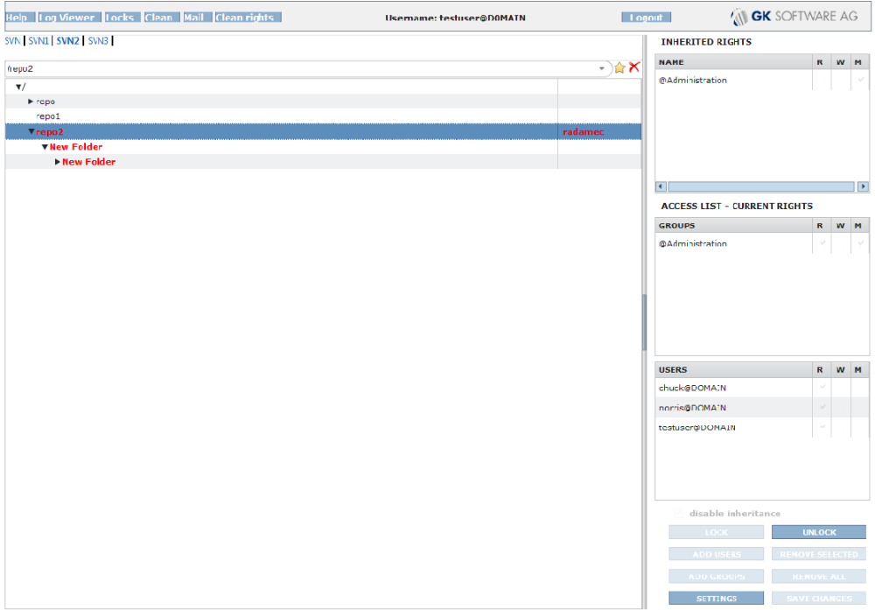
Notes:
- Locking shortcut is Ctrl+L, unlocking is Ctrl+U
- The locked directories are marked red, root directory contains the name of the person who locked it.

Lock Confirmation
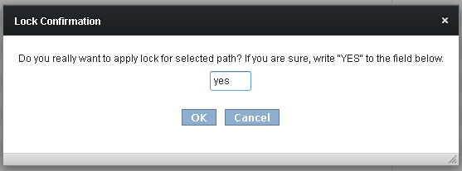

Mask
GUI-element | Content
Text | “Do you really want to apply lock for selected path? If you are sure, write “YES” to the field below.
Edit field | Place for inserting the confirmation string

Buttons
Caption | Action | Enabled
OK | Confirm locking | Yes
Cancel | Go back | Yes

Unlock Confirmation
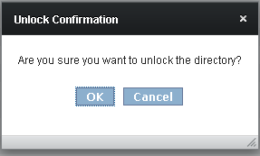
Mask
GUI-element | Content
Text | “Are you sure you want to unlock the directory?”

Buttons
Caption | Action | Enabled
OK | Confirm un-locking | Yes
Cancel | Go back | Yes

Locks
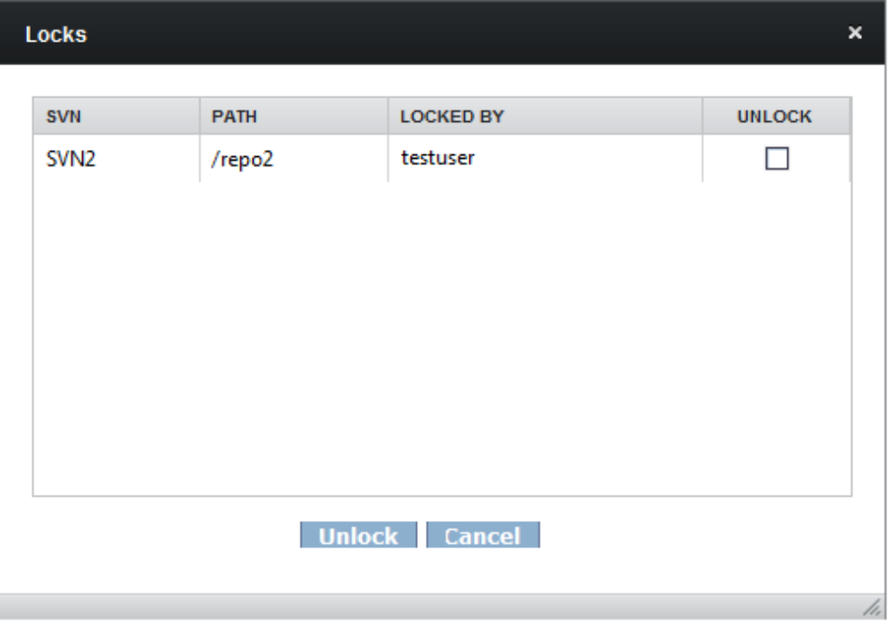
Mask
GUI-element | Content
Table | All used locks: SVN repo, Path, User who locked it, Unlock checkbox

Buttons
Caption | Action | Enabled
Unlock | Confirm un-locking | Yes
Cancel | Go back | Yes

Unlock Confirmation
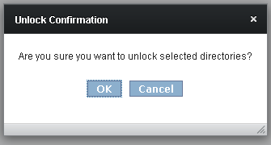
Mask
GUI-element | Content
Text | “Are you sure you want to unlock selected directories?”

Buttons
Caption | Action | Enabled
OK | Confirm un-locking | Yes
Cancel | Go back | Yes

Clean rights
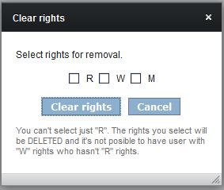
Mask
GUI-element | Content
Text | “Select rights for removal.”
Check boxes | Selection of the rights for removal (Read/Write/Modify)
Text | You can't select just „R“. The rights you select will be DELEDTED and it is not possible to have user with „W“ rights who doesn't have “R“ rights

Buttons
Caption | Action | Enabled
Clear rights | Confirm rights clearing if some of them are selected. Otherwise the error message is shown | Yes
Cancel | Go back with no changes | Yes

Clean rights confirmation
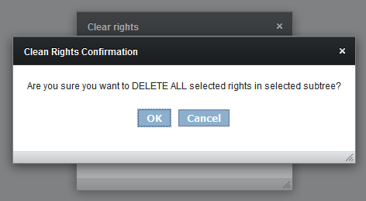
Mask
GUI-element | Content
Text | “Are you sure you want to DELETE ALL selected rights in the selected sub-tree?

Buttons
Caption | Action | Enabled
Ok | Confirm rights clearing | Yes
Cancel | Go back with no changes | Yes

No rights for removal selected
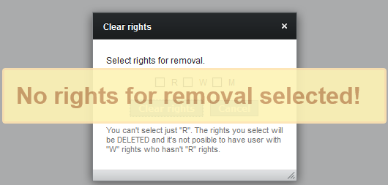
Mask
GUI-element | Content
Text | “No rights for removal selected“

Mail
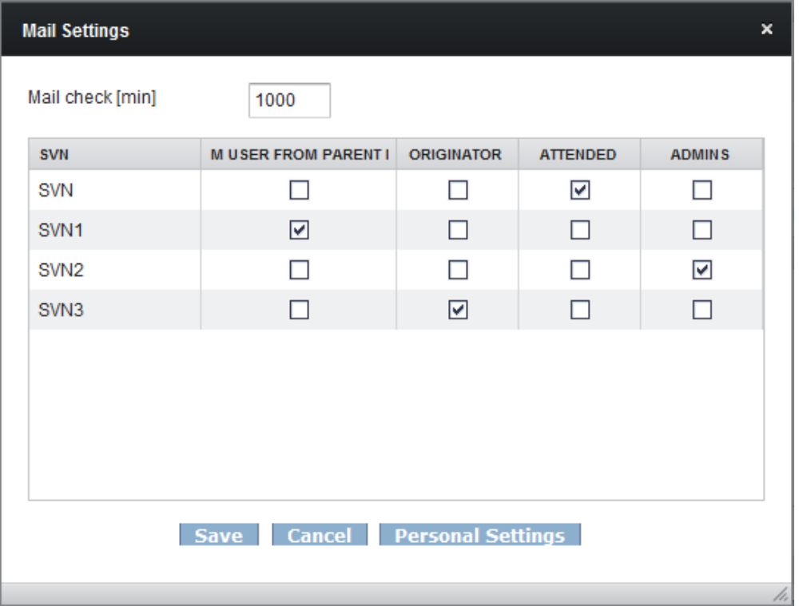
Mask
GUI-element | Content
Edit field „Mail check[min]“ | Interval for control mail folder to send emails
Table | General settings for all repositories: SVN repo, checkbox (M USER FROM UP NODE/ORIGINATOR/ATTENDED/ADMINS)

Buttons
Caption | Action | Enabled
Save | Saves settings | Yes
Cancel | Go back with changes | Yes
Personal Settings | Opens the mask „Personal mail settings“ | Yes
Allows to set for each repository who will receive the e-mail messages.

Personal mail settings
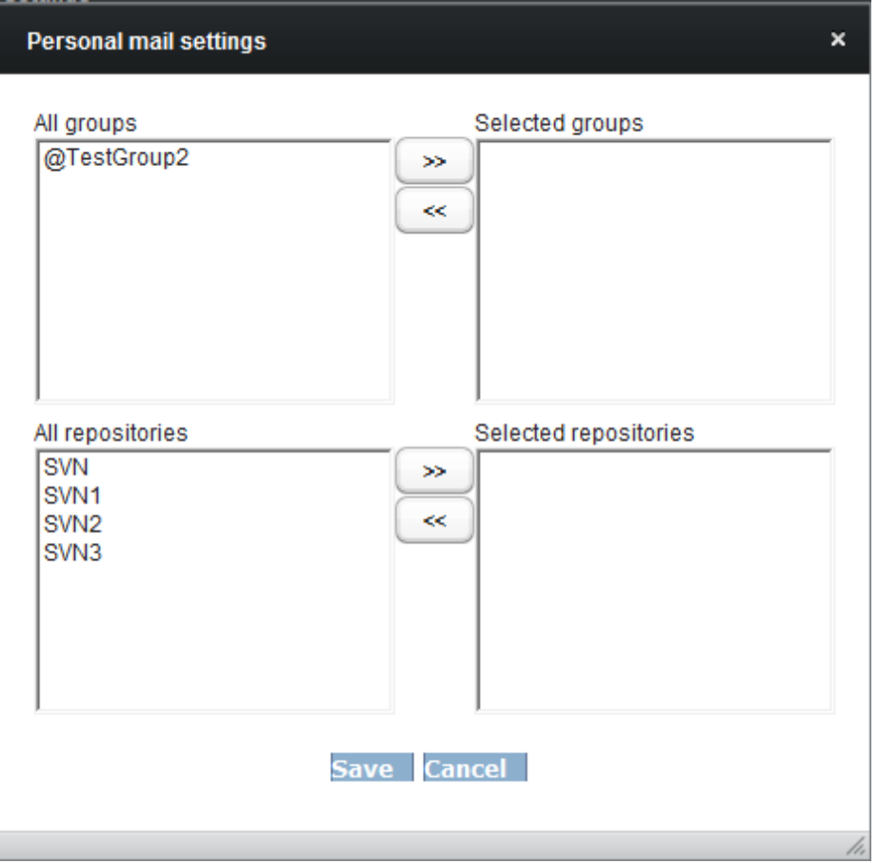
Lists
Use buttons to move repositories (groups) from the list on the left to the list on the right and vice versa.

All groups | List of groups to which the user belongs.
Selected groups | User approves to receiving messages about changes in these groups.
All repositories | List of all repositories.
Selected repositories | User approves to receiving messages about the changes in these repositories.

Buttons
Caption | Action | Enabled
Save | Save these settings and close the window | Yes
OK | Go back with no changes | Yes

Settings
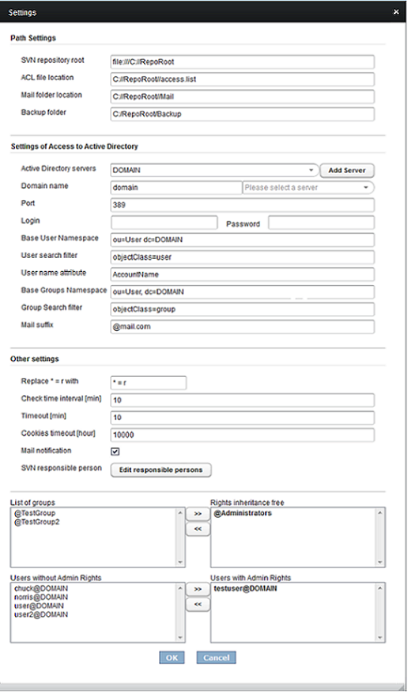
Mask
GUI-element | Content
Edit field “SVN repository root” | The place where are the available repositories physically saved
Edit field “ACL file location” | Physical location of the access list file
Edit field “Mail folder location” | Physical location of the files with e-mail content.
Edit field “Backup folder” | Where the access list is stored – it is saved always when it is changed
Combo boc „Active directory servers“ | List of the available LDAP servers.
Edit field “Domain name” | Name of the domain for connections and downloading of information
Combo box “Domain” | List of the available servers for selected domain (the list is generated automatically with a change in field “Domain name” after pressing TAB or selecting another field
Edit field “Port” | Port for connection
Edit field “Login” | In case that the server doesn’t have support for anonymous access to LDAP. It should be a fully qualified DN name.
Edit field “Password” | Password of the user whose name is in “Login” field.
Edit field “Base User Namespace” | The place where would the searching for users start in the tree structure
Edit field “User search filter” | Restriction of object types for users
Edit field “User name attribute” | Selection of the object type – the user object contains more information than only the username
Edit field “Base Groups Namespace” | The place where would the searching for groups start in the tree structure
Edit field “Group Search filter” | Restriction of object types for groups
Edit field “Mail suffix” | Edit field “Mail suffix”
Edit field “Replace *=r with” | If there is found an old definition “* = r” define the string to be replaced with
Edit field “Check time interval [min]” | How often will be a query sent to the server. Check if the structure was changed: User groups are downloaded from LDAP and if they are different than the current ones the whole access list will be saved
Edit field “Timeout [min]” | Time after which will be the inactive user automatically logged out
Edit field “Cookies timeout [hours]“ | Time after which will be all the favourites-related cookies deleted from the browser
Checkbox “Mail notification” | Select if mailing should be allowed.

Lists
Use the buttons to move the users (groups) from the list on the left to the list on the right and vice versa. These lists are related to all directories in SVN.
List of groups | List of the groups affected by the disable inheritance checkbox.
Rights inheritance free | The groups in this list are not affected by the disable inheritance checkbox.  For example, suppose we have a directory and its subdirectory. Suppose groups A and B have some rights assigned in the parent directory. Suppose group A is in the List of groups list and group B is in the Rights inheritance free list.  Now, if someone checks the inheritance checkbox in the subdirectory, the inheritance is disabled.  The group B is automatically added to the list of groups for the subdirectory with the same rights it has in the parent directory. Meanwhile the group A in the subdirectory does not have the rights which it has in the parent directory.  When someone locks a directory, the disable inheritance checkbox is automatically checked. Hence the rights for a locked directory are affected by the Rights inheritance free list as well.
Users Without Admin Rights (Left) | List of all users that are not currently set as administrators
Users With Admin Rights (Right) | List of all users that are currently set as administrators

Buttons
Caption | Action | Enabled
Cancel | Go back without changes | Yes
OK | Confirm settings | Yes
--> | Add selected users from left box to right box | Yes
<-- | Remove selected users from right box | Yes
Edit Responsible Person | Opens the mask “Edit Responsible person” | Yes
Add Server | Opens the mask “New LDAP server settings” | Yes

New LDAP server settings
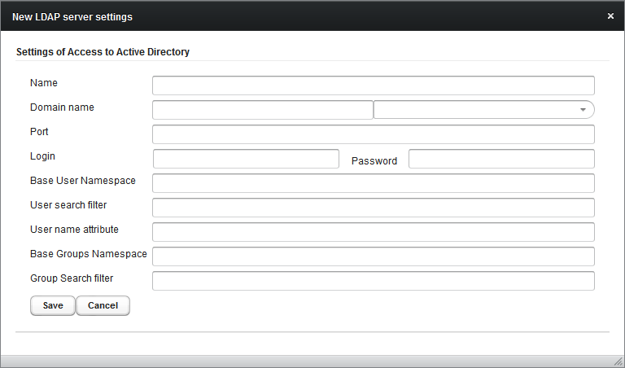

Mask
GUI-element | Content
Edit fields “Name” | Name of LDAP server. Should be name of domain. It is used like suffix for user in this domain.
Edit field “Domain name” | The name of the domain for connections and downloading of information
Combo box “Domain” | List of available servers for selected domain (the list is generated automatically with change in field “Domain name” after pressing TAB or selecting another field)
Edit field “Port” | Port for connection
Edit field “Login” | In case server doesn’t have support for anonymous access to LDAP. It should be fully qualified DN name
Edit field “Password” | Password of user whose name is in “Login” field
Edit field “Base User Namespace” | The place where will start searching for users in the tree structure
Edit field “User search filter” | Restriction of object types for users
Edit field “User name attribute” | Selection of the object type – the user object contains more information than only username
Edit field “Base Groups Namespace” | The place where will start searching for groups in the tree structure
Edit field “Group Search filter” | Restriction of object types for groups

Allows adding a new LDAP server to the list.

Buttons
Caption | Action | Enabled
OK | Confirm changes | Yes
Cancel | Go back | Yes

Edit Responsible Person
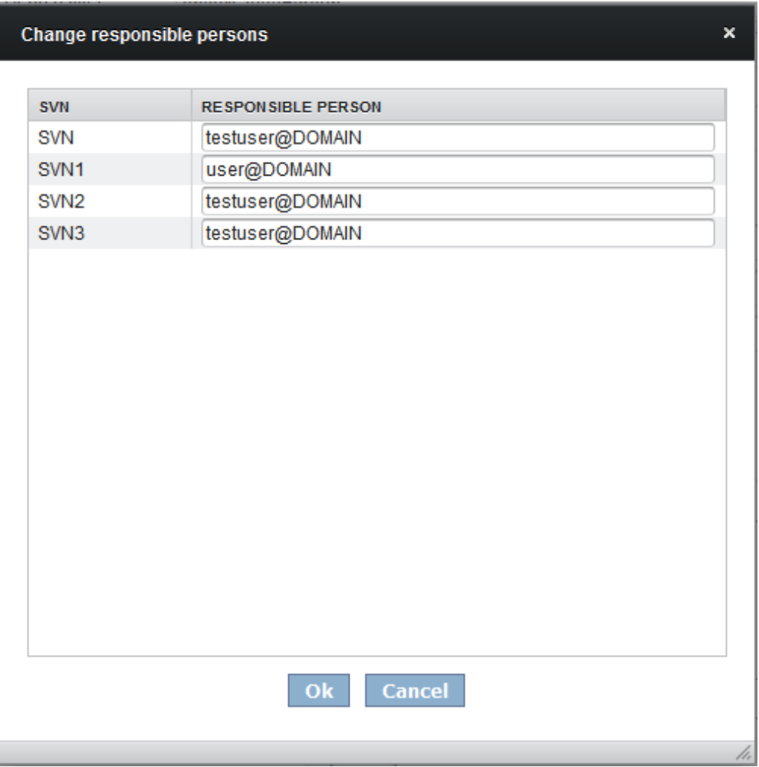
Mask
GUI-element | Content
Edit fields “repository name” | Name of the owner of the repository

Allows adding of the owner of the repository. It can be added with domain or without domain, case insensitive. This owner is then shown as a tooltip when mouse is above repository (used for logViewer).
Buttons
Caption | Action | Enabled
OK | Confirm changes | Yes
Cancel | Go back | Yes

Cleaner
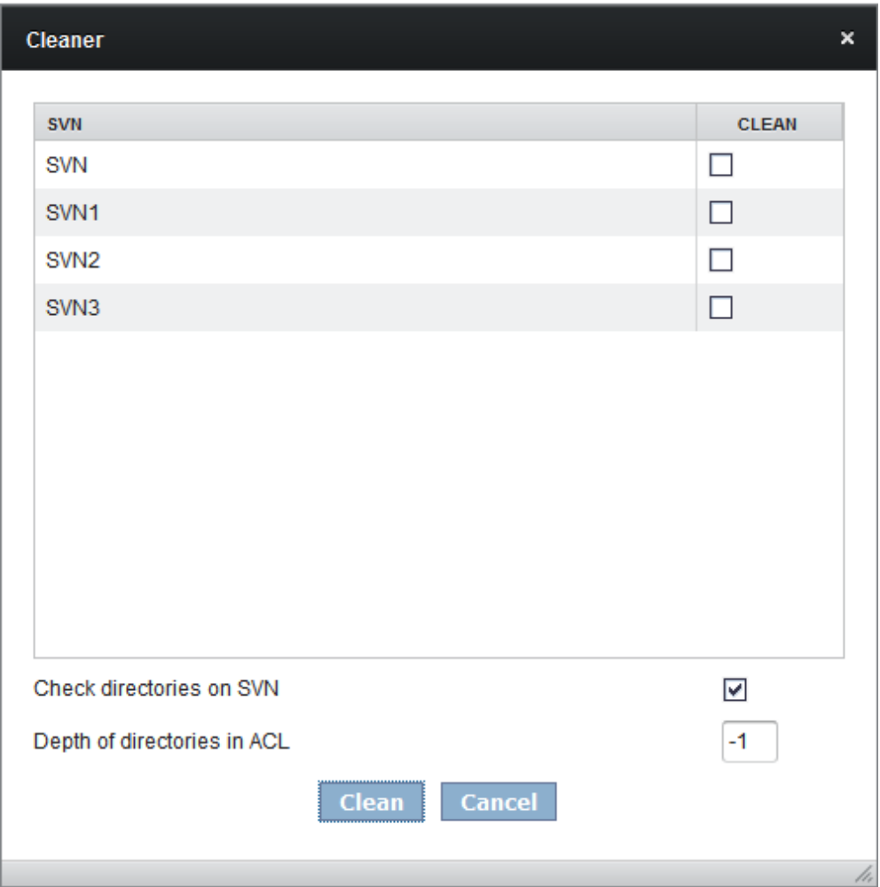
Mask
GUI-element | Content
Checkboxes “Clean” | Selection of repositories to be cleaned
Checkbox “Check directories on SVN” | Select if the directories should be checked at SVN
Edit field “Depth of directories in ACL” | Depth of directories for deletion from access list. Default „-1“ or any other negatime number means that the depth parameter will not be applied.

Buttons
Caption | Action | Enabled
OK | Confirm changes | Yes
Cancel | Go back | Yes

Process

Logging in
Before entering the application, user must log himself in with his username, password and domain. This action is confirmed by pressing the button “Login” in the login mask. If the username or corresponding password is not valid a warning message is shown and user can correct the appropriate data or leave the program.
If a user is inactive for more than the defined time (property “Timeout” – see section “Settings”) the session is terminated, user automatically logged out and the tool left.
The application will access the SVN using a local file system, so there’s no need to login for access to the SVN.

Directory selection and browsing
Repository is selected by clicking on the desired one in the upper menu. After this selection the tree structure is updated in the Tree View field.
Directories can be rolled out or in by clicking on the “unpack” or “pack” sign at the left side. The path to the directory that is currently rolled out is always shown in the edit field. Selected repository is always highlighted by bold font. The address can be edited by inserting a different address and confirming it by pressing “Enter” key. The desired path is then rolled out. If we enter a path that doesn’t exist, message “Wrong path” is shown.
To select the directory for access rights view, click on it with the left mouse button. The access list for selected directory is then shown.

Favourites
The locations that are used the most (amount of usage of addresses will be stored) will be saved using cookies and direct link to 15 most used locations will be available at the list box when user clicks to the address field. The offered 15 locations are sorted by:
- First are the favourite ones (added to favourites by user) sorted from the newest.
- Second are sorted by amount of usage of particular location (stored in cookies).
- In the case of identity in the previous rule will be first the one that was used later (the newest one).
In the opened list box is possible to:
- Select and apply the desired location by mouse click.
- Select the desired location by arrows and apply by pressing Enter.
- Select the desired location by arrows and then delete it with the Red Cross button.
- Add particular address to favourites – by pressing the “Star” icon in the address line when you are in the desired location. These favourites will be sorted from newest to the oldest added and will have priority over the automatically saved ones (from cookies).
When some location is deleted, its count history is deleted with it from cookies.
The count of particular location is raised with use of the button “Save” – the count raises when the location was really used, not only when user visits it and doesn’t do anything there.

Open question:
It is not possible to save in memory only 15 most used locations because when the last one will have at least 2 accesses, it won’t be possible for any other to enter the favourite list (because it will have always only 1 access and then it will be never saved).
The question is how many items to save? The above described problem can appear always for finite lists, but for longer ones is unlikely to cause some problems. So we will save 100 items? 1000?

Access list and its editing
When a directory is selected, the corresponding access list is shown – with groups and employees separately. Each line also contains three columns that show the exact SVN rights for each user (group) – R (read) / W (write) / M (modify) on the right side. If the user has authorization to change rights it is possible to add/remove directly some paritcular rights by clicking in the appropriate field. Changed items are coloured in red before saving - mark “” for rights that were added (R/W/M) or if a right was removed, the character used is changed from “” to “” and also marked with red colour. These actions must be confirmed by pressing the button “Save changes”.
To add a user or a group, click on the appropriate button and a new window with list of all users / groups is shown. One or more of them are selected by clicking on their names and then are the appropriate access rights selected from the checkbox. The edit field above the user / group list serves for filtering of lists according to the entered string (without confirmation). Filter is cancelled with deletion of the entered string. Action is confirmed by pressing the “OK” button. Newly added users and their rights are marked with red colour until saving . To see members of some user group, double-click on it and the list of users will appear.
Multi-selection of directories and therefore mass editing of access rights is also available. Directories changed during multi-selection are marked with red dots.
Button “Remove all” removes all entries from the access list (after the confirmation of the message “Are you sure you want to remove all users and groups?”), button “Remove selected” removes only the selected users also after the confirmation of the message “Are you sure you want to remove selected users/groups?”. It is possible to do a multi-select using the Ctrl key and left mouse key for both the user list and the group list .
Button “Settings” opens a window with tool settings and properties.
Checkbox “disable inheritance” is enabled only for users with ‘M’ rights. If this field is checked, the access list data will not be inherited from above in the current directory and its children.
Inherited rights for selected users or groups can be disabled in the following way: click on “add users/groups”, select the desired users or groups and leave all checkboxes unselected. After pressing the “OK” button a warning message “No rights selected” (see correspondent mask) will appear and after confirmation all inherited rights will be disabled.

Log Viewer
Log viewer is a servlet that reads the information from the log of access list changes. It can be entered by authorized persons after clicking on the button “Log Viewer” (see the GUI description for more details – for authorized person appears the form for details filling, unauthorized person sees the message “You have no rights to see this content”).
By radio-button checking you can enter the dates (time interval) of the desired logs or enter the amount of days you want to go to the past from the date entered in ”To". After the time selection logs for the selected period are shown :
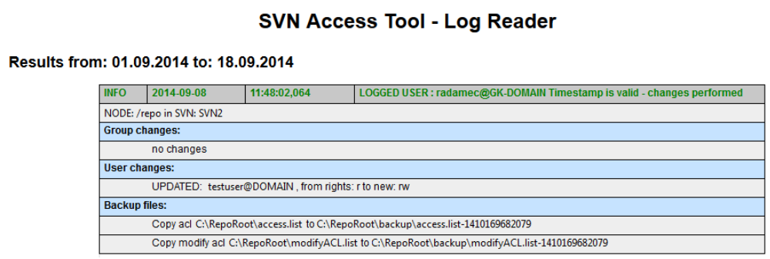
If we also enter a searched text only logs that contain the searched text are shown:
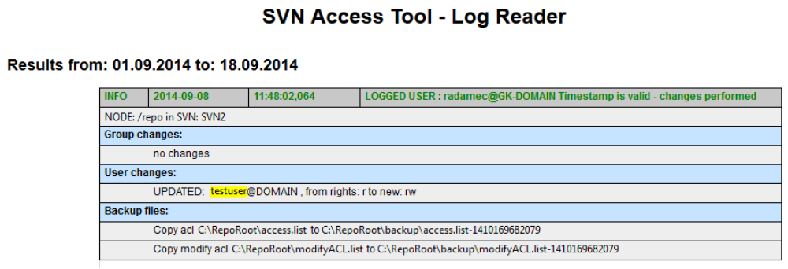

Locking
All users that have the Write (W) or Modify (M) rights to the particular location have the possibility to lock the whole tree below (and including) the selected directory have.
- User locks a particular directory and he is then the only one who can check in and modify files in the selected tree. No modifications of rights even for users with M and administrator rights are allowed.
- All users and groups that had rights “W” for the locked directory or all subdirectories won’t have them any more.
- The locker is automatically listed extra by SVN access tool (added as a user) with “W” rights to the whole locked tree. If there are any sub-directories where this user doesn’t have “W” rights, this will remain the same (no additional “W” rights will be given).
- The information about locking is saved to the file for modification rights in a form of a comment.
- When the structure is unlocked all users will have their previous rights back (they obtain the same rights they had before locking).
- All inherited rights will be temporally disabled by checking of the filed “disable inheritance”. The rights from above are then not valid in selected directory and structure below it.
- It is again necessary to un-check back the field “disable inheritance” when unlocking the directory if it was un-checked before.
- It should be possible to unlock the whole locked branch only from the level where it was locked - it is not possible to unlock the branch from the lower levels.
What must be saved when locking the directory:
- Name of the user who locked the directory (only he or anyone with “M” rights is allowed to unlock it in this or upper directory).
- The path to the locked directory.
All users with Modify (M) rights have a button “Locks” accessible in the upper banner (see the GUI section describing the Main window). Using this button it is possible to view all active locks together with the information about them and the possibility to unlock (checbox).
If the user that locked the directory was part of a group that had the rights for the specified directory it is necessary to write him down to the access.list explicitly. He will be deleted later during the cleanup process.
Marking of locked directories:
- When a directory is locked it must be visible in the tree.
- The locked directory and its subdirectories should be graphically marked (red font).
- The locked directory (root) must contain the red text “Locked by name-of-user-who-locked-it” in brackets .
Protection:
The action of locking a part of the tree must be protected by the confirmation message so that the user knows what he is doing and is warned about it.
After pressing the lock a following message appears:
“Do you really want to apply lock for selected path? If you are sure, write “YES” to the field below.”
Below it is an edit field where the text “YES” must be inserted and confirmed by pressing the “OK” button. The action can be stopped by pressing the “Cancel” button.
Visibility of locks:
- Ordinary user sees only those locks that were made by him.
- User with M rights sees all locks in the directory one level above and those which were locked by him. Administrators should see all locks.

Settings
Change of settings is available only for users with admin rights. There are four groups of settings:
- Path Settings
  - SVN repository root – specifies the path to the root directory of SVN
  - ACL file location – specifies the location of the file with access list
  - Backup folder – storage place for the access list file

- Settings of Access to Active Directory – detailed settings
- Domain name – name of the domain and the server for connections and downloading the information
- Port – port for connection
- Login – fully qualified DN name for login to LDAP.
- Password – password corresponding with Login.
- Base User Namespace – the place where would searching for users start in the tree structure
- User search filter – restriction of object types for users
- User name attribute – selection of the object type, the user object contains more information than only the username
- Base Groups Namespace – the place where would searching for groups start in the tree structure
- Group Search filter – restriction of object types for groups
- Mail suffix – in the case that there is no mail attribute on LDAP address in format sAMAccountName + mail suffix is used.
- Other settings
  - Replace * = r – what should replace the old “* = r” marking for read rights for all
- Timeout [min] - time after which will the inactive user be automatically logged out
  - Check time interval – time period for the periodical check. Each n minutes a revision of groups and users will be launched if the structure was changed
  - Cookies timeout [hour] – time after which all the favourites-related cookies will be deleted from the browser
- Administration of users with admin rights – users can be added or removed from the group with administrator rights by selecting them and clicking the appropriate button (“-->” to add users or “<—“ to remove them). More than one user can be selected at once.
Changes in the settings are confirmed by pressing the “OK” button or the mask is left without changes by pressing the “Cancel” button. A warning message with text “Settings were changed, leave without saving?” is shown when the button “Cancel” is pressed after changing something in the “Settings” window. Action is confirmed by pressing “Yes” or the tool returns to the settings window by pressing the “No” button.

Solution of conflicts
Problem of a conflict in data saving can appear when two or more users are modifying access lists at once. The check is done in three steps:
First is when the user starts to modify the file. If someone else is already modifying it the tool must warn the user that the file is already being modified somewhere else.
Second check is done when someone is checking/un-checking some checkbox (for Read, Write or Modify rights).
Third check is performed during saving. When one of them wants to save modified access list it must be certain that no other access list was saved in a different place of the tree structure by someone else in between. So the tool must remember files from the path to root from the currently modified file and when a user wants to save the access list all files from this path must be checked whether they were modified or not. If not the process can continue but if at least one of them was modified the tool doesn’t let the user to save the changed data and shows an error message “Unable to save data, changes will be lost”.
Examples:
- We start changing the access list for the orange directory “c123” (path: root/c/1/2/3) while someone changes and saves the access list for the green directory “a3” (path: a/3). When we want to save our changes in the file “c123” the tool checks the path to root (orange line). No file has been changed on that path so “our” file can be saved with changes:
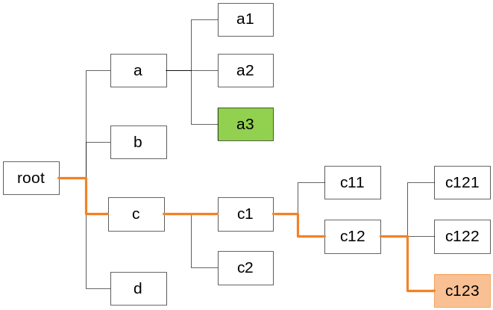

- We start changing an access list for the orange directory “c123” (path: root/c/1/2/3) while someone changes and saves the access list for the green directory “c1” (path: c/1). When we want to save our changes in the file “c123” the tool checks the path to root (orange line). The file was changed on that path so “our” file cannot be saved with the changes and an error message “Unable to save data, changes will be lost” is shown and changes made in the access list file for directory “c123” are lost.
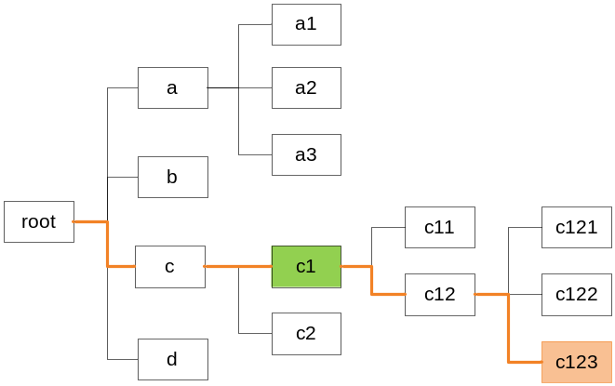

Mailing
There is a possibility of sending messages about changes on LDAP groups or repositories. Default settings are that nobody will receive messages and there are two levels how to allow sending mails.
- Administration level
Administrators or M users are allowed to set who can be entitled to receive messages in „Mail settings“ window by checking of some check boxes. There are four groups of users for selection.
- Admin users – administrators
- Attended users – users whose rights has been changed
- Originator – user who made a change
- M user from parent node – M user who owns the parent node

- User level
Each user has personal mail settings. He can allow groups or repositories from which he wants to receive e-mails.
Mails are generated continuously and sent periodically at interval set in settings window.

Clean Rights
Clean rights function is available only for the users with “M” or Admin rights. All selected rights will be deleted for all users on all folders in the tree. Users with no remaining rights will be deleted and the user who called the clean rights procedure is not affected.

Structure and handling of Access List
The file access.list has following structure:
First is the list of all available groups and their members, e.g.:
test-group = testuser@DOMAIN,chuck@DOMAIN, norris@DOMAIN

Then follow all directories (paths from the repository tree structure) that contain the file access.list and below it is written its content:
[repo:/]
* = r
svnadmin@DOMAIN = rw

[repo:/folder/]
* =
@test-group = rw
svnadmin@DOMAIN = rw

[repo:/folder/subfolder]
svnadmin@DOMAIN = rw

Paths to a particular directory are listed in square brackets. There are access rights listed for each directory path under it. The possibilities are:
- Groups – starts with at sign, e.g.: @test-group
- Users – name followed by suffix @DOMAIN, e.g.: svnadmin@DOMAIN
- Groups and users have assigned rights: = r, = rw
- All users with read rights that cancels inheritance for the current directory: * = r. This will be replaced by a different information, see the chapter about “Settings” for more details
- All users with read rights that cancels inheritance of all access right that were defined before in the tree structure: * =

Here is an example of edits that can be done on this part of the access.list file together with a brief description of entries:
[repo:/]
* = r
testuser@DOMAIN= rw this user has been added here and its new rights will be inherited down the tree if the following directories will not contain “* = r” or “* = “
svnadmin@DOMAIN = rw user

[repo:/folder/] directory path
@test-group = rw group
svnadmin@DOMAIN = rw
* = This line cancels inheritance of everything before, i.e. nothing from directories on the path to the root will be inherited to deeper structure from here. But the inheritance of users or groups listed in this or deeper directory works in a usual way as long as it is not cancelled again by this entry (“ * = “).

[es:/_tools/track_rule_checker]
svnadmin@DOMAIN = rw The group “@test-group” has access rights here but the user “testuser@DOMAIN” doesn’t because of the inheritance cancel from the parent directory.

Rights for viewsvn:
Standard rights for the svn:
[repo:/folder/]
svnadmin@DOMAIN = rw
Additional rights for viewsvn:
[viewsvn:/repo:/folder/]
svnadmin@DOMAIN = r

List of Shortcuts
All dialogs with the buttons “OK” and “Cancel” will also function for keyboard buttons: Enter as OK and Esc as Cancel.

Moreover, following shortcuts can be used instead of direct buttons:
- Lock Ctrl+L

- Unlock Ctrl+U

- Add user Alt+U

- Add group Alt+G

- Remove selected Alt+R

- Remove all Alt+A

- Settings Alt+S

- Save changes Ctrl+S

Clean up Process
While editing the access list a check that will search for duplicities and other duplicate data is executed. SVN Access Tool should show warning during the conflict and shouldn’t allow saving of the file (or repair the mistake directly and send a warning about that action – TO BE DISCUSSED).

Current problems
We currently deal with various problems during assignment of rights and saving to SVN:
- The data contain a huge amount of redundant information that must be cleaned (multiple repetition of the same employees and groups)
- Anyone is able to read all files stored in the repository – this is not desirable and it should be restricted in the same way as writing.
All repositories are in a tree structure and the file access.list can contain various entries (one line = one new entry), see corresponding chapter “Structure and handling of Access List”.

Clean up process
A clean up application is created for the removal of the redundant and unnecessary data. It can be executed and it loads the access.list file and processes the following steps in the tree path:
- Removes the duplicate data in the file if the access.list file contains, in the list for the same tree, an employee name which is already in listed employee group then this name is deleted from the list and nothing is changed on the access rights of that user.
- Removes the names of employees that don’t work in the company anymore or names written with mistakes.
- It has special mask “Cleaner” where can be selected which SVN will be cleaned and set if the directories should be checked at SVN (if not they will be removed). It also allows setting the depth of directories for which should be the rights kept.
e.g.: /repo/folder has depth 3, so if the value will be set to 3, all directories with higher depth will be deleted from the access list. Default value „-1“ (or any other negative number) means that the depth parameter will not be applied.
Clean up process is performed hierarchically so duplicities of users/groups are checked also in superior directories until the root directory or „disable inheritance“ is found or it is decided whether the given right will be deleted or not.
Clean up process can be executed only by administrators.

