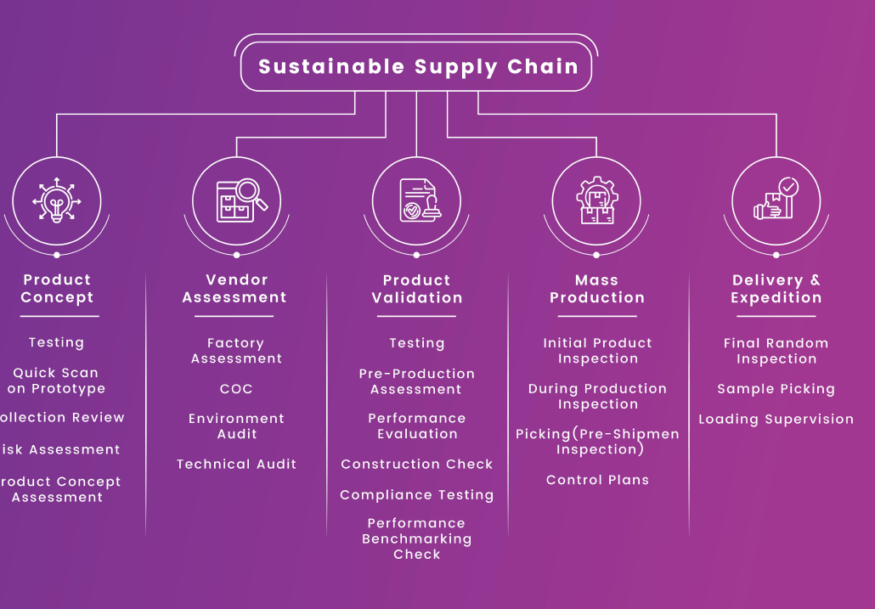

|  |  |  |  |  |
| --- | --- | --- | --- | --- |
| Product Concept | Vendor Assessment | Product Validation | Mass Production | Delivery & Expedition |
|  | Factory Assessment (FA) | Testing | Fabric Inspection (FAB) | Final Random Inspection (FRI) |
|  | Technical Audit (TA) | Benchmark Product Assessment (BPA) | Initial Production Inspection (IPI) | **Complete Assurance Program** (100% Inspection) |
|  | Social Compliance Audit (SCA) |  | During Production Inspection (DPI) | **Packing Compliance Inspection (PCI)** |
|  | CT-PAT |  | Sample Picking (SAP) | Container Loading Supervision (CLS) |
|  | Environment Audit (EA) |  |  |  |



As displayed in euroasia Website, below content to add on cover page.

**Elevating Excellence**

**Through Rigorous Testing & Inspection**



Below Photo to add on cover page, along with current picture.

Consumer Product

Testing & Inspection

Textiles / Leather & Footwear / Toys

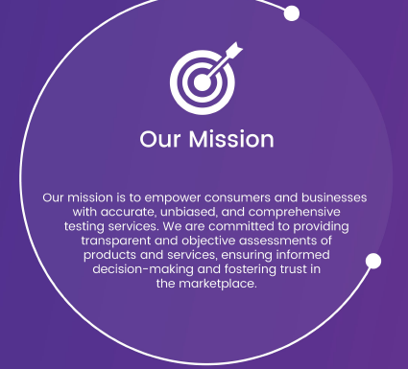

Our mission is to empower consumers and businesses with accurate, unbiased, and comprehensive testing & Inspection services. We are committed to providing transparent and objective assessments of products and services, ensuring informed decision-making and fostering trust in the marketplace.



Our vision is to be the global leader in testing & inspection services, recognized for our unwavering dedication to quality, integrity, and innovation. We strive to create a world where individuals and organizations make confident choices based on reliable testing & inspection information, contributing to safer, more reliable, and higher-quality products



At EuroAsia, we are dedicated to providing a wide array of scientific services to meet the unique needs of our clients. We specialize in an extensive range of areas, including Textiles, Footwear, Toys, Food, and Cosmetic product’s testing & inspection. We take immense pride in our leadership as an independent market player, particularly in the field of Consumer Products quality assurance



Service locations to add on Last page for visibility.

**Gurgaon / Bangalore / Tirupur**

17025 Accreditation certificate also need to add to gain client confidence

Add company website QR Code on last page - “ Scan to Visit our Website”

Also Add Email id – Contact [**enquiry.esi@euroasiasci.com**](mailto:enquiry.esi@euroasiasci.com)

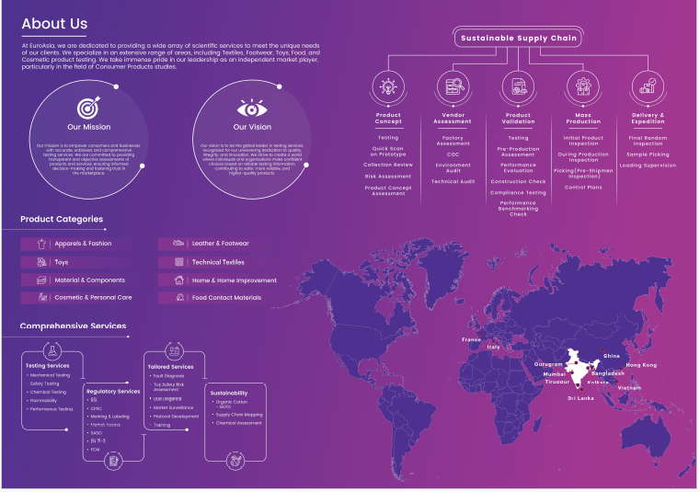

**“We exist to create experiences where passion and purpose come together.”**

Add above content at the bottom line of the page.