# **InfraWorks Road Style Wizard V1.0 - UNOFFICIAL**

# **Manual**



## **1 Introduction**

This applications helpers Infraworks modellers to quickly and efficiently batch-produce custom road-cross-sections to import into Autodesk Infraworks 2019/2020 without relying on the cumbersome manual otherwise required via Infrawork’s GUI.

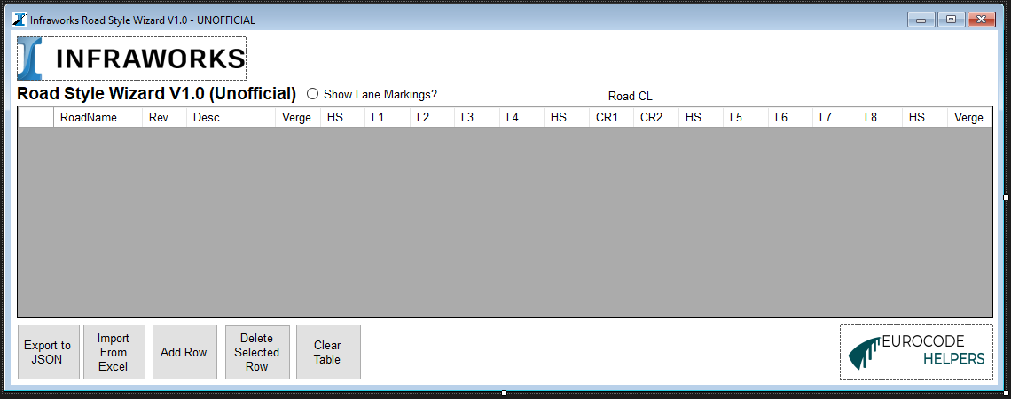

The program allows users to specify road cross-sections either via the GUI tabular input or direct import via an Excel file. The program then produces a “styles.json” file which can be readily imported into Infraworks using the procedure below.

## **2 Procedure**

Multiple road styles can be defined using either the tabular format baked into the application or optionally via an Excel Worksheet which can be used to fill in the table more effectively.

**2.1 Application Method**

Let us create a simple 7.3m carriageway with 2m verges each side.

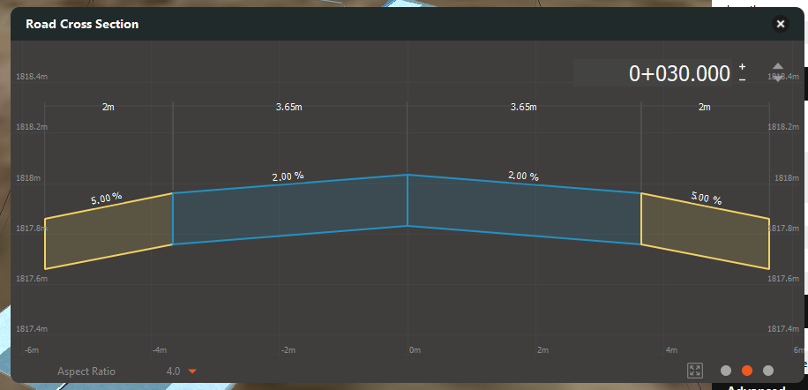

1. Click the “Add Row” button to add a new row to the table.
2. Enter “Single CW” in the RoadName column.
3. Enter in 1 into the Revision column – it is recommended that only integers i.e. 1,2,3 etc rather than P01,P02 etc are used.
4. Enter in “Single 7.3m carriageway with 2m verges” in the “Desc” column.
5. Enter values into the rest of the columns as in the below screenshot. Take care to note the position of the lanes – it is assumed in this example that the alignment is positioned centrally about the carriageway cross-section.

Key:

L1,L2,L3,L4 etc = Lanes.

HS = Hard strip.

CR1/CR2 are two halves of a central reserve if appropriate.

The string centreline is always about the centreline of the central reserve if it exists.

1. Click the “Export to JSON” button – a message box will popup if successful and give the location of the

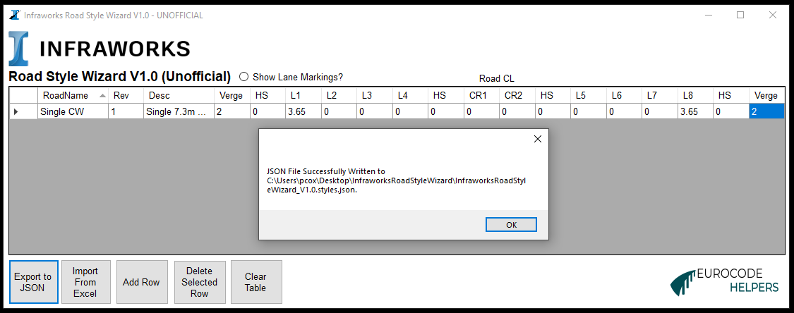

1. In Infraworks, click the Roads icon/Style Pallette and scroll down to the Component Catalogue

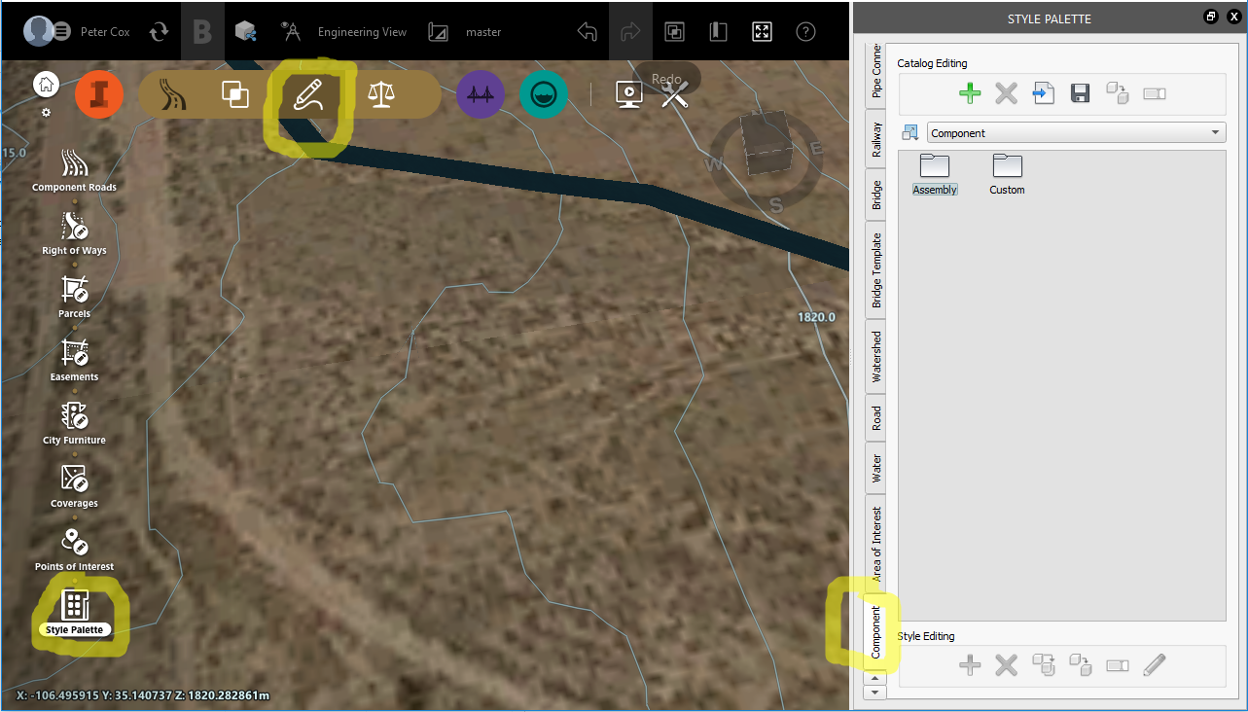

1. Click the “Import and existing style catalogue” button and navigate to the location of the file explorer (where the project is stored).

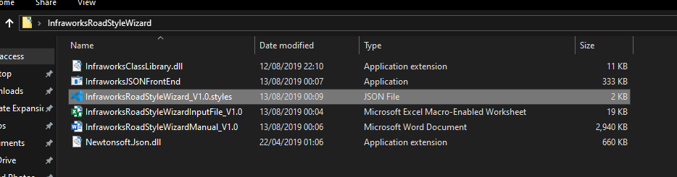

1. The cross-section we created should now be in the newly created “Custom” folder ready to be applied to any road. Double click to examine it.

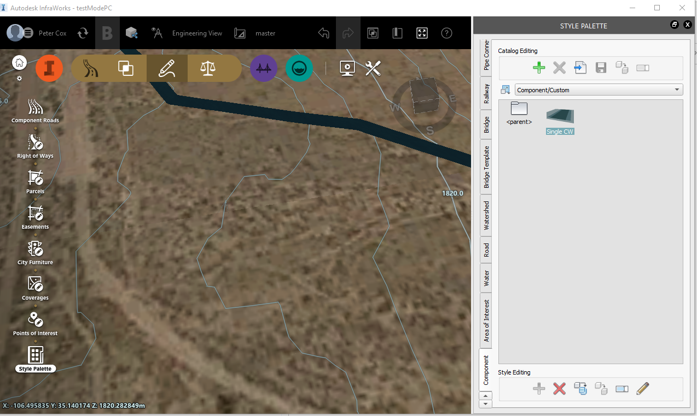

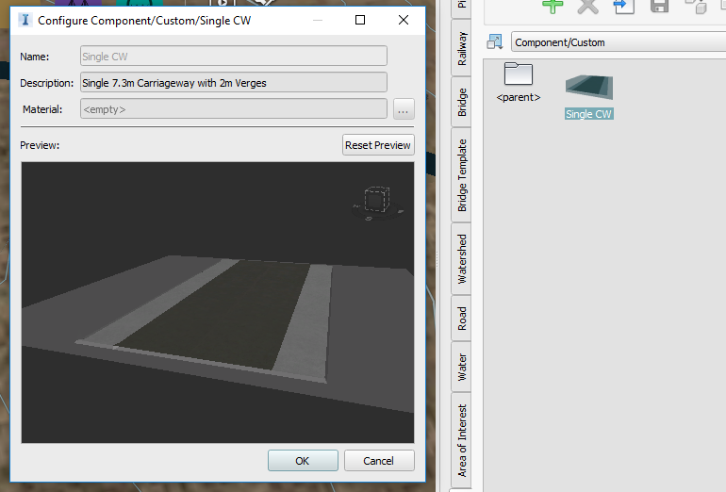

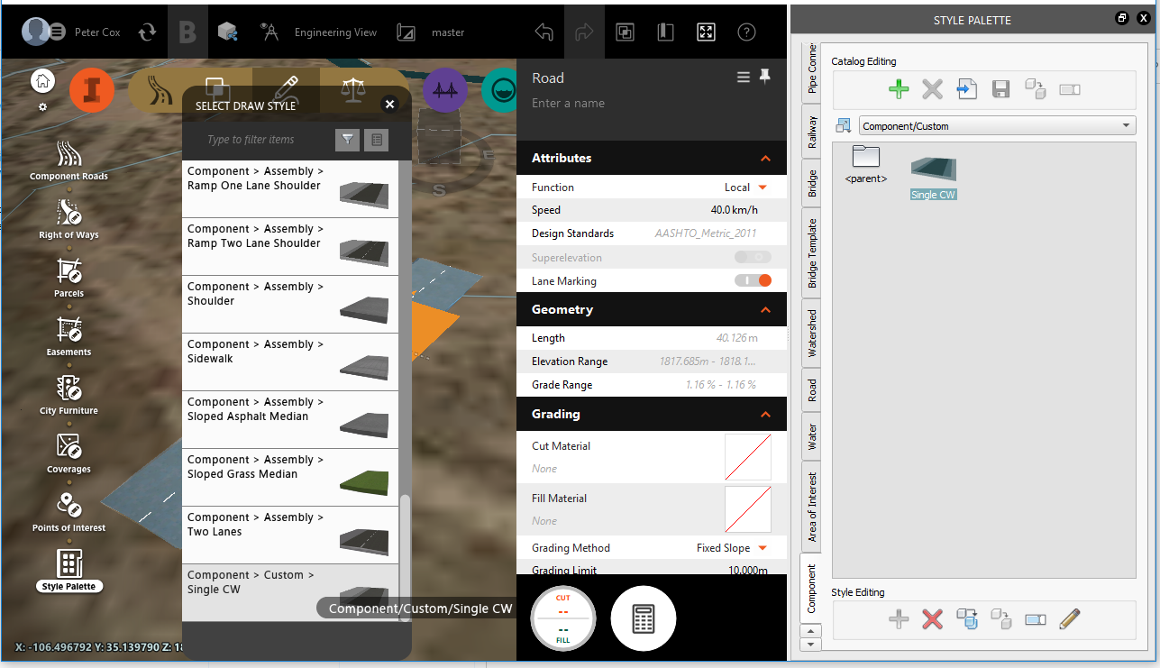

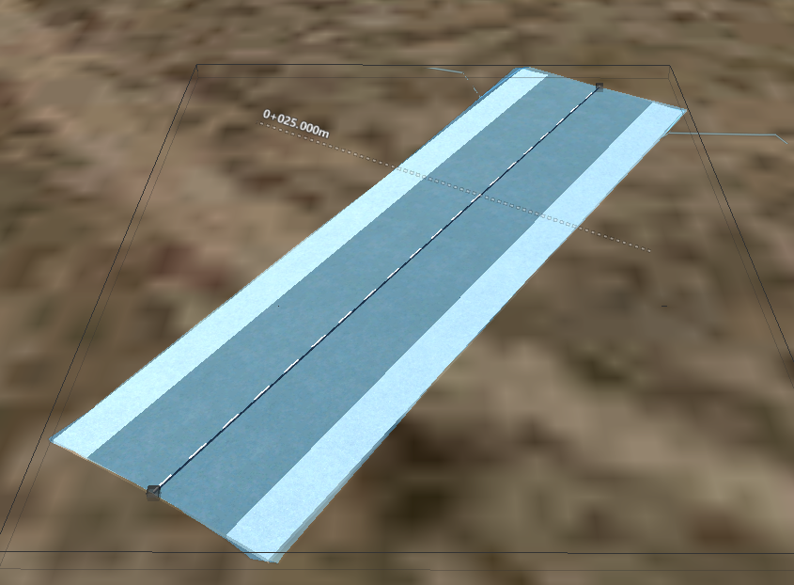



**2.2 Excel Method**

1. Open up the excel spreadsheet and enter in some cross-sections as below.

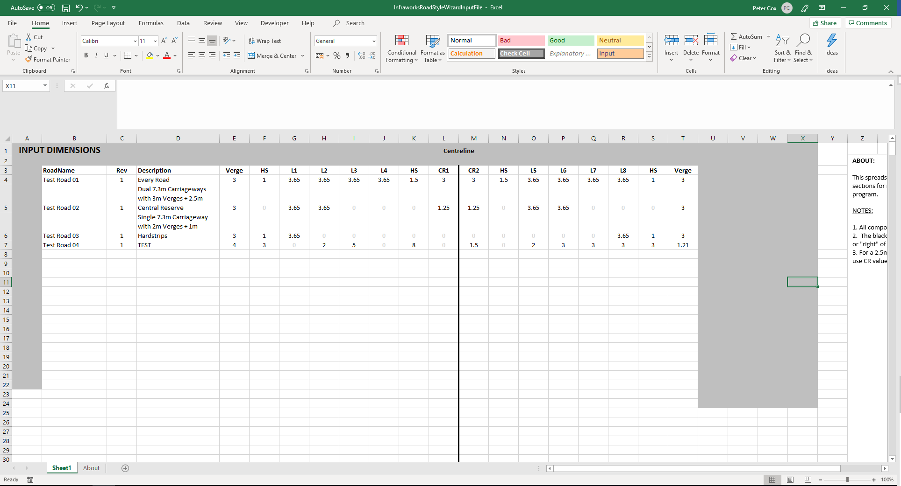

2.