Pubs around Hotel International
Map available here: https://en.mapy.cz/s/lurotohusu
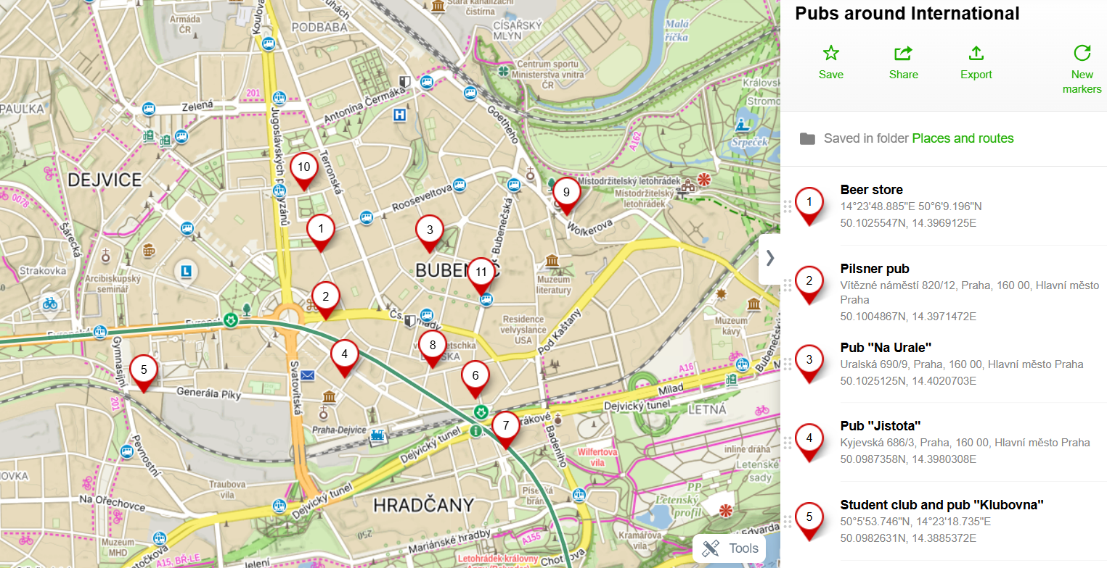
1 – small store packed with various brands from craft breweries. Always two random beers on tap (to go).
2 – Big restaurant with Pilsner Urquell on tap, good Czech and international cuisine
3 – Pleasant pub / restaurant with either Pilsner Urquell or local craft beer Únětice. Good Czech and international cuisine. May be crowded.
4 – Beer bar specializing on craft beers. Always at least six on tap. No meals, only small snacks.
5 – Student club Klubovna with two or three craft beers on tap, open until 3a.m (or empty). No meals only snacks or burgers. Main seating area outside with kids and dogs mingling around. Sometimes with movie eveneings on the garden. Kind of „hippie“ atmosphere
6 – Bistro Matuška is fancy hipster bar with delicious craft beer, but relatively expensive
7 – 500 - restaurant with international cuisine and Pilsner Urquell and Matuška beer on tap.
8 – pub U veverky – similar to No3.
9 – Pub Na Slamníku is closest to a typical pub when we consider interior. You can feel like in 1940’s. It was also a place for alternative subculture during communnist time. Craft beer Únětice on tap, maybe Pilsner Urquell. Cusine not tried.
10 – Pub Na pětníku – similar to No3, most crowded of all
11 – craft brewery Bubeneč – interesting beers worth trying, brewed on the spot. Only snacks available.
Another craft breweries:
Libocký pivovar at the tram (No 20, 26) stop „Divoká Šárka“ – pub with fairly good Czech and international cuisine and homemade beer.
Břevnovský pivovar – inside already described monastery. Good restaurant and also a beer garden, home made beers (reminding Belgian kloister beers); Bus 180 from „Vítězné náměstí“ (2 tram stops from Hotel International) to „Břevnovská“ stop and further 300m walk.

Strahovský pivovar -

