GeoAI support for the common operational picture: challenges for applying generative AI in risk determination and spatial planning
Rob Peters  Province of Utrecht  rob.peters@provincie-utrecht.nl | Willem Treurniet  Netherlands Institute for Public Safety (NIPV)  willem.treurniet@nipv.nl
Guido Legemaate
Safety Region Amsterdam-Amstelland
guido.legemaate@veiligheidsregioaa.nl

ABSTRACT
This practitioner’s paper examines three generative AI proofs-of-concept co-developed by professionals to enhance rapid decision support in emergency management. The prototypes include a spatial opportunity-map generator, a 3D geolocation and object-classification tool, and an operational Virtual Assistant that automates situational awareness during incidents. Together, they demonstrate the growing potential of hybrid GeoAI systems to integrate scenario generation, spatial analysis and legislative constraints. While results show promising accuracy and applicability, particularly in accelerating incident information management, they also reveal limitations in interpreting complex policy frameworks. The paper assesses whether current AI solutions are sufficiently trustworthy and transparent for responsible operational adoption. The assessment was carried out by members of Inowit, the Dutch National advisory board on digital technology and innovation for emergency management. The aim of this assessment is to feed the future research agenda regarding validation of AI supported crisis information management.

Keywords
Geo AI, Emergency Information Management, Trustworthy AI

INTRODUCTION
One of the most promising developments of generative AI in the field of emergency management information systems is the combination of fast scenario generation, object identification and multi factor scenario analyses. The problem in this combined development is to make AI-agents understand all the aspects that determine the accumulated risk and the allocation of resources in a truly spatial manner and to keep it maintainable. In this practitioner’s paper we will describe three AI proof-of-concepts and a validation mechanism that were co-developed by professionals to help their peers in rapid decision support. We explored whether we deem AI trustworthy and helpful enough from a practitioner’s point of view to implement such solutions at this moment in time. The assessment is carried out by an acknowledged expert group that acts as advisor agency for senior National management ( Inowit Informatievoorziening - BrandweerNederland.nl)

CURRENT PROTOTYPES AND APPLICATIONS
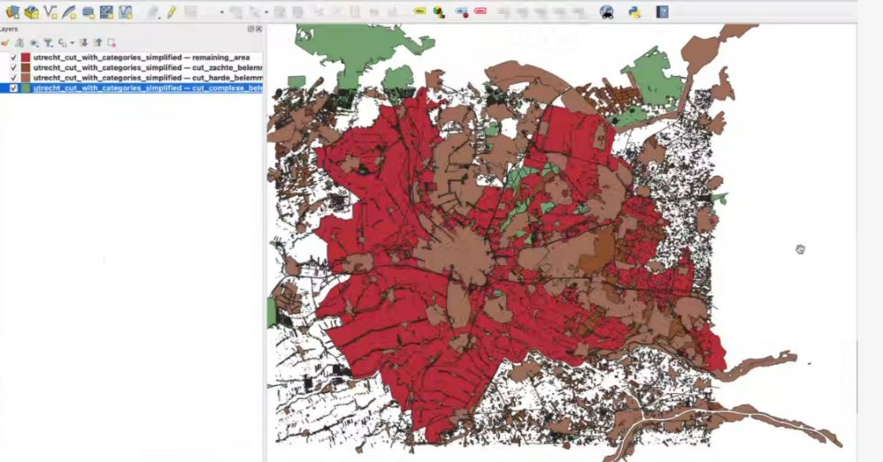
The first prototype is an on-the-fly ‘opportunity map generator’ that is already applicable in the legislative safety permitting stage of spatial planning to prevent safety issues at a later stage. This application creates spatial views based on automatic selection of relevant parameters for the positioning of objects, taking safety aspects and emergency management processes into account. Think for example of ‘hazardous fuel storage’ or noisy/high windmill or an evacuation area. The first step in the N8N (https://n8n.io/) based AI-workflow orchestration is a tuning agent that applies a Retrieval-Augmented Generation (RAG) cycle that processes all the relevant policy- and risk related documents and combines it with a general-purpose Large Language Model (LLM). In so doing it automatically derives the parameters that are relevant for the object or task from a permitting process or an emergency management perspective. This can be conditions such as ‘near a hospital’ or ‘in a Natura 2000’ area (https://natura2000.eea.europa.eu/) or ‘near housing area’ that would conflict with putting the object near a high-risk environment. The goal of this tuning agent is to be able to identify relevant parameters and then eliminate all zones from a city contour or a regional contour that would hamper the positioning of the object or task. The training agent then delivers the combined zones that remain available after this elimination to a spatial agent that generates the remaining opportunity areas in JavaScript Object Notation (JSON) programming code and visualises the result in a map-viewer such as QGIS (https://qgis.org/). The prototype did produce a reliable map with relevant cutouts, but it failed to derive the comprehensive and sometimes the most relevant sets of legislative norms from all hundreds of policy documents. The development of the prototype also highlighted the need for close collaboration between practitioners and AI developers, especially in the legislative domain about what documents and semantics exactly are required and which rules or norms should be applied.
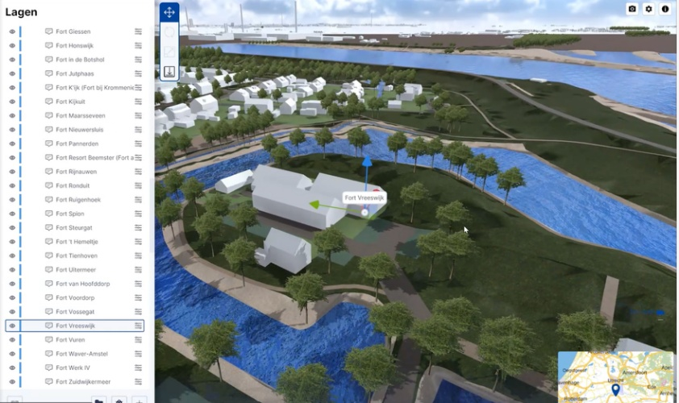
The second prototype is a similar identification, geolocation and approximation tool. It is built to support the rapid generation of all measures that allow or disallow object allocation near risk objects in a 3D environment. The placement of housing or buildings near a large UNESCO World Heritage area of - in this case - protected medieval fortresses is only allowed with compensating actions such as sound walls, for example. But windmills or solar panels on top of those walls are not allowed if near a UNESCO contour. The AI supports fast geolocation in coordinates and classification of all objects and contours and generates Blender (https://code.blender.org/) or JSON/unity (https://unity.com/) code to identify opportunities and constraints. This second prototype did generate fast overviews for a very large area during a preliminary Heritage Impact Assessment and seems applicable for many different application domains, where legislative muti-factor analyses and scenario building are required.
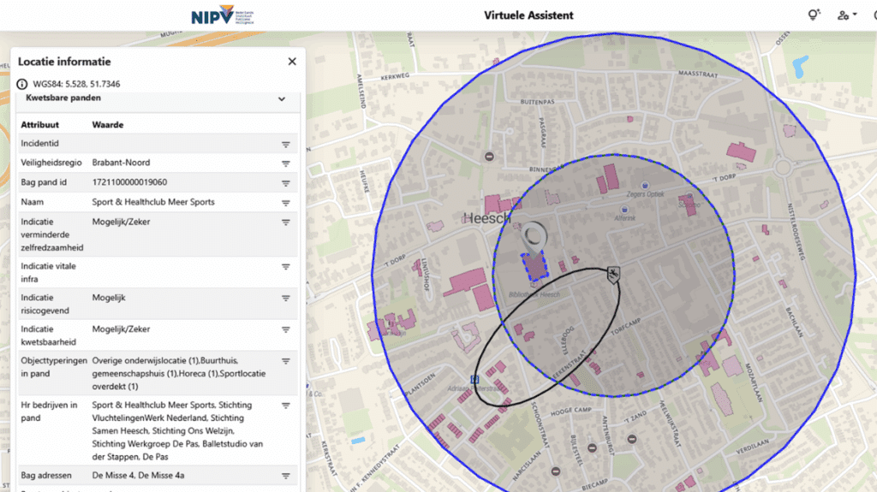
The third prototype is the Virtual Assistant (VA). The VA provides an automated situational picture of an incident based on public and restricted information sources. It supports the emergency coordinator and the operational information manager in providing information during an incident. The automated collection of relevant information sources provides a complete picture of all vulnerable and hazardous objects near the incident, improving and accelerating picture compilation and decision-making during an incident. This VA is operationally available for all safety regions in the Netherlands. Two additional functionalities of the VA are still in the pilot phase. The first one uses LLM technology to search for past incidents similar to the current incident, identifying relevant lessons learned and bringing them to the attention of the response organization. The second one addresses the challenges of interpreting emergency Governance Network Maps (BNKs) within a concrete operational context - a task where previous iterations of the VA faced limitations. While generic AI often struggles with the broader context of governance responsibilities, the third prototype utilizes a hybrid AI approach that combines RAG with Knowledge Graphs (KG) and vector embeddings to transform complex legal and governance diagrams into machine-readable ‘triples’. The KG is the validation mechanism for the professional.
This setup allows the system to analyze a brief, free-text incident description and, within less than a minute, identify the relevant legal frameworks and the specific organizations that must be involved. Evaluations of the proof-of-concept demonstrated high reliability, achieving accuracy scores between 97% and 98%, while reducing the time required for manual network mapping from over two hours to just sixty seconds. Crucially, the use of KGs ensures traceability and transparency, allowing crisis managers to see exactly why a specific organization is recommended based on the underlying BNK. This shifts the role of the information manager from manual searching to expert validation, ensuring that the right crisis partners are at the table during the “golden hour” of a crisis.

RESEARCH CHALLENGE
In the three examples described, validation is crucial. In all three examples, it was possible to arrive at sufficiently explainable solutions. The picture below shows how considerations applied by the AI agent can be traced back to the Environmental Vision of the Province of Utrecht. At the same time this decision table support user validation and can be used in SKILLS (Home \ Anthropic) to feed new prompts as a guiding principle.
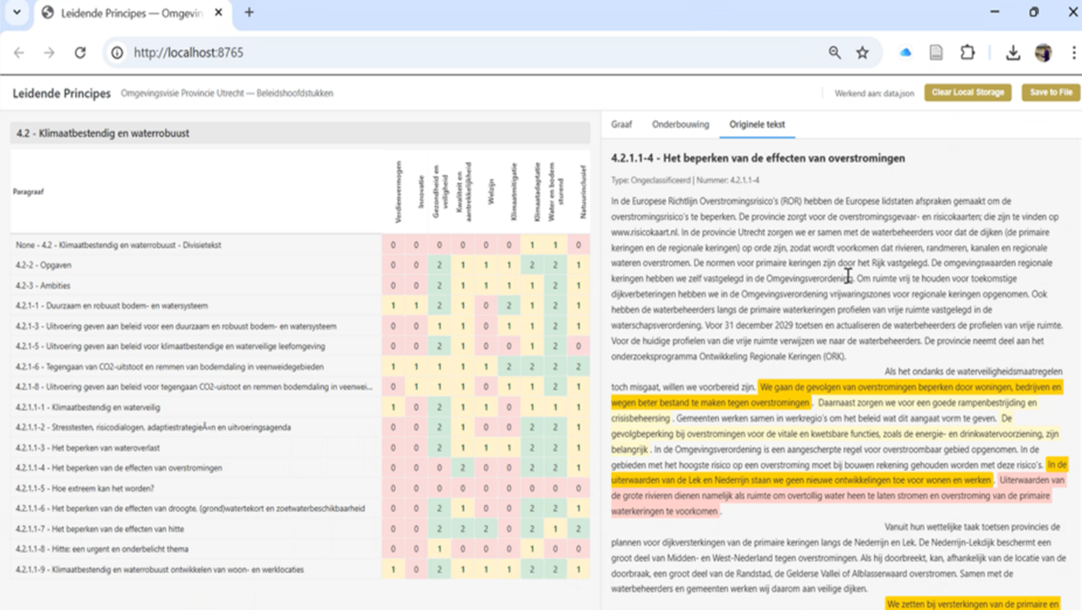
In our view, an important challenge for researchers is therefore to find a generalizable solution for validation in such a way that it is an integral part of the working process and the government policy cycle (design, programming, permission and monitoring).

CONCLUSION
The focus of this practitioner paper was to explore whether generative AI is mature enough to support the challenges of practitioners in a responsible manner. GeoAI or Spatial AI is getting up to speed. Whereas large software companies still struggle to bridge GIS knowledge and AI knowledge, the combination is already very powerful for practitioners. Developing a generalizable solution to correctly - and, more importantly, verifiably - infer the legal and policy constraints affecting safety zones and spatial planning will require additional time. We therefore propose this as a key challenge for future research. Validation must be an integral part of the working process, the agent orchestration architecture and the emergency policy cycle to ensure the integrity of public values in a FAIR way . In addition to GIS and AI orchestration knowledge, legislative, safety and policy domain knowledge is a third knowledge area that requires in depth investments for developers and practitioners. In the three examples described, hybrid combinations of rule-based agents and genAI based agents seem to work at least promising for that purpose.

ACKNOWLEDGEMENTS
The authors would like to thank the GIS-team of the province of Utrecht, the University of Applied Sciences Utrecht and the many safety regions involved in the development of the Virtual Assistant and the MultAI-functionality for their highly valuable role and contributions. Part of this research was supported by the Genecity project of the HORIZON-MISS-2025-04-CIT-02 call of the European Commission.

