# SSL

 | With SSL | w/o SSL
Latency | 9.7ms | 8.2ms
TPS | 1024 | 1212

# B-tree index

# Index TPS scan
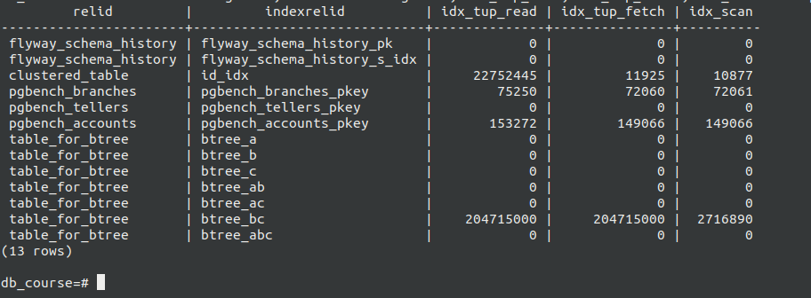

# Index comparation

 | B-Tree | Hash | BRIN
TPS | 9809 | 10442 | 133
Latency | 1.01ms | 0.958ms | 74ms
Size | 7720Kb | 4672Kb | 24Kb

