

Milestone M10 Report

Title: Functional prototype of technology chain (Compressor, exchanger, medium)
WP7 – Implementation of Flexibility & Carbon Reducing Solutions in RIs
Reporting date: 28 February 2026

1. Scope and WP7 Context
Task 7.2 (Maintaining indoor climatic conditions) focuses on improving humidity control for large-scale research infrastructures by optimizing the thermodynamic technology chain (compressor, heat exchanger, cooling medium) used for air dehumidification and humidification. Based on long-term weather assessment and multi-year Building Management System (BMS) measurements, the ELI engineering team and external design partners designed and implemented an efficient dehumidification solution for the fresh-air HVAC units serving the laser halls. Milestone M10 verifies that a functional prototype of the integrated compressor-exchanger-medium chain is installed and operational at ELI, and that the configuration supports best price-performance operation (normal operation at higher efficiency with an automatic switch to enhanced dehumidification when required).

2. Implemented Prototype Chain at ELI
At ELI Beamlines, the functional prototype technology chain has been implemented (Technical report in GitHub) in the fresh-air HVAC system serving research laser halls. The prototype integrates a dedicated low-temperature chiller (compressor stage), newly installed cooling coils/heat exchangers in air-handling units 17AB, 18AB and 19AB (exchanger stage), and the corresponding working-medium chain and controls.
- Compressor stage: new chiller installed in technical room SO03, nominal cooling capacity 1,015 kW; two screw compressors with variable-speed control (VFDs); refrigerant R134a; smooth capacity modulation 15-100% (down to approx. 150 kW partial load).
- Exchanger stage: additional cooling coils installed in air-handling units 17AB, 18AB and 19AB to enable dehumidification of fresh air by cooling to dew point; coils connected via pressure-independent control valves and equipped with condensate drainage and anti-freeze protection.
- Working media: refrigerant R134a in the chiller refrigeration circuit; chilled water circuit typically operated at +8°C supply (with automatic switch to +4°C for enhanced dehumidification) and condenser water connected to existing cooling towers (29/35°C).
- Control and monitoring: integration into the upgraded BMS (implemented under Task 7.1) for automatic mode switching, setpoint management, interlocks, and continuous trending of temperatures, pressures, humidity and energy use.
Together, these elements (Table 1) form a complete compressor-exchanger-medium chain that is ready for operational validation and optimisation towards the target indoor climate requirements.
Chain element | Implemented component | Key parameters / settings | Verification status for M10
Compressor | Dedicated low-temperature chiller in SO03 | 1,015 kW; 2x screw compressors with VFDs; refrigerant R134a; 15-100% modulation; normal setpoint +8°C, enhanced +4°C | Installed, connected to hydronic circuit and BMS; operation modes defined.
Heat exchanger | Cooling coils in AHUs 17AB/18AB/19AB | Dehumidification by cooling to dew point; condensate drainage; anti-freeze tempering when intake air <5°C | Installed in fresh-air units and controlled via BMS.
Working medium | Refrigerant + chilled water + condenser water loops | Refrigerant R134a; chilled water 4/10°C design (typically +8°C supply); condenser water 29/35°C to existing towers; pumps in 100% backup configuration | Integrated into existing infrastructure with motorised valves and instrumentation.
Controls & instrumentation | BMS integration and sensor inputs | Automatic setpoint switching and interlocks; monitoring of temperatures, pressures, humidity and energy | Implemented (BMS upgraded under Task 7.1) and used for prototype operation.
Table 1: List of elements of technological chain.
The new heat exchangeres were installed before mixing of the air in the AHU (see Figure 1 for AHU 18AB example). The logic is that by cooling down just the incoming air, we are lovering the amount of air needed to be cooled down to dew point and then heated back up, as fresh air makes only around 30% of AHUs air output.
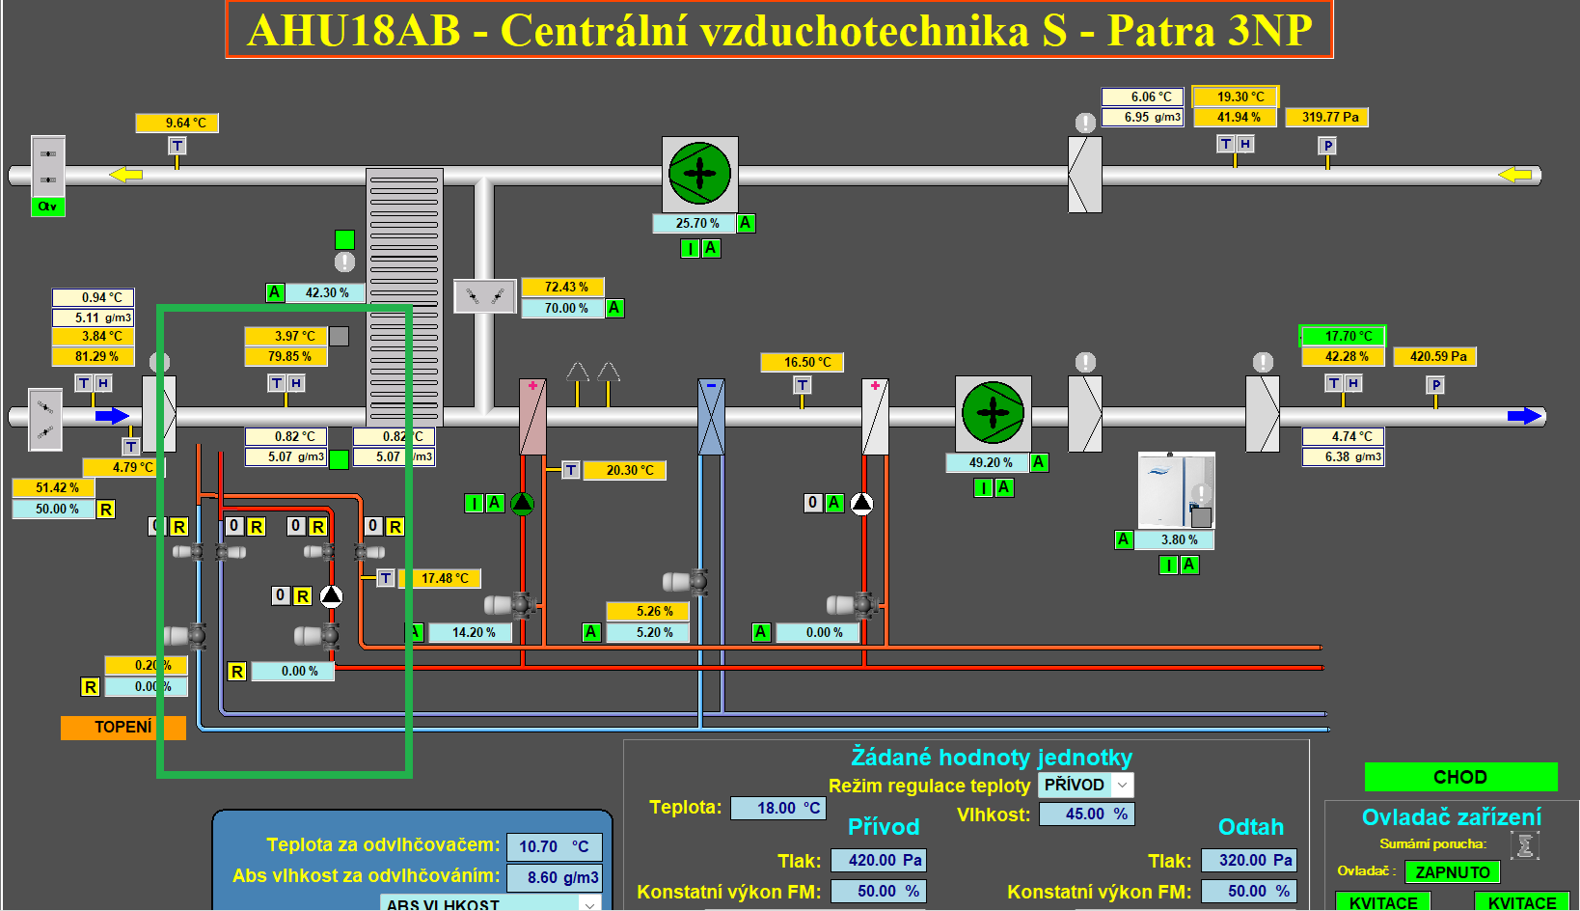
Figure 1: Implementation of new heat exchangers, print screen from SCADA (BMS) system.

Implementation timeline and commissioning status
The prototype technology chain was installed and commissioned in stages during 2024-2025 (Table 2). While the core hardware (chiller, heat exchangers) and software (BMS integration, operating modes, monitoring and interlocks) have been implemented, commissioning did not proceed fully smoothly and several obstacles were identified during testing. The most critical open item is ongoing mixing in hydraulic balancer tank in the chilled-water circuit, which prevents consistently reaching the targeted temperatures at the new heat exchangers; a temporary bypass of the main hydraulic balancer tank (on cooling was introduced to keep the system operational while the root cause is being resolved. In addition, discrepancies in measured values were detected, leading to procurement of higher-accuracy sensors but before installation a freezing incident in Q4 2025 resulted in damage to two heat exchangers, which are currently under repair. These issues do not change the M10 verification outcome (installed, operational, and instrumented chain), but they are key focus points to be resolved in the next operational period to reach full target performance.
Quarter | Key activity / observation
Q1 2024 | Installation of the prototype
Q3 2024 | Connection of heating to new heat exchangers as antifreeze protection
Q4 2024 | Bypass of main hydraulic balancer tank on cooling because of problems of mixing of water, not reaching correct temperatures
Q2 2025 | Start of testing the prototype chain
Q3 2025 | Found discrepancies in measured values; started purchase of a new more precise sensor
Q4 2025 | Freezing of two heat exchangers and their damage
Table 2: Implementation timeline.

3. Engineering Configuration and Operational Parameters
The prototype is configured to supply low-temperature chilled water to the fresh-air HVAC units and thereby enable controlled dehumidification of supply air for the laser halls. Operation is structured into modes that prioritise efficiency (price-performance) while providing the required humidity control capability.
- Normal operation (high-efficiency): New chiller operates with chilled water setpoint +8°C; cooling output approx. 150 kW to 1,000 kW; existing chillers in standby.
- Enhanced dehumidification: New chiller setpoint automatically lowered to +4°C when dehumidification at +8°C is insufficient. Trigger criterion: supply-air humidity at the outlet of one of the AHUs exceeds the required value by >5% for >15 minutes.
- High-load / redundancy: If cooling demand exceeds the new chiller capacity or for periodic compressor rotation, one of the existing chillers can provide cooling in the 500 kW to 2,300 kW range.
- Free cooling (winter conditions): When outdoor temperature is approximately +2°C or lower, chillers are off and cooling is provided via free-cooling devices to produce ~+8°C water when dehumidification is not required.
Indoor climate requirements that drive control setpoints are summarised in Table 3 (temperature stability and seasonal relative humidity targets).
Hall / area | Air temperature stability | Air humidity stability
L1 | 18.7±0.5 °C | 35±5 % (winter); 55±5 % (summer)
L2 | 18±0.5 °C | 35±5 % (winter); 55±5 % (summer)
L3 | 19.5±0.5 °C | 35±5 % (winter); 55±5 % (summer)
L4b | 18±0.5 °C | 35±5 % (winter); 55±5 % (summer)
L4c | 19±0.5 °C | 35±5 % (winter); 55±5 % (summer)
IT servers | 20±2 °C | 30–60 %
Table 3: Indoor climate requirements.
Dehumidification is achieved by cooling the outdoor air to its dew point in the fresh-air units and draining the resulting condensate. Humidification (when required) is provided by steam generation (boiling water) and injection into the air stream. To reduce energy demand while maintaining stability within ±5% RH – requirement for laser operation, seasonal humidity setpoints are applied: 35% RH in winter (minimising steam humidification) and 55% RH in summer (reducing deep dehumidification).
A dedicated meteorological station (GitHub) has been procured to support weather prediction and proactive switching between seasonal humidity targets. This enables the BMS to adjust HVAC operation ahead of outdoor humidity changes and further improve overall efficiency.

4. Price-Performance Evaluation
The implemented configuration optimises both CAPEX and OPEX by combining right-sized equipment, flexible operating modes and predictive control strategies. The key price-performance optimisation measures include:
- Right-sizing based on operational evidence: the dedicated 1 MW-class chiller was selected to cover the dehumidification load of the fresh-air units while avoiding oversizing; variable-speed compressors allow efficient part-load operation down to ~150 kW.
- Efficiency-first temperature strategy: the system operates with +8°C chilled water for most of the year to maximise COP; the +4°C setpoint is enabled only when enhanced dehumidification is required.
- Reuse of existing infrastructure: condenser side connection to existing cooling towers (29/35°C) and integration into the existing hydronic network minimise installation complexity and cost.
- Flexibility and resilience: defined modes for free cooling in winter conditions and fallback to existing chillers for high-load situations reduce operating risk and support continuous availability.
- Demand reduction by seasonal humidity targets: switching between 35% RH (winter) and 55% RH (summer) reduces steam humidification and deep dehumidification requirements, lowering overall HVAC energy use.
These measures support the task targets (compressor efficiency expressed by COP 3-4, dehumidification efficiency >90% and substantial energy reduction) and provide a scalable basis for further optimisation.

5. Assurance Statement
The M10 claim is limited to functional validation of the integrated compressor–exchanger–medium chain and to the demonstration of measurable operational performance under defined test conditions. No extrapolated industrial-scale performance claims are made beyond the validated prototype data

6. Conclusion (Milestone Achievement)
The compressor-exchanger-medium technology chain is implemented and operational at ELI. The new chiller and the associated heat exchangers in the fresh-air HVAC units are installed, integrated into the hydronic system and connected to the BMS for automatic control and monitoring. The prototype supports seasonal humidity targets (35±5% RH in winter and 55±5% RH in summer) and provides enhanced dehumidification capability via automatic switching to low-temperature (+4°C) chilled water when required. Commissioning and testing, however, revealed several practical obstacles that require final resolution: 1. mixing in the chilled-water circuit that limits achieving the targeted temperatures at the heat exchangers (temporary bypass applied), and 2. repair/replacement of two heat exchangers damaged by a freezing event, alongside upgrades to measurement accuracy (new sensors). With these corrective actions underway, Milestone M10 is achieved as a functional prototype ready for continued performance optimisation and observed-parameter consolidation.

