

Milestone M3 Report
Title: Functional Prototype of the Technology Chain (UPS, UPQ, PVP, DA)
WP4 – Efficient Use of Battery Arrays
ELI Beamlines
Reporting date: 28 February 2026

Abbreviations used in the text:
Abbreviation | Meaning in this text
WP | Work Package
RI / RIs | Research Infrastructure / Research Infrastructures
ELI | ELI facility (Extreme Light Infrastructure)
M3 | Milestone 3
UPS | Uninterruptible Power Supply
UPQ | Uninterruptible Power Quality (system) (mentioned as “UPQ system”, not separately implemented)
PV | Photovoltaics / on-site PV generation
PVP | PV plant / PV production (used as “PV (PVP)” and “PVP (on-site PV)”)
CHP | Combined Heat and Power
DA | Diesel aggregate (implemented as a motor-generator backup set)=MG, DG
MG | Motor Generator
BMS | Building Management System
PQ | Power Quality
FMEA | Failure Modes and Effects Analysis
HVAC | Heating, Ventilation, and Air Conditioning
CDA | Clean/Compressed Dry Air (utility air system) (listed among critical auxiliaries; not expanded in the text)
LVRT | Low Voltage Ride Through
BESS | Battery Energy Storage System
DG | Diesel Generator
GenSec | Genset / generator set (written as “GenSec” in the text)
EN 50160 | EN 50160 power-quality standard reference (voltage characteristics / reporting frame)
KPI | Key Performance Indicator
GHG | Greenhouse Gas (emissions)
CF | Carbon Footprint (used in CF_after / CF_before)

1. Scope and WP4 Context
WP4 addresses integration of storage and power-quality measures in RIs, within the technology chain (UPS, UPQ, PVP, DA) and with the objective of improved cost/emissions/reliability performance. M3 confirms functional operation of the integrated chain at ELI under real load conditions.
Details about installed equipment are attached in GitHub (Battery study for UPS containing UPS+MG logic, Technology report on PV and CHP installation, Opinion of energy specialist).

2. Implemented Prototype Chain at ELI
The implemented prototype integrates UPS (critical loads), PVP (on-site PV), DA (Diesel aggregate = Motor Generator) as backup power, and CHP as an on-site generation component and grid stabilizer.
The technology chain was selected to provide a functional, risk-based protection concept for the ELI experiment-critical boundary, where power disturbances can directly interrupt experiments or invalidate experimental conditions. The design prioritizes continuity and stability for both experimental equipment and the supporting systems whose disturbance stops or compromises experiments (e.g., cooling, HVAC, vacuum, CDA, demineralized water, drives, chillers, pumps, and associated control and management systems). Within this boundary, the UPS provides immediate ride-through and isolation from short-duration disturbances; based on an FMEA-driven criticality assessment, UPS coverage was expanded beyond core experiment loads (Figure 1) to include essential control layers (notably equipment management/critical control systems). 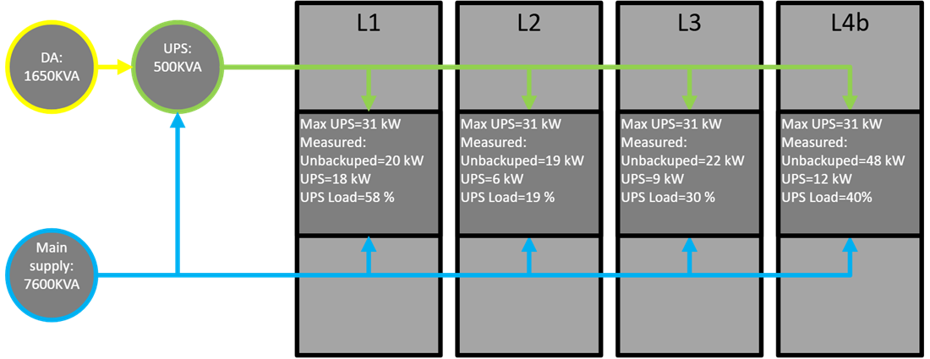Figure 1: Research on the use of UPS for four research halls for additional equipment connection Q2/2025.
For longer-duration interruptions, the DA function is provided by a motor–generator set operated in backup-only mode; following a main supply failure, it starts within the required restoration window and sustains the UPS and selected critical auxiliaries (Figure 2), preserving experiment continuity while avoiding backup of out-of-scope loads. The CHP unit is included for its low-voltage ride-through (LVRT) capability and its contribution to local grid stabilization, enabled by the inertia and synchronous-machine behavior of its rotating equipment (as briefly described in the attached CHP technical report). PV panels reduce dependence on the external grid and therefore can modestly reduce dip propagation; in addition, LVRT operation and potential reactive power injection may further support grid stability, which will be evaluated experimentally.
The chosen chain also delivers the required “best price–performance” as a combined value proposition: resilience and power quality for critical systems alongside ongoing energy and carbon benefits. PV is implemented behind the meter under a zero-export, self-consumption operating concept aligned with the facility’s high demand profile, while CHP provides dispatchable generation that improves operational economics and reduces carbon intensity relative to grid-only operation, without requiring continuous 24/7 running. A standalone UPQ subsystem was deliberately not implemented; instead, the project applies a functional substitution approach, demonstrating that a designed chain of established technologies (UPS + motor-generator backup + PV + CHP integration and control) can deliver the UPQ-equivalent outcome that matters for the experiment-critical boundary. This approach is structured for objective verification through Class A power quality monitoring at both the grid-side reference and the post-UPS critical-load reference, enabling EN 50160-framed reporting and comparative analysis (including CHP-on versus CHP-off operation) as part of the milestone evidence package. For the timeline of implementation of the Prototype of technology chain, see Table 1. For the diagram of internal electricity grid with Prototype chain implemented see Figure 2.
Period | Equipment / subsystem | Status in that period | Notes (boundary-relevant)
2023 (baseline) | UPS (existing) | In operation (pre-existing) | UPS already supported experimental equipment; this year is the baseline before PV + CHP implementation.
 | PV (PVP) | Not installed | —
 | CHP | Not installed | —
 | MG | Installed | MG serves as a backup power generator in case of long term power disruption
Q1 2024 | PV (PVP) | Installed and commissioned | PV implemented behind the meter under zero-export/self-consumption operating concept.
Q2 2024 | CHP | Started operation (initial reduced mode) | CHP introduced as dispatchable on-site generation (not 24/7).
Q4 2024 | PV + CHP | Running in operational mode | PV + CHP running; forms the generation component of the chain.
 | UPS (expanded coverage – partial) | Partial extension implemented | Partial UPS coverage extended to selected critical controls (e.g., BMS / critical control systems) based on risk/FMEA logic.
Q2 2025 | UPS (expanded coverage – controls) | Expanded coverage adopted by experiments | Experiments connected their controls to UPS following the study/recommendation; strengthens experiment continuity by protecting the control layer.
2025–2026 | Full chain (UPS + PV + CHP + MG) | Benchmark operation period | Stable facility mode for verification and performance benchmarking (including PQ comparison and CHP-on vs CHP-off analysis).
Table 1: Timeline of installed equipment (ELI – experiment-critical boundary)
At the end of the project, a consolidated evaluation will determine whether the existing prototype configuration based on UPS can be further optimized through the integration of an UPQ system, subject to technical and cost–performance justification.
Table 2 documents the load-segmented UPS strategy implemented within M3. It situates the UPS layer within the broader hierarchy of possible power-failure mitigation technologies. It distinguishes sub-second conditioning (UPS, converters), second-scale bridging solutions (CHP with LVRT capability), and minute-scale backup (diesel generation), thereby demonstrating that the M3 prototype constitutes the first-response layer of a multi-tier resilience architecture.

Short assessment of the logic of technical solutions, Table 2:
Type of power failure mitigation | Technology | Time frame from Failure (T₀)
Battery Energy Storage System (BESS) | Battery storage | T₀ -> Hours
Low Voltage Ride Through (LVRT) | Combined Heat and Power (CHP) (applied in ELI) | T₀ -> Seconds  (when in use)
 | DC to AC converters (applied in ELI) | T₀ -> Seconds  (when in use)
 | Wind power plant (not applicable) | T₀ -> Seconds  (when in use)
 | Flywheels (not applicable) | T₀ -> Seconds  (when in use)
Emergency power supply | Diesel generator (DG, GenSec) | T₀+1 minute -> unlimited
Table 2: Layered Resilience Architecture: Power-Failure Mitigation by Response Time
Note: BESS is included as a reference mitigation architecture for subsequent phases and is not yet claimed as physically implemented within M3.
As part of the project training program, a session was delivered for which researchers on batteries and grid-stabilization systems were conducted. Table 3 summarizes the benefits associated with different types of UPS solutions.
Type of connection | How it works | Protection against | Cost | Lifetime | Usecase for Ris
Online Double Conversion | AC-DC, DC-AC conversion | All power disturbances | Most costly | Shortest | Most sensitive equipment, control systems
Line-Interactive | Voltage boost circuitry, backup within 4-6 millisec. power break | Under and over voltages | Moderate cost | Average | Sensitive equipment that can manage short power interuptions
Offline/ Standby/ Battery Backup | Battery backup - switch on with voltage drop | Persistent blackout | Cheapest | Longest | Equipment that has inertia - important pumps, ventilators…
Table 3: Comparison of UPS architectures by disturbance mitigation capability, transfer dynamics, lifecycle cost, and suitability for RI load categories. Shaded are those used in the prototype.
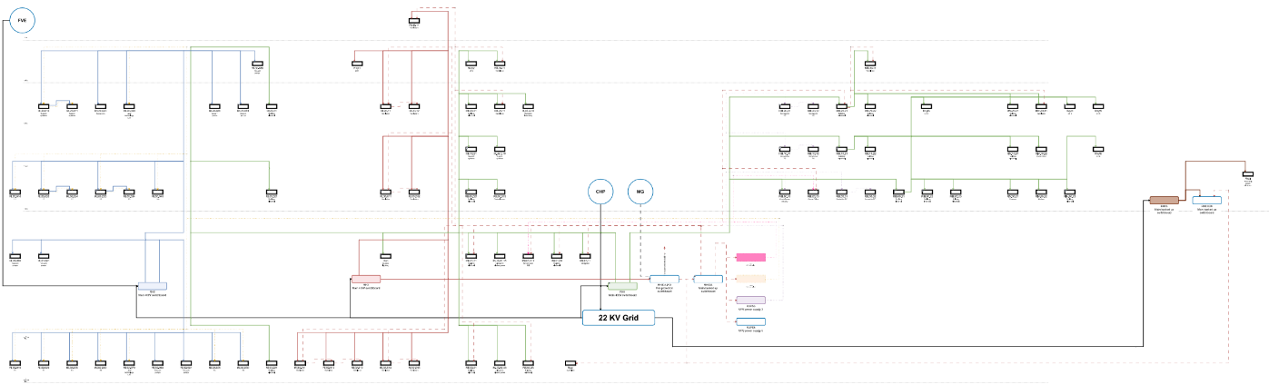Figure 2: Model of internal grid in ELI with Technology chain implemented. See GitHub for better resolution.

3. Operational Baseline (2023, 2024 and 2025 change)

3.1 Electricity consumption
Year | Total electricity consumption [MWh] | Change
2023 | 10 377 | —
2024 | 10 670 | +2.82%
2025 | 11 748 | +11.67%
Table 4: Electricity consumption 2023 – 2025

3.2 On-site generation integration (2024)
Source | Production [MWh] | Share of total [%]
PV | 305 | 2.86
CHP | 1012 | 9.48
Total | 1317 | 12.34
Table 5: On-site production 2024

3.3 On-site generation integration (2025)
Source | Production [MWh] | Share of total [%]
PV | 341.00 | 2.90
CHP | 1332.00 | 11.34
Total | 1673.00 | 14.24
Table 6: On-site production 2025
Status | Unit | Amount
Greenhouse gas emissions before project implementation | tons/year | 11187.70
Greenhouse gas emissions after project implementation | tons/year | 9638.45
Reduction in greenhouse gas emissions | tons/year | 1549.25
Reduction in greenhouse gas emissions | % | 13.80%
Table 7: GHG emissions reduction; for details see in GitHub “Opinion of energy specialist_ZVA_KGJ_27-3-2025"

4. Validation Approach
Validation relies on continuous monitoring (BMS + PQ analyzer) and incident tracking with correlation to external grid events. A structured FMEA methodology complements the hardware chain for root-cause mitigation. Pre-installation incident archives are partially incomplete due to the 2023 ransomware event; therefore, M3 evidence prioritizes reproducible post-commissioning monitoring and transparent KPI definitions. We have proposed KPIs (Table 8) complementing those in Description of Acton and more in depth described in Midterm report. We also have a list of impacts of power instabilities from Control Systems department on Experiments (Figure 3), Elspec Analyzer data from RH2 and after RUPS2 (Figure 2) and BMS data. Elspec data and BMS data on CHP operation (On/OFF) combined can be seen in Table 9 and Figures 4 and 5.
Indicators | Target / Definition | Measured / Status
Power-quality metric | Sags_after / Sags_before ≤ 0.8  (EN 50160) | On-track (monitoring active)
On-site integration | On-site generation share ≥10% | 12.3% (Achieved)
Carbon footprint ratio | CF_after / CF_before < 1 | On-track (Tool quantification)
Table 8: Measured System Indicators Against Defined Acceptance Criteria

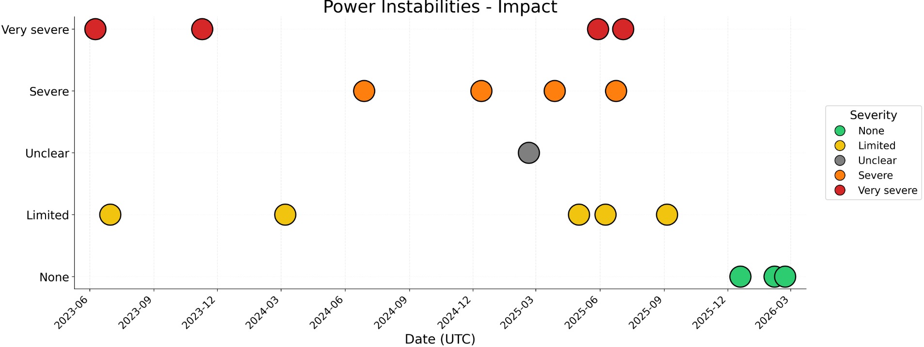
Figure 3: Recorded internal grid instabilities in ELI from Control System department of the Experiment Halls
Elspec ID | Event | Severity | Start | End | Duration  (sec.) | CHP during incident | Column1
3069 | Dip | 68 | 21.06.2024 5:15 | 21.06.2024 5:15 | 0.059854 | OFF | 0
3515 | Dip | 51 | 08.07.2024 3:16 | 08.07.2024 3:16 | 0.025092 | OFF | 0
3620 | Dip | 52 | 12.07.2024 4:37 | 12.07.2024 4:37 | 0.050030 | OFF | 0
3877 | Dip | 52 | 22.07.2024 4:43 | 22.07.2024 4:43 | 0.039984 | OFF | 0
4575 | Dip | 61 | 18.08.2024 16:10 | 18.08.2024 16:10 | 0.060006 | OFF | 0
4624 | Dip | 64 | 21.08.2024 3:49 | 21.08.2024 3:49 | 0.060006 | OFF | 0
4951 | Dip | 65 | 03.09.2024 0:52 | 03.09.2024 0:52 | 0.045155 | OFF | 0
4963 | Dip | 53 | 03.09.2024 5:05 | 03.09.2024 5:05 | 0.050064 | OFF | 0
5341 | Dip | 55 | 18.09.2024 6:14 | 18.09.2024 6:14 | 0.059837 | ON | 1
5442 | Dip | 59 | 22.09.2024 2:33 | 22.09.2024 2:33 | 0.049931 | OFF | 0
5678 | Dip | 70 | 01.10.2024 6:31 | 01.10.2024 6:31 | 0.050099 | ON | 1*
7502 | Dip | 255 | 12.12.2024 18:40 | 12.12.2024 18:40 | 6.398907 | OFF | 0
7505 | Dip | 111 | 12.12.2024 18:41 | 12.12.2024 18:41 | 0.490205 | OFF | 0
7506 | Dip | 111 | 12.12.2024 18:41 | 12.12.2024 18:41 | 0.500256 | OFF | 0
7509 | Dip | 111 | 12.12.2024 18:42 | 12.12.2024 18:42 | 0.490241 | OFF | 0
Table 9: CHP on vs Dips recorded, source is Elspec Analyser and BMS system
* see Figure 5 below.
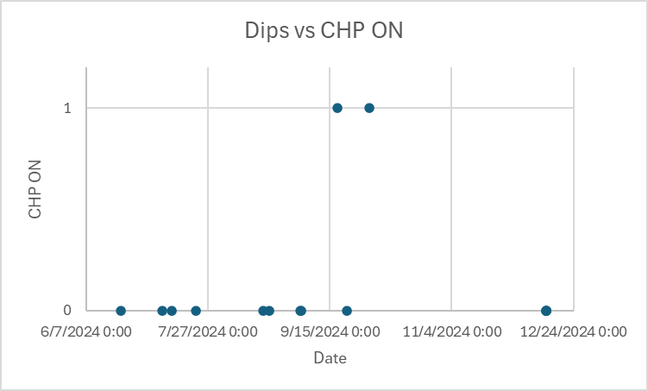
Figure 4: Graphical representation of the Table 2.
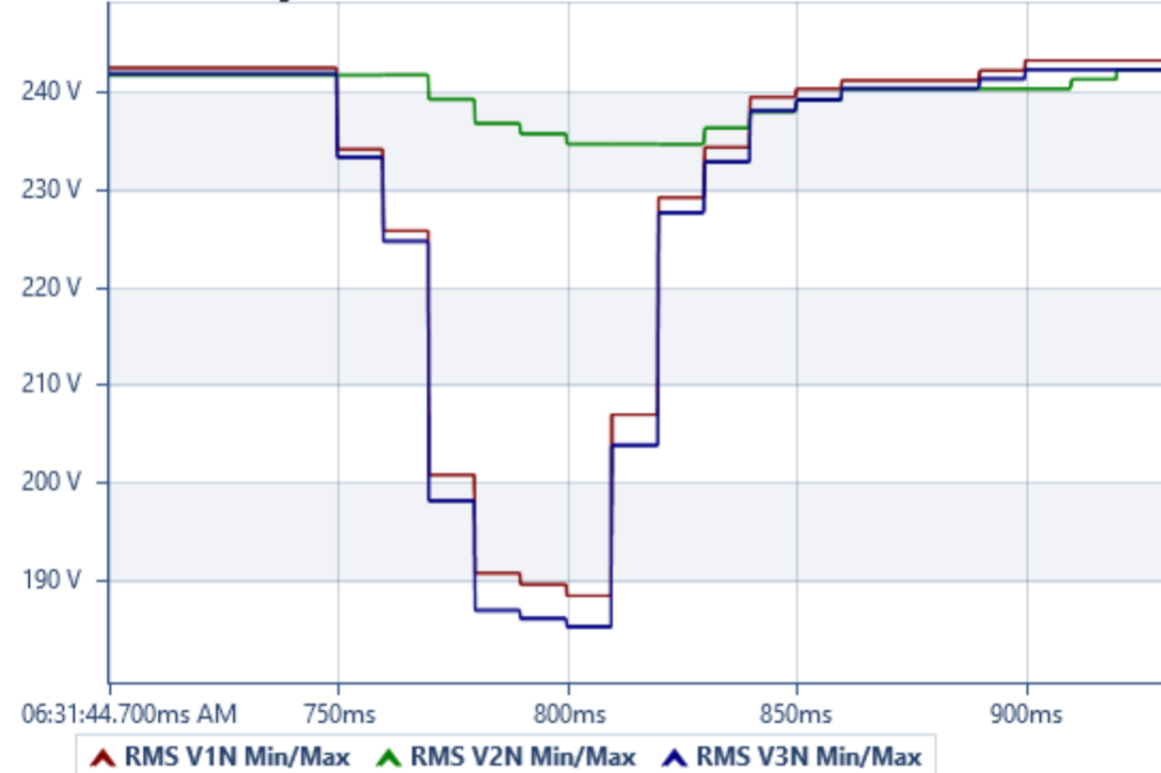
Figure 5: Showing ID 5678 refer to Table 2: CHP operation during DIP occurrence

5. Assurance Statement
The M3 claim is limited to functional operation and measurability of the integrated chain (UPS, UPQ, PVP, DA) at facility scale. The evidence base comprises metered annual consumption (2023–2024), documented PV and CHP production and an active monitoring stack (BMS + PQ analyzer) enabling reproducible post-commissioning evaluation. Where pre-2024 incident archives are incomplete, this limitation is explicitly stated and addressed by relying on traceable datasets collected during the project period.

6. Conclusion (Milestone Achievement)
The technology chain (UPS, UPQ, PVP, DA, CHP) is implemented and operational at ELI. The system demonstrates measurable integration of on-site generation, and a reproducible disturbance tracking record. Milestone M3 is therefore achieved as a functional, instrumented, and operational prototype under real high-load facility conditions.

