
Summary
In order to evaluate impacts of the widespread use of electric vehicles (EVs), we build three main models: Investment and Return (I&R) Model, Harm Degree (HD) Model, and Multi-objective Optimization Model. After modeling and analyzing, we’d like to draw our conclusion that the widespread use of EVs is feasible. Therefore, EVs should be greatly supported by the government and vehicle manufacturers.
When considering the economic impact, we use I&R Model to draw EVs’ penetration rate curve over time after government and vehicle manufacturers have funded in supporting EVs. We also predict that EVs’ penetration rate in 2060 will be 74% of the entire automobile market and, at that time, the economic benefits of EVs to the society will be 3 times over the initial investment.
When studying the environmental impact, we first build Cellular Automata Simulation Model to calculate the maximum pollution tolerance of the land, and then use I&R Model to get the EV battery recycling benefit curve after government and vehicle manufacturers’ investment. Finally, we calculate environmental impact of EV battery and the investment returns to the government and manufacturers, and also come to the conclusion that the recycling rate of the EV battery will be 93% if there is investment on battery pollution and recycle technology.
In researching the health impact, we combine HD Model with One-compartment model based on pollutant density absorption, draw HD curves to crowd around the road and around power plant and find out that HD to crowd around the road is five times more than that to crowd around the power plant.
In discussing the social impact, we consider to use EVs as energy storage units that can be employed to store to be used during peak demand hours to help improving the reliability of the grid. We analyze this method’s influence to the coal consumption rate in thermal power plant and find out that it will help saving 8.5% coal per day.
After that, we give a solution in all the four aspects by using Analytic Hierarchy Process (AHP) to analyze the weight of these impacts and find that the economic and social impacts are the key factors. In addition, we use the models built above to estimate that about 1531.8 billion ton oil per year would be saved.
When EV’s penetration rate reaches a certain level, we consider the lowest cost, lowest HD and maximum possibility to avoid using un-renewable energy and use multi-objective programming model to solve the problem of the amount and type of electricity generation needed that will produce the largest number of benefits.
Contents
1. Introduction............................................................................................................................... ...................2
2. Logic of the simulation process.........................................................................................................2
3. Basic Models........................................................ .........................................................................................3
3.1 Investment and Return Model........................................................ ...............................................3
3.1.1 Symbols and Definitions.................. .................. .................. .................. .................. ........3
3.1.2 The Foundation Model........... ..... ........... ..... ........... ..... ........... .........................................3
3.2 Harm Degree Model.............. .............. .............. .............. .............. .............. .............. .............. .....3
3.2.1 Symbols and Definitions....................................... ....................................... ........................3
3.2.2 The Foundation of Model....................................... ....................................... .....................3
3.3 Multiple optimized model………………………………………………………………………….4
3.3.1 Symbols and Definitions…………………………………………... ..............…………….4
3.3.2 The Foundation of Model……………………………………………………………….….4
4. Model application and problem solving….. ......... ......... ......... ......... ......... ......... ......... .........5
4.1 Economic impact... ......... ......... ......... ......... ......... ......... ......... ......... ......... ......... ......... ......... .......5
4.1.1 Penetration Model......... ......... ......... ......... ......... ......... ......... ......... ......... ......... ......... .......5
4.1.2 The policy that government promote electric vehicles and the benefits of the decision-making...... ......... ......... ......... ......... ......... ......... ......... ......... ....... .................6
4.1.3 Model Verification......... ......... ......... ......... ......... ......... ......... ......... ......... ......... ......... ......7
4.2 Environmental impact. ......... ......... ......... ......... ......... ......... ......... ......... ......... ......... ......... .........8
4.21 Maximum Land Pollution Tolerance Model..... .........................................................8
4.22 Decisions made by the government about improving the battery recycling and the benefits it brings to the environment........................ ........................ .............8
4.3 Health impact......... ......... ......... ......... ......... ......... ......... ......... ......... ......... ......... ......... ..................9
4.3.1 Pollution model......... ......... ......... ......... ......... ......... ......... ......... ......... ......... ......... ......... ..9
4.3.2 Model improvement......... ......... ......... ......... ......... ......... ......... ......... ......... ......... ...........10
4.3.3Verify......... ........ ......... ......... ......... ......... ......... ......... ......... ......... ......... ......... ......... ......... ....10
4.4 Social impact..... ......... ......... ......... ......... ......... ......... ......... ......... ......... ......... ......... ......... ............11
5. Key problems analyzing........ ......... ......... ...... ......... ......... ......... ......... ......... ......... ......... ......... ....12
5.1 Oil saving ................................................................................................................................................12
5.2. The key decisions government should consider......... ................ ......... ......... ......... ......12
5.2.1Build comparison matrix......... ......... ......... ......... ......... ......... ......... ......... ......... ............13
5.2.2 Order arrangement and consistence verification......... ......... ......... ......... ............14
5.2.3 Total order arrangement and consistence verification......... ......... ......... ......... ..15
5.2.4 Conclusion......... ......... ......... ......... ......... ......... ......... ......... ......... ......... ......... ......... ..........15
5.3 The multi-objective programming problem ......... ......... ......... ......... ......... ......... ......... ....16
5.3.1 Variable Definition and Model Preparation......... ......... ......... ......... ......... ......... ....16
5.3.2 Discussion......... ......... ......... ......... ......... ......... ......... ......... ......... ......... ......... ......... ......... ..17
5.3.3 Model Analysis and Solution......... ......... ......... ......... ......... ......... ......... ......... ......... ...17
6 Assessment of the advantages and disadvantages of the main models…………..…18
7 Recommendations and Conclusions......... ......... ......... ......... ......... ......... ......... ......... ......... .....19
Appendix 1......... ......... ......... ......... ......... ......... ......... ......... ......... ......... ......... ......... ......... ......... ......... ....19
Appendix 2......... ......... ......... ......... ......... ......... ......... ......... ......... ......... ......... ......... ......... ......... ......... ....20
References......... ......... ......... ......... ......... ......... ......... ......... ......... ......... ......... ......... ......... ......... ...............22
1. Introduction
As we all known, nowadays, pollution problem caused by fossil fuels attracts people’s awareness all over the world. Would the wide spread use of electric vehicles (EVs) take place of fossil-fuel vehicles (FFVs)? If so, what measures should government and vehicle manufacturers take to ensure safe, efficient, effective transportation? Our group introduces a very practical model to analyze the environmental and economical effect from the aspect of environment, society, business and individuals. In addition, we discuss the percentage that all types of electricity generation account for and the policy the government ought to make to let people lead a better life. At last, we conclude that it’s a worthwhile endeavor and an important part of an overall strategy to address global energy needs in the face of dwindling fossil fuel supplies.

2. Logic of the simulation process
Investment and return model
Multi-objective programming model

Harm degree model

Environment

Economy

Society

Health

Cellular Automata

One-compartment model

Lowest cost

Best decision

Lowest HD

Avoid using fossil fuels

The type and amount of electricity generation & distribution

3. Basic Models
3.1 Investment and Return Model
3.1.1 Symbols and Definitions
Variable Definition | Variable Definition
x(t) Current achievement  M Maximum achievement | r₀ Growth rate before government investment  r Growth rate after government investment
Assumption: original growth is a small constant number
3.1.2 The Foundation of Model
In this model, we mainly focus on making short-term forecasts of the achievement growth after government investment. The growth process is changing dynamically, because it is a common process in the investment and return problems. In our first model, we assume the growth rate is a constant number.
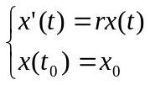
It is easy to know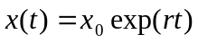, when time is limited of infinity, the achievement will be grown exponentially, which is, without doubt, unreasonable under the circumstance of the certain research time, resources and prosperity. In order to overcome this exponentially growth defect of this model, we decide to use logistic model.
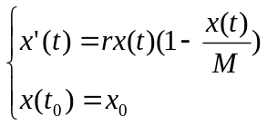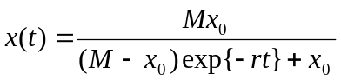
Due to the complex research environment, some factors’ impacts to the growth rate after investment will be changed over time, we decide to use non-autonomous logistic modal to predict the future achievement’s trend of the world as follows:
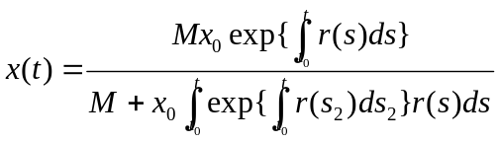

3.2 Harm Degree Model
3.2.1 Symbols and Definitions
Variable Definition | Variable Definition
HD The sum of degree  N_{i} Population distribution in certain scope; | C_{i} A percentage of possible harm in certain scope;  h_{i} Intake harmful gases density to the crowd per second.

3.2.2 The Foundation of Model
In terms of waste emissions compared to other sources, power plants are far from the area of people's lives. Human beings’ health hazards are primarily caused by people exposure harmful substances around power plants. This type of health hazards changes with population density fluctuating. If people are crowded near the power plants, harmful gases will do more hazards on human beings, otherwise, it will do fewer hazards to human beings.

In order to compare all kinds of gas pollution emission and evaluate its effect to the environment as well as human beings from the health perspective, we introduce harm degree (HD) concept and build a HD model. HD is the definition of total average intake harmful gases concentration in different scope. This model intends to assess how much harm that different pollution around pollution sources would do to the health of human beings which is as follows:
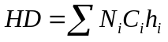
h_{i} directly associates the amount of pollutant quantity with people’s health, thus the government will have important reference to the environmental policy and make better criteria about pollution emission.

3.3 Multiple optimized model
3.3.1 Symbols and Definitions
Variable Definition | Variable Definition
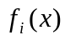 Objective function  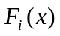 Optimal value  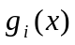 Constraints | 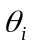 Tolerance value  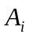 Optimal solution  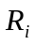 Feasible region

3.3.2 The Foundation of Model
Make an order of the multi-objective programming problem, the number of which is P. Assume 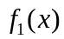is the most important, 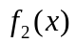 the second, 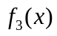the third. . . And the final is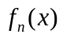.At first, we should find the target function with, the same Constraints in the primal problem P_{1:}
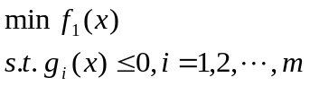
When we calculate the target function, we find the optimal solution A₁ and the optimal value F₁(x), we also find:
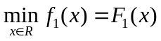,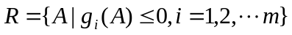,
R is the feasible region. Then we solve the second problem P_{2:}
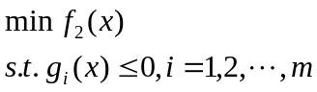
we find the optimal solution A₂ and the optimal value 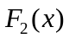，we also find 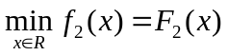,R₁ is the feasible region in P₂.Then we solve the third problem P3…Till we find the optimal solution A_{n} of P_{n}.

When we use the Lexicographic method, if there is only one optimal solution of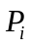, 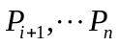will be the only one optimal solution too. So we modify the Lexicographic method: We select some small fit positive number 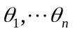as Tolerance value. So 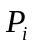modified is as follows:
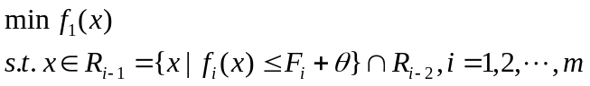
Then we solve the other P_{i} with the method above and obtain the optimal value.

4. Model Application and Problem Solving

4.1 Economic impact
4.1.1 Penetration Model
In order to make a specific definition of “widespread use”, we build a penetration model to evaluate the penetration rate
Variable Definition | Variable Definition
P(t) Penetration rate of EVs  M Maximum penetration rate | r₀ Original penetration rate  r Penetration rate after investment
We consult 2010 data of EV number in China under the stimulate policy and find out the growth rate, at first, reaches its maxima and then decreases gradually. According to this feature, we use 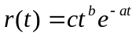 to make function 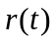 fitting. However, this function is non-linear, and is not belonged to common types of fitting function in Matlab. Therefore, we decide to Logarithm both sides to make function 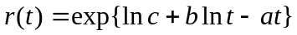fitting.
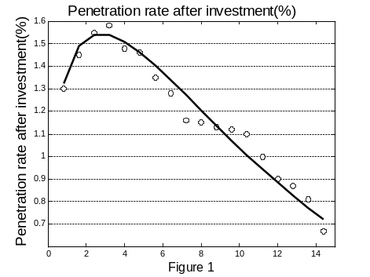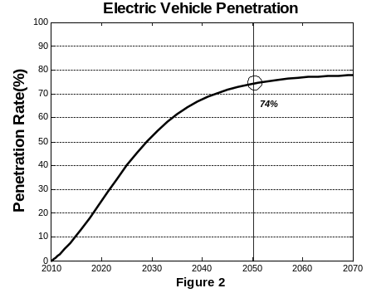
The penetration function after government investment is as follows:
The residual sum of squares:
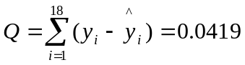
Q is extremely small which means our fitting process is successful.
We use the penetration rate in 2010 as the initial value to get the penetration rate’s simulation curve.
And government will reduce 5% purchase tax per car.

4.1.2 The policy that government promotes electric vehicles and the benefits of the decision-making
The widespread use of EVs instead of ICE vehicles all over the world will have a great influence on the global economy.

Our model is based on a microeconomic model of total cost of ownership for both EVs and ICE vehicles. For the economic model, we model the following cost categories: purchase price, insurance, maintenance, financing, fuel and resale (see Table 2.1)

Table 1 Comparison of FFV and EV costs
FFV Costs |  | EV Costs
Purchase | $24,000 | Purchase | $28,450
Fuel  (100,000 Miles) | $18,000 | Fuel  (100,000 Miles) | $14,450
Maintenance | $7,855 | Maintenance | $2,000
Insurance | $11,960 | Insurance | $9,080.49
Financing | $5,351 | Financing | $4,505.81
Resale | -$5,000 | Resale | -$4,217.93
Total | $56,003 | Total | $48,800
Difference of Total Cost $7,203
As the total costs of ownership for EVs and FFVs are listed (see Table 1), individual consumers would save $7,203 over the life cycle of an EV. We apply this number to the penetration rate to calculate total savings as follows:
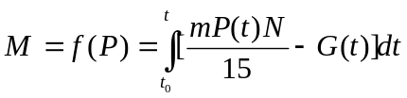
Where M is total money savings from 2010 to 2060, m is the individual savings, P(t) is the penetration rate, N is total number of registered vehicles in the world, which was 1.05 billion in 2010, and which we estimate to grow at 1.8% per year and G(t) is the investment costs per year. We assume that individual savings (Difference of total cost) remains the same every year. The life-cycle is 15 years per vehicle (both FFV and EV).
The loss of tax revenue that used to support EVs and the fund put into recycling used batteries per car per year can be calculated by the economic model, which is $152. Figure 4 is the net return.

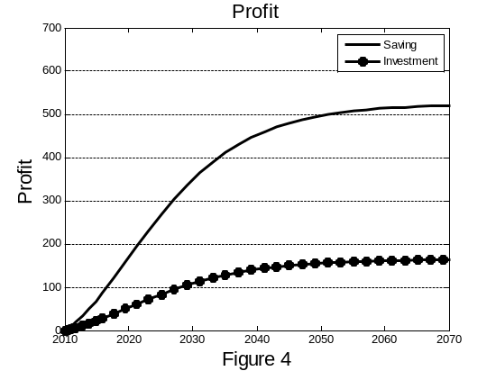
We can easily find out that with the government and car manufactures’ investment, the penetration rate will increase greatly and also bring huge benefit, which almost save 3 times of the money they invest.

4.1.3 Model Verification
After adopted China policy of fostering small displacement car, we compare the data about the share of small displacement car with the data about the electric vehicles that we get from our model.
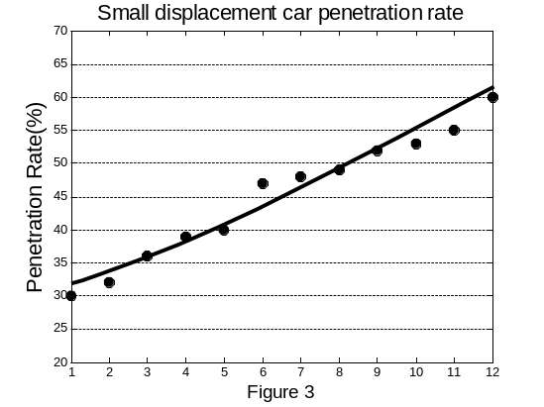
Then we find that the curves that we get from model can relatively completed overlap with the increasing curves of share of small displacement car. Thus, to some extent, it verifies that our model is with the facts.

4.2 Environmental aspect
We believe that the environmental problems caused by electric cars mainly deal with the problem in the battery. The battery can be recycled when it can’t be used any more. Recycling rate may achieve 80% and the remaining 20% we can bury them in the earth.
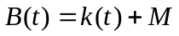
B(t) is the the percentage of treatment and recycling in year t, k(t) is the battery recycling rate in year t and M is the percentage of landfill in non-recycling battery.
4.2.1 Maximum Land Pollution Tolerance Model
Every land has the self-recovery capability, so we can bury the under composed battery in the land and use the land's self-recovery capability to dispose the used batteries.
Assumption:
Each cellular represents the land buried with batteries. Each land buried with batteries represents the polluted land. Each land with no batteries represents the clean land.
We consider that the Cellular will turn to general cellular after a certain time.
Every polluted cellular is harm to the land. The cellular will erode the near land with a certain speed, but the speed of the erosion will decrease and disappear over time.

If a cellular are surrounding with many polluted cellular, it will be polluted. Through our computing of cellular automata, we find that the Maximum tolerance of pollution for lands if 12%. It means that the 12 square meters of land can be used to bury per 100 square meters of land. We combine the policy by the U.S. Government of the landfill site’s size and calculate the M as 32%.

4.2.2 Decisions made by the government about improving the battery recycling and the benefits it brings to the environment
We apply investment and return model evaluate the economic and environmental impacts of the widespread use of EVs.
Variable Definition | Variable Definition
E(t) Utilizing rate per used battery  SE Maximum reused ability per used battery | r₀ Original reusing ability growth rate per battery  r Reusing ability growth rate after investment per battery

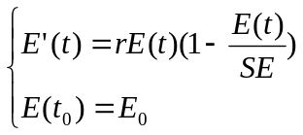
Assumption:
The reusing ability growth rate data after investment per battery is hard to find, but the reusing technology is far from reaching its highest level. Therefore, we used old experience of subside policy to EV owners given by the government to be the function as follows:
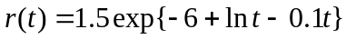
We can conclude from appendix[n], a scrap EV can be reclaim by $53.When penetration rate rises to 74%, the government will give allowance to 8% of the EVs and it will spend $7.2billion. All EVs’ recycling rate rises to 93%.

4.3 Health impact
Variable Definition | Variable Definition
C_{i} A percentage of possible harm in certain scope  N_{i} Population distribution in certain scope | HD The total harm degree  h_{i} Average intake harmful gases concentration to the crowd, absorbed pollutant quantity per second
In order to compare the harm caused by FFVs with it caused by EVs, we measure it with Pollution model.
Assumption: 1. In EVs’ using process, there is no emission, which means EVs do not have the exhaust pipe or any waste emission.
2. In the process that crude oil refines to gasoline, the air pollution can be ignored compared with FFVs’ waste emission.
3. Within a certain range, the pollutants’ density remain the same

4.3.1 Model one: Pollution model
Pollution model can be derived from the HD model. The model focuses on the pollution around the power plant, which do harm to human beings. For the pollution degree to human beings, we set it as the respiration rate (v_{i}) multiply different pollutant number density (s). Pollution model can be summarized as follows:
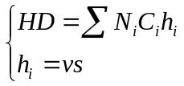
And 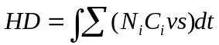
Crowd distribution around power plant (See Table 2) and the Road (See Table 3):
Table 2 Average Distribution Characteristic of Crowd around Power Plant
Population in 100km  （million） | Population in 100-500km（million） | Population in 500-1000km（million） | Population outside 1000km  （million）
14.082 | 187.179 | 442.513 | 634.849
Table 3 Average Distribution Characteristic of Crowd around the Road
Population in 100km（million） | Population in 100-500km（million） | Population in 500-1000km（million） | Population outside 1000km（million）
786.265 | 486.264 | 215.545 | 113.684

According to statistic research, average human respiration rate (v_{i}) is 20m³/day.
From Table 2 and 3, we find that HD to crowd around the road is five times more than that to crowd around the power plant. We can also conclude that even if the two kind emission amounts are the same, harmful gases density is different because crowd distribution differs by distance. FFVs’ exhaust pollution is much more than the industrial pollution to the crowd. In other words, compared to industry exhaust pollution, human beings intake much more harmful gases produced by FFVs.

4.3.2 Model improvement
One-compartment model of pollutant inhalation harm
Inhaled pollutant concentration changes over time，in order to express the density change rate with time more accurately, we need to know the relationship between the maximum density and the maximum density (M)：
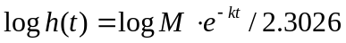
4.3.3 one-compartment model of pollutant inhalation harm verify:
We compared the actual concentration distribution of inhaled carbon dioxide in medicine with one-compartment model of pollutant inhalation harm.
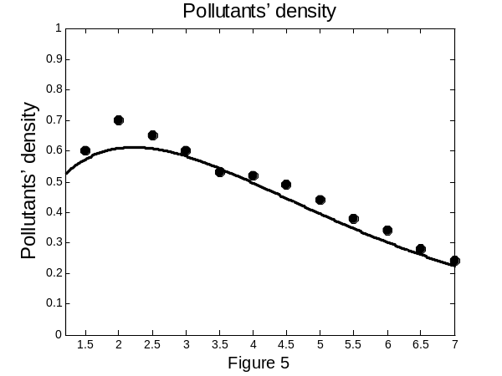
Then we find that the curves that we get from One-compartment model of pollutant inhalation harm can relatively completed overlap with concentration distribution of inhaled carbon dioxide. From the comparison in the graph, we satisfy with the Anatomizes level. Thus, to some extent, it verifies that our model is with the facts.
Analysis and results:
If the number of EVs is equal to the number of FFVs, the harm degree of EVs will be 5-10 times smaller than that of FFVs.
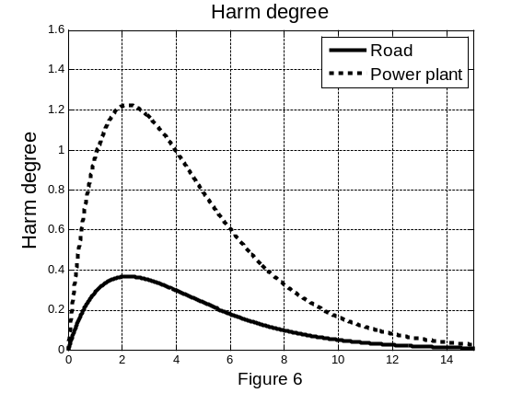
The harm of EVs to people mainly comes from industrial pollution emissions from power generation. Compared with industrial pollutant emission, FFVs’ exhaust emissions are closer to the ground and dense population in urban areas, while power plants are far from the area of people's lives.
Therefore, we can safely come to the conclusion that EVs’ impact to the environment is much smaller than that of FFVs’.

4.4 Social impact
In an ever modernizing world, the stress of unique and increasingly nonlinear operating loads to deliver constant power to linear devices is beginning to take its toll. The rising demand of total power is also taxing current transmission and distribution systems, increasing the number of rolling blackouts, cascading failures, and other large-scale problems in the grid. These failures are having a significant negative impact on the world’s economy. These problems will only become more costly if they are not solved in the near future. Electricity demand is expected to increase well into the future as the world’s economy continues to expand and grow, and the present-day power grid is not equipped to handle such a continuous rate of development.
Power plants’ coal consumption is closely related to coal consumption rate. Coal consumption ratio is the required amount of coal to general 1kWh, and its unit is g/kWh. At normal, the larger the generating set, the smaller the coal consumption rate will be. Also, coal consumption rate of the same generating set changes when the set is generating different level of electricity (See figure 7). The function can be fitting to be a conic section f = f (Q)

We find out that the curve is getting close to 320MW, and that the smaller the coal consumption rate, the higher coal utilization rate.

We therefore suggest that government should use EVs as energy storage units that could be connected to the power grid. This can allow generators to be operated at a consistent energy delivery schedule, producing additional power during off-peak hours to be stored by EVs for later use. This can also help improving the reliability of the grid while stabilizing the power generation rate at a more cost-effective value. Moreover, EVs have much more energy storage capacity that can be employed to store energy produced by intermittent sources to be used during peak demand hours.

The model to estimate the saving of coal per day is below:
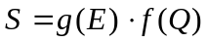
Where S is saving of coal, g(E) is electricity consumption at different hour (see figure 7), and f(Q) is the coal consumption rate. The saving of coal is shown in Figure 8 and, in total, we can save 8.5% coal per day by suing EVs as energy storage units.
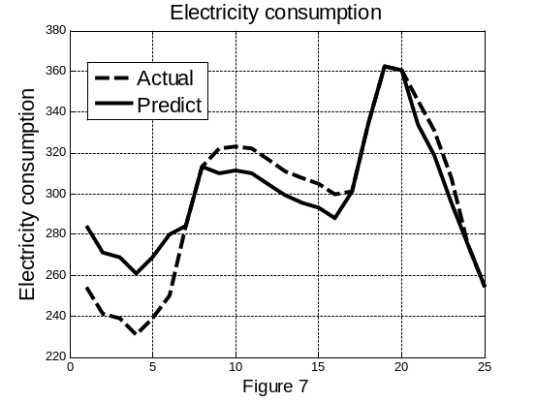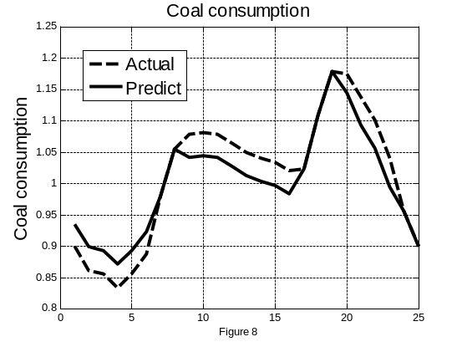

5 Key problems analysis
5.1 Oil saving
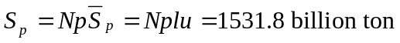
N is the total number of vehicles and we estimate N will be 2.3billion in 2060.p is the Penetration of the EVs in 2060. , is the distance traveled by an EV per year and u is the automobile fuel consumption per km. Annual savings of the world's oil is roughly 1531.8 billion ton.

5.2 The key decisions government should consider
We use Analytic Hierarchy Process (AHP) to determine the key decisions that should be considered and draw the ratio of the weight of each decision.

Available proposals p₁, p₂, p₃, p₄, p₅ are as follows:
p₁: Government should give subside to the EV owners to
p₂: Government should fund in recycling used EV batteries
p₃: Government should fund in power plants’ dust treatment
p₄: Government should promote the policy to use EVs as energy storage units
p₅: Government should reduce EVs’ insurance and impose heavier pollution tax

Build a hierarchical structure model to estimate the proposals. The top level is our eventual goal A, which is meeting total energy supply over the world. The second top level is a criterion level, which includes three criteria:
B_{1:} It has higher feasibility and the effects can be seen in a short period.
B₂: It has higher return on the investment.
B₃: It can significantly reduce the environment pollution made by fossil-fuel vehicles.

5.2.1 Build comparison matrix
Use A as the comparison criterion, the pair wise comparison matrixes of all factors in B level is A-B. Similarly, use B_{i} as the comparison criterion, the pair wise comparison matrixes of all factors in P level is B_{i} –P. Therefore, we get 4 comparison matrixes.
AHP uses pair wise comparison method to get weight. The specific method is that when it uses the factor C in the higher level as the comparison criterion, we can use a comparison scale a_{ij} to express the relatively importance of the factor i to j in the lower level. The scale of a_{ij} is normally from 1 to 9. The matrix 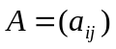 made of a_{ij} is called comparison matrix.

To the eventual goal A
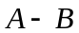 | 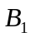 | 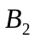 | 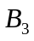
 | 1 | 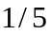 | 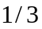
 | 5 | 1 | 3
 | 3 |  | 1
After analyzing data in different categories, we get the entire comparison matrix of the third order to the second order.
To criterion B₁, we have
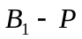 | 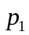 | 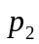 | 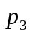 | 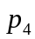 | 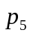
 | 1 | 3 | 5 | 4 | 2
 | 1/3 | 1 | 3 | 2 | 1/2
 | 1/5 | 1/3 | 1 | 1/2 | 1/3
 | 1/4 | 1/2 | 2 | 1 | 1/2
 | 1/2 | 2 | 3 | 2 | 1

To criterion B₂, we have
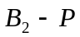
 | 1 | 2 | 5 | 1/2 | 3
 | 1/2 | 1 | 3 | 1/3 | 2
 | 1/5 | 1/3 | 1 | 1/7 | 1/2
 | 2 | 3 | 7 | 1 | 5
 | 1/3 | 1/2 | 2 | 1/5 | 1

To criterion B₃, we have
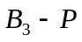 |  |  | 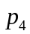 | 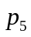
 | 1 | 3 | 2 | 3
 | 1/3 | 1 | 1/2 | 1
 | 1/2 | 2 | 1 | 1
 | 1/3 | 1 | 1 | 1

5.2.2 Order arrangement and consistence verification
Use EVM method to make data processing to get the standardized eigenvectors, weight vector corresponding to the max Eigen-value.
Use 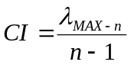consistency index to be the standard of measuring degree of inconsistency.
Use RI given by Lsaaty as the average random consistency index
 | 1 | 2 | 3 | 4 | 5 | 6 | 7 | 8 | 9
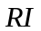 | 0 | 0 | 0.58 | 0.94 | 1.12 | 1.24 | 1.32 | 1.41 | 1.45
When n = 1 and n = 2, RI = 0;
When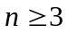,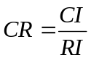, where CR is consistency ratio. When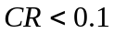, we consider the consistency of the comparison matrix to be acceptable, otherwise, we should revise the matrix.
Table 4 Weight vector order in single level
Matrix | Weight vector order in single level | λ_{MAX} | 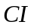 |  | 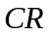
 | (0.1047,0.6370,0.2583) | 3.0385 | 0.0193 | 0.58 | 0.0332
 | (0.4246,0.1655,0.0668,0.1079,0.2352) | 5.0795 | 0.0199 | 1.12 | 0.0177
 | (0.2619,0.1524,0.0524,0.4446,0.0887) | 5.0280 | 0.0070 | 1.12 | 0.0063
 | (0.4588,0.1436,0.2260,0.1716) | 4.0458 | 0.0153 | 0.94 | 0.0159
As we can see in Table 4, all the four CR order in single level are less than 0.1, which meets the consistency requirement.

5.2.3 Total order arrangement and consistence verification
Given that weight vector that the second order (order B) relative to the eventual goal is:
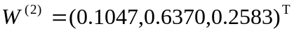
The weight vectors that use the criteria in the first three orders (order P and factor i in second order B_{i}) are as follows:
The order that the third order (P order) relative to the eventual goal:
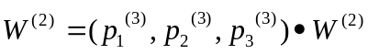
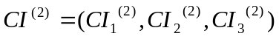
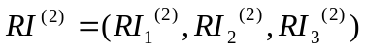
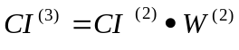
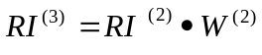
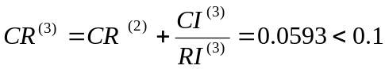 (5)
According to the (5), all the CR⁽³⁾ order in total level are less than 0.1, which meets the consistency requirement.
5.2.4 Conclusion
p₁: Government should give subsides to the EV owners, weight 0.3298
p₂: Government should fund in recycling used EV batteries, weight 0.1515
p₃: Government should fund in power plants’ dust treatment, weight 0.0987
p₄: Government should promote the policy to use EVs as energy storage units, weight 0.3388
p₅: Government should reduce EVs’ insurance and impose heavier pollution tax, weight 0.0811

5.3 The multi-objective programming model
5.3.1 Assumption：
In the auto market, EVs' penetration rate reaches a high level (74%).

Variable Definition and Model Preparation:
- 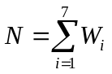 N is the sum of electricity EVs required per year
(2)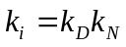, k_{i} is the percentage of energy EVs can use and k_{D} is the rate that energy can be applied to electricity generation (We will use 74% of the energy used in the transportation to transfer to power generation).
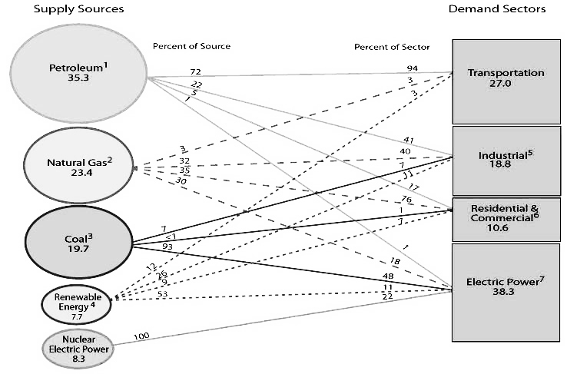
k_{N} is the ratio of electricity needed by all vehicles and total global electricity generation.
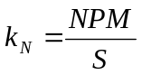= 8.7%
Where N is the world’s total vehicle number, we predict the total number of vehicles in 2060 will be 2.3 billion, P is the penetration rate of EVs (which is 74%), M is the average electricity consumption per EV per year (which is 2000 kWh/EV/Y) and S is the world’s total electricity consumption, which we obtained from BP Energy Statistics Yearbook that S in 2050 will be 2.5 times of that in 2008, which is 20300 billion kWh. Therefore, we can calculate k_{N} = 8.7%.

- sum₁ is the annual available energy production.
The total number of fossil fuel energy per year could be found out from BP Energy Statistics Yearbook. Even though all kinds of energy are not 100% used to generate electricity, we calculate their utility rate and use kWh as unit of the total energy.
- Harm degree of each kind of energy that generates 1kWh (HD1)
- Cost per kWh (M₁)

Table 5 Variable Definition and Model Preparation
 | Production per Year (kWh) | Electricity Production for EVs per Year (%) | Predicted power supply per year sum1 (Trillion kWh) | Harm Degree | Cost per kWh (cent)
 |  |  |  | (HD1) | Cost per kWh (cent)
Natural Gas | W1 | 32.22 | 7.984 | 1.5 | 5.1
Coal | W2 | 93 | 12.348 | 3.2 | 4.7
Petroleum | W3 | 54.28 | 16.823 | 3.2 | 20
Nuclear | W4 | 100 | 24.551 | 0.9 | 4
Hydroelectricity | W5 | 53 | 6.354 | 0 | 4
Wind Energy | W6 | 53 | 20.574 | 0 | 1.5
Solar Energy | W7 | 53 | 20.574 | 0 | 20
5.3.2 Discussion
However, we find out the development of renewable energy, such as Nuclear, Wind Energy and Solar Energy is growing at a dramatic speed. Therefore, we decide to calculate each kind of renewable energy’s growth rate during the year of 1980 to 2006 in order to get every sum1 in the future.

5.3.3 Model Analysis and Solution
Our goal is to lower the sum of the cost (Y);
Let electricity generated from renewable energy as much as possible, lower the ratio (P) of the sum of fossil fuel to the sum of renewable energy, which means P=P_{min};
Assume the sum of all energy resources consumption per year is a fixed value S;
Electricity generated per year by all resources should be more than the electricity demand of EVs (N) per year;
Annual consumption of natural energy is less than to energy production per year
The model is as follows:
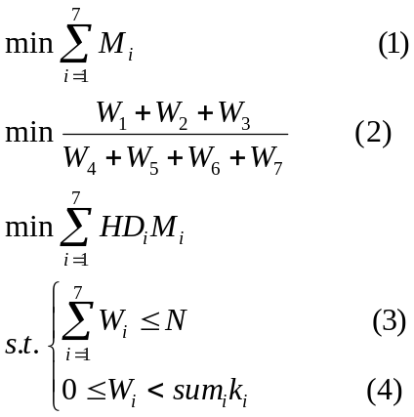
Lexicographic method:
Make orders of two goals in the multi-planning problem, we assume IF₁ is more important and cost M₁ is less important.
Firstly, find the problem p1 that use the first goal as the objective function, while the original constraints remain the same:
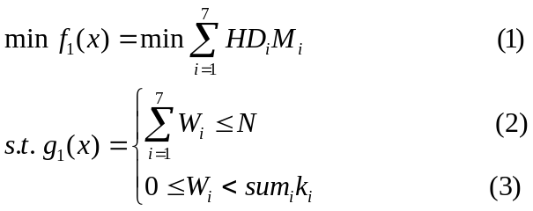
We can find the optimal solution a₁:
W1:W2:W3:W4:W5:W6:W7 = 0:0:0:3.1:1.2:2.8:2.9
Then, we can find problem p₂
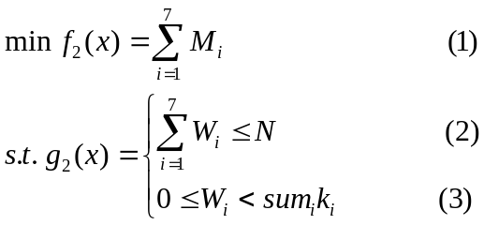
We can find the optimal solution a2:
W1:W2:W3:W4:W5:W6:W7 = 1.2:1.8:0:3:1.9:4.1:0
Thirdly, we can find problem p3
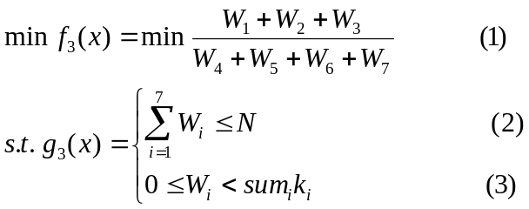
We can find the optimal solution a3:
W1:W2:W3:W4:W5:W6:W7 = 0:0:0:5.2:1.2:1.8:1.8
Discussion:
It is easy to see that when using Lexicographic method to solve problem pi, the optimal solution is unique. Therefore, we set a 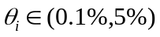 to every constraints g_{i}(x), and the problem is revised as follows:
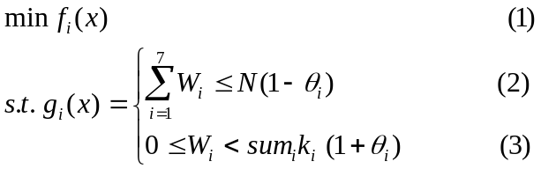
Use different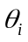, we find out that the solution will reach consensus. At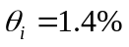, we get the real solution W1:W2:W3:W4:W5:W6:W7 = 0:1:0:4:1:2:2, which means
Natural Gas: Coal: Petroleum: Nuclear: Hydroelectricity: Wind Energy: Solar Energy = 0:1:0:4:0.9:2.2:1.9

6. Assessment of the advantages and disadvantages of the main models

Advantage:
Investment and Return Model is in higher accuracy in a big event.
All model are Practical and realistic. In the Investment and Return Model, we take many factors into consideration. Our group believes that Cellular Automata combines with the Matlab programming perfectly, simulating of the real problems out. Compared with our analysis, we support some advices about the improvement of the model and predict the future development in science and technology about security problem.

Disadvantage:
Harm Degree Model的Intake harmful gases density to the crowd per second. It can’t be solved in the complex condition. When the multi-objective programming model solves a single objective problem, if there is more than one answer, it will be very hard solving the next problem.

7. Recommendations and Conclusions
Our suggestion is the government and vehicle manufacturers should focus on social marketing policy as well as the method to use EVs as energy storage units that could be connected to the power grid. In addition, they should choose nuclear energy as the main approach as well as the renewable energy, such as wind power and solar energy to generate electricity to be the source of EVs.

Appendix 1
Using the cellular automata stimulates the largest land pollution tolerance
Cellular Automata is a method that we can use it to stimulate the local rules and local links. The typical Cellular Automata is defined on the Internet. Every point represents a cellular with a finite state. The changed rules suit for every cellular and can work at the same time. The typical changing rules are decided by the cellular state and its (4 or 8) neighbor’s state.
We set the percolation cluster and land's life cycle.

Definition and assumption:
A cellular just has two states that is 0 or 1. 0 represents unpolluted land; 1 represents polluted land.
When stimulating, every step is equal to one month in the real world. 120 steps (10 years) are equal to one time cycle.
When the cellular stimulate 20 time cycle, if the cellular can control the polluted cellular below 30% within a certain scope in every time cycle, we think the land can be successfully deal with the pollution.

Rules:
A random number r is between 0 and 1 that is used as a judge of percolation.
Then make the sum of the 8 surrounding neighbors. The cellular have a single parametric state to record whether they have nonzero state neighbors.
After the sum of one cellular, if the total sum is less than or equal with 4, then the state at next step does not change; otherwise the state is 1.
If the sum is more than 0 and r is more than threshold (which is 0.2), or the cellular never has neighbor, then the cellular=1.
If the sum is more than 0, then set the record's mark to record those cellular having a nonzero neighbor.
If the cellular record lasts 1 for one week, then the cellular is 1 at next step.

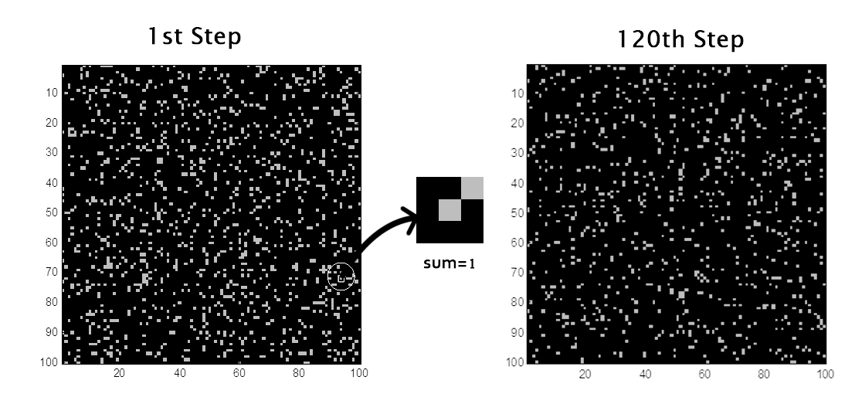
Through the stimulating of cellular automata, we come to the condition of maximum pollution tolerance level is 12%.

Appendix 2
One-compartment model based on pollutant density absorption

1. Construct the one-compartment model
After human body absorbing pollutant, the pollutant absorption and eliminates usually describes with the first-level dynamics process. One-compartment of model is to calculate medicine transportation speed medicine transportation density in the Pharmacology research. Its dynamics process involves with absorption rate which is related with absorption rate constant Ka and with absorption degree which is related with absorption rate F.

According to the absorption model graphical representation above, there is available simultaneous differential equation expressing pollutant’s change speed in body and body’s absorption spot. Pollutant’s change speed of body’s absorption spot:
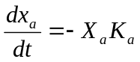
Pollutant’s change speed in body:
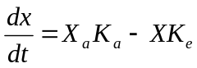
In the initial conditions, it appease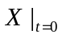
Simultaneous equations by the Laplace integral transform:
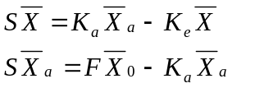

Where F refers to the percentage of the pollutant dose absorbed into the body.
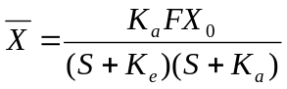
After the Laplace integral transform, we conclude that pollutant dose and time satisfy the double exponential function equation:
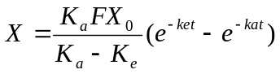
This shows that the pollutants absorbed into the body a single time, the amount of contamination and time satisfy the exponential function, If that is expressed with the concentration, it is:
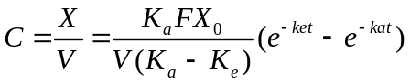

2. one-compartment model with absorption parameters of the solution
As shown by the curve of the data，the K_{a} number of most drugs is more than the K_{e} number, so that when the time t is large enough, it satisfies e^{-kat} << e^{-ket} and the second item in 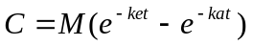 can be ignored. So 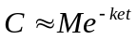reflects the relationship between drug concentration-time curve of the tail section and the plasma concentration time data in the last few experimental points satisfies the function:
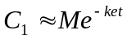
It on both sides of the logarithmic:
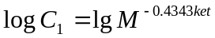.
Let
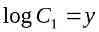, 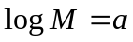
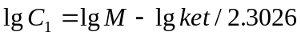, is the plasma concentration - time half the number of picture on the terminal segment, a straight line with slope k/-2.3026.
We calculate it with the Method of Residual, each concentration minus each corresponding experimental values and the residual values are obtained, which are named Blood concentration of the remaining (Cr). The logarithmic form is
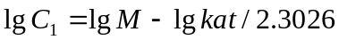
The straight line with slope ka/-2.303

References
Matt Draper, Ernesto Rodriguez,Phil Kaminsky, Ikhlaq Sidhu*, Burghardt Tenderich,2008. Economic Impact of Electric Vehicle Adoption in the United States, 5-8.
Valerie J. Karplus, Sergey Paltsev, John M. Reilly, 2010. Prospects for plug-in hybrid electric vehicles in the United States and Japan: A general equilibrium analysis, 10-16.
Antritter F, Svaricek F, 2010. A Model Based Control Design Approach for Powertrain Control of a Parallel Hybrid Electric Vehicle. AT-AUTOMATISIERUNGSTECHNIK 58, 568-579.
BP Statistical Review of World Energy. BP Statistical Review of World Energy June 2010, 1-50.
Lopes JAP, Soares FJ, Almeida PMR, 2011. Integration of Electric Vehicles in the Electric Power System. PROCEEDINGS OF THE IEEE 99, 168-183.
Li JW, Cui XL, 2009. Steering Stability Improvement of Electric Vehicle by DYC Based on New Target Defination, 457-461.
Msashall JD, Toh SK, NazarofWW, 2005. Intake fraction of nonreactivevehicle emission in us urban area. Atmospheric Environment 39, 1363-1371.
Helbing D, 2001. Traffic and related self-driven many-particle systems. Review Modern Physics 73, 1066-1067.
Su Yinfa, 2006. Differential Method for Calculating the Pharmacokinetic Parameters of Single Compartmental Drugs Based on the Plasma Level of the Drug after the Intravenous Infusion Injection. Journal of Mathematical Medicine 19, 1-2.
Zadeh A，Fahim A, EIGindy M,1997. Neural Networks and Fuzzy Logic Application to Vehicle System．International Journal of Vehicle Design 18(2), 132-193.
Rao M V C，Prahlad V,1997. Tunable Fuzzy Logic Controller for Vehicle Active Suspension Systems．Sets and Systems 85,11-21．
Glen WG，Zelenka MP，Graham RC,1996. Relating meteorulogical variables and trends in motor vehicle emissions to monthly urban carbon monoxide concentrations. Atmospheric Environment 30, 4225-4232．
Lim JM, Kim GH, 2010. Crash protection of Hybrid Electrical Vehicles for amending the KMVSS No. 91. INTERNATIONAL JOURNAL OF HYDROGEN ENERGY 35, 12709-12715.
He HW, Xiong R, Chang YH, 2010. Dynamic Modeling and Simulation on a Hybrid Power System for Electric Vehicle Applications. ENERGIES 3, 1821-1830.
Dyke KJ, Schofield N, Barnes M, 2010. The Impact of Transport Electrification on Electrical Networks.IEEE TRANSACTIONS ON INDUSTRY 57, 3917-3926.
Ekman CK, 2011. On the synergy between large electric vehicle fleet and high wind penetration - An analysis of the Danish case.546-553.
Dixon RK, McGowan E, Onysko G, 2010. US energy conservation and efficiency policies: Challenges and opportunities. ENERGY POLICY 38, 6398-6408.
USABC Battery General Sales and Administration and Research and Development and Other Fixed Overhead Costs.
http://www.uscar.org/guest/article_view.php?articles_id=143

