**1. Database section**

**1.1 Entity-Relationship Diagram**

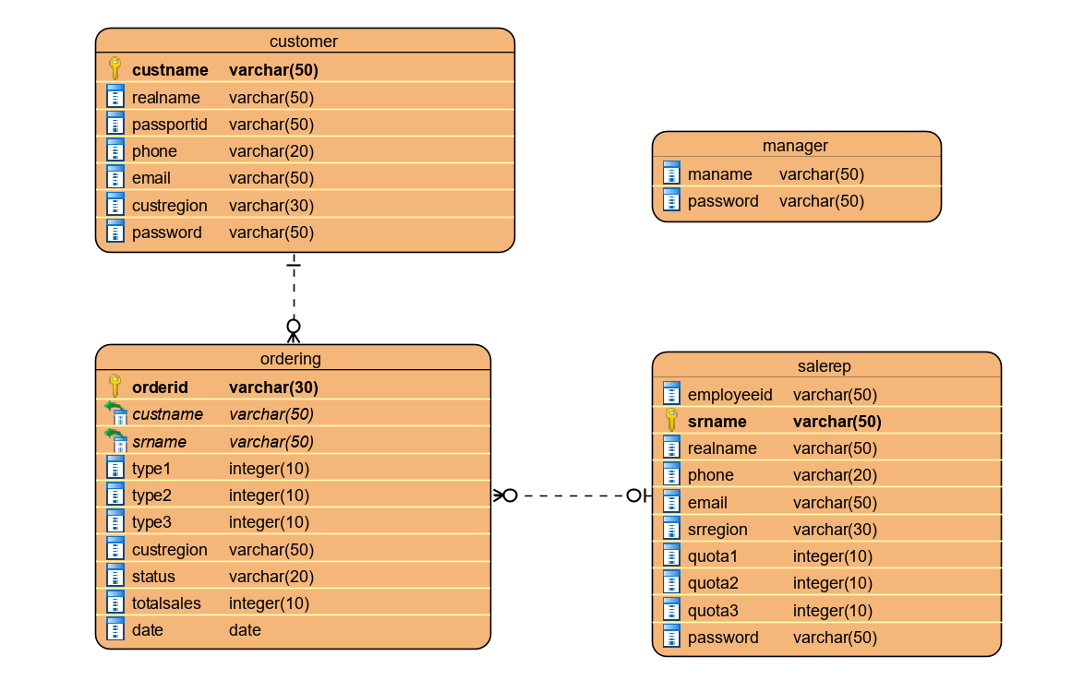

**1.2 create table SQL statement**

USE shyhl11;

CREATE TABLE `customer` (

`custname` varchar(50) NOT NULL,

`realname` varchar(50) NOT NULL,

`phone` varchar(20) NOT NULL,

`email` varchar(50) NOT NULL,

`custregion` varchar(30) NOT NULL,

`password` varchar(50) NOT NULL,

`passportid` varchar(50) NOT NULL

) ENGINE=InnoDB DEFAULT CHARSET=utf8mb4;

CREATE TABLE `manager` (

`maname` varchar(50) NOT NULL,

`password` varchar(50) NOT NULL

) ENGINE=InnoDB DEFAULT CHARSET=utf8mb4;

CREATE TABLE `ordering` (

`custname` varchar(50) NOT NULL,

`custregion` varchar(50) NOT NULL,

`date` datetime NOT NULL,

`orderid` varchar(30) NOT NULL,

`srname` varchar(50) NOT NULL,

`status` varchar(20) NOT NULL,

`type1` int(11) NOT NULL,

`type2` int(11) NOT NULL,

`type3` int(11) NOT NULL,

`totalsales` double NOT NULL

) ENGINE=InnoDB DEFAULT CHARSET=utf8mb4;

CREATE TABLE `salerep` (

`srname` varchar(50) NOT NULL,

`employeeid` varchar(50) NOT NULL,

`realname` varchar(50) NOT NULL,

`phone` varchar(20) NOT NULL,

`email` varchar(50) NOT NULL,

`srregion` varchar(30) NOT NULL,

`quota1` int(11) NOT NULL,

`quota2` int(11) NOT NULL,

`quota3` int(11) NOT NULL,

`password` varchar(50) NOT NULL

) ENGINE=InnoDB DEFAULT CHARSET=utf8mb4;

ALTER TABLE `customer`

ADD PRIMARY KEY (`custname`);

ALTER TABLE `manager`

ADD PRIMARY KEY (`maname`);

ALTER TABLE `ordering`

ADD PRIMARY KEY (`orderid`),

ADD KEY `fk_srname` (`srname`),

ADD KEY `fk_custname` (`custname`);

ALTER TABLE `salerep`

ADD PRIMARY KEY (`srname`);

ALTER TABLE `ordering`

ADD CONSTRAINT `fk_custname` FOREIGN KEY (`custname`) REFERENCES `customer` (`custname`),

ADD CONSTRAINT `fk_srname` FOREIGN KEY (`srname`) REFERENCES `salerep` (`srname`);

COMMIT;

**2. System design**

**2.1 System and flow chart**

**2.1.1 Customer system**

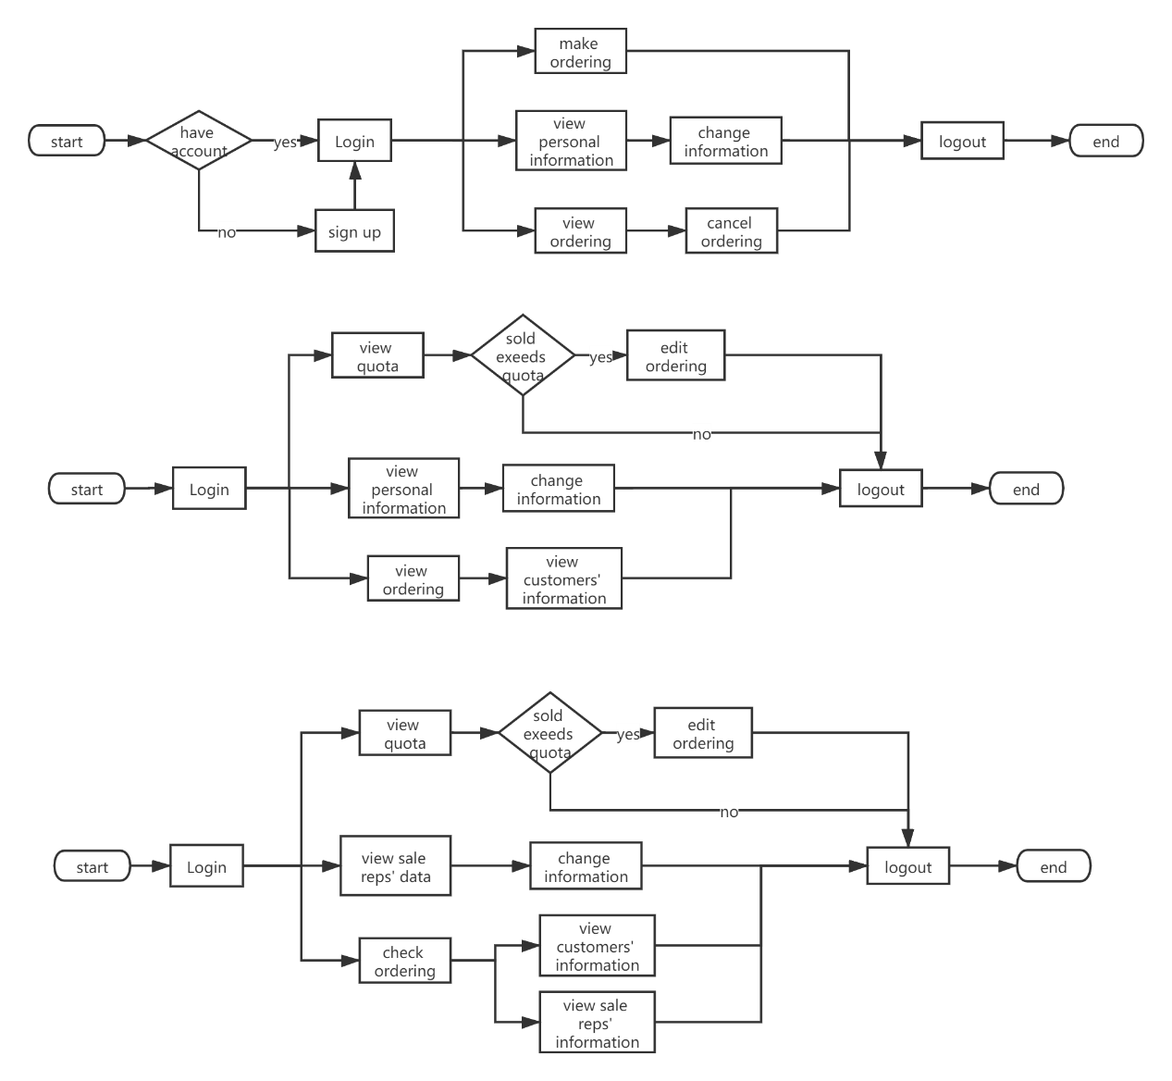

**2.1.2 Sale rep system**

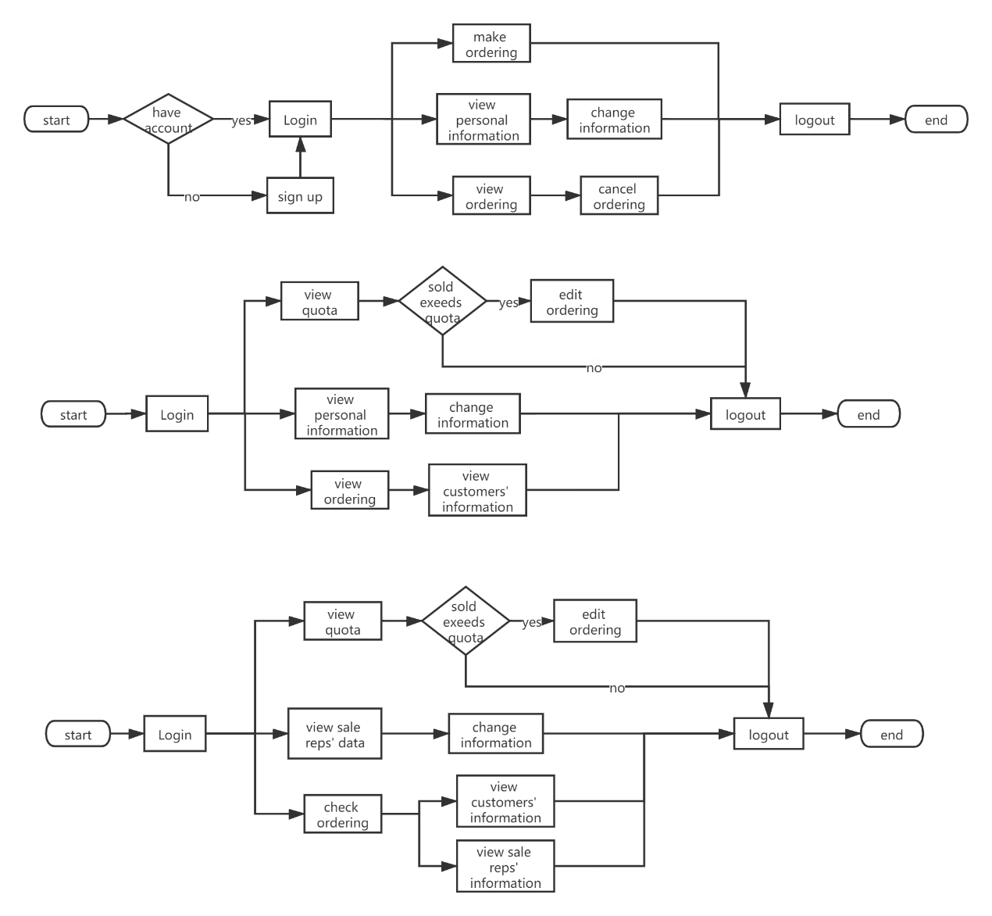

**2.1.3 Manager system**

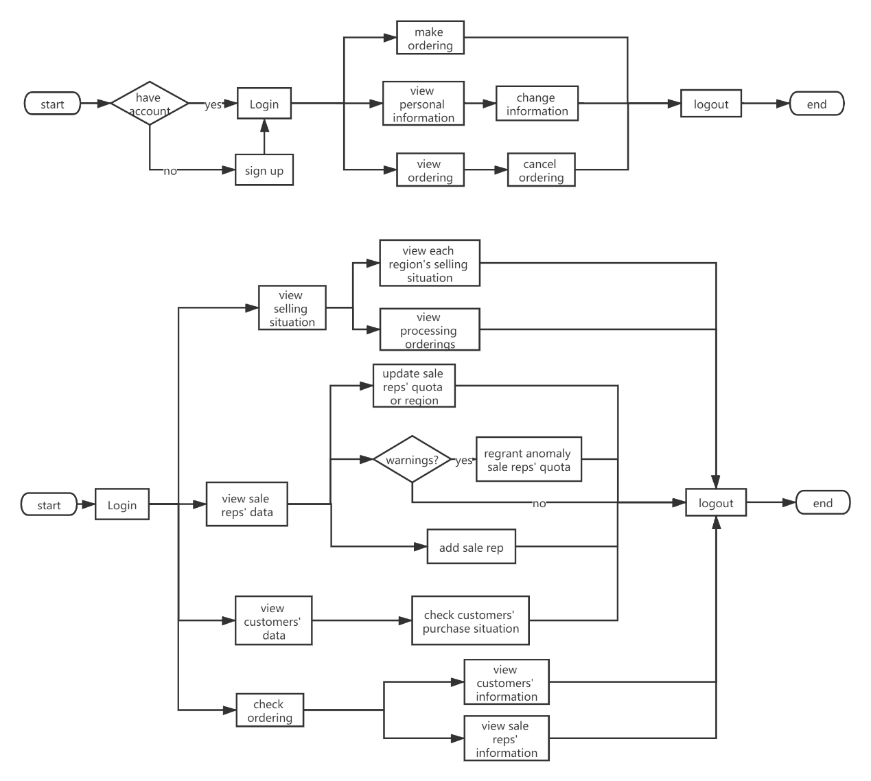

**2.2 Functionality**

1. Customer register
   1. All of information should be completed.
   2. Username should contain at least one letter.
   3. Username can only consist of letter and digit.
   4. Username cannot repeat.
   5. Telephone can only contain digit and over 11 numbers.
   6. Email should have format as xxx@xxx.xxx.
   7. Repeat password should be same as password that entered.
2. User login
   1. System can judge which role is trying to login and jump to the right page.
3. Customer purchase
   1. The quantity of three types mask cannot all be zero.
   2. Customer can choose sale rep in the same region when buying.
   3. Ordering ID can be generated automatically to avoid repeat.
4. Customer view ordering
   1. Orderings are grouped into ‘All’, ’Processing’, ’Completed’ and ‘Cancelled’ four kind of situation.
5. Customer cancel ordering
   1. The ordering can be cancelled for no reason within 24 hours.
6. Customer edit personal information
   1. Only can change email, telephone and password
7. Sale rep view the quota situation
8. Sale rep view and edit personal information
   1. Only can change email, telephone and password
9. Sale rep view orderings
   1. Orderings are grouped into ‘All’, ’Processing’, ’Completed’ and ‘Cancelled’ four kind of situation.
10. Sale rep cancel orderings
    1. Orderings can be cancelled only if sold number exceeds quotas.
    2. Only processing orderings can be cancelled.
11. Sale rep view customers’ information
12. Manager view selling situation
    1. The proportion of total selling quantity of three types mask for each region can be viewed by pie chart.
    2. Every day’s selling quantity of three types mask can be checked by bar chart.
    3. Every day’s selling quantity in each region can be viewed by pie chart.
13. Manager view processing orderings
    1. The proportion of under order’s quantity in each region can be checked by pie chart.
    2. The detailed ordering information in each region can be viewed.
14. Manager view sale reps’ data
    1. Manager can view every sale rep’s personal information
    2. Manager can view sale reps’ quota and remaining
    3. The selling quantity for everyday can be viewed by bar chart.
    4. The total selling quantity of three types can be viewed.
15. Manager edit sale reps’ information
    1. Manager can update quotas
    2. Manager can assign sale rep to another region
16. Manager add new sale rep
    1. Employee ID should be generated automatically to avoid repeat.
    2. All of information should be completed.
    3. Username should contain at least one letter.
    4. Username can only consist of letter and digit.
    5. Username cannot repeat.
    6. Telephone should only contain digit and over 11 numbers.
    7. Email should have format as xxx@xxx.xxx.
    8. Repeat password should be same as password that entered.
17. Manager get warning
    1. Manager can be notified when he login if there are anomalies.
18. Manager handle anomalies
    1. Manager can regrant quotas to remove anomalies.
19. Manager view customers’ data
    1. Manager can view all customers’ personal information
    2. Manager can view the proportion of each types mask for each customer.
    3. Manager can view every customer’s total ordering amount, total quantity of mask and total sales.
20. Manager search the ordering conditionally
    1. Manager can choose different region.
    2. Manager can choose different ordering status.
    3. Manager can pick a range of date.
21. Manager view orderings’ customer and sale rep’s information
22. User logout
    1. Jump to start page after logout

**3. Walk through the whole system**

**3.1 Start**

**3.1.1 Start Page**

Open the link <http://cslinux.nottingham.edu.cn/~shyhl11/src/index.php>, the first page show 3 types of mask’s name, price and brief description. Nav-bar contains button sign up, login and company name (jump to start page).

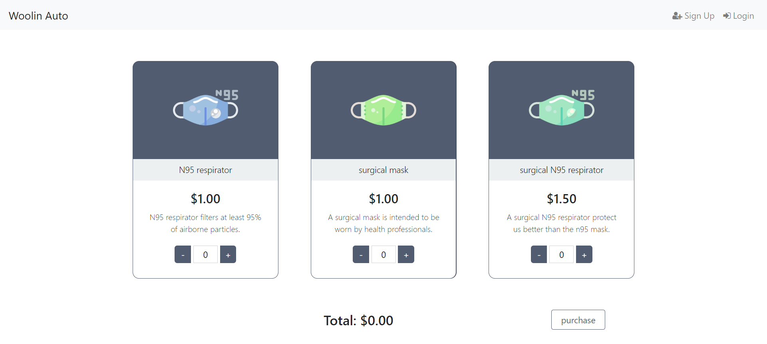

**3.1.2 Sign Up**

Click sign up button to jump to sign up page. Customers can register their account here.

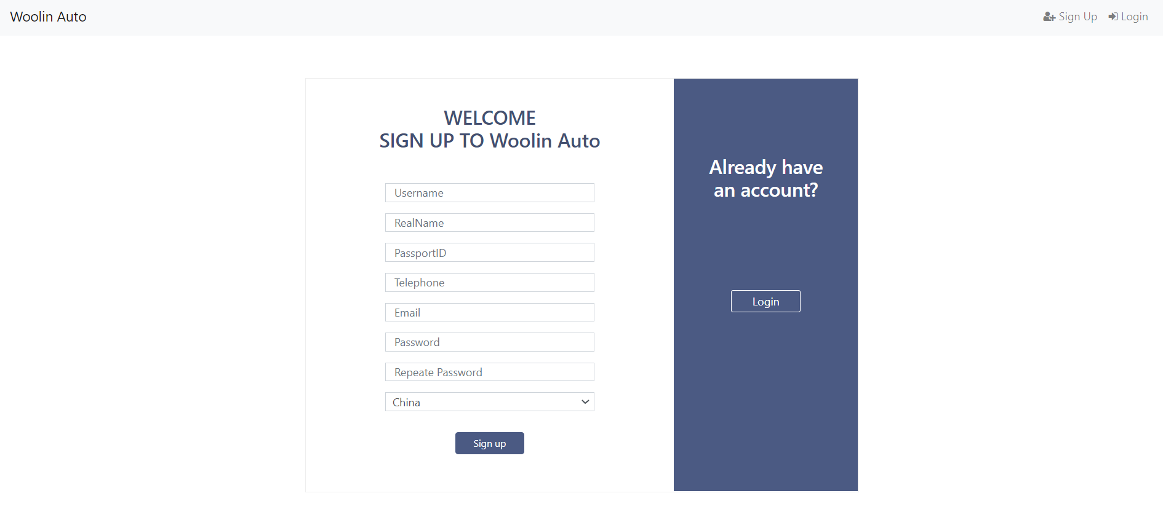

**3.1.3 Login**

System will judge which role is trying to login and jump to the right page automatically.

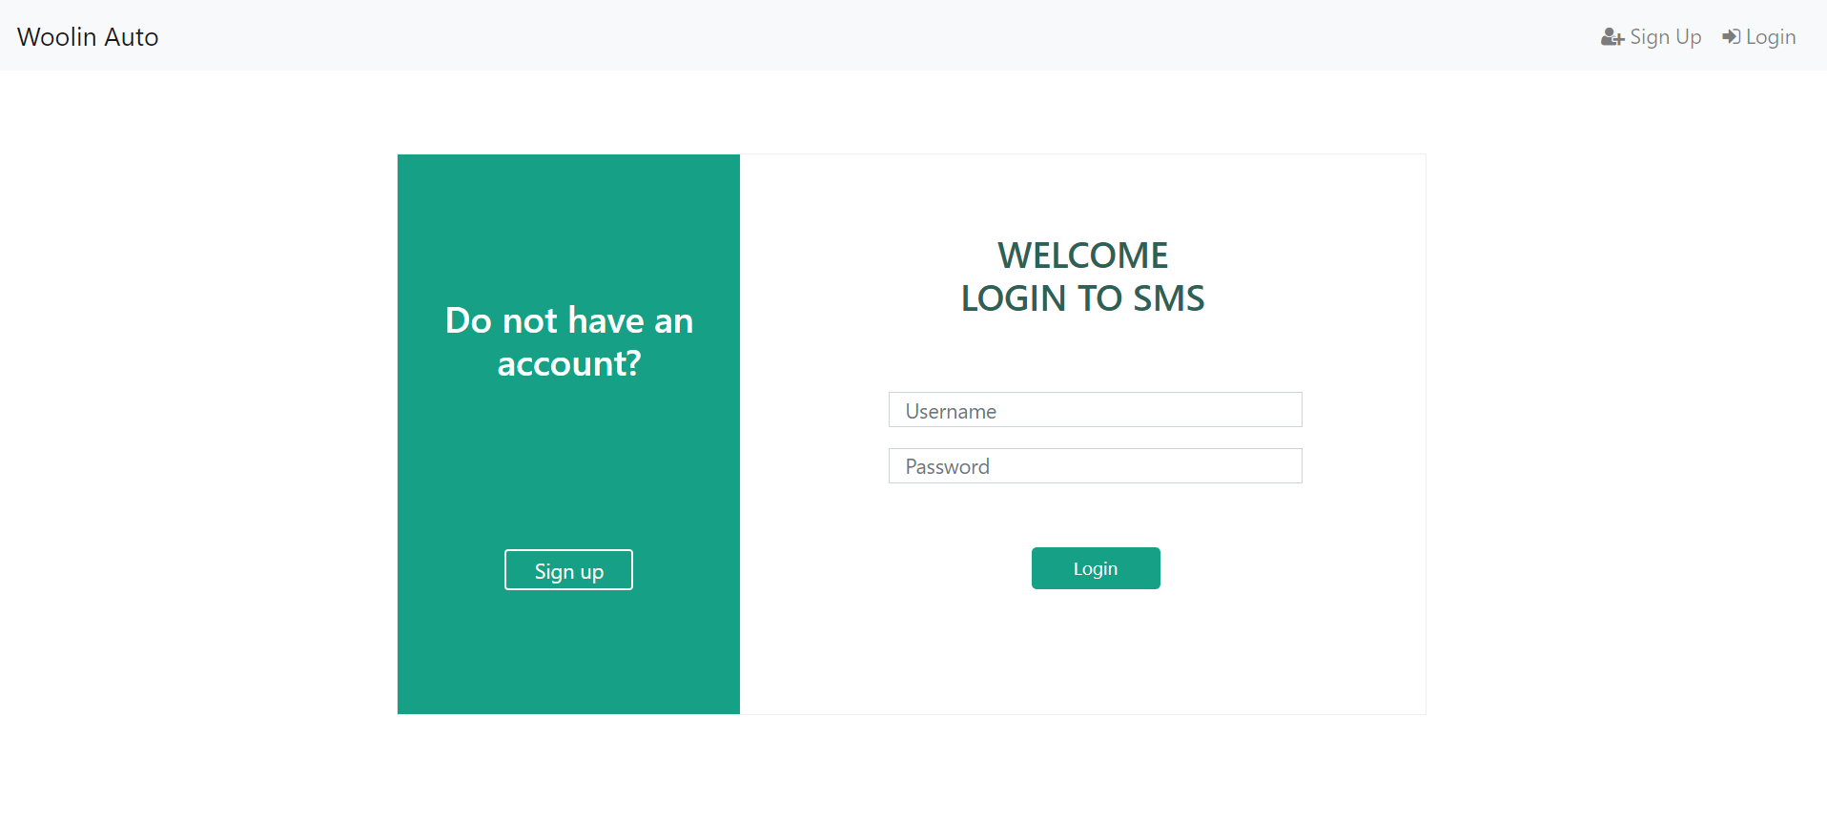

**3.2 Customer System**

When customer log in successfully, navigation bars will change. Customer can click button to see each content. Customers can click ‘+’ and ‘-‘buttons or just input numbers in quantity box to change quantity they want to get. Number cannot be reduced less than 0 and any character except digit cannot be input into quantity box.

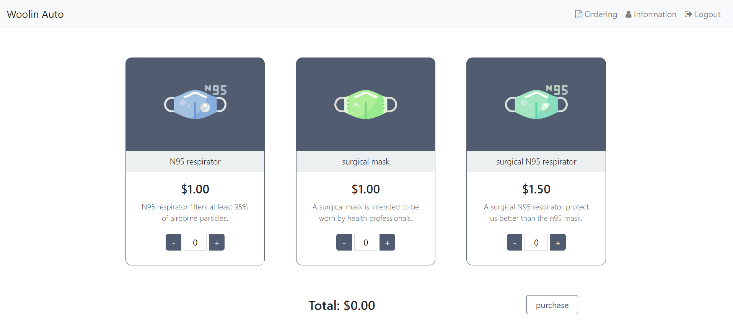

After chosen products, customers are asked to choose one sale rep to complete ordering.

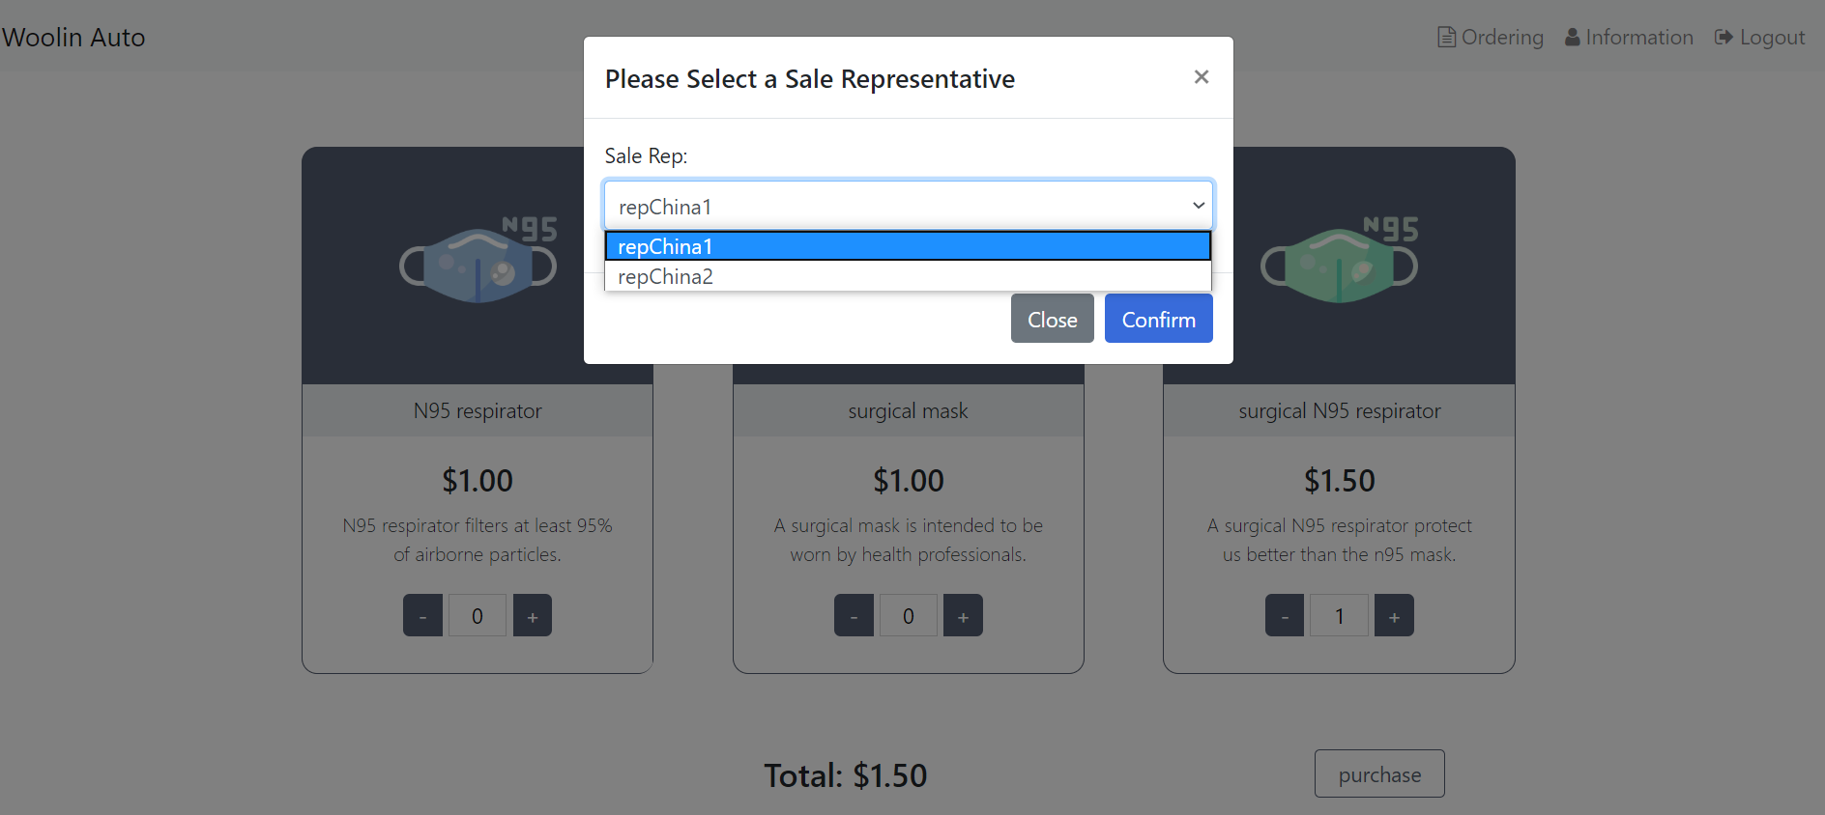

Click ‘ordering’ button in nav-bar, customers can view their ordering information here. They can check 3 kind of status’ orderings respectively.

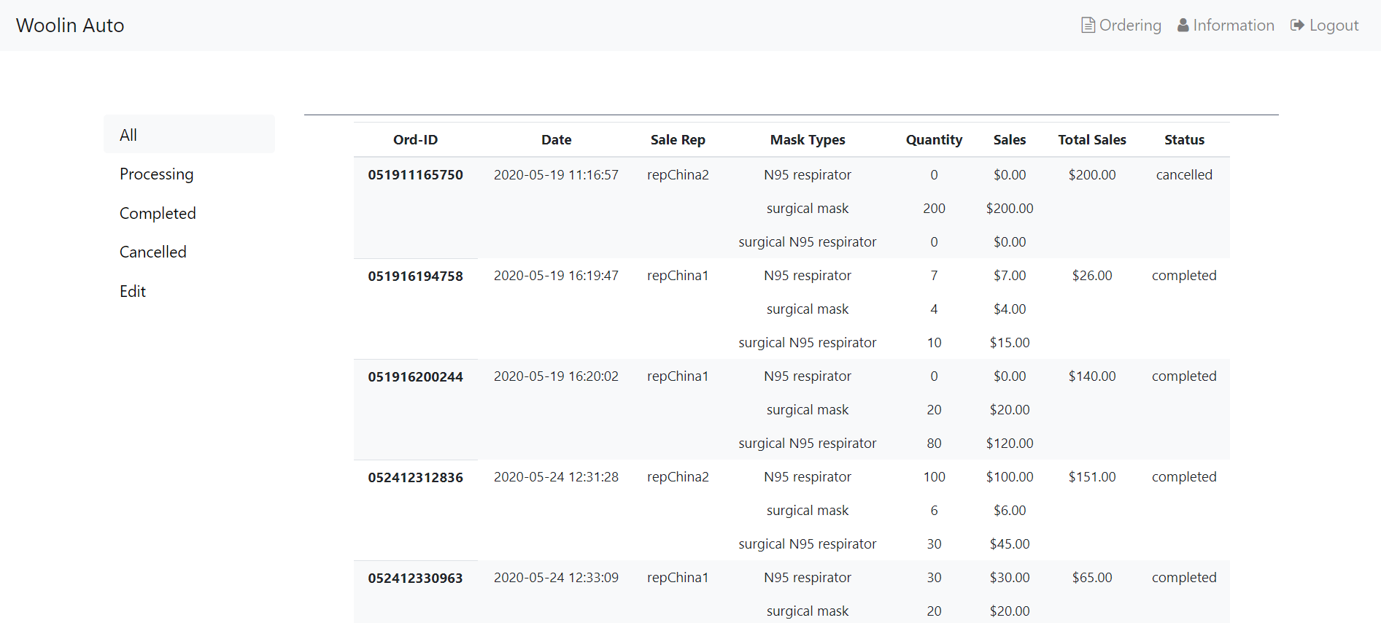

Click ‘Edit’ button, customer can see orderings they have made within 24 hours, and they can cancel them for no reason.

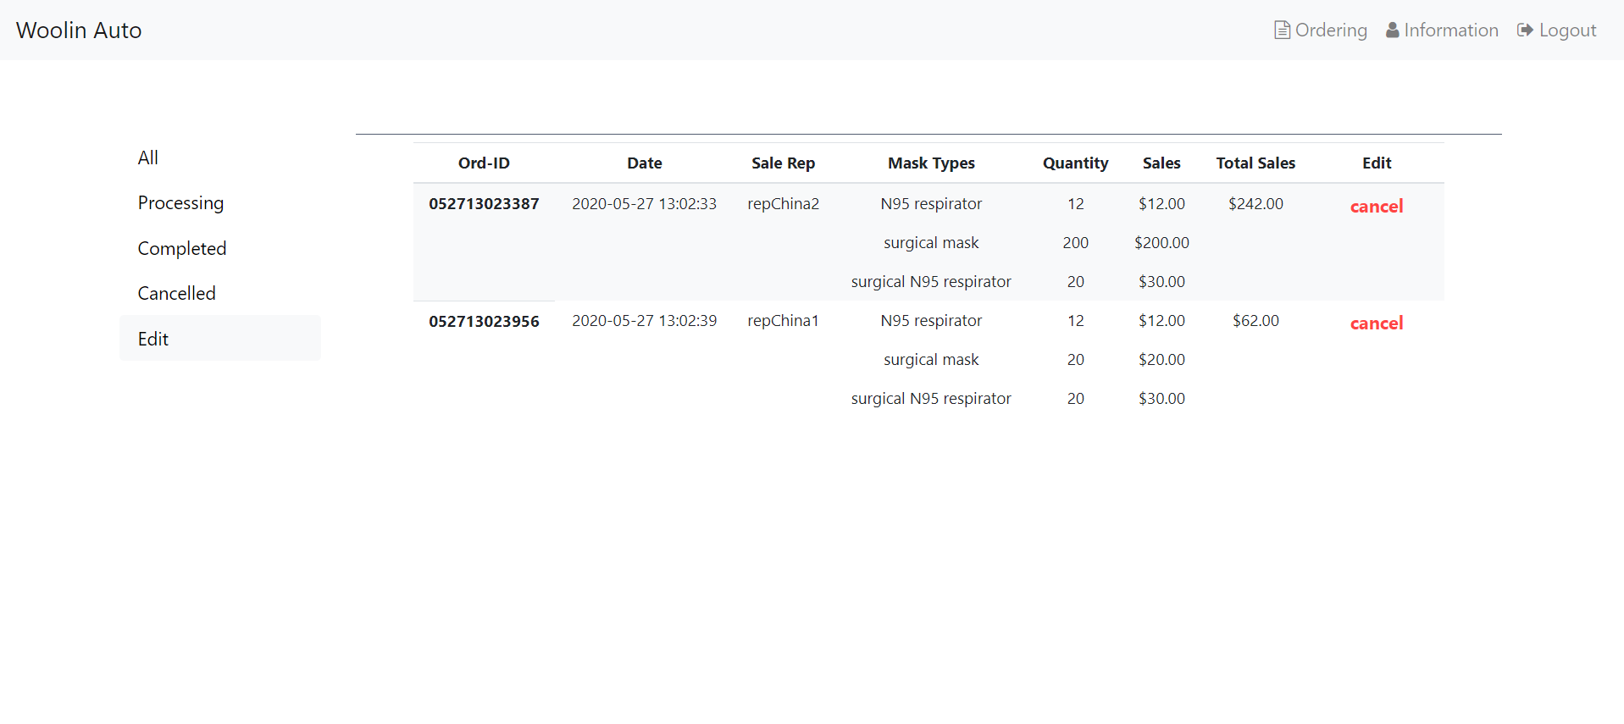

Click ‘Information’ button, customer can view their personal information and make some changes.

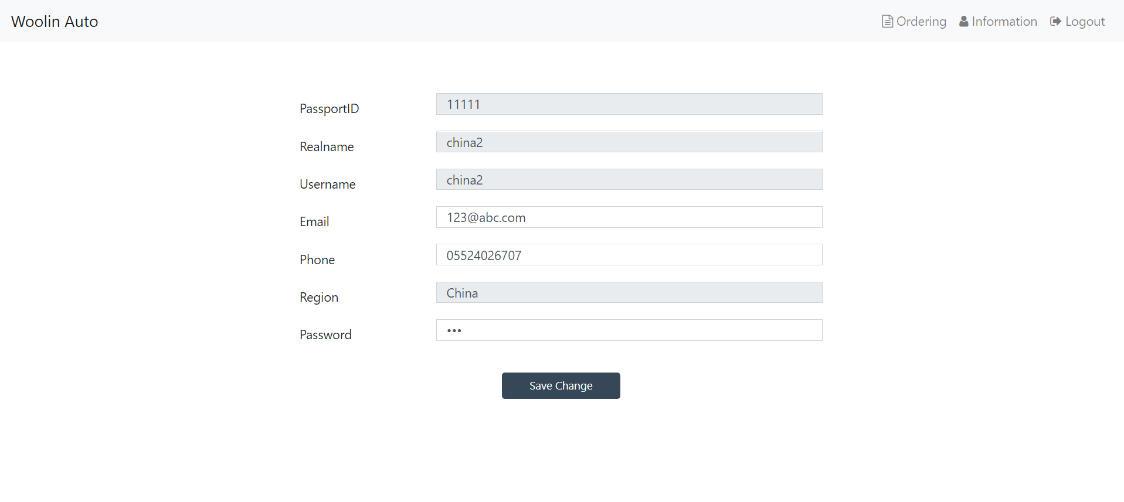

**3.3 Sale Rep System**

**3.3.1 Information page**

After jump to sale rep page, the personal information and quota sold situation will be shown. If there are red part in quota circle, it means sold quantity exceeds quota. Sale rep can change their personal information here.

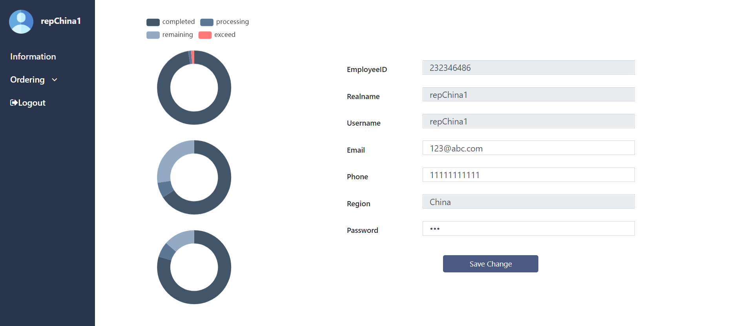

**3.3.2 Ordering**

Sale rep can view all orderings under his role. And he can check them by different status respectively.

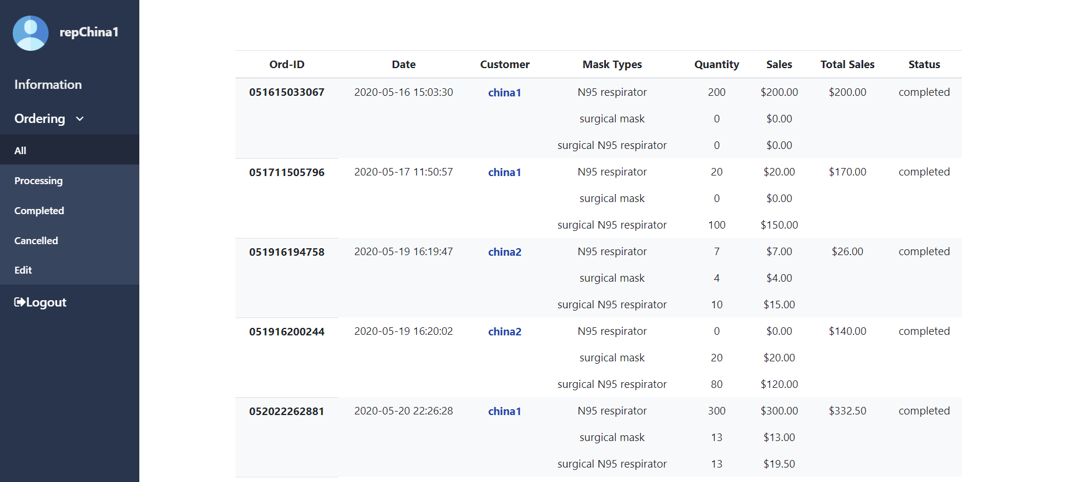

Click customer name in orderings, the personal information of this customer will be shown.

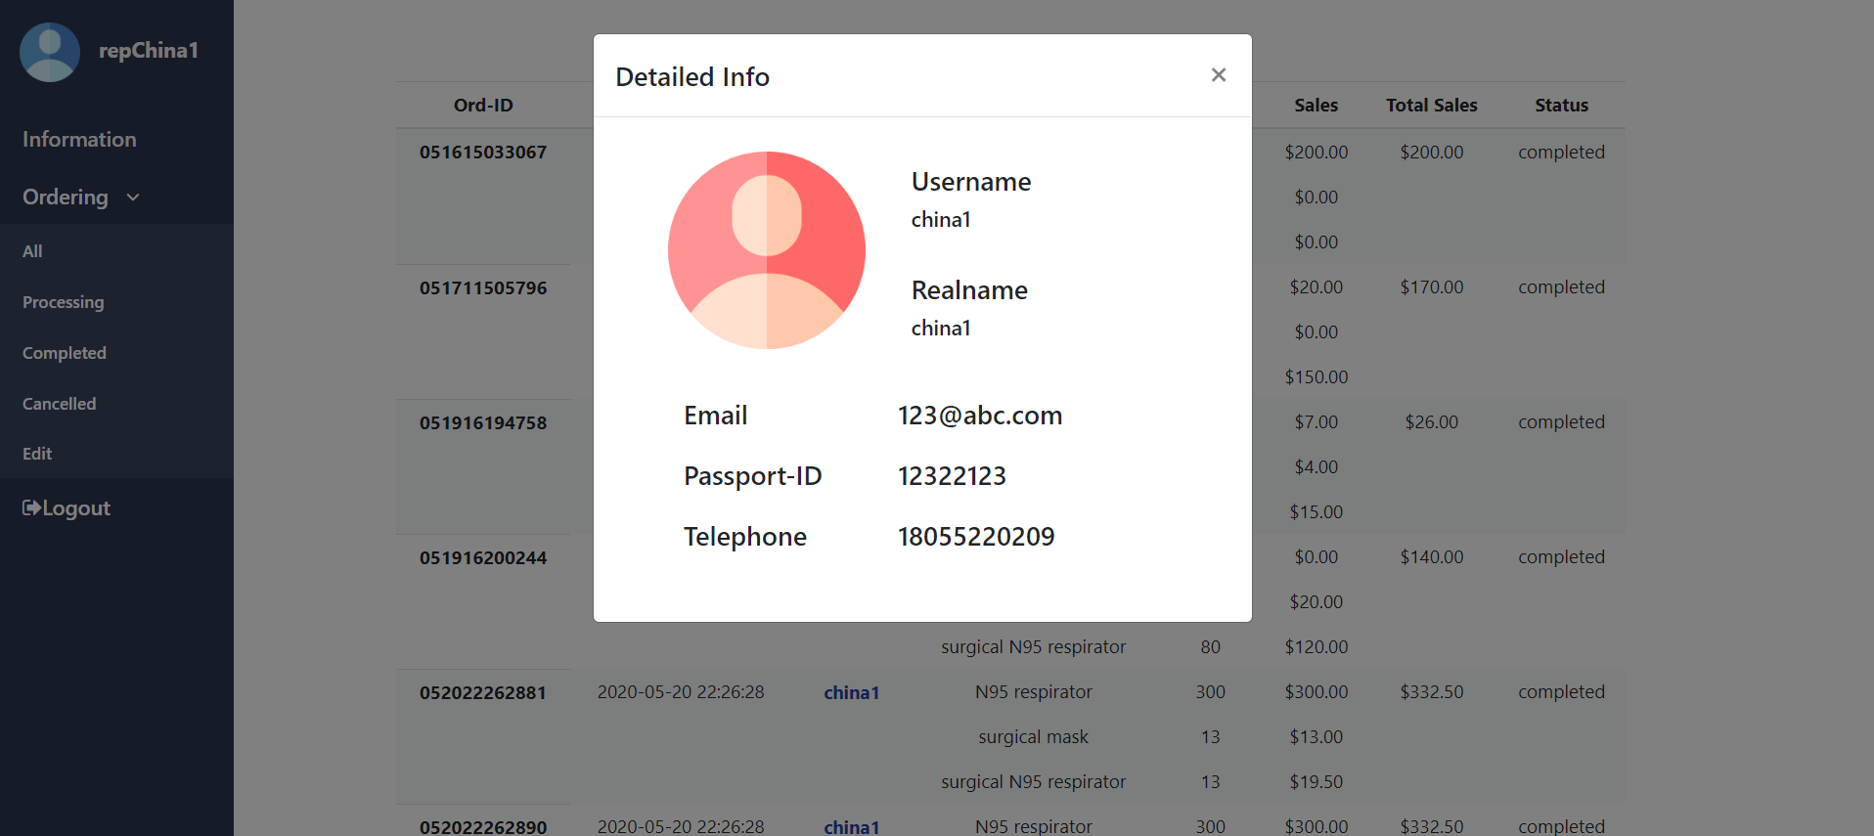

If sold number exceeds quota that rep has, sale rep can cancel orderings which haven’t completed yet to handle this situation.

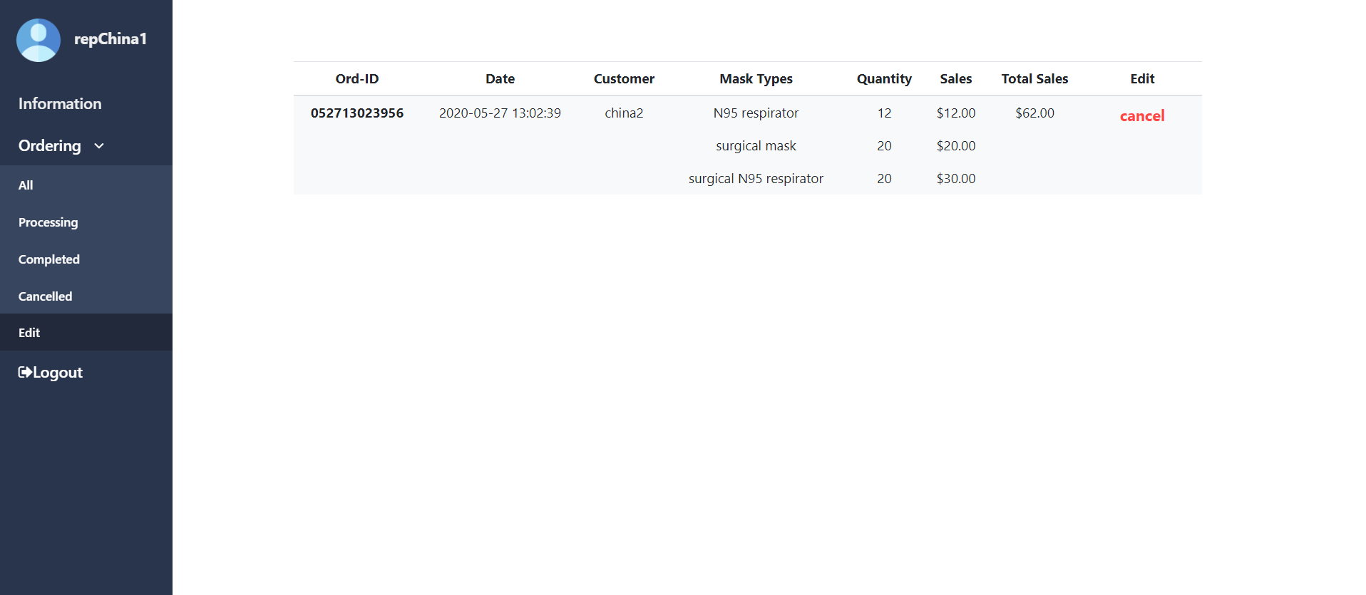

**3.4 Manager System**

**3.4.1 Selling situation page**

In this page, manager can view the proportion of each region’s sold quantity for three kind of mask.

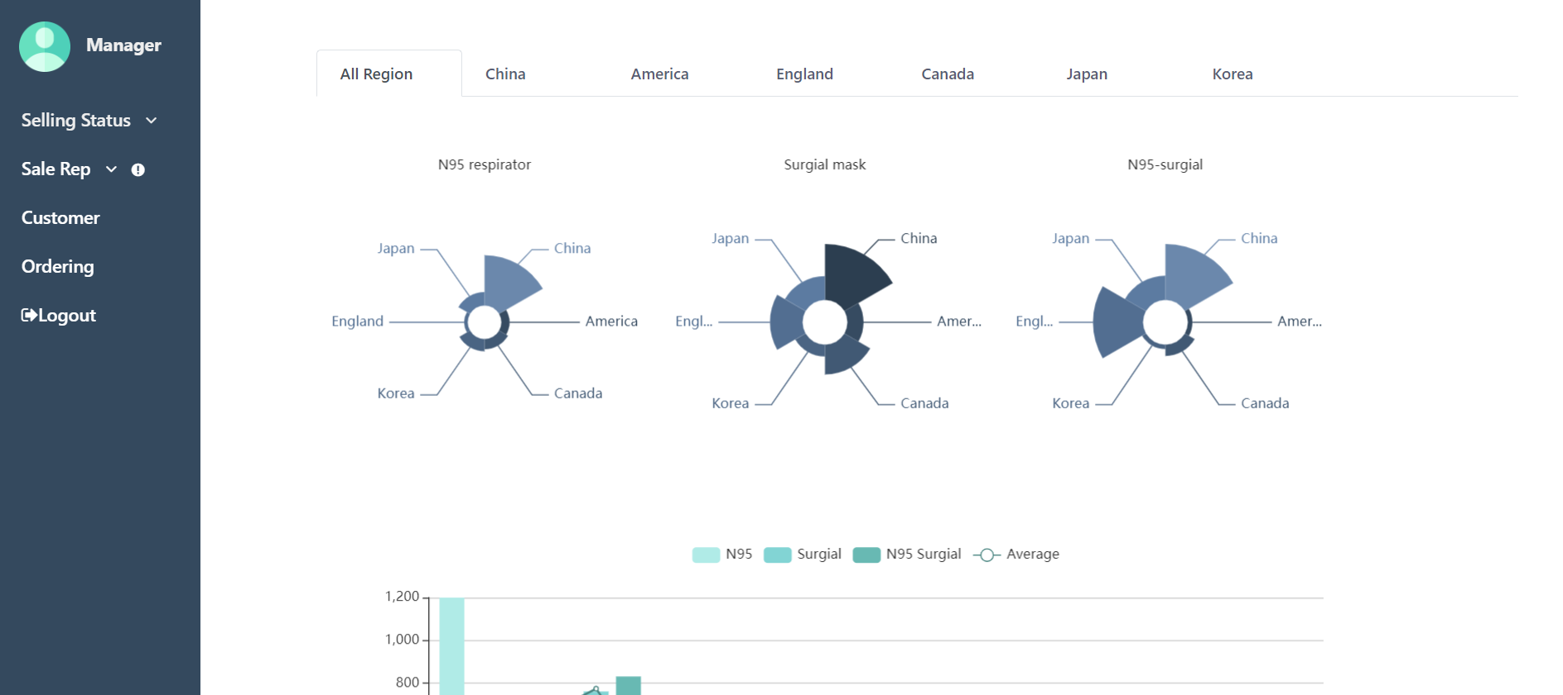

Every day’s selling situation can be viewed too.

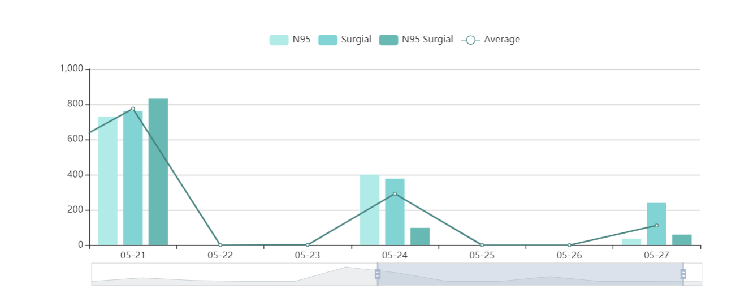

Drag the bar at the bottom to see selling status for different dates

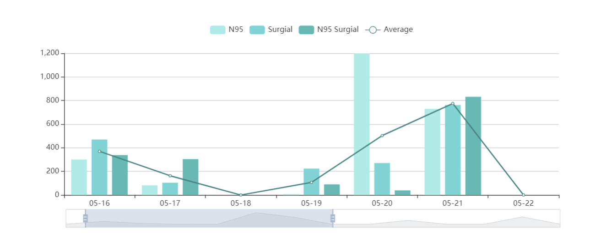

Click region name, each region’s daily selling situation can be viewed. Total quantity and revenue of all three type masks are shown.

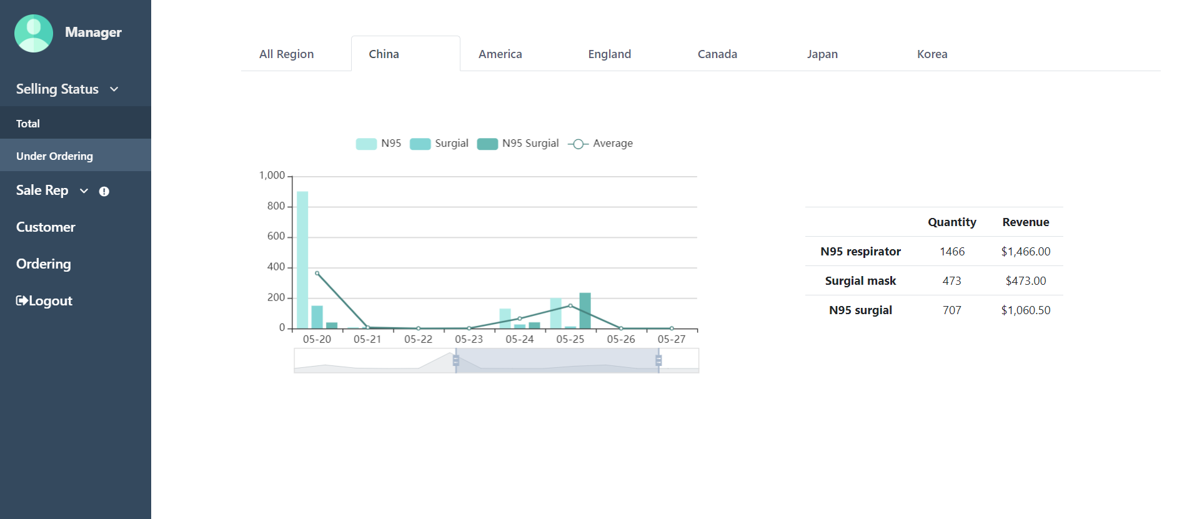

**3.4.2 under ordering page**

In this page, manager can view the proportion of each region’s processing orderings’ quantity for three types mask.

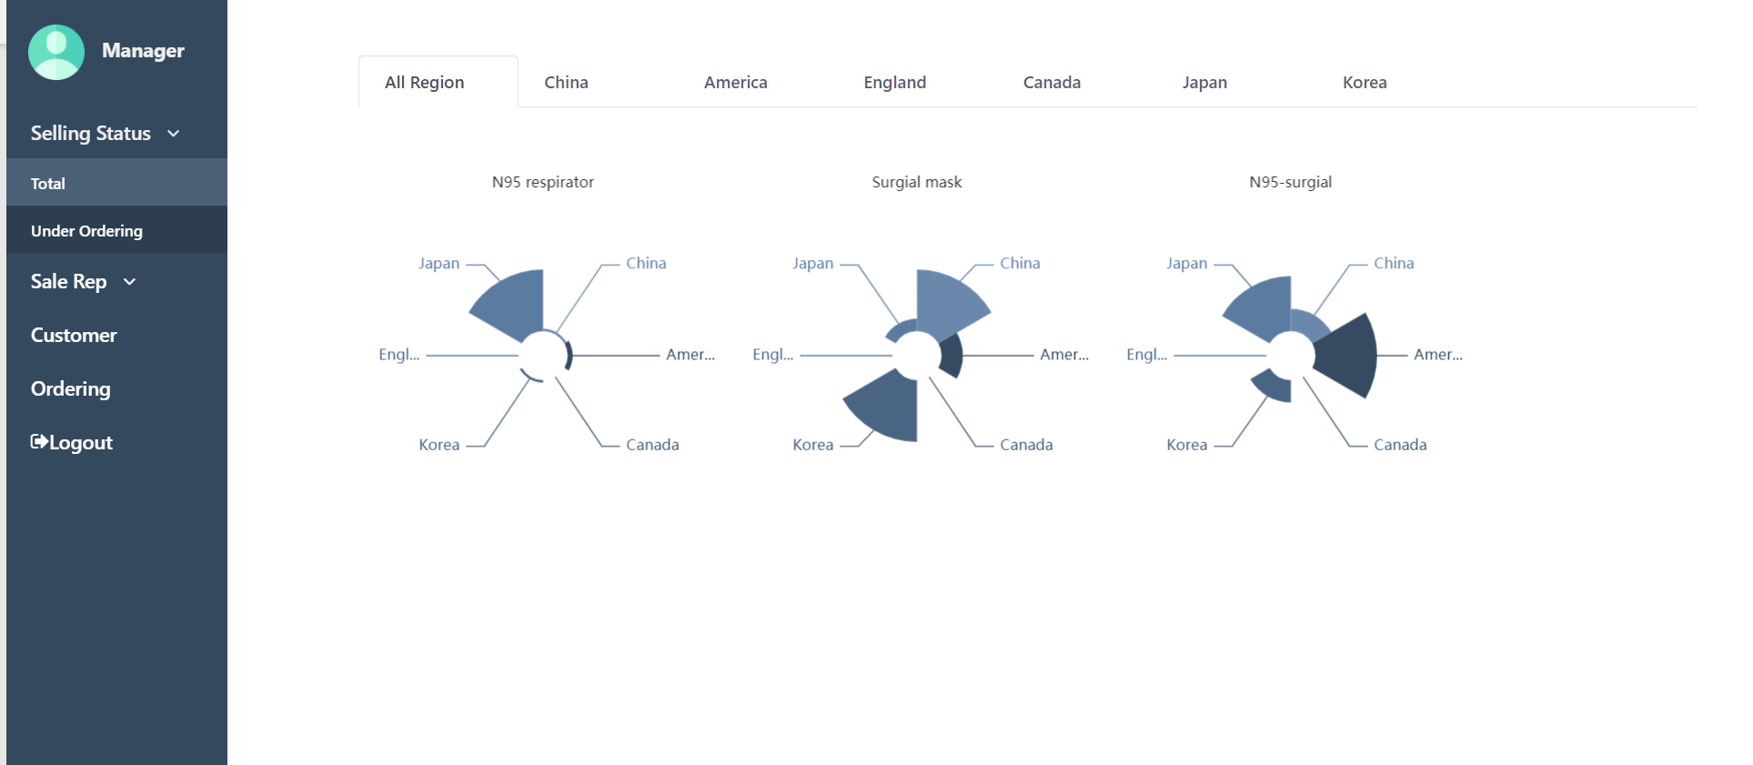

Click each region’s button,，the region’s processing orderings can be shown.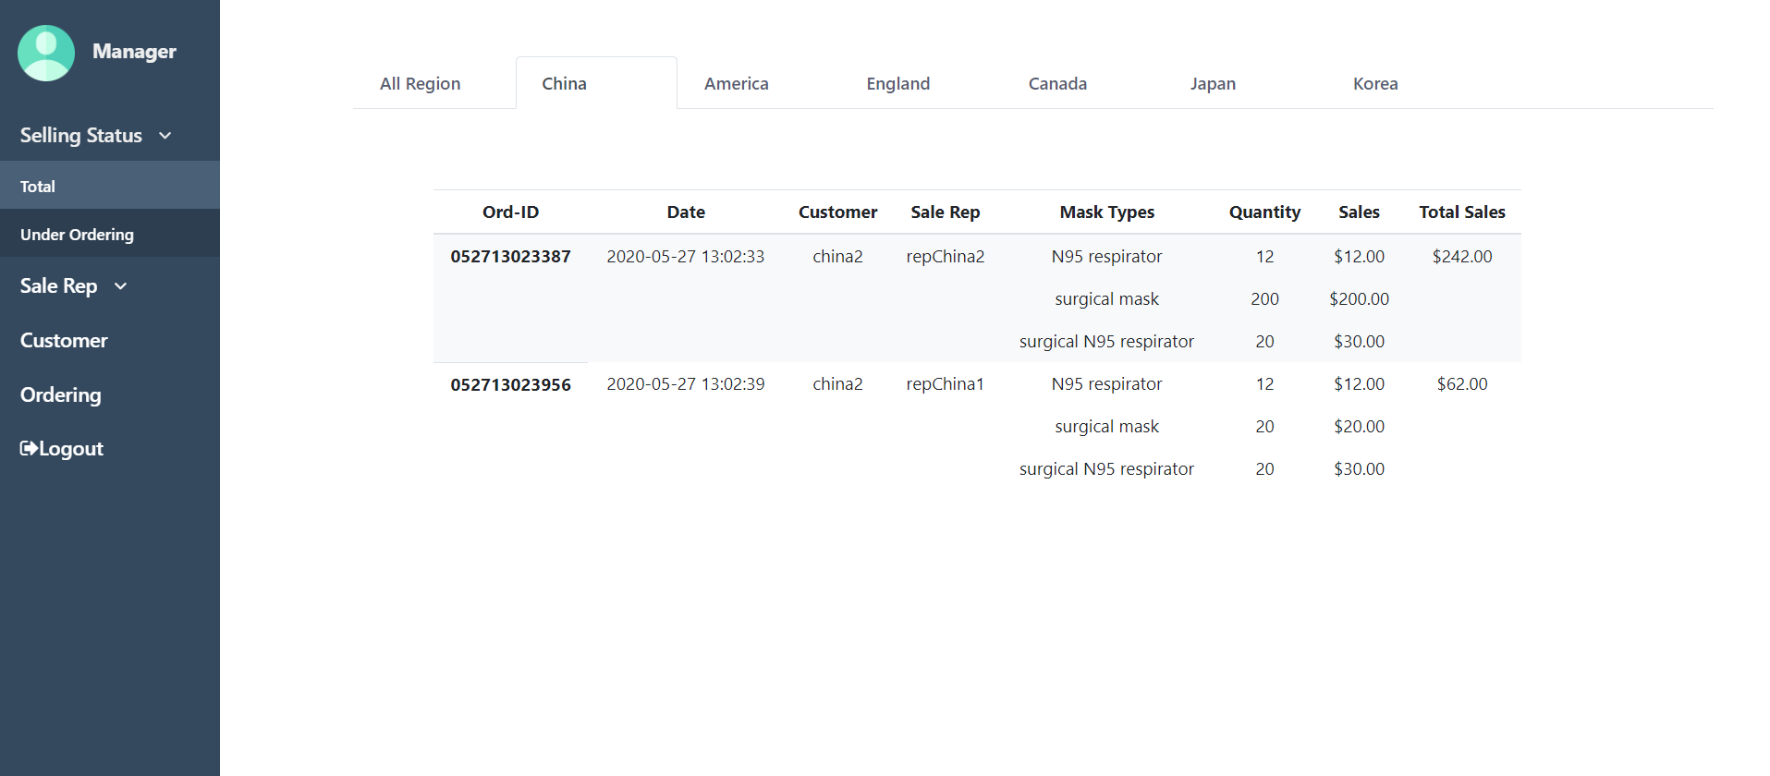

**3.4.3 Sale reps’ data page**

Manager can view every sale rep’s personal information here. Click Inverted triangle button, the sale rep’s quota situation, daily selling situation and total quantity of each mask.

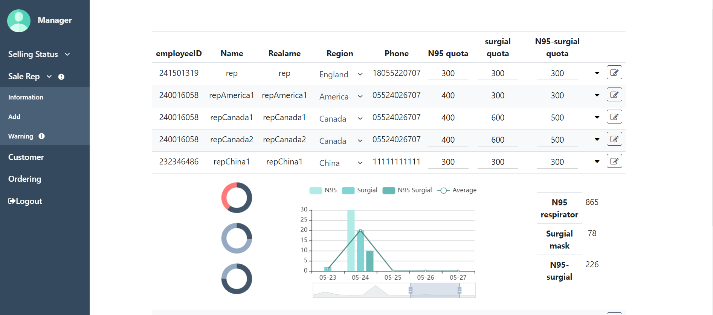

Manager can assign sale rep to a new region or update quotas.

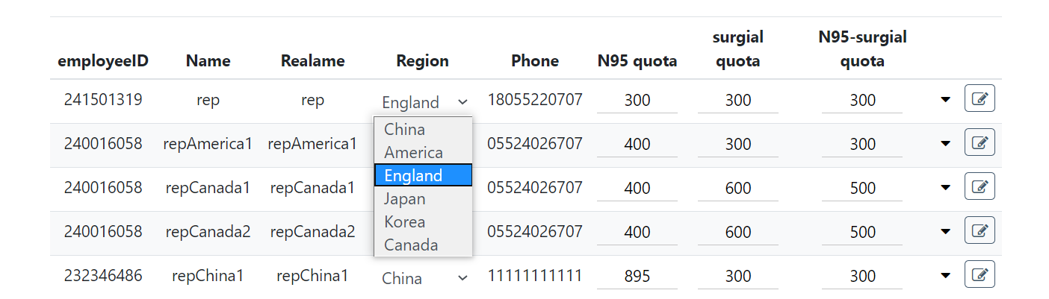

**3.4.4 add sale reps**

Sale reps are registered by manager, employee ID is generated by system automatically to avoid repeat.

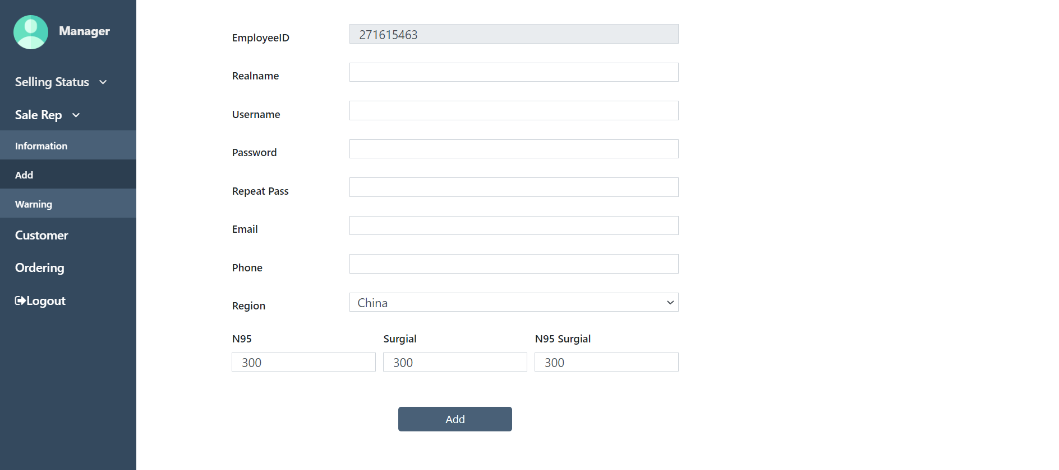

**3.4.5 warning page**

If completed orderings’ quantity exceeds the quota, which means anomaly occurs. Manager will get reminder as long as he logs in to the system. Manager can regrant the quota for them.

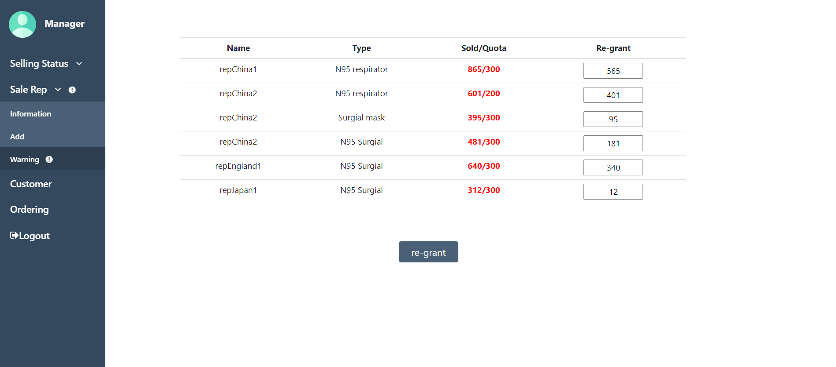

After regrant, anomalies should disappear.

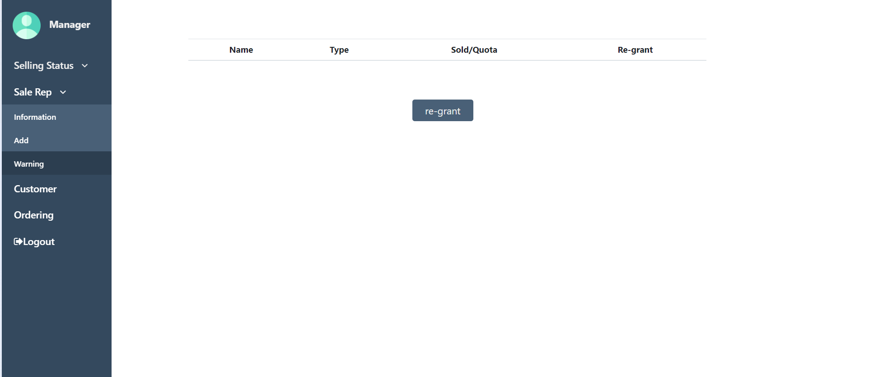

**3.4.6 customer data page**

Manager can view each customer’s personal information here.

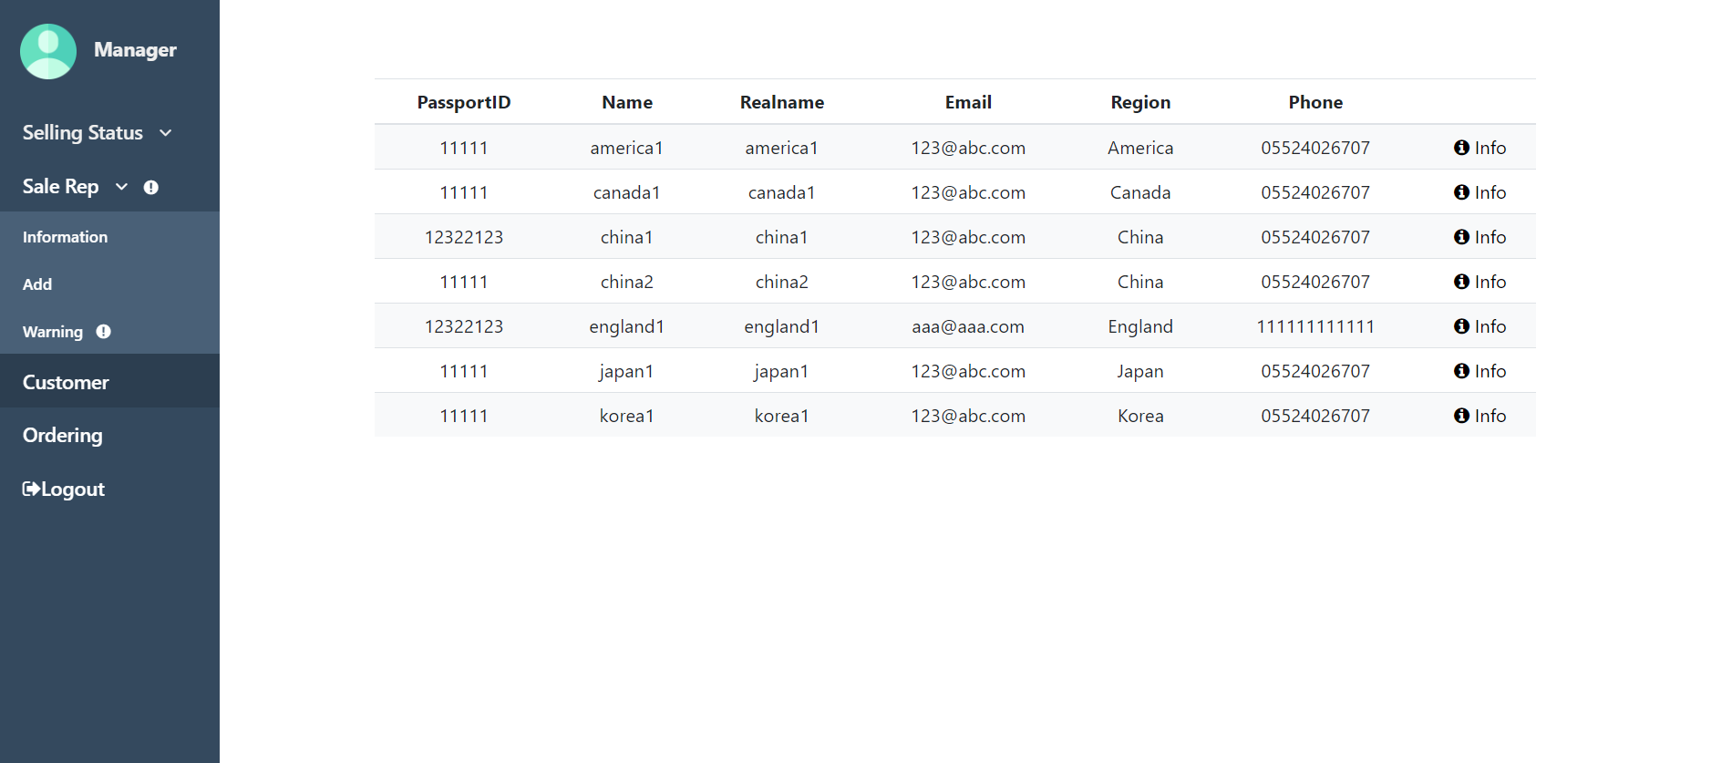

Click ‘info’ button, detailed purchase information will be displayed.

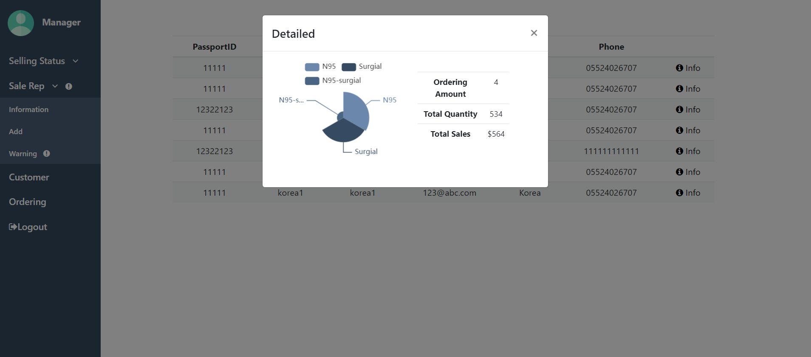

**3.4.7 ordering checking page**

Manager can check orderings by condition.

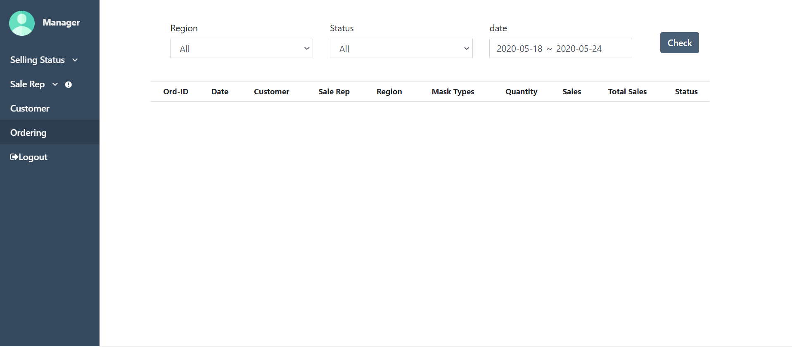

Date range, region and status of ordering can be picked by manager.

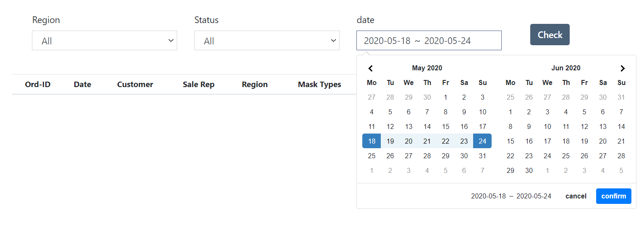

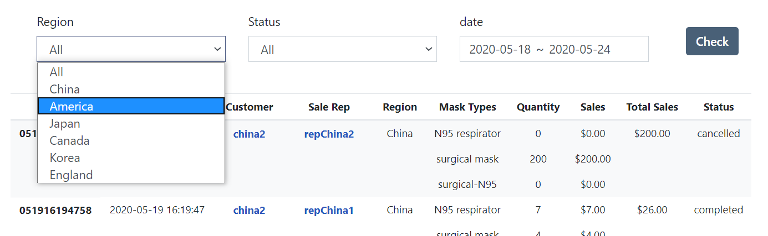

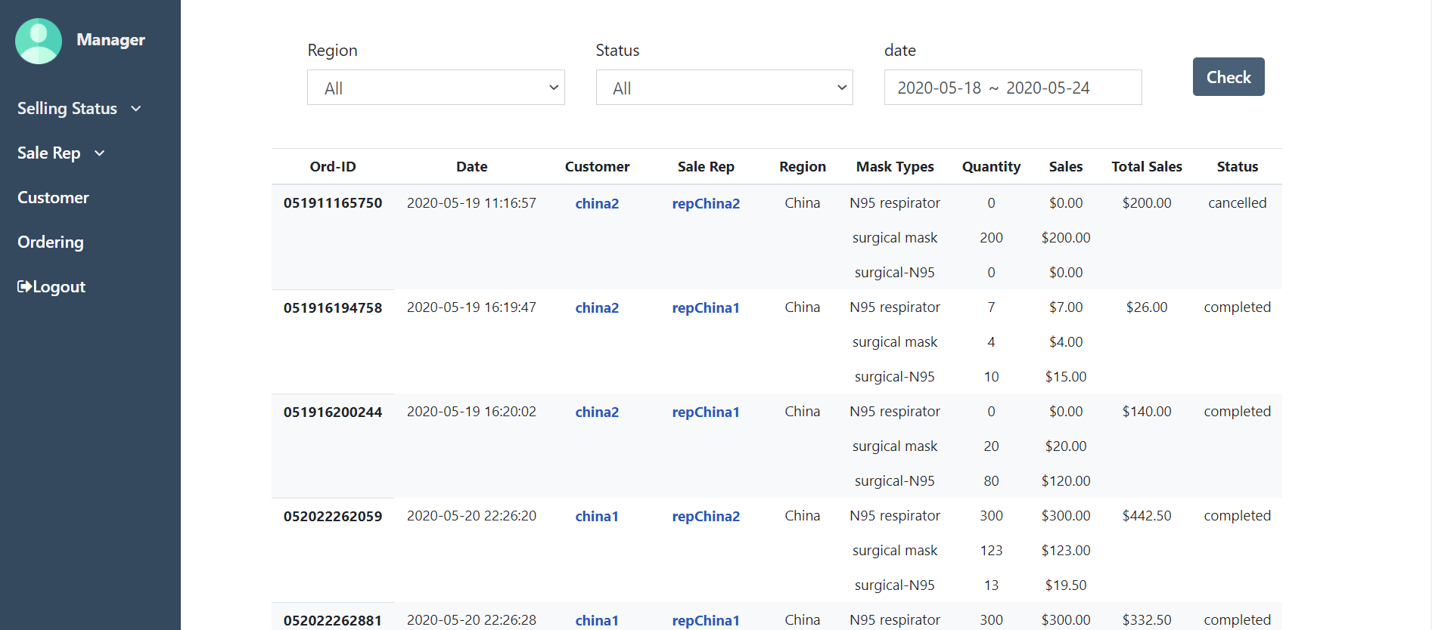

Click customer name button or sale rep name button, personal information will be displayed.

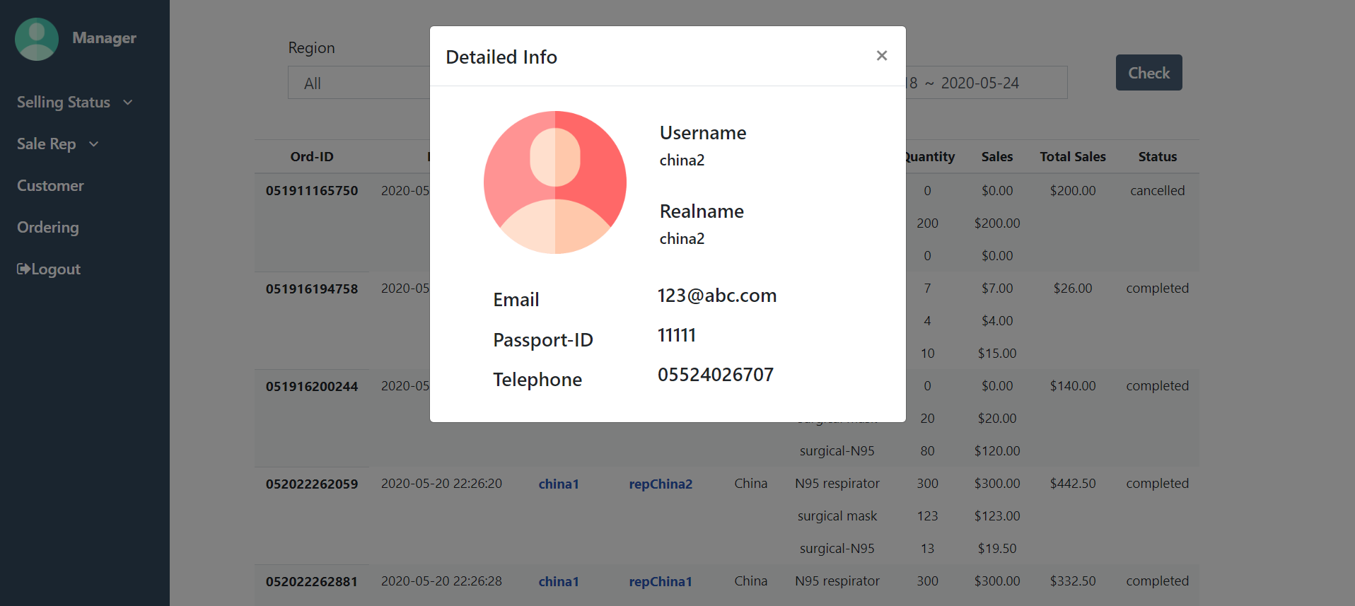

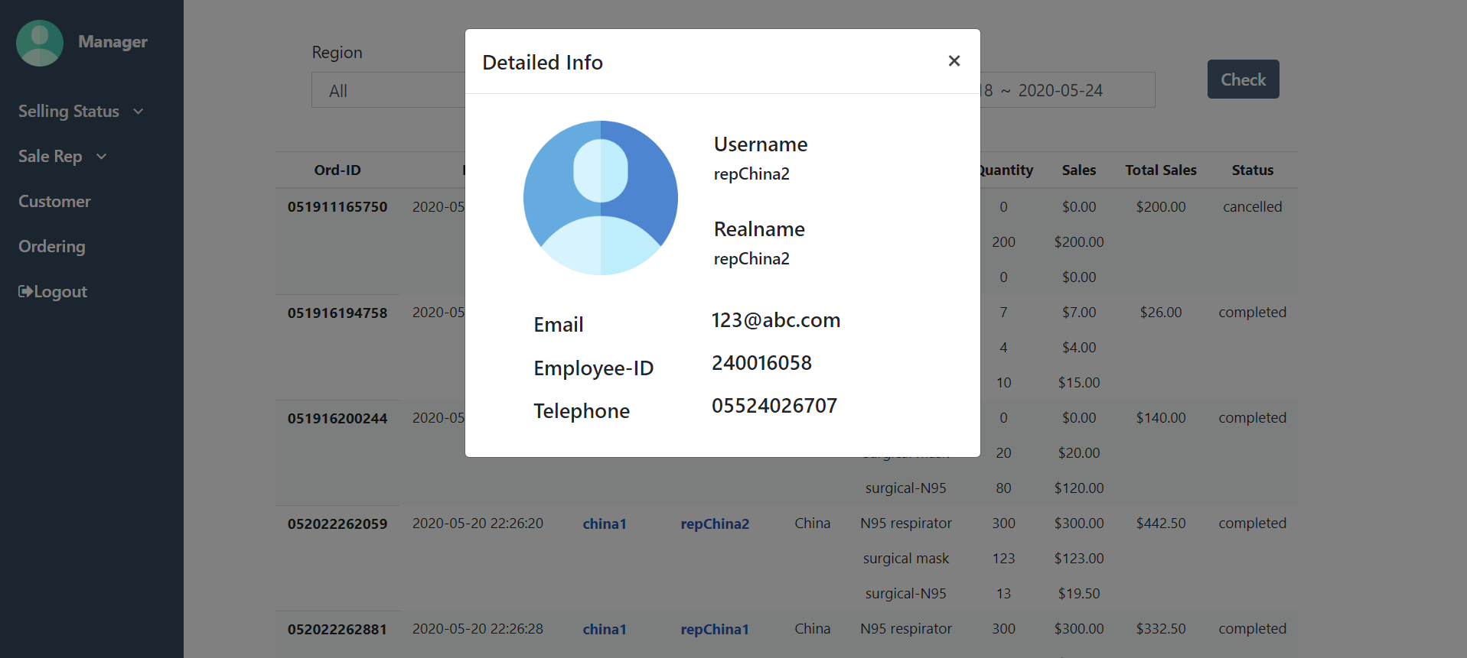

**4. exception handling**

1. **Start**

If user click purchase button but do not login, system will alert this tip.

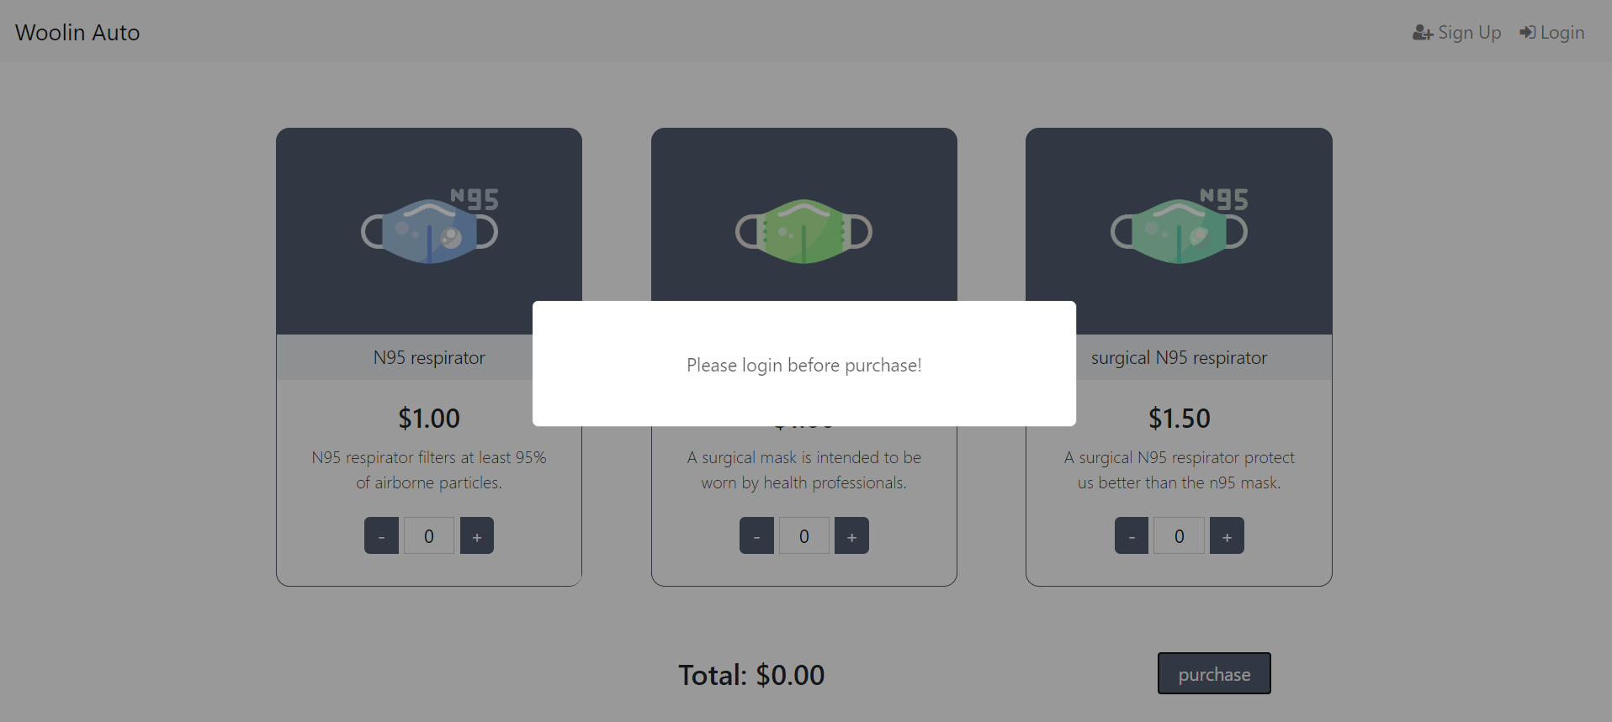

1. **Sign up**

If user doesn’t input information as request format, some tips will occur.

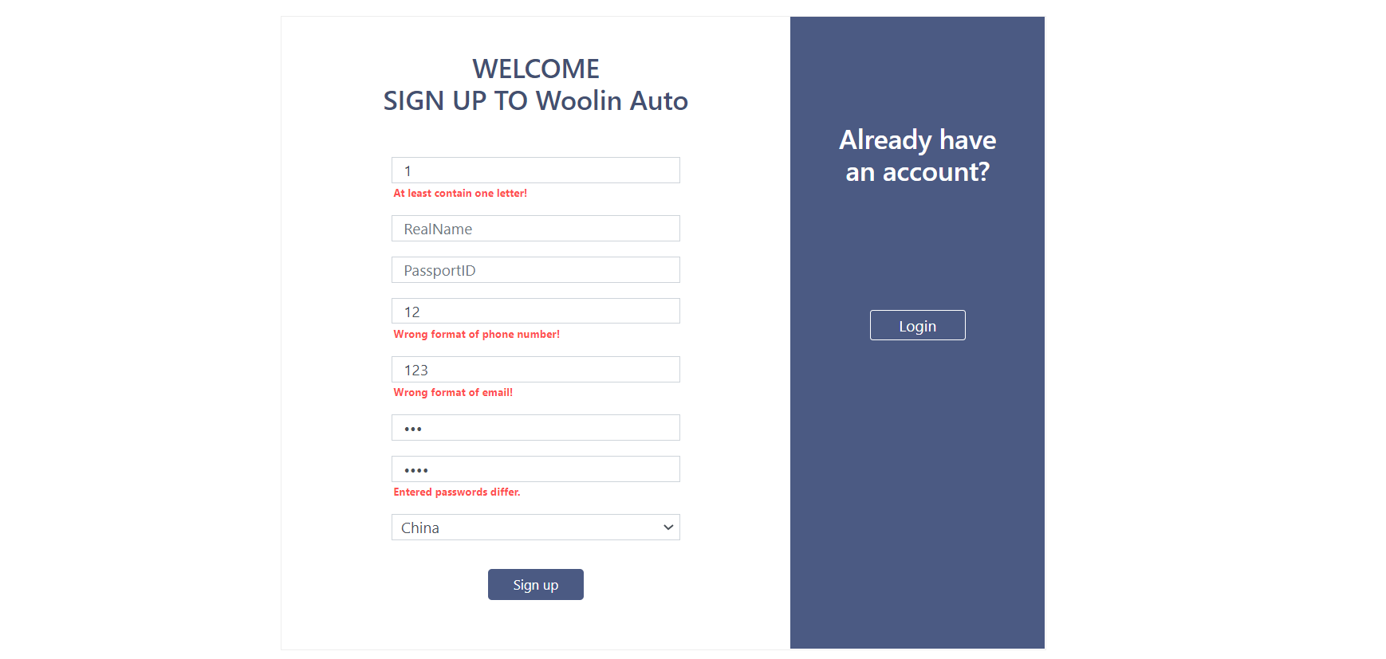

User will get tip if he clicks Sign up button but didn’t complete form or complete form as right format.

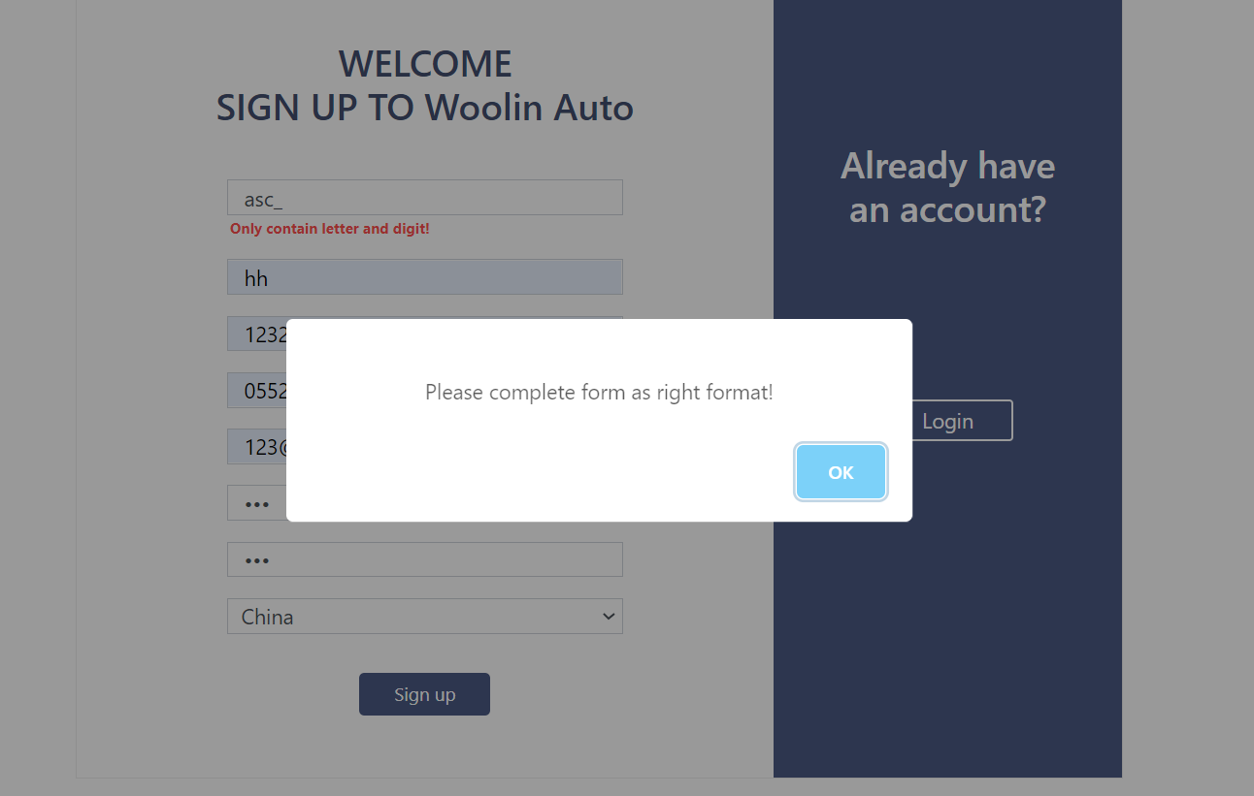

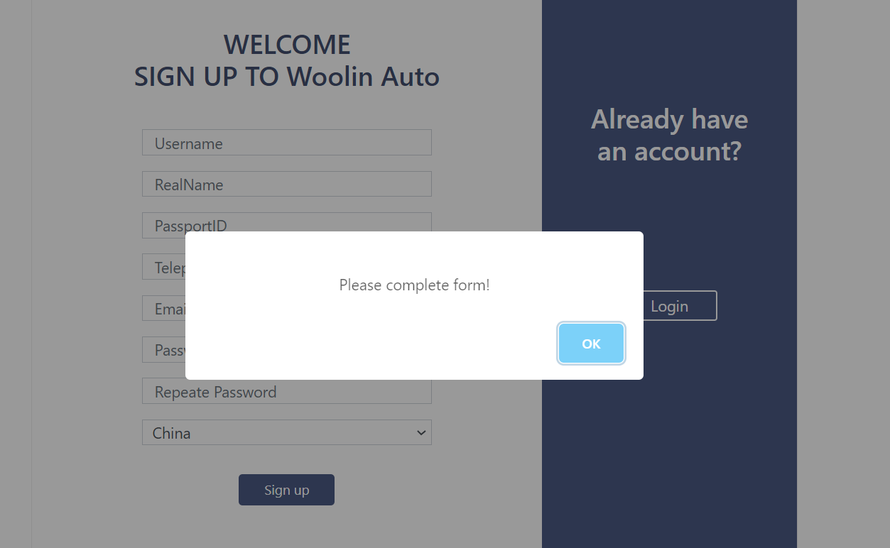

If username is repeat, this tip will be displayed.

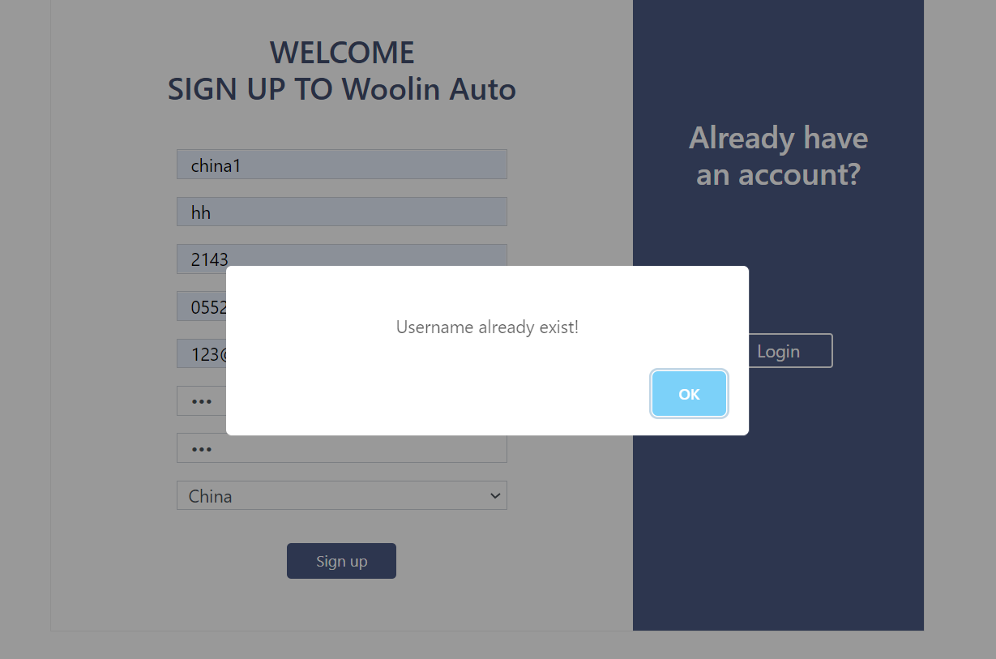

1. **Login**

If username doesn’t exit or password is not right, system will alert a tip.

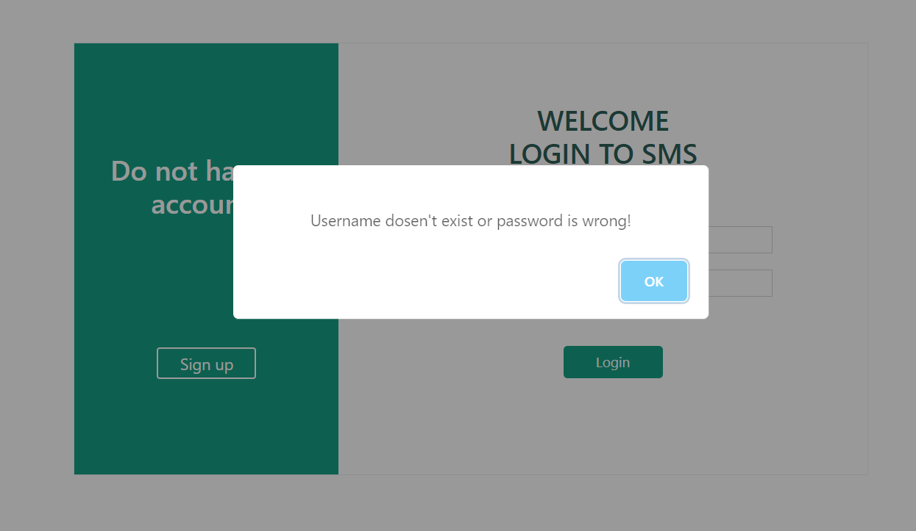

1. **Purchase**

If customer doesn’t select any product, the tip will be alerted.

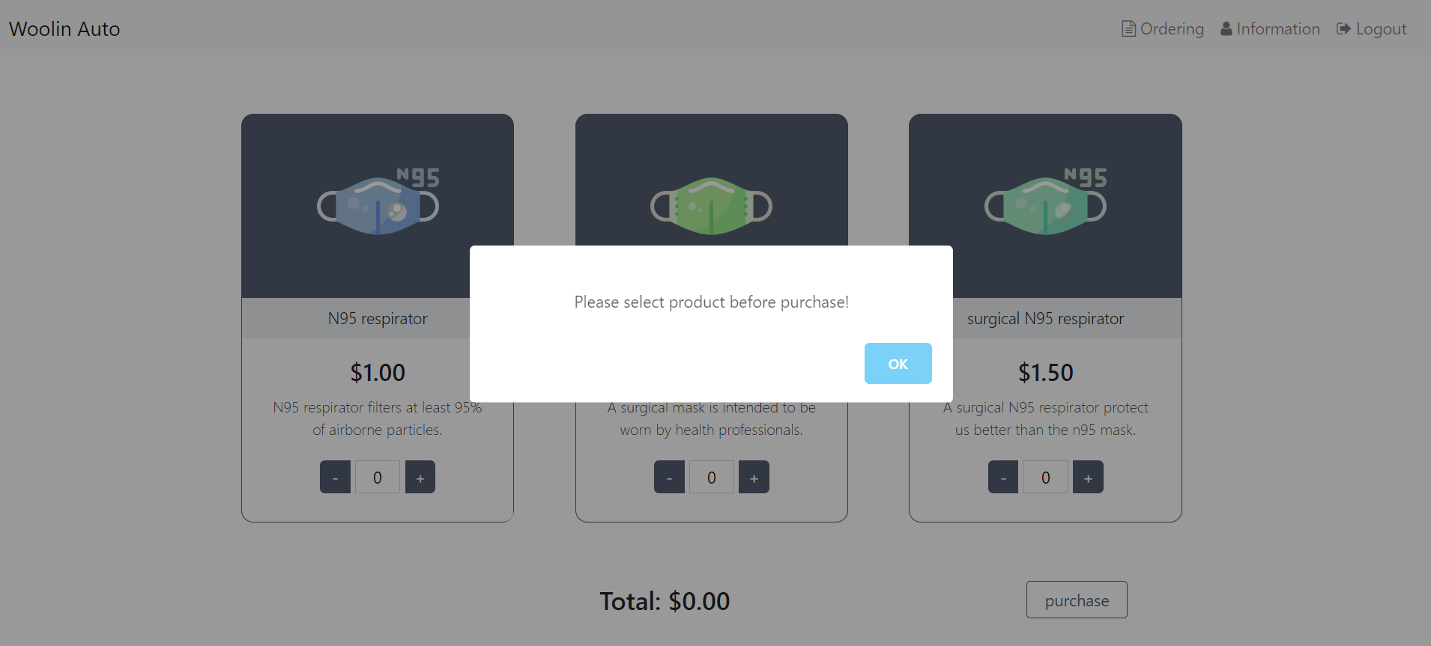

If customer’s region have no sale rep, this message will be displayed.

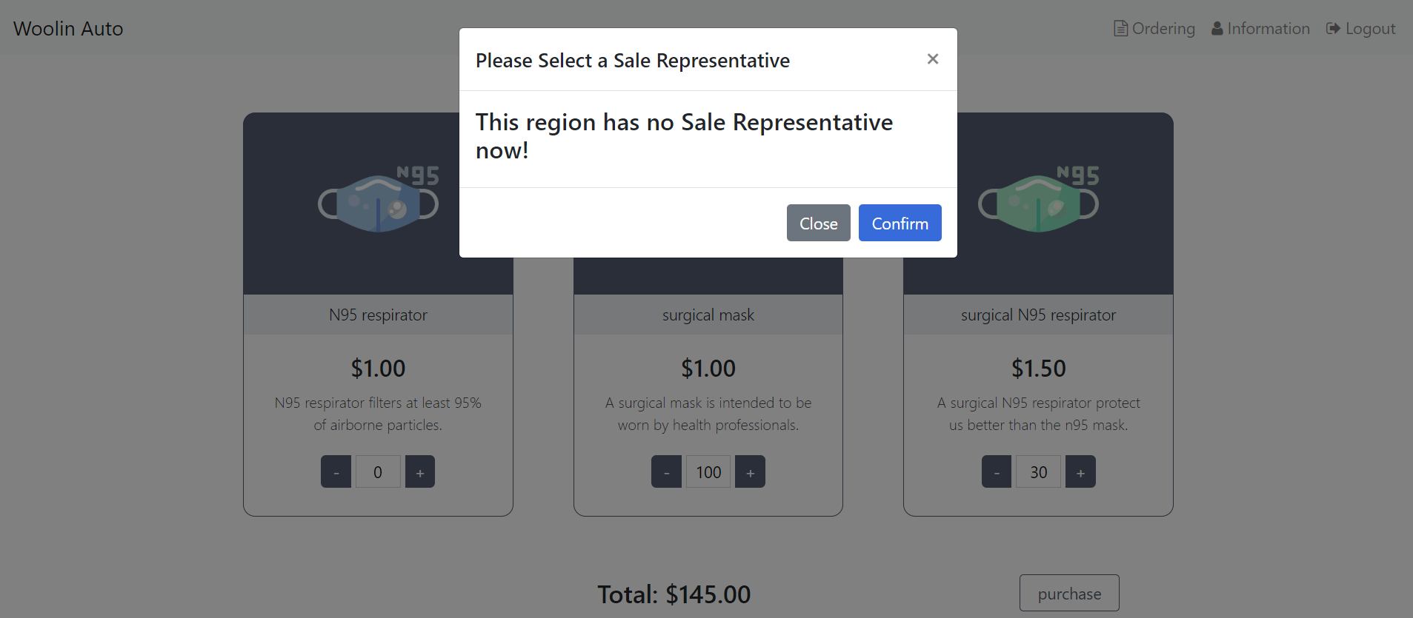

1. **Customer change personal information**

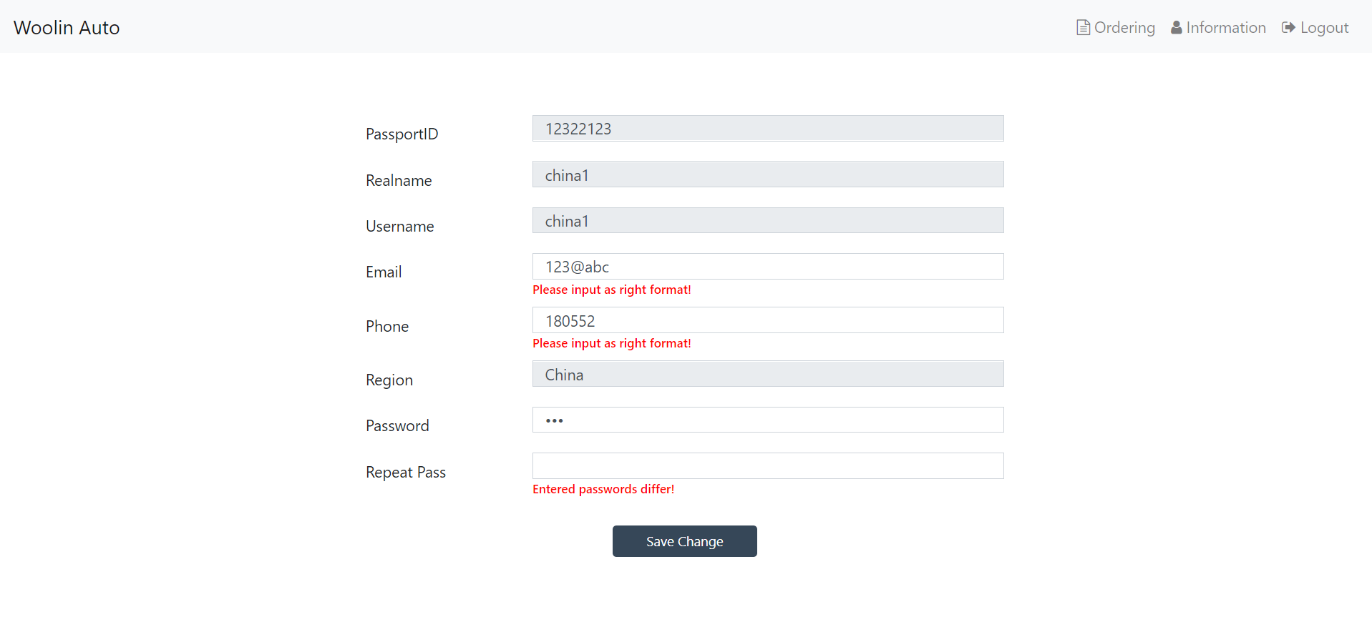

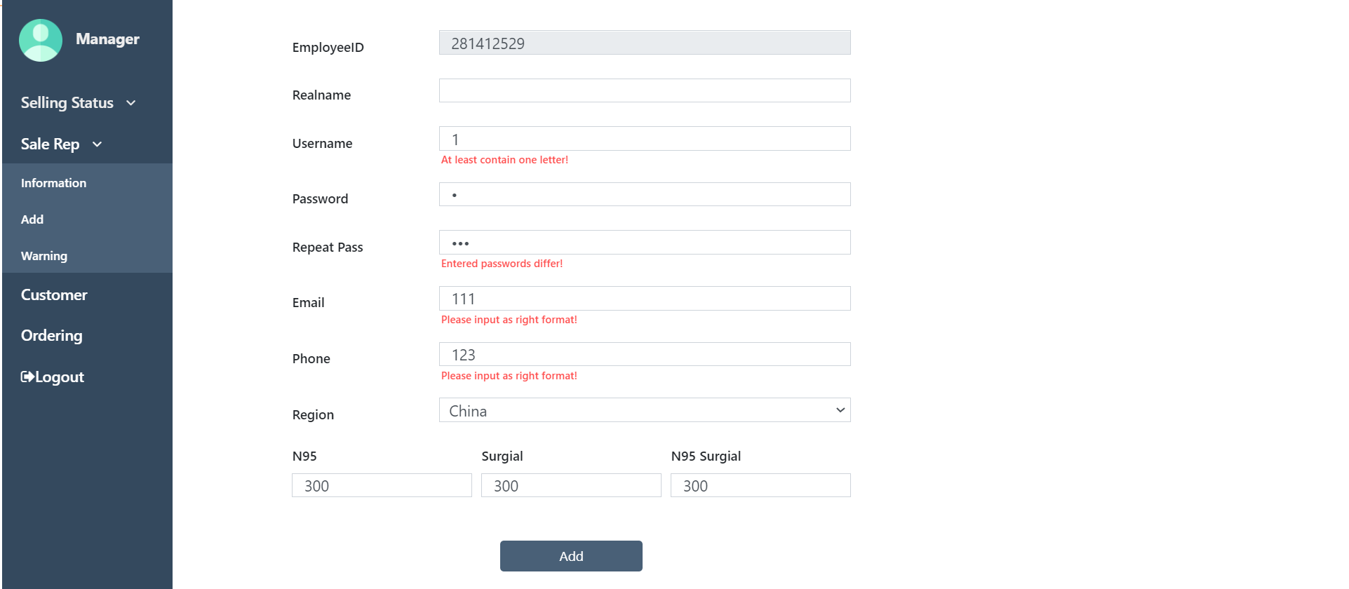

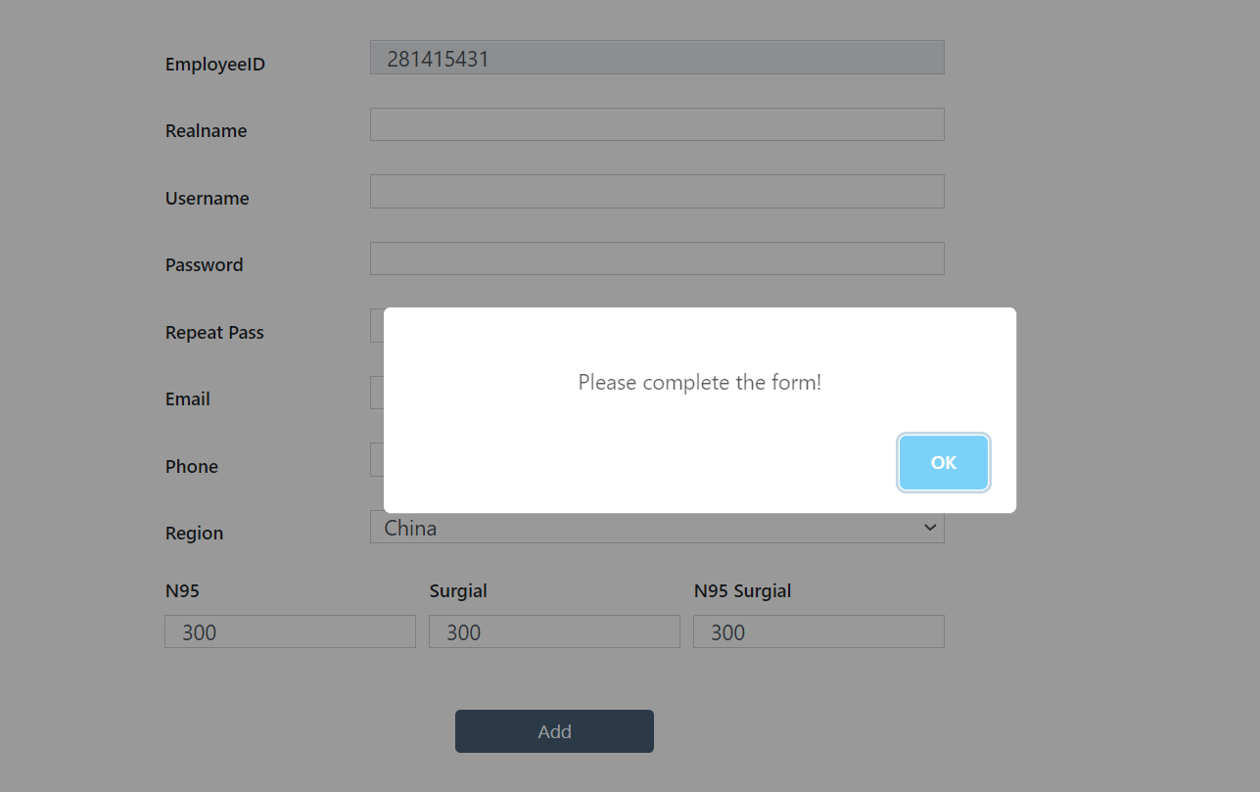

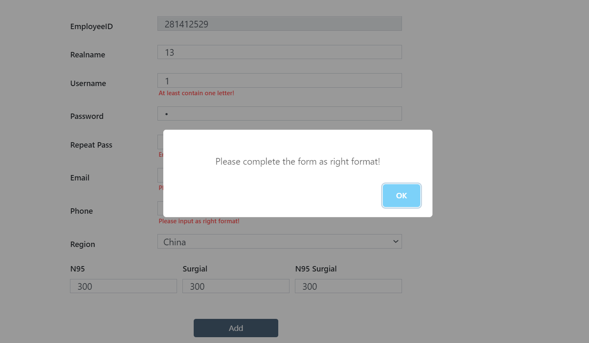

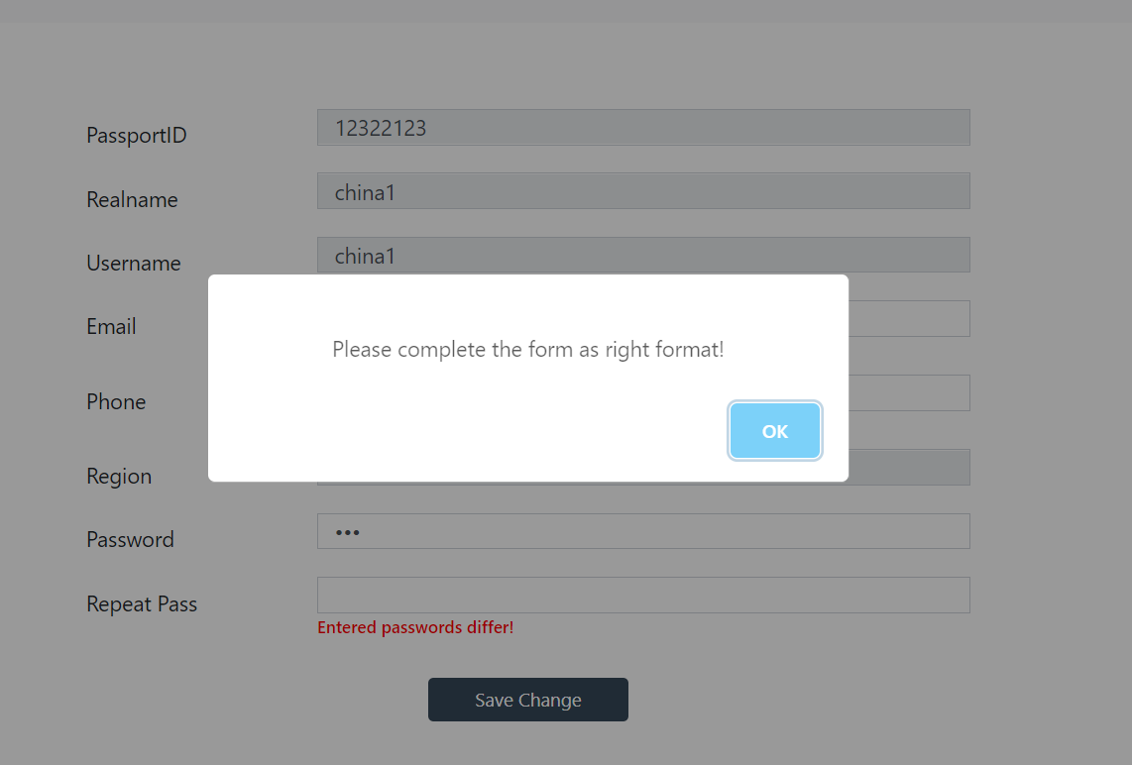

**5. external libraries**

* Bootstrap
* Echarts
* Font-awesome
* Jquery
* Moment.js
* Data-range-picker
* Sweetalert