ACCOMPLISHMENT REPORT
"Boses ng Kabataan: Future Leaders ng Bayan"
February 16, 2024

The project event was carried out by AKBAY and KASANGGA, two organizations that collaborated to ensure the successfulness of the project event. The event commenced promptly at 9:00 in the morning at NB1, with attendees signing the attendance sheets to the assigned registration. The event was hosted by Ms. Anna Joy Abrigo and Mr. Melvin Alegre. The Opening prayer was led by Mr. Almico Revaulo from the organization of KASANGGA, followed by the Philippine National Anthem and the opening remark by Prof. Stephany Darrel Ann Fontanilla, with a brief introduction and words of gratitude were offered to the participants and guest.
Mr. Romulo Oserin Jr. now has the platform, delivering a heartwarming and inspirational message that resonated with the vibrant energy and untapped potential of the student leaders gathered. The hosts seamlessly transitioned the program by inviting Mr. Rommel Alpuerto the President of KASANGGA Org. to introduced the first speaker for today which is Mr. Rondel Garcia the guest speaker who graduated from Dalubhasaan ng Lunsod ng Lucena on the year of 2016-2017.
Mr. Rondel Garcia, in his seminar topic titled “Different types of Leaders and The Benefits of Being a Leader” was discussed the 6 Different of type leaders which is the; Charismatic, Democratic, Servant, Transformation, Autocratic and the Laissez-faire leadership that tackles about the diversity of each leadership that offers an advantage and disadvantages of influencing the organizational culture and the development of those student leaders. The effectiveness of a leader often depends on the context and the nature on how the student leader acts and behave depending on the situation that he/she uses the type of leadership. The benefits of being a leader were also discussed including the sense of fulfillment of being able to serve fellow students. Embracing the role of a leader signifies embarking on a fulfilling journey of impact, growth, and lasting contribution.
After the discussion of Mr. Rondel Garcia, He was honored by accepting the invitation and token of appreciation led by the Advisers. Lunch break has also started.
The second part of the event, the afternoon event commenced at exactly 1:00 in the afternoon, with the participants signing again at the registration for the afternoon attendance. The event hosted by Ms. Anna Joy Abrigo and Mr. Melvin Alegre. Followed by the Ice Breaker of Mr. Claide Ivan Bacus, while randomly selected participants with the question of "I'm a student leader, Of ​​Course____'. Through this game, participants not only complete the sentence but also share their perspectives, values, and commitments as student leaders. It serves as a dynamic and engaging way to showcase the diverse qualities and principles that contribute to effective leadership within a student community. After this fun game, Ms. Rozette Balbarosa took the stage to give a heartwarming welcome/introduction to Mr. Arnel G. Avila, a professional News FM and TV broadcaster. We were grateful to given a chance to invite him to this major event of ours together with the KASANGGA Org.
Mr. Arnel G. Avila started his discussion with some questions aligned with the topic titled, “How Leaders can work towards promoting diversity in leadership roles?”. With his message, he offered his knowledge and experiences to the students’ leaders that’s why they’re able to give some meaningful question aligned with the topic. The speaker happily answered the students' questions. After the discussion of Mr. Arnel G. Avila, He was honored by accepting the invitation and token of appreciation led by the Advisers. Followed by giving the snacks of Fudgee Bar and water with the closing remarks of Prof. Vincent De Gala that concluded with a warm appreciation to all participants for their active engagement.
The project event was concluded with the giving of certificated and token of appreciations to all participated and committee together with the Advisers.

Prepared by:

MARY DHIL C. SAROMINES
Assistant Secretary of AKBAY

Signed by:

PROF. STEPHANY DARREL ANN FONTANILLA
Adviser, AKBAY

Noted by:

MR. RYAN N. ALEMANIA
Coordinator, Office of the Student Affairs and Services

Approved by:

DR. MARIA CHARMAINE V. LAGUSTAN
President/Dean, Dalubhasaan ng Lungsod ng Lucena

DOCUMENTATION
"Boses ng Kabataan: Future Leaders ng Bayan"
February 16, 2024

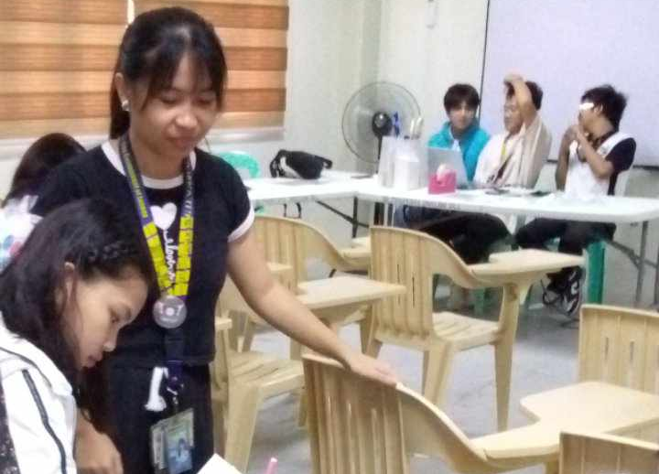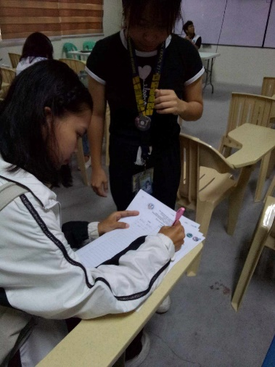
The event commenced promptly at 9:00 in the morning at NB1, with attendees signing the attendance sheets to the assigned registration
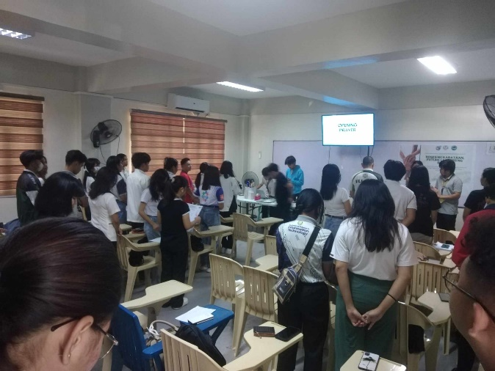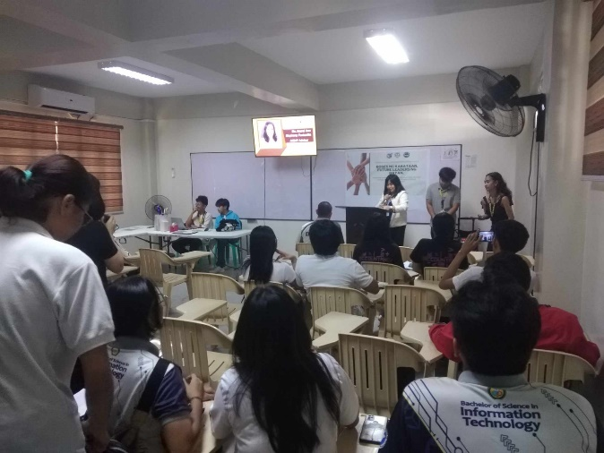
The event was hosted by Ms. Anna Joy Abrigo and Mr. Melvin Alegre. The Opening prayer was led by Mr. Almico Revaulo followed by the Philippine National Anthem and the opening remark by Prof. Stephany Darrel Ann Fontanilla.

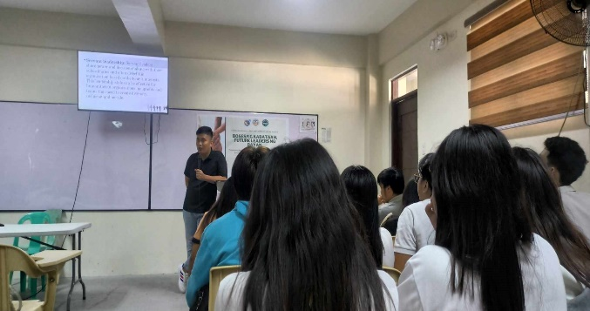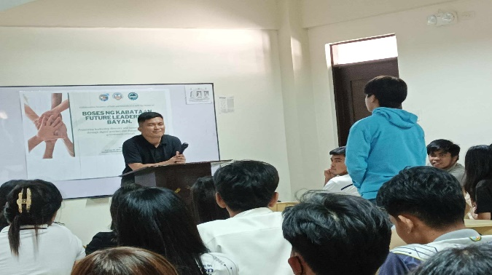
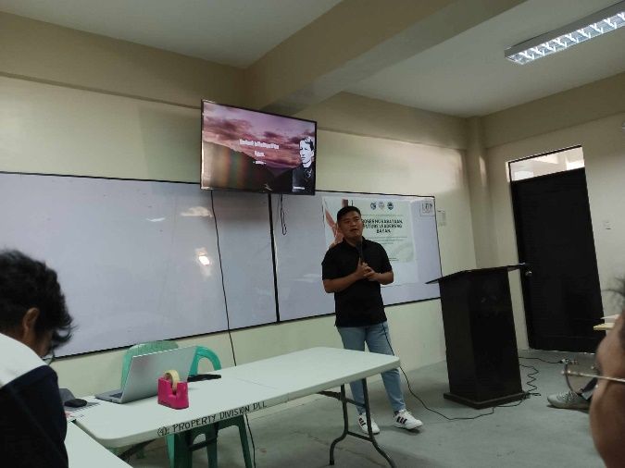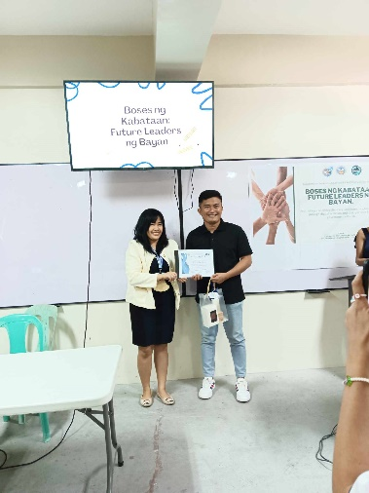
Mr. Rondel Garcia, in his seminar topic titled “Different types of Leaders and The Benefits of Being a Leader”. Embracing the role of a leader signifies embarking on a fulfilling journey of impact, growth, and lasting contribution.
After the discussion of Mr. Rondel Garcia, He was honored by accepting the invitation and token of appreciation led by the Advisers.

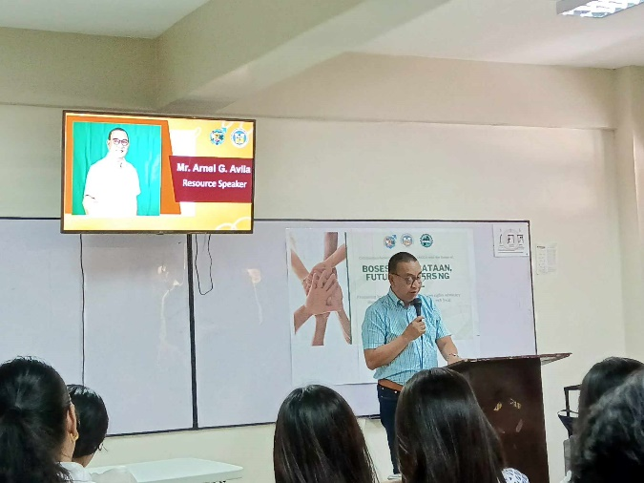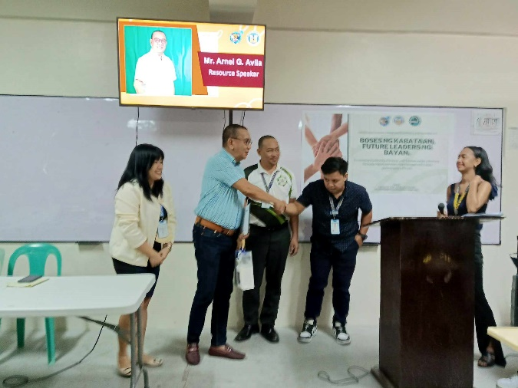
Mr. Arnel G. Avila started his discussion with some questions aligned with the topic titled, “How Leaders can work towards promoting diversity in leadership roles?”. And was honored by accepting the invitation and token of appreciation led by the Advisers.
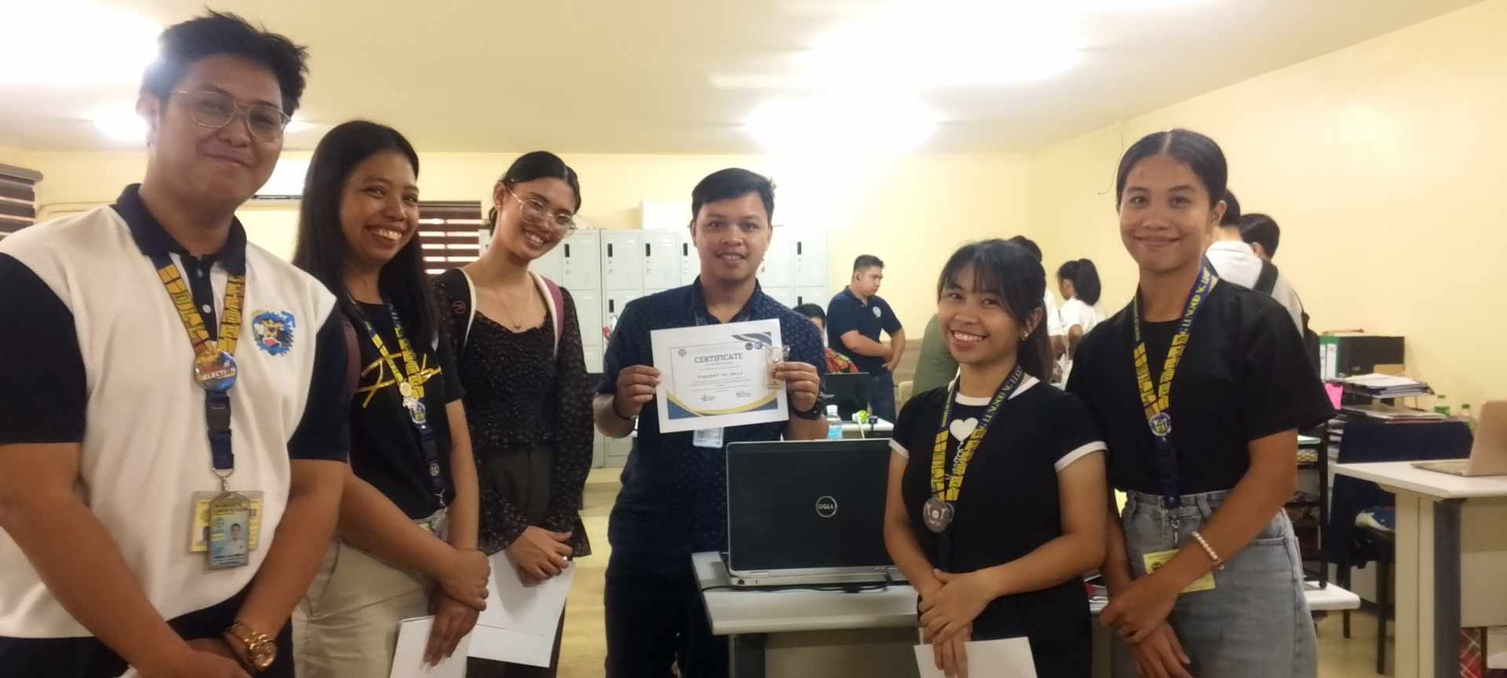

Followed by giving the snacks of Fudgee Bar and water with the closing remarks of Prof. Vincent De Gala that concluded with a warm appreciation to all participants for their active engagement.

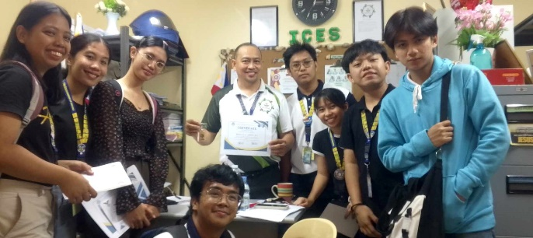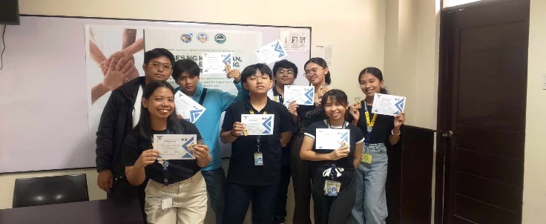
The project event was concluded with the giving of certificated and token of appreciations to all participated and committee together with the Advisers.

