ACCOMPLISHMENT REPORT
LGBTQ+ Rights Awareness: Celebrating Individuality, Fostering Inclusivity: A Journey of Authenticity and Acceptance
April 20, 2024

The project event was carried out by AKBAY, ROTARACT and ENGAGE, these three organizations collaborated to drive the effectiveness of the project event. The event commenced promptly at 9:00 in the morning at AVR, with confirmation of registered attendees through signed attendance sheets. The event was led by Mr. Claide Ivan B. Bacus. Followed by the Opening prayer that by Ms. Mary Dhil C. Saromines from the organization of AKBAY, followed by the Philippine National Anthem and the opening remark by Prof. Stephany Darrel Ann Fontanilla, a welcoming introduction with words of gratitude delivered off the event.to the participants and guest.
This seminar, led by Mr. Neric Rivera, tackled important issues related to gender and sexuality. As Mr. Rivera centered the topic by focusing on identifying and expressing gender identity while actively working to dismantle the stigma that often surrounds it. The guest speaker provides an opportunity for participants to broaden their perspectives, moving beyond binary notions of sexuality and embracing the richness of human diversity. By clarifying the sexual orientation, he empowers individuals to embrace and celebrate the unique ways people navigate their identities. Through this seminar, attendees are encouraged to expand their knowledge base, cultivating a more informed and empathetic outlook towards gender and sexuality.
Following Mr. Neric Rivera's presentation, he was recognized for his participation by the Advisers, who presented him with a memento of appreciation. The afternoon recess has also begun.
The program resumed for the afternoon activity at exactly 1:00 pm with the attendees and participants registration. The event hosted by Mr. Claide Ivan B. Bacus. With each contestant introduced, they then took center stage to showcase their talents to impressive abilities for the judges and audience. Following the showcase of talents, the announcement of the champions took place, with photos capturing the moment the winners were presented with their trophies and sashes.
Marking the successful completion of the project, the event closed with the presentation of certificates and tokens to the judges and committees.
Prepared by:

MARY DHIL C. SAROMINES
Assistant Secretary of AKBAY

MARY ANGEL M. ZURBANO
President, AKBAY

Signed by:

PROF. DARREL ANN STEPHANY P. FONTANILLA
Adviser, AKBAY

MR. VINCENT I. DE GALA
Adviser, AKBAY

MR. JELF VHON I. LABORTE
Adviser, ENGAGE

MR. BERNIE C. LECHUGA
Adviser, ROTARACT

Noted by:

MR. RYAN N. ALEMANIA
Coordinator, Office of the Student Affairs and Services

Approved by:

DR. MARIA CHARMAINE V. LAGUSTAN
President/Dean, Dalubhasaan ng Lungsod ng Lucena

DOCUMENTATION
LGBTQ+ Rights Awareness: Celebrating Individuality, Fostering Inclusivity: A Journey of Authenticity and Acceptance
April 20, 2024

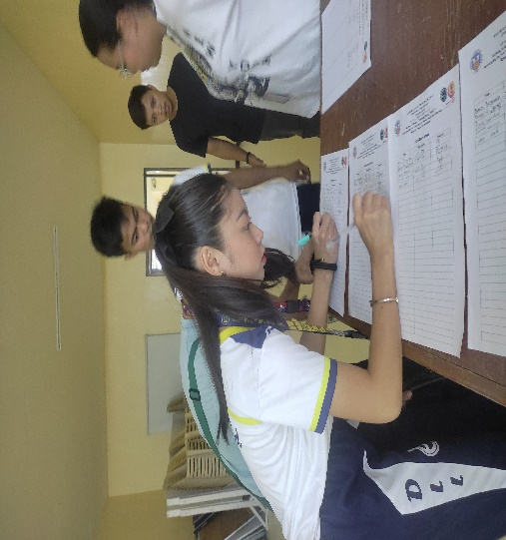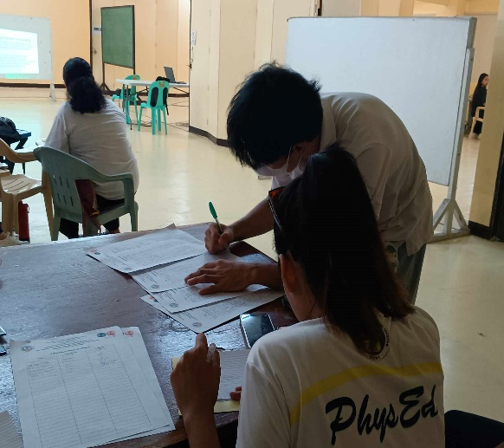
The event commenced promptly at 9:00 in the morning at AVR, with confirmation of registered attendees through signed attendance sheets.
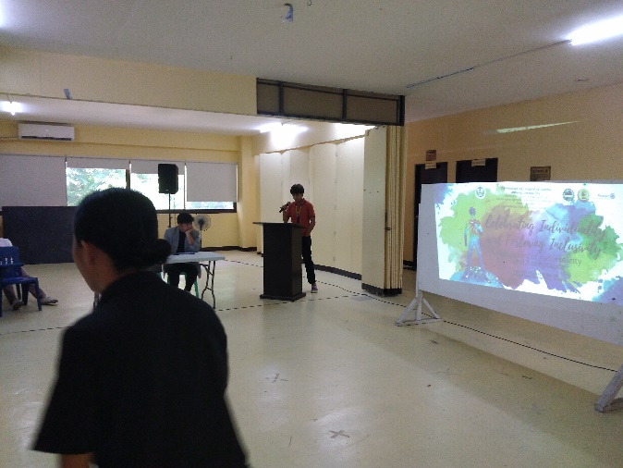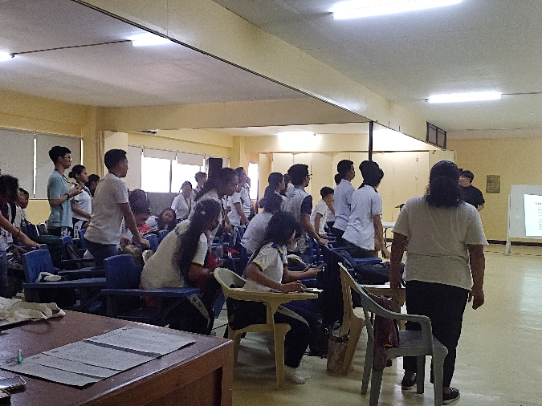
The event was led by Mr. Claide Ivan B. Bacus. Followed by the Opening prayer that by Ms. Mary Dhil C. Saromines from the organization of AKBAY, followed by the Philippine National Anthem
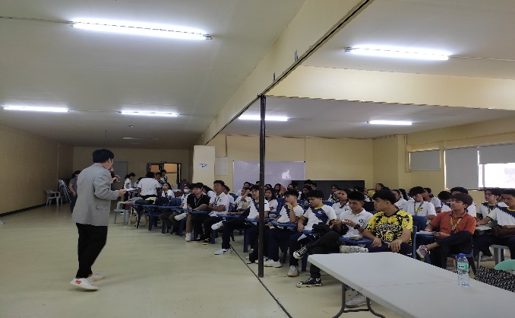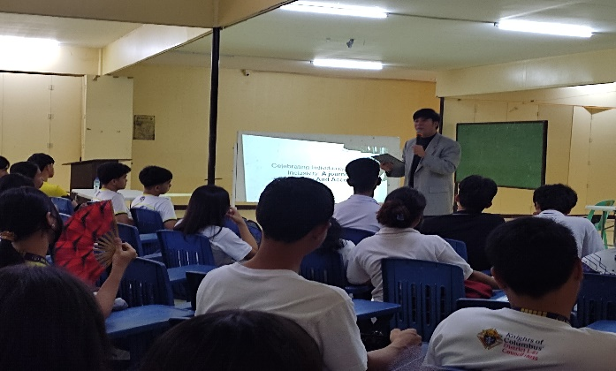
This seminar, led by Mr. Neric Rivera, tackled important issues related to gender and sexuality. As Mr. Rivera centered the topic by focusing on identifying and expressing gender identity while actively working to dismantle the stigma that often surrounds it.
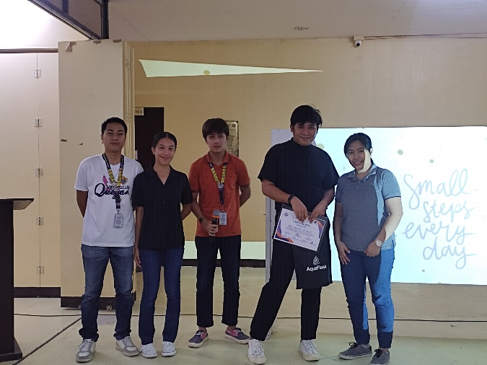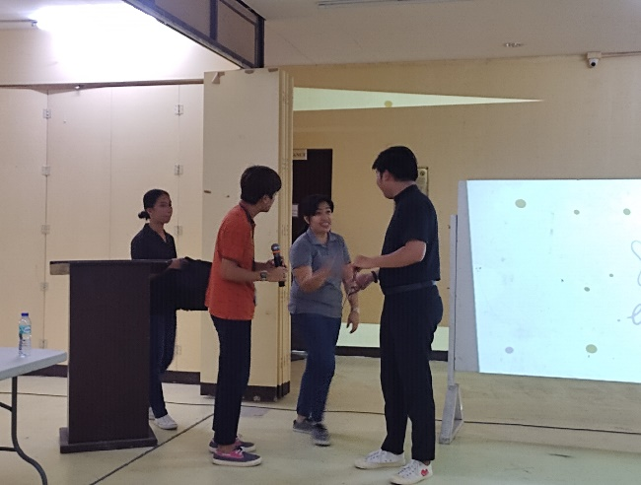
Following Mr. Neric Rivera's presentation, he was recognized for his participation by the Advisers, who presented him with a memento of appreciation. The afternoon recess has also begun.
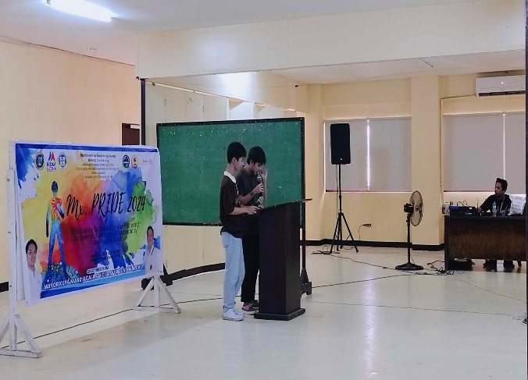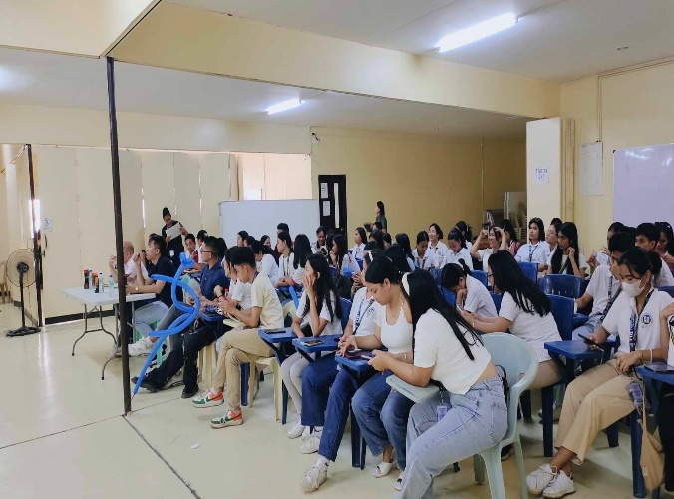
The program resumed for the afternoon activity at exactly 1:00 pm with the attendees and participants registration. The event hosted by Mr. Claide Ivan B. Bacus.
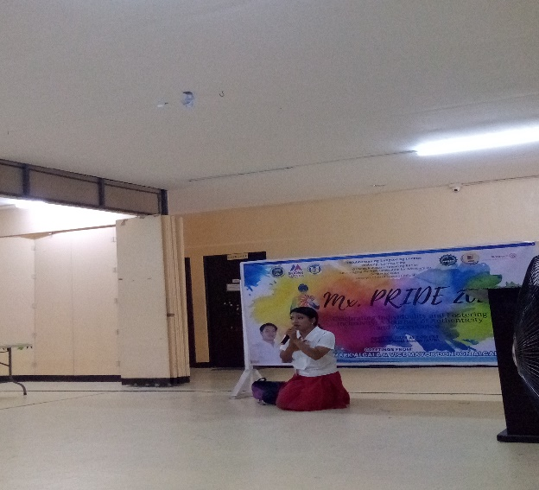
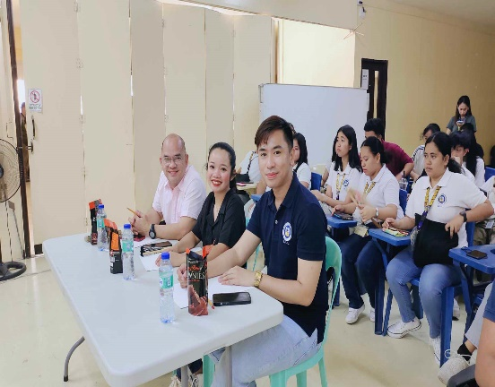
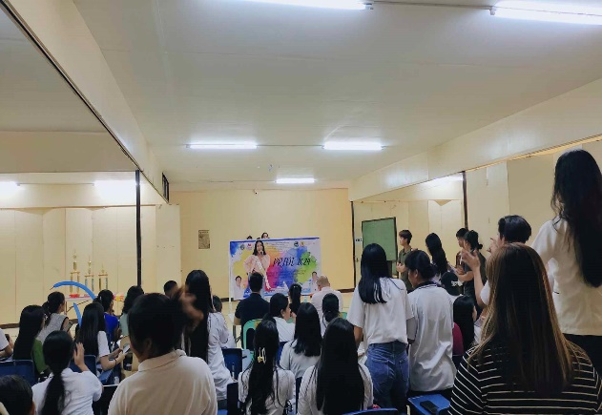
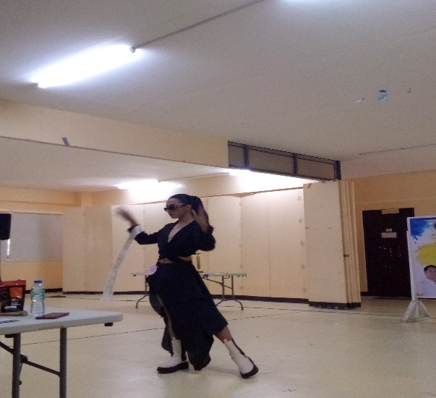
The contestant introduced their selves to the audiences and judges. Followed by showcase their talents to impressive abilities for the judges and audience.
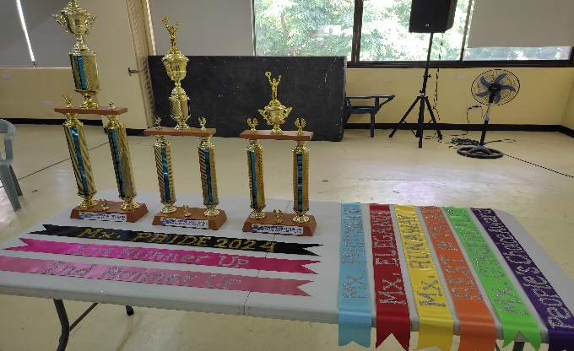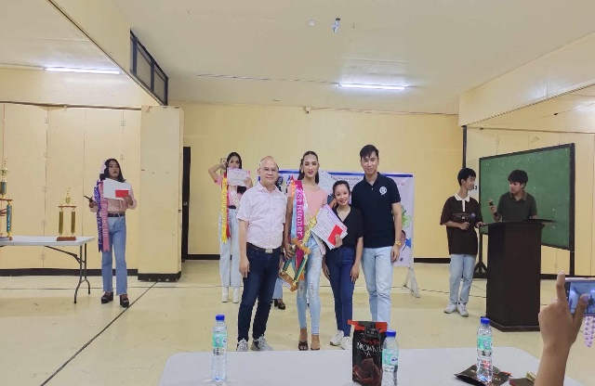
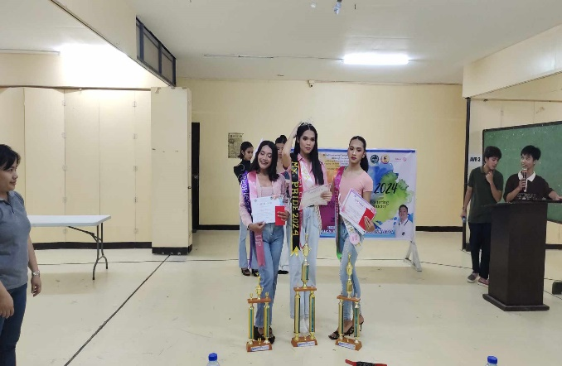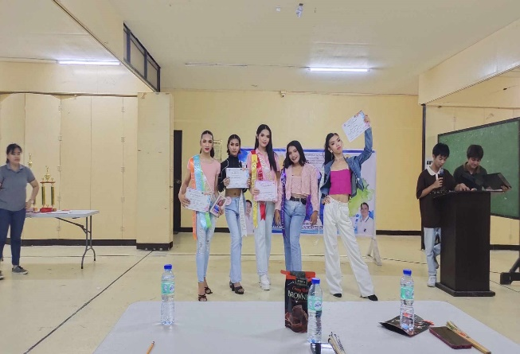
Following the showcase of talents, the announcement of the champions took place, with photos capturing the moment the winners were presented with their trophies and sashes.
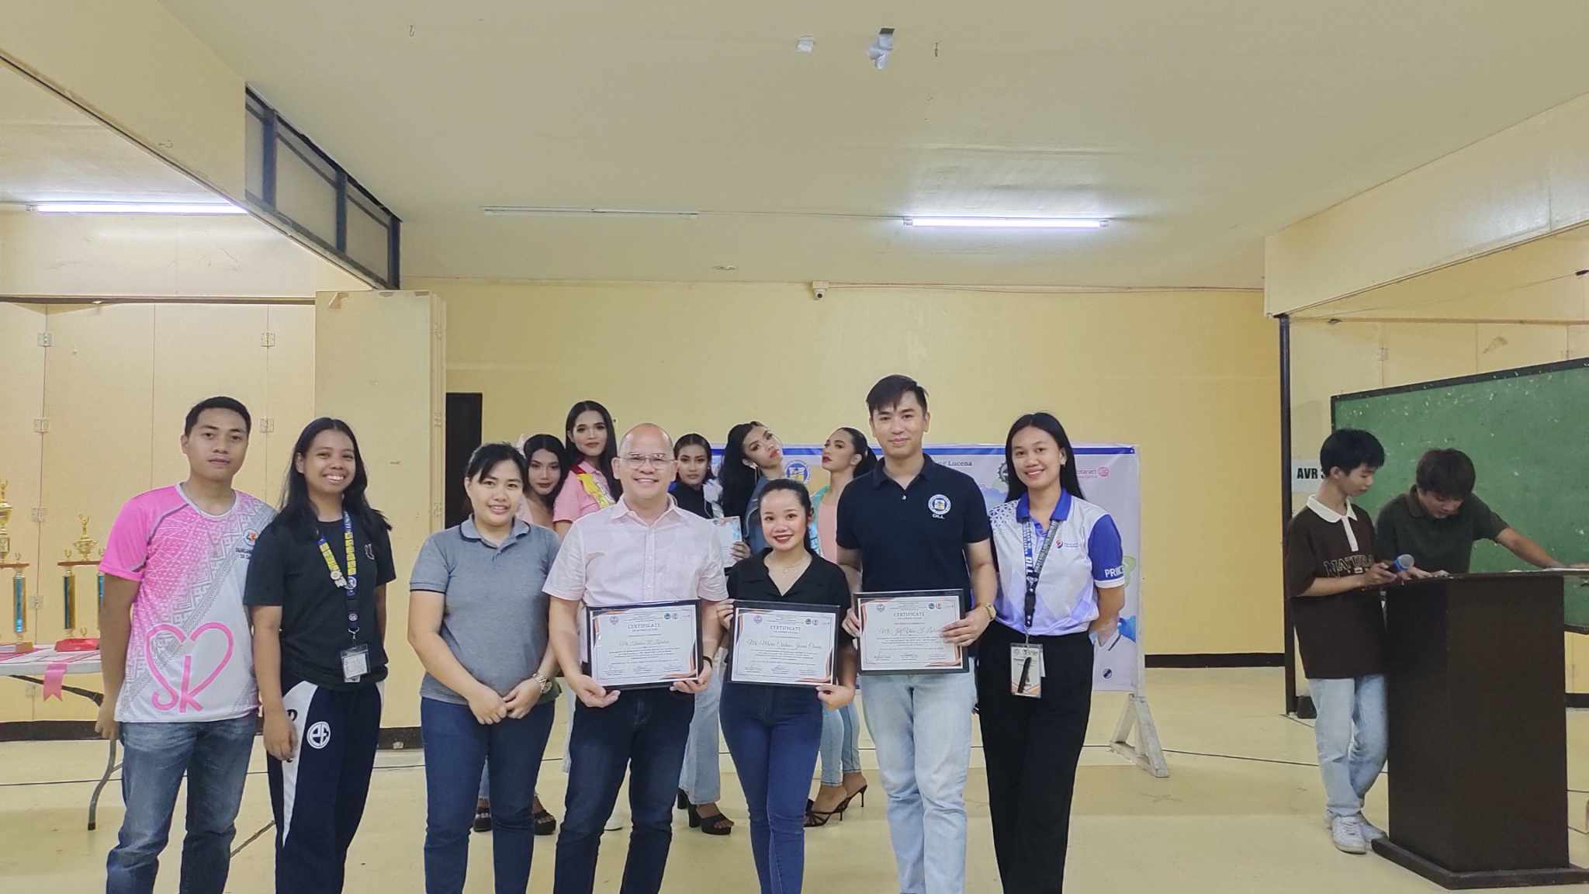
Marking the successful completion of the project, the event closed with the presentation of certificates and tokens to the judges and committees.

