SIEM SECURITY MONITORING PROJECT
Log Forwarding Architecture & Unauthorized Access Detection

1. Project Overview
This project demonstrates the deployment of a centralized logging infrastructure in a hybrid environment. I configured a Kali Linux sensor to forward security logs to a Splunk Enterprise instance on Windows 11. This pipeline was validated by simulating and detecting unauthorized SSH authentication attempts in real-time.

2. Network Architecture
Component | OS | IP Address | Role
Sensor | Kali Linux | 192.168.1.197 | Traffic Generation & Log Source
Analyzer | Windows 11 | 192.168.1.229 | Data Indexing & SIEM Visualization
EVIDENCE 01: SENSOR NETWORK CONFIGURATION
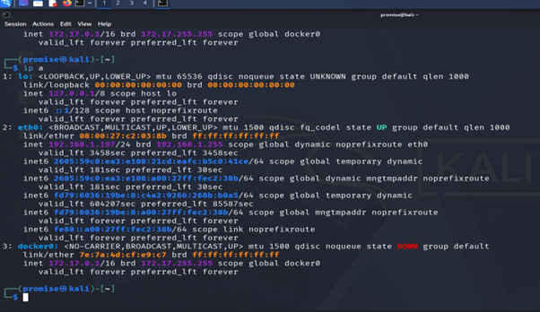Verification of the network interface on the Kali Linux sensor.

3. Data Pipeline Implementation
The Splunk Universal Forwarder was installed on the Kali sensor and configured to communicate with the receiver (Windows) via management port 9997.
EVIDENCE 02: DESTINATION CONFIGURATION
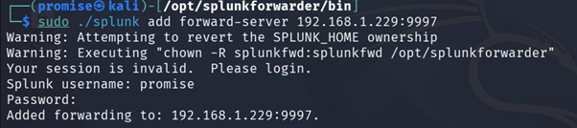
EVIDENCE 03: HANDSHAKE VERIFICATION

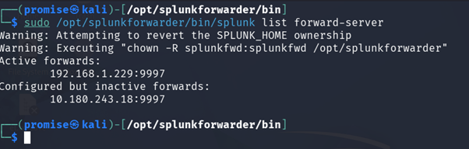

4. Security Incident Detection
An SSH 'attack' was simulated by attempting unauthorized access to the Kali machine. These events were piped into a dedicated log file and instantly forwarded to the SIEM.
EVIDENCE 04: SIMULATED SSH BRUTE FORCE
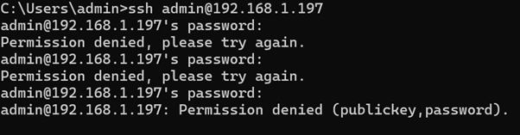

EVIDENCE 05: SIEM ALERT ANALYSIS

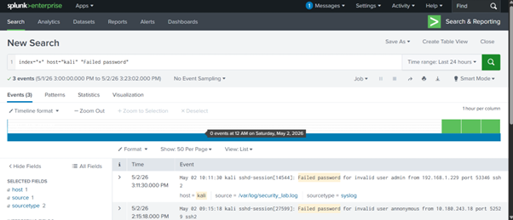

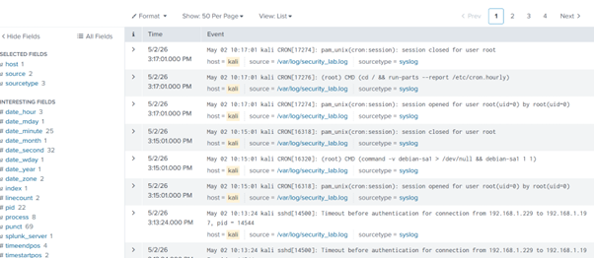

5. Analysis: The Timezone Discrepancy
Observation: As seen in Evidence 05, the log text shows 10:11 AM while the Splunk indexer reports 3:11 PM.
The Technical Reason: This is a 5-hour Timezone Offset. The Kali sensor is configured to UTC (Coordinated Universal Time) or a different local zone, while the Windows SIEM instance is recording events based on its local system clock.
Professional Remediation: In an enterprise SOC, we implement NTP (Network Time Protocol) synchronization across all systems to ensure chronologically accurate incident timelines for forensic investigations.

