Part I – sed

1. What will be the effect of the following commands? (provide screenshots of the result and short explanation) [6 marks]

sed '/^$/d' intro > text.out

sed 's/\([Uu]nix\)/\1(TM)/g' intro > text.out

date | cut -c12-16

1. Write the command to **f**ind all logged-in users with usernames of at least 6 characters. [3 marks]

Use : cut , /etc/passwd, sed

Sample output:

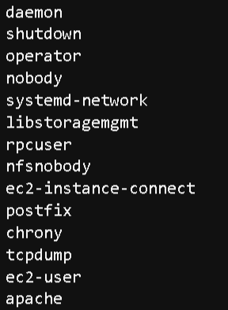

<https://www.gnu.org/software/sed/manual/sed.html>

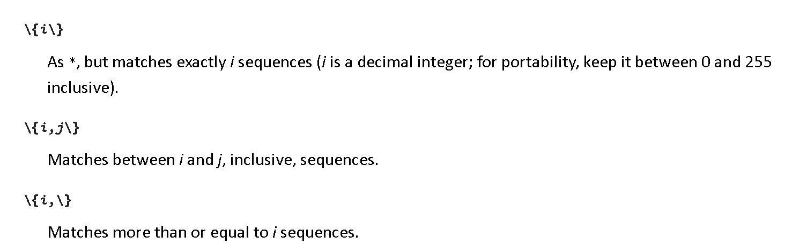

1. Write the command to **f**ind all the names with a as the second letter. [3 marks]

Use the text file “names”

Sample output:

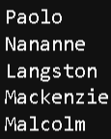

1. Challenge [3 marks]

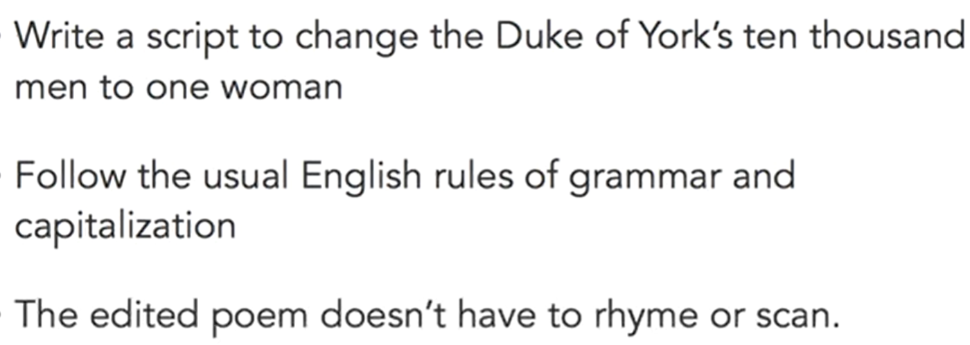

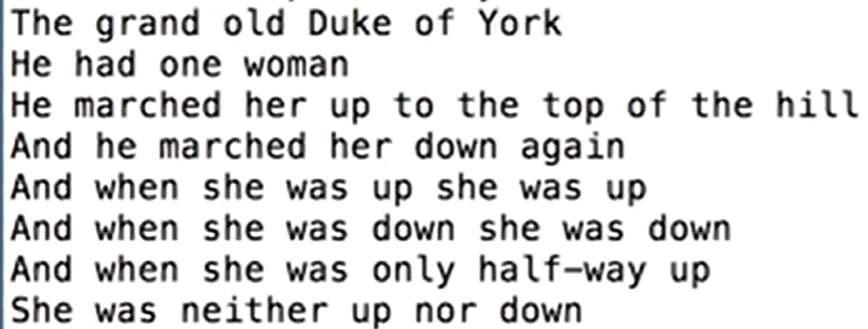

Sample output

Given file: dukeofyork.txt