**SCADA System Overview**

**Contents**

1. System Overview 3

2. System Structure 3

3. Network Layer 5

4. Data Layer 6

4.1. Real-time data 7

4.2. Historical Data 7

5. Human-machine Interface Layer 7

5.1. Real-time Monitoring 8

5.2. Real-time Data 9

5.3. Data Query 9

5.4. Report Statistics 10

5.5. Curve Analysis 11

5.6. Box-type Transformer Monitoring 11

5.7. Wind Turbine Control 11

# System Overview

Supervisory Control and Data Acquisition System, namely SCADA Secure Edition System (hereinafter referred to as SCADA), is a basic platform for functional requirements design and new research and development based on years of experience in wind farm monitoring operation and maintenance. Platform-based distributed system architecture, modular design, full use of network programming technology, multi-threaded concurrency, asynchronous mode, real-time library, cross-platform development (Windows, Linux), predictive algorithms, embedded development and other technologies to achieve a set of a safe wind farm monitoring system with high stability, high operating efficiency, easy to use, low maintenance, and convenient for secondary development.

# System Structure

SCADA is mainly divided into three layers：

* Network Layer

The network layer is mainly for wind turbine monitoring network equipment, including wind turbine switches and optical fiber networks.

* Database Layer

The database of SCADA includes a real-time database and a historical database, and the database layer mainly completes the function of connecting the previous and the next. The real-time database reads and writes data from the wind turbine, and then sends the current data to the client interface, and accepts the client's operation control request.

* Human-machine Interface Layer

The human-machine interface layer of SCADA can vividly display the current status of the wind turbine on the computer monitor, and allow the user to complete the control operation of the wind turbine. The client of SCADA can be configured with multiple, but the standard configuration is two.

SCADA is installed in the central control room of the wind farm to complete the monitoring and control of the wind turbine and provide a data platform for the expansion of the system. In SCADA, real-time data is the data that the data acquisition subsystem regularly transmits to the master station. These data mainly constitute the basis for various monitoring screen status, alarm information and report display in the monitoring system. In the case of a failure of SCADA, the operation of each wind turbine will not be disturbed. Similarly, in the case of a failure of each wind turbine, the operation of SCADA will not be disturbed.

# Network Layer

SCADA generally uses a double closed-loop network to connect all wind turbines(shown in Figure 1), and the system supports a larger number of closed-loop networks.

Each wind turbine is equipped with an industrial-grade switch. In the server cabinet, each closed-loop network needs to be configured with an industrial switch, and the model of the industrial switch is the same as all the switches in each Wind turbine. The switch uses 2 optical ports and 3 electrical ports.

If the installation conditions on site are complex, more closed-loop networks can be configured. The optical fiber closed-loop network supports any point of network disconnection without affecting the network operation, and all data communication is normal.

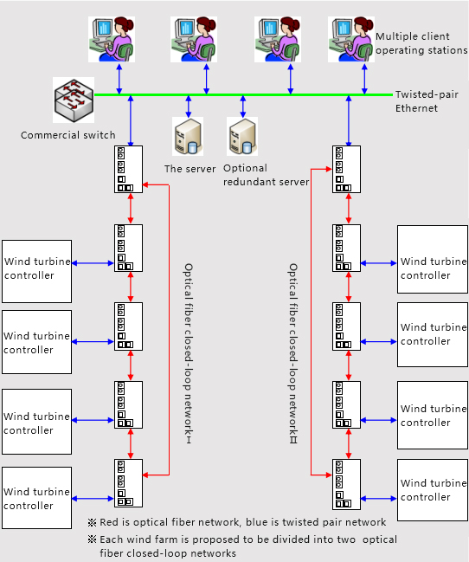

Figure 1. The Network Structure of SCADA

# Data Layer

SCADA supports simultaneous collection of data from all wind turbines in the wind farm, and all data collection uses concurrent connections.

The data collection of SCADA uses data memory blocks for data exchange to improve communication efficiency. At the same time, data collection also supports the designation of the data exchange rate of each memory block, which improves the need by reducing the refresh rate of unnecessary high-speed data collection memory blocks the data refresh rate of the high-speed acquisition data memory block.

## Real-time data

The real-time database can support redundant server configuration. If configured as mutually redundant servers, the system will automatically switch the servers in the dual computers.

The following are some data collection indicators:

* The real-time data processing module supports at least 20 client-side concurrent access, and it supports 20 operator stations.
* Supports continuous transmission when the network is disconnected to avoid loss of operating data caused by network failures.
* The communication protocol interface supports the CDT protocol, 104 protocol, ModbusRTU serial protocol, ModbuTCP network port protocol, etc. of the power industry, and other communication protocols can be dynamically added according to demand.
* Data collection supports remote configuration and maintenance, and remote centralized management of equipment.
* Support multi-device collection, such as Wind turbine, box-type transformers, wind measurement towers, booster stations, electric energy metering, reactive power compensation, etc., and all device data supported by interfaces can be collected.

## Historical Data

SCADA uses an industrial-grade historical database to support unlimited data records without increasing the query time due to the increase in data volume. The following are some indicators:

* Data storage period: 0.2~2S; data statistics period: 1s real-time value, 1min, 5min, 10min, 1h average value.
* On-site second-level data storage time is greater than 6 months.
* On-site data preservation integrity: 99.99%.
* The fault start/end time is accurate to 1S.

# Human-machine Interface Layer

For the wind farm monitoring system, the operating conditions and main parameters of each wind turbine must be displayed first, and then the wind turbine must be remotely controlled. As one of the main components of monitoring application software, the human-machine interface is a direct way to realize the monitoring and control functions of the wind farm monitoring system, as shown in Figure 5. The human-machine interface of SCADA (shown in Figure 6) contains the following 8 modules: real-time monitoring, real-time data, data query, report statistics, curve analysis, box-type transformer monitoring, wind turbine control, and the following will introduce the functions of each module in detail.

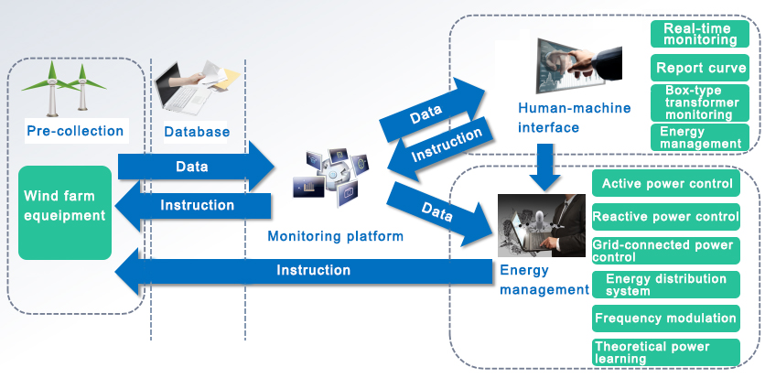

Figure 2. System Data Instruction Interaction Diagram

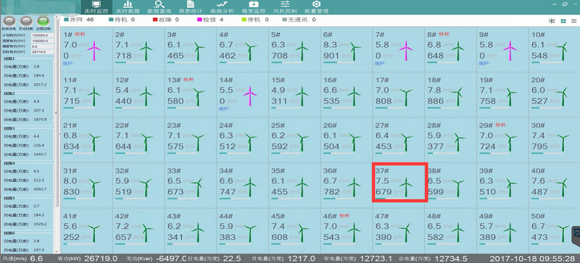

Figure 3. SCADA Interface

## Real-time Monitoring

Real-time monitoring can support free switching between the whole wind turbine monitoring screen and the single wind turbine monitoring screen. The real-time monitoring interface of the whole wind farm is the main interface of system start-up, which can view the distribution of all wind turbines in the entire wind farm, as well as the operating status, real-time wind speed and power of each Wind turbine. Real-time monitoring of a single machine can view the real-time status of a single Wind turbine. The detailed functions are as follows:

* Display the wind direction of the wind turbine to the north angle, wind speed, power, variable pitch angle, and speed information in the form of a dashboard.
* Display the static information, status and some statistical information of the Wind turbine, the name and address of the owner.
* It can realize remote start, remote stop and remote reset, active/reactive power control. Also, real-time curve and real-time data can be browsed.
* Display the status history and fault history of the last month.
* The monitoring points of the data panel can be customized to achieve multiple monitoring points comparison according to actual needs (multi-temperature comparison, multi-IO comparison, etc.).

## Real-time Data

The real-time data module displays the current monitoring results of the wind turbine in the wind farm. The specific functions are as follows:

* Wind turbine data of the whole wind farm is displayed in table form.
* Wind turbine data of the whole wind farm is displayed in the form of a bar graph.
* Freely configure the wind turbine IO information that needs to be displayed.
* Real-time data can be exported to local.

## Data Query

The data query contains three sub-modules: fault data, status data, and minute data. High-integrity, high-precision fault data can help determine the cause of the fault, and take timely measures to solve the problem to reduce the loss of wind abandonment. The historical status statistics will provide important data support for wind turbine performance evaluation. Each sub-module can freely choose to query partial or full-field wind turbine data, and customize the query time range. All data can be exported to the local report. The specific functions of each sub-module are as follows:

**Failure Data:**

* View the fault details, fault number, duration and power loss of a single fault of the selected Wind turbine.
* The start and end time of the fault data is accurate to the second.

**Status data:**

* View the historical status code, status description, first touch code, and first touch code description of the selected Wind turbine.

**Minute data:**

* The client-side supports 1min, 5min, 10min, 1h data query, and second-level data is stored in the database.
* Freely choose the IO points you need to query, support custom data query templates, and add, delete, and modify the IO list of the template.

## Report Statistics

Statistics the various data in the form of reports to help users to conduct comprehensive data analysis. Report statistics include three sub-modules: power generation statistics, wind turbine performance statistics, and lost power generation statistics. All reports can be exported to the local area, and each sub-module can be freely choose to query partial or full-site wind turbine reports, and customize the statistical time range. Through power generation statistics, wind turbine performance statistics, and lost power generation statistics, the performance of wind turbine can be objectively and comprehensively evaluated, and a long-term power balance monitoring system can be established to ensure the wind farm in the early stage of power loss, it can be detected in time and dealt with effectively to prevent the expansion of power loss and ensure that economic benefits are not affected. The specific functions of each submodule are as follows:

**Power generation statistics:**

* Support time report, daily report, monthly report and all data.
* The statistical results include Wind turbine, time, average wind speed, maximum wind speed, minimum wind speed, power generation, and full power hours.
* Total data of query results can be displayed.

**Wind turbine performance statistics:**

* The statistical results include Wind turbine, wind speed, effective wind hours, power generation hours, equivalent utilization hours, power generation, number of failures, failure hours, maintenance hours, hours of waiting for wind, hours of power restriction, hours of yaw and availability.
* Total data of query results can be displayed.

**Statistics of lost power generation:**

* The statistical results include the number of Wind turbine, potential power generation, actual power generation, failure loss power generation, maintenance loss power generation, remote shutdown loss power generation, maintenance loss power generation, grid power curtailment loss power generation, and master control power curtailment loss power generation.

## Curve Analysis

The curve analysis includes four sub-modules: power curve, free trend, relational curve, and wind frequency graph. Each sub-module supports data display, freely selects the time range to be queried, and exports graph data or table data to the local.

**The power curve** is the corresponding curve between the power of the wind turbine and the wind speed. During the operation of the Wind turbine, the power always changes with the change of wind speed. The trend of the power curve can describe the relationship between power and wind speed intuitively. The monitoring system power curve module can query 5 wind turbines at the same time, and provide the standard power curve as a reference. The display methods include trend graph and scatter graph.

**The free trend module** can freely select IO points to view the trend graph (curve), and supports single wind turbine multi-points and multiple wind turbines and single point modes. Single wind turbine multi-points can display the trend of multiple IO points for a single wind turbine in a certain period of time figure, supports simultaneous selection of three IO points for comparative analysis. Multiple wind turbines and single point modes can display the trend graph of the same IO point for multiple wind turbines within a certain period of time, and supports simultaneous selection of three wind turbines for comparative analysis.

**The relational curve** can view the relationship trend chart between any two IO points of a certain wind turbine within a certain period of time, and at the same time, the XY axis can be switched according to needs.

The wind frequency chart is used to count the occurrence frequency of different wind speeds of a specified wind turbine in a certain period of time. The X axis is the wind speed, and the Y axis is the number of occurrences of the corresponding wind speed. It supports selecting three wind turbines at the same time for comparison and query.

## Box-type Transformer Monitoring

View the remote measurement and remote signaling value of the wind turbine box-type transformer, and can perform remote opening or closing operations.

## Wind Turbine Control

The selected wind turbine can be remotely started/stopped, and all control actions will be saved in corresponding records, and the wind turbine control command history query will be provided to ensure that the operation records can be traced.