**SCADA System Overview**

**Contents**

1. System Introduction 4

2. System Overview 4

2.1. Network Layer 7

2.2. Data Layer 7

2.2.1. Real-time Data 8

2.2.2. Historical Data 9

2.3. Human-machine Interface Layer 9

2.3.1. Real-time Monitoring 9

2.3.2. Real-time Data 10

2.3.3. Data Query 10

2.3.4. Report Statistics 11

2.3.5. Curve analysis 12

2.3.6. Box-type transformer monitoring 13

2.3.7. Wind turbine control 13

3. System Support Interface 13

3.1. Data Collection Protocol 13

3.2. Data Forwarding Protocol 14

3.3. IO Collection and Forwarding 14

3.4. Data Collection and Forwarding Message Storage 14

3.5. Collect and Forward IO Points 14

3.6. Wind turbine standard status table 19

4. System Deployment Environment 19

4.1. System Hardware Structure 19

4.1.1. Central Monitoring Room System Part 19

4.1.2. Tower Base Cabinet Monitoring System Part 20

4.2. System Software Environment 20

4.2.1. Support Operating System 20

5. System Performance Indicators 21

5.1. System Availability 21

5.2. System Real-time 21

5.3. System Resources 21

5.3.1. CPU Average Load Rate of Each Workstation 21

5.3.2. Network Load Rate 21

5.3.3. Capacity 21

5.3.4. Historical Data Storage 22

6. Safety protection 22

6.1. Virus Protection 22

6.2. The Connection Between Mingyang Data and Firewall 22

7. Wind Turbine Optical Fiber Network 23

7.1. Wind Farm Network Optical Fiber Loop 23

7.2. Wind Farm Cable Distance Design Requirements 23

7.3. Single-mode Fiber Optic Cable Specifications 23

# System Introductions

The central monitoring system, namely SCADA Security Edition System(hereinafter referred to as SCADA system), is a basic platform for functional requirements design and new research and development based on years of experience in wind farm monitoring operation and maintenance. Platform-based distributed system architecture, modular design, full use of network programming technology, multi-threaded concurrency, asynchronous mode, real-time library, cross-platform development (Windows, Linux), predictive algorithms, embedded development and other technologies to achieve a set of a safe wind farm monitoring system with high stability, high operating efficiency, easy to use, low maintenance, and convenient for secondary development.

# System Overview

SCADA System mainly divided into three layers:

* Network Layer

The network layer is mainly for wind turbine monitoring network equipment, including wind turbine switches and optical fiber networks.

* Data Layer

The database of SCADA system includes a real-time database and a historical database, and the database layer mainly completes the function of connecting the previous and the next. The real-time database reads and writes data from the wind turbine, and then sends the current data to the client interface, and accepts the client's operation control request.

* Human-machine Interface Layer

The human-machine interface layer of SCADA system can vividly display the current status of the wind turbine on the computer monitor, and allow the user to complete the control operation of the wind turbine. The client of SCADA system can be configured with multiple, but the standard configuration is two.

SCADA system is installed in the central control room of the wind farm to complete the monitoring and control of the wind turbine and provide a data platform for the expansion of the system. In SCADA system, real-time data is the data that the data acquisition subsystem regularly transmits to the master station. These data mainly constitute the basis for various monitoring screen status, alarm information and report display in the monitoring system. In the case of a failure of SCADA system, the operation of each wind turbine will not be disturbed. Similarly, in the case of a failure of each wind turbine, the operation of SCADA system will not be disturbed. The software structure model is shown in Figure 1.

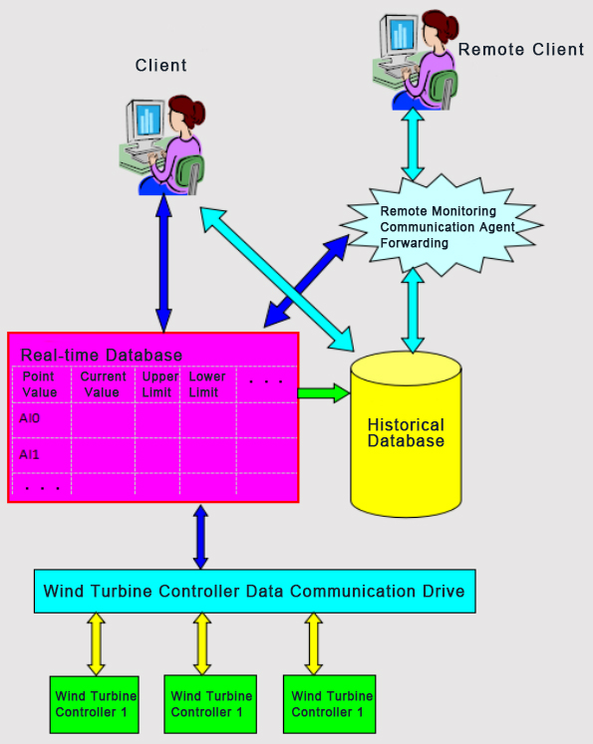

Figure 1

## Network Layer

SCADA system generally uses a double closed-loop network to connect all wind turbines(shown in Figure 2). The system supports a larger number of closed-loop networks, and each closed-loop network supports 20 to 50 wind turbines.

Each wind turbine is equipped with an industrial-grade switch. In the server cabinet, each closed-loop network needs to be configured with an industrial switch, and the model of the industrial switch is the same as all the switches in each wind turbine. The switch uses two optical ports and three electrical ports.

If the on-site installation conditions are complex, more closed-loop networks can be configured. The optical fiber closed loop network supports any point of network disconnection, without affecting the network operation, and all data communication is normal.

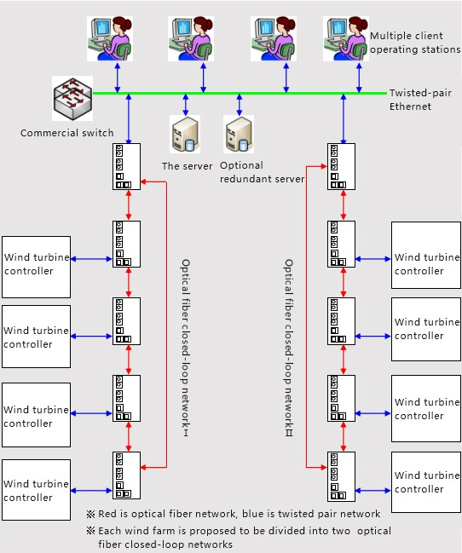

Figure 2

## Data Layer

SCADA system supports the simultaneous collection of data from all wind turbines in the field, and all data collection uses concurrent connections.

The data collection of the central control system adopts data memory blocks for data exchange to improve communication efficiency. At the same time, data collection also supports specifying the data exchange rate of each memory block, and improves the need by reducing the refresh rate of unnecessary high-speed data collection memory blocks. The data refresh rate of the high-speed acquisition data memory block.

### Real-time Data

The real-time data processing program module receives the real-time data sent from the data acquisition module of SCADA system and forwards it to all other applications that require real-time data, including historical databases. The forwarding efficiency is very high, and the forwarding time delay will not exceed 50 milliseconds.

The real-time database can support redundant server configuration. If it is configured as mutually redundant servers, the system will automatically switch the servers in the dual computers.

The following are some of the data collection indicators:

* Support high frequency recording, the acquisition frequency can be set, the shortest period can reach 50ms.
* Customizable selection of recording test points, setting of periodic timing recording, custom conditions to trigger recording, automatic upload of recording files to the wind farm SCADA system, providing a favorable data basis for finding the cause of wind turbine failure and locating faulty components.
* The real-time data processing module supports at least 20 clients concurrent access, and supports 20 operator stations.
* Support for resumable transmission when the network is disconnected to avoid loss of operating data caused by network failures.
* The communication protocol interface supports the 104 protocol of the power industry, Modbus RTU serial port protocol, Modbus TCP network port protocol, etc. At the same time, other communication protocols can be dynamically added according to demand.
* Data collection supports remote configuration and maintenance, and remote centralized management of equipment.
* Support multi-device collection, such as wind turbines, box-type transformers, wind measuring towers, booster stations, electric energy metering, reactive power compensation, etc., and the device data supported by the interface can be collected.

### Historical Data

SCADA system uses an industrial-grade historical database, which is specially designed for the record of a very large historical data system such as a wind farm. It supports almost unlimited data records without increasing the query time due to the increase in the amount of data. The following are some indicators:

* Data storage period: 0.2~2S; data statistics period: 1s real-time value, 1min, 5min, 10min and 1h average value.
* On-site second-level data storage time is greater than 6 months.
* On-site data preservation integrity: 99.99%.
* The fault start/end time is accurate to 1S.

## Human-machine Interface Layer

For the wind farm monitoring system, the operation status and main parameters of each wind turbine must be displayed first, and then the wind turbine must be remotely controlled. As one of the main components of monitoring application software, the human-machine interface is a direct way to realize the monitoring and control functions of the wind farm monitoring system. The human-machine interface of SCADA system includes the following 7 modules:

a) Real-time monitoring

b) Real-time data

c) Data query

d) Report statistics

e) Curve analysis

f) Box-type transformer monitoring

g) Wind turbine control

The function of each module will be introduced in detail below.

### Real-time Monitoring

Real-time monitoring can support the free switching the monitoring screen of the wind turbines in the entire wind farm and the single wind turbine monitoring screen. The full-site real-time monitoring interface is the main interface for system startup. You can view the distribution of all wind turbines in the entire wind farm, as well as the operating status, real-time wind speed and power of each wind turbine; single-machine real-time monitoring can view the real-time status of a single wind turbine. The detailed functions are as follows:

* Display the wind direction of the wind turbine to the north angle, wind speed, power, variable pitch angle, speed information in the form of a dashboard.
* Display the static information, status and some statistical information of the wind turbine, the name and address of the owner.
* It can realize remote start and stop, reset, active/reactive power control, real-time curve and real-time data can be browsed.
* Display the status history and fault history of the last month.
* The monitoring points of the data panel can be customized, and multiple monitoring points can be compared according to actual needs (multi-temperature comparison, multi-IO comparison, etc.).

### Real-time Data

The real-time data module displays the monitoring results of the wind turbines at the current moment. The specific functions are as follows:

* The data of wind turbine in the entire wind farm is displayed in table form.
* The data of wind turbine in the entire wind farm is displayed in the form of a bar graph.
* The IO information of wind turbine that needs to be displayed can be freely configured.
* Real-time data can be exported to local.

### Data Query

The data query contains three sub-modules: fault data, status data and minute data. High-integrity and high-precision fault data can help determine the cause of the fault, and take timely measures to solve the problem to reduce the loss of wind abandonment. Historical status statistics will be correct the performance evaluation of wind turbines provides important data support. Each sub-module can freely choose to query the data of part or all wind turbines in the entire wind farm, and customize the query time range. All data supports to export report to local. The specific functions of each sub-module are as follows:

**Failure Data:**

* •View the fault details, fault number, duration and power loss of a single fault of the selected Wind turbine.
* •The start and end time of the fault data is accurate to the second.

**Status data:**

* •View the historical status code, status description, first touch code, and first touch code description of the selected Wind turbine.

**Minute data:**

* •The client-side supports 1min, 5min, 10min, 1h data query, and second-level data is stored in the database.
* •Freely choose the IO points you need to query, support custom data query templates, and add, delete, and modify the IO list of the template.

### Report Statistics

Statistics the various data in the form of reports to help users to conduct comprehensive data analysis. Report statistics include three sub-modules: power generation statistics, wind turbine performance statistics, and lost power generation statistics. All reports can be exported to the local area, and each sub-module can be freely choose to query partial or full-site wind turbine reports, and customize the statistical time range. Through power generation statistics, wind turbine performance statistics, and lost power generation statistics, the performance of wind turbine can be objectively and comprehensively evaluated, and a long-term power balance monitoring system can be established to ensure the wind farm in the early stage of power loss, it can be detected in time and dealt with effectively to prevent the expansion of power loss and ensure that economic benefits are not affected. The specific functions of each sub-module are as follows:

Power generation statistics:

* •Support time report, daily report, monthly report and all data.
* •The statistical results include wind turbine, time, average wind speed, maximum wind speed, minimum wind speed, power generation, and full power hours.
* •Total data of query results can be displayed.

Wind turbine performance statistics:

* •The statistical results include Wind turbine, wind speed, effective wind hours, power generation hours, equivalent utilization hours, power generation, number of failures, failure hours, maintenance hours, hours of waiting for wind, hours of power restriction, hours of yaw and availability.
* •Total data of query results can be displayed.

Statistics of lost power generation:

* •The statistical results include the number of Wind turbine, potential power generation, actual power generation, failure loss power generation, maintenance loss power generation, remote shutdown loss power generation, maintenance loss power generation, grid power curtailment loss power generation, and master control power curtailment loss power generation.

### Curve analysis

The curve analysis includes four sub-modules: power curve, free trend, relational curve, and wind frequency graph. Each sub-module supports data display, freely selects the time range to be queried, and exports graph data or table data to the local.

The power curve is the corresponding curve between the power of the wind turbine and the wind speed. During the operation of the Wind turbine, the power always changes with the change of wind speed. The trend of the power curve can describe the relationship between power and wind speed intuitively. The monitoring system power curve module can query 5 wind turbines at the same time, and provide the standard power curve as a reference. The display methods include trend graph and scatter graph.

The free trend module can freely select IO points to view the trend graph (curve), and supports single wind turbine multi-points and multiple wind turbines and single point modes. Single wind turbine multi-points can display the trend of multiple IO points for a single wind turbine in a certain period of time figure, supports simultaneous selection of three IO points for comparative analysis. Multiple wind turbines and single point modes can display the trend graph of the same IO point for multiple wind turbines within a certain period of time, and supports simultaneous selection of three wind turbines for comparative analysis.

The relational curve can view the relationship trend chart between any two IO points of a certain wind turbine within a certain period of time, and at the same time, the XY axis can be switched according to needs.

The wind frequency chart is used to count the occurrence frequency of different wind speeds of a specified wind turbine in a certain period of time. The X axis is the wind speed, and the Y axis is the number of occurrences of the corresponding wind speed. It supports selecting three wind turbines at the same time for comparison and query.

### Box-type transformer monitoring

View the remote measurement and remote signaling value of the wind turbine box-type transformer, and can perform remote opening or closing operations.

### Wind turbine control

The selected wind turbine can be remotely started/stopped, and all control actions will be saved in corresponding records, and the wind turbine control command history query will be provided to ensure that the operation records can be traced.

# System Support Interface

## Data Collection Protocol

SCADA system supports data collection of multiple data protocols, including:

|  |  |
| --- | --- |
| Protocol name | Description |
| Modbus TCP | Support function code 01 (read coil status), 02 (read discrete input status), 03 (read holding register), 04 (read input register), 05 (write coil status), 06 (write single holding register), 15 (write multiple coils status), 16 (write multiple holding registers) |
| Modbus RTU | Support function code 01 (read coil status), 02 (read discrete input status), 03 (read holding register), 04 (read input register), 05 (write coil status), 06 (write single holding register), 15 (write multiple coils status), 16 (write multiple holding registers) |
| ADS Protocol | Support two ways of variable collection: address mode and variable name collection mode |
| OPC Protocol | Support data collection of OPC protocol |
| IEC 104 | Support data collection of IEC104 protocol |

Table 1

All the above protocols can meet the four remote functions:

|  |  |
| --- | --- |
| Protocol name | Description |
| Remote measurement | Support remote measurement data collection |
| Remote signaling | Support remote signal data collection |
| Remote control | Support the issuance of remote control data, and remotely control some remote switch control equipment |
| Remote adjustment | Support receiving and executing remote control commands, and control and debug remote control equipment |

Table 2

## Data Forwarding Protocol

SCADA system supports data forwarding of multiple data protocols to meet the data upload requirements of provincial dispatch centers and local dispatch centers. The support protocols include:

* Modbus TCP
* Modbus RTU
* IEC 104

## IO Collection and Forwarding

Both the IO points collected by the SCADA system and the forwarded IO points support dynamic configuration. The implementation personnel of SCADA system can customize the configuration of IO points according to the actual situation of the wind farm.

## Data Collection and Forwarding Message Storage

SCADA system collects and forwards messages and supports record storage. The message information of the corresponding time period can be found in the log recording program.

## Collect and Forward IO Points

The main point table for collection and forwarding of a single wind turbine (parts are listed below):

|  |  |  |  |
| --- | --- | --- | --- |
| Serial Number | Owning system | IO name | Chinese description |
|  | Environment | grOutdoorTemperature | 室外温度 |
|  | grAirDensity | 空气密度 |
|  | grCorrectedWindSpeed | 修正风速 |
|  | grWindSpeed | 风速 |
|  | grWindDirctionToNorth | 风向对北角度 |
|  | grWindDirction | 风向 |
|  | grWindSpeed1 | 风速1 |
|  | grWindSpeed2 | 风速2 |
|  | grWindDirction1 | 风向1 |
|  | grWindDirction2 | 风向2 |
|  | grWindSpeed30s | 30s平均风速 |
|  | grWindSpeed10min | 10min平均风速 |
|  | grWindTurbulence | 湍流 |
|  | Pitch system | grPitchAngle1A | 桨叶角度1A |
|  | grPitchAngle1B | 桨叶角度1B |
|  | grPitchAngle2A | 桨叶角度2A |
|  | grPitchAngle2B | 桨叶角度2B |
|  | grPitchAngle3A | 桨叶角度3A |
|  | grPitchAngle3B | 桨叶角度3B |
|  | grPitchAngleSetPoint1 | 变桨角度设定值1 |
|  | grPitchAngleSetPoint2 | 变桨角度设定值2 |
|  | grPitchAngleSetPoint3 | 变桨角度设定值3 |
|  | grPitchSpeed1 | 桨叶1变桨速度 |
|  | grPitchSpeed2 | 桨叶2变桨速度 |
|  | grPitchSpeed3 | 桨叶3变桨速度 |
|  | grPitchMotorCurrent1 | 桨叶1电机电流 |
|  | grPitchMotorCurrent2 | 桨叶2电机电流 |
|  | grPitchMotorCurrent3 | 桨叶3电机电流 |
|  | grPitchBackupPowerCabinetTemperture1 | 电池箱1温度 |
|  | grPitchBackupPowerCabinetTemperture2 | 电池箱2温度 |
|  | grPitchBackupPowerCabinetTemperture3 | 电池箱3温度 |
|  | grPitchDriverCabinetTemperture1 | 轴1箱温度 |
|  | grPitchDriverCabinetTemperture2 | 轴2箱温度 |
|  | grPitchDriverCabinetTemperture3 | 轴3箱温度 |
|  | grPitchMotorTemperture1 | 电机1温度 |
|  | grPitchMotorTemperture2 | 电机2温度 |
|  | grPitchMotorTemperture3 | 电机3温度 |
|  | grHubTemperture | 轮毂温度 |
|  | grPitch1BackUpPowerCapacity | 变桨轴1电容模组容量值 |
|  | grPitch2BackUpPowerCapacity | 变桨轴2电容模组容量值 |
|  | grPitch3BackUpPowerCapacity | 变桨轴3电容模组容量值 |
|  | iPitch1StateWord | 变桨轴1状态字 |
|  | iPitch2StateWord | 变桨轴2状态字 |
|  | iPitch3StateWord | 变桨轴3状态字 |
|  | grPitch1DCLinkVoltage | 桨叶1驱动器直流母线电压 |
|  | grPitch2DCLinkVoltage | 桨叶2驱动器直流母线电压 |
|  | grPitch3DCLinkVoltage | 桨叶3驱动器直流母线电压 |
|  | grPitch1PercentageOfTorque | 桨叶1电机转矩百分比 |
|  | grPitch2PercentageOfTorque | 桨叶2电机转矩百分比 |
|  | grPitch3PercentageOfTorque | 桨叶3电机转矩百分比 |
|  | grPitch1DriveHeatSinkTemperature | 桨叶1驱动器散热片温度 |
|  | grPitch2DriveHeatSinkTemperature | 桨叶2驱动器散热片温度 |
|  | grPitch3DriveHeatSinkTemperature | 桨叶3驱动器散热片温度 |
|  | grPitchPercentageOfBatteryLifeRemainingHealthy1 | 桨叶1电池健康寿命残余百分比 |
|  | grPitchPercentageOfBatteryLifeRemainingHealthy2 | 桨叶2电池健康寿命残余百分比 |
|  | grPitchPercentageOfBatteryLifeRemainingHealthy3 | 桨叶3电池健康寿命残余百分比 |
|  | grPitchAxisBackUpVoltage1 | 变桨轴后备电压1 |
|  | grPitchAxisBackUpVoltage2 | 变桨轴后备电压2 |
|  | grPitchAxisBackUpVoltage3 | 变桨轴后备电压3 |
|  | grPitchChargerOutputVoltage1 | 变桨轴充电输出电压1 |
|  | grPitchChargerOutputVoltage2 | 变桨轴充电输出电压2 |
|  | grPitchChargerOutputVoltage3 | 变桨轴充电输出电压3 |
|  | grPitchChargerOutputCurrent1 | 变桨轴充电输出电流1 |
|  | grPitchChargerOutputCurrent2 | 变桨轴充电输出电流2 |
|  | grPitchChargerOutputCurrent3 | 变桨轴充电输出电流3 |
|  | grPitchCapacitorTemperature1 | 变桨电容温度1 |
|  | grPitchCapacitorTemperature2 | 变桨电容温度2 |
|  | grPitchCapacitorTemperature3 | 变桨电容温度3 |
|  | grPitchCapacityValue1 | 变桨容量值1 |
|  | grPitchCapacityValue2 | 变桨容量值2 |
|  | grPitchCapacityValue3 | 变桨容量值3 |
|  | grPitchCoolerTemperature1 | 变桨散热温度1 |
|  | grPitchCoolerTemperature2 | 变桨散热温度2 |
|  | grPitchCoolerTemperature3 | 变桨散热温度3 |
|  | grPitchAxis1HubSpeed | 变桨轴1轮毂速度 |
|  | grPitchAxis2HubSpeed | 变桨轴2轮毂速度 |
|  | grPitchAxis3HubSpeed | 变桨轴3轮毂速度 |
|  | giPitchBearingLubricationActionTimes | 变桨轴承润滑动作次数 |
|  | giPitchBearingToothLubricationActionTimes | 变桨齿面润滑动作次数 |
|  | grPitchBearingToothLubricationOperationTime | 变桨齿面运行时间 |
|  | grPitch1FollowingDifference | 桨叶1跟随偏差 |
|  | grPitch2FollowingDifference | 桨叶2跟随偏差 |
|  | grPitch3FollowingDifference | 桨叶3跟随偏差 |
|  | gdiPitchBearingLubricationOperationTime | 变桨轴承运行时间 |
|  | gdiPitch1MotorOpetationTime | 桨叶1电机运行时间 |
|  | gdiPitch2MotorOpetationTime | 桨叶2电机运行时间 |
|  | gdiPitch3MotorOpetationTime | 桨叶3电机运行时间 |
|  | gbPitch1HeartBeatNormal | 变桨1心跳正常 |
|  | gbPitch2HeartBeatNormal | 变桨2心跳正常 |
|  | gbPitch3HeartBeatNormal | 变桨3心跳正常 |
|  | gbPitch1LimitSwitchActive91 | 桨叶1限位开关91度触发 |
|  | gbPitch2LimitSwitchActive91 | 桨叶2限位开关91度触发 |
|  | gbPitch3LimitSwitchActive91 | 桨叶3限位开关91度触发 |
|  | gbPitch1LimitSwitchActive95 | 桨叶1限位开关95度触发 |
|  | gbPitch2LimitSwitchActive95 | 桨叶2限位开关95度触发 |
|  | gbPitch3LimitSwitchActive95 | 桨叶3限位开关95度触发 |
|  | gbPitchBypassCommand | 桨叶旁通命令 |
|  | gbPitchEFCCommand | 变桨EFC命令 |
|  | gbPitchSafeSignal | 变桨安全信号 |
|  | gbPitchSafetyPosition | 变桨安全位置信号 |
|  | gb5DSwitchStateA1 | 轴A5度接近开关 |
|  | gb86DSwitchStateA1 | 轴A86度接近开关 |
|  | gb5DSwitchStateA2 | 轴B5度接近开关 |
|  | gb86DSwitchStateA2 | 轴B86度接近开关 |
|  | gb5DSwitchStateA3 | 轴C5度接近开关 |
|  | gb86DSwitchStateA3 | 轴C86度接近开关 |
|  | giPitchBearingLubricationOnCommand | 变桨轴承润滑动作命令 |
|  | giPitchBearingToothLubricationOnCommand | 变桨齿面润滑动作命令 |
|  | giPitchBearingLubricationPulse | 变桨轴承润滑动作反馈信号 |
|  | giPitchBearingToothLubricationPulse | 变桨齿面润滑动作反馈信号 |
|  | Rotor system | grRotorSpeed1 | 叶轮转速1 |
|  | grRotorSpeed2 | 叶轮转速2 |
|  | grRotorPosition | 叶轮位置 |
|  | giRotorLockValveActiveTimes | 叶轮锁定电磁阀动作次数 |
|  | giRotorBrakeValveActiveTimes | 主轴刹车电磁阀动作次数 |
|  | gdiRotorLockValveActiveTime | 叶轮锁定电磁阀动作时间 |
|  | gdiRotorBrakeValveActiveTime | 主轴刹车电磁阀动作时间 |
|  | gdiRotorTurns | 主轴转数 |
|  | gbRotorLock1Actived | 叶轮锁定销1锁定 |
|  | gbRotorLock2Actived | 叶轮锁定销2锁定 |
|  | gbRotorLock1Deactived | 叶轮锁定销1释放 |
|  | gbRotorLock2Deactived | 叶轮锁定销2释放 |
|  | gbRotorLockActiveCommand | 叶轮锁定销伸出命令 |
|  | gbRotorLockDeactiveCommand | 叶轮锁定销收回命令 |
|  | Trigger | giTurbineOperationStatus | 机组运行状态 |
|  | giTriggerSCAdress | 首触故障地址 |

Table 3

## Wind turbine standard status table

|  |  |
| --- | --- |
| Turbine Operation Status giTurbineOperationStatus | Status Name |
| 1 | Untether |
| 2 | Start machine |
| 3 | Grid-connected operation |
| 4 | Failure |
| 5 | Overhaul |
| 6 | Maintain |
| 7 | Manual shutdown |
| 8 | Remote shutdown |
| 9 | Small wind shutdown |
| 10 | Wind speed or wind direction exceeds the limit and shutdown |
| 11 | Grid failure and shutdown |
| 12 | High outdoor temperature |
| 13 | Low outdoor temperature |

Table 4

# System Deployment Environment

## System Hardware Structure

The main hardware equipment of the SCADA system includes data servers, industrial switches, server cabinets, UPS power supplies, operator station computers and so on.

### Central Monitoring Room System Part

The central control room is equipped with two servers and two operation station computers as standard. The server is configured as one main and one standby dual server. The number of operator stations can be configured to a larger number according to user requirements, and the functions of each operator station are exactly the same without conflict with each other. One operation station in the central control room is equipped with an alarm speaker as standard.

### Tower Base Cabinet Monitoring System Part

The tower base cabinet monitoring system is mainly a monitoring system industrial switch. The switch is equipped with two optical ports and multiple electrical ports, and the power supply of the switch adopts the power supply of the tower base cabinet control system. All tower base cabinet industrial switches are connected to a closed loop network through optical ports.

The main equipment of the monitoring system configuration is as follows:

|  |  |  |  |
| --- | --- | --- | --- |
| Name | Quantity | Unit | Description |
| Data server | 2 | set | Real-time data collection, data processing, real-time database update and management and data query, etc. . |
| Operator workstation | 2 | set | Used to run the monitoring system software. Operation duty personnel pass through the operator station, realize the monitoring, control and management of the wind turbine. |
| Voice alarm speaker | 1 | set | Used for voice alarm when the fan fails or abnormal. |
| Report printer | 1 | set | Printing of reports and related documents. |
| Hardware firewall | 1 | set | Control the flow of information into and out of the network according to the network structure and security policy with strong resistance to attack. |
| Core switch | 1 | set | The backbone network of the monitoring system. |
| Fiber aggregation switch | 1 | set | Used for the access of optical fiber ring network signal. |
| UPS power supply | 1 | set | Power supply guarantee for system and network equipment. |

Table 5

## System Software Environment

### Support Operating System

Operating systems compatible with SCADA system:

|  |  |
| --- | --- |
| Windows | Windows 7 |
| Windows 8 |
| Windows 10 |
| Windows Server 2008 |
| Windows Server 2012 |
| Windows Server 2016 |
| Windows Server 2019 |
| Linux | RedHat V6/V7/V8 |
| CentOS V6/V7/V8 |
| Ubuntu V16/V18/V19 |
| Zhongbiao Qilin V6/V7 |
| Hunan Qilin V3.2/V3.3 |
| Yinhe Qilin V4 |

Table 6

# System Performance Indicators

## System Availability

1. Annual availability rate of dual machine system: ≥99.98%
2. Operating life of main equipment in the system: ≥99.98%
3. Correct rate of control operation: ≥99.99%
4. Operating life of main equipment in the system: ≥99.98%

## System Real-time

1. Time from generation to output of manual control command: ≤1s
2. The response time of the entire screen call:
3. Real-time picture: ≤1s
4. Other pictures: ≤2s
5. Real-time data refresh cycle of the screen: ≤3s
6. Active/standby switching time of dual redundant system: ≤2s

## System Resources

### CPU Average Load Rate of Each Workstation

1. The average load rate of the workstation CPU: ≤15%

### Network Load Rate

1. The average load rate of the main station LAN: ≤10%

### Capacity

1. Analog quantity: ≥8000points
2. State quantity: ≥10000points
3. Remote control: ≥500points
4. Calculation amount: ≥2000points

### Historical Data Storage

1. Historical report data storage: ≥5 years
2. Event alarm data storage: ≥5 years
3. Second-level data storage: ≥6months
4. Data storage integrity: ≥99.99%

# Safety protection

## Virus Protection

Install anti-virus software, update the software version in time and perform virus detection on a regular basis.

Prohibit the use of removable storage devices on the computer, and disable the USB port.

Disable spare network ports and set a whitelist of network devices.

## The Connection Between Mingyang Data and Firewall

The equipment that exchanges data with the Mingyang SCADA system must pass through a firewall to establish a connection with the Mingyang server.

The hardware firewall is to implement the firewall program in the chip, and the hardware performs these functions, which can reduce the burden on the CPU and make the routing more stable. When the communication initiates a connection, it checks whether the rule allows the connection to be established and then adds a record to the cached state detection table. There is no need to check the rule in the future. Just check the state detection table and it will be OK. The speed is greatly improved. Promote. As shown in figure three:

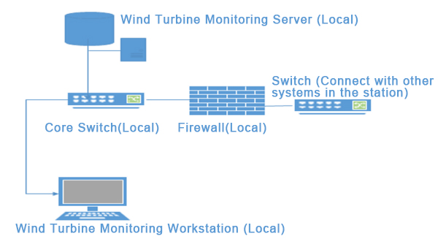

Figure 3

# Wind Turbine Optical Fiber Network

## Wind Farm Network Optical Fiber Loop

After each wind turbine switch in the wind farm network environment is connected to form a link, it will be connected to the booster station aggregation switch at the same time from the start to the end to form a ring network. The physical link of data transmission has two directions. When one link fails, the other link will be activated. The communication failure of any wind turbine will not affect the communication of the entire line. As shown in Figure four:

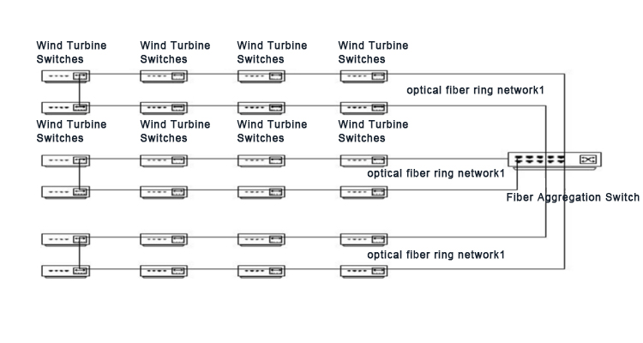

Figure 4

## Wind Farm Cable Distance Design Requirements

If the communication optical cable and the directly buried power cable are laid parallel to the trench or the optical cable crosses the cable, they must be treated in layers. The buried optical cable should be above the directly buried cable, and the minimum clear distance is greater than 0.5 meters. The overhead clear distance between the overhead optical cable and the power line is greater than 1 meter.

## Single-mode Fiber Optic Cable Specifications

All lines of the on-site optical cable adopt the working wavelength of 1310nm, 8-core single-mode optical cable can meet the needs, and appropriately reserve 4n cores due to the subsequent expansion needs. According to the erection method, local characteristics and actual communication method to determine the fiber optic cable model, it is recommended to use ADSS fiber optic cable for the overhead part; GYFTA53 fiber optic cable for the buried part, and PE sheath on the outside.