Training + Testing on RoboFlow happens in the cloud: Launch: Train and Deploy RF-DETR Models with Roboflow (New transformer model launched)
For testing:
- The versions tab (train) stores all the trained models. Clicking on one of the trained model lists the Metrices obtained, model checkpoint, model type.
- Scrolling down, the dataset details along with the training graphs are provided.
- Under the Deploy model, we can try the model, using test images from files in the browser.
- The above gives confidence score, and bounding boxes for the detections. The sliders can be adjusted to observe changes in predictions.
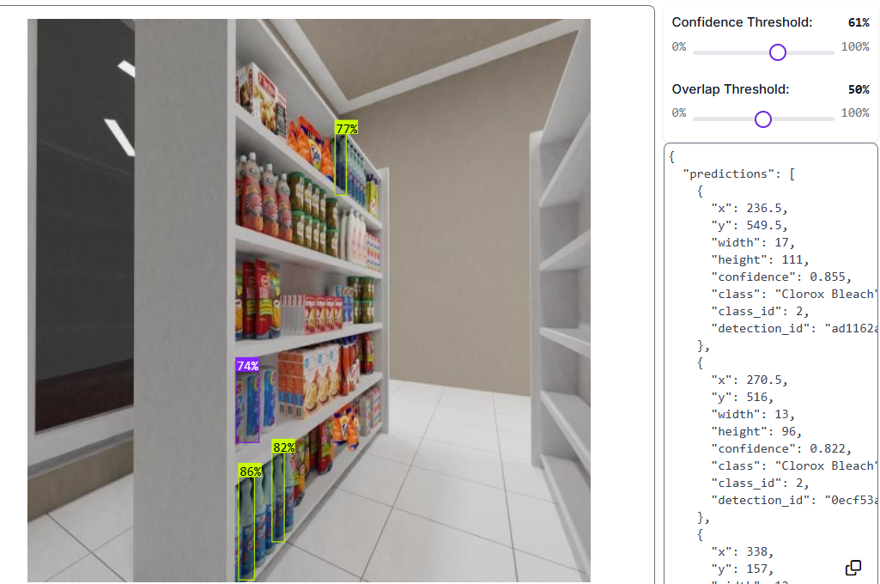
- Under Deploy model, there is seen a highlighted tab to Try workflows, which provides various templates.
- When clicked on Detect, count and visualize, a flowchart consisting of bounding box visualization, and labels for classes are autogenerated and sized for the best fit as per the annotation files provided.
- For counting, we use the model prediction function, to perform a list of operations. Extract property of the class names using either confidence scores or labels, and count the number per class.
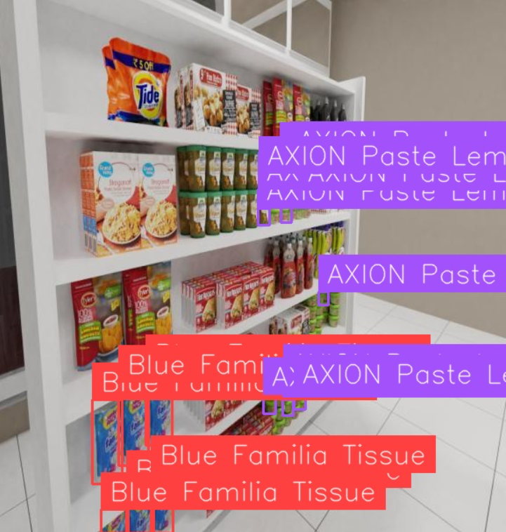
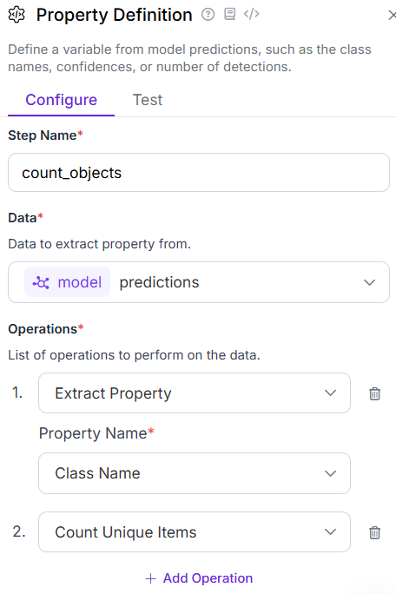
- Small Object Detection: Used the same detector model, to check if small defined classes at different occluded areas were detected. Similarly in this architecture, there were flowchart blocks
