**MCD**

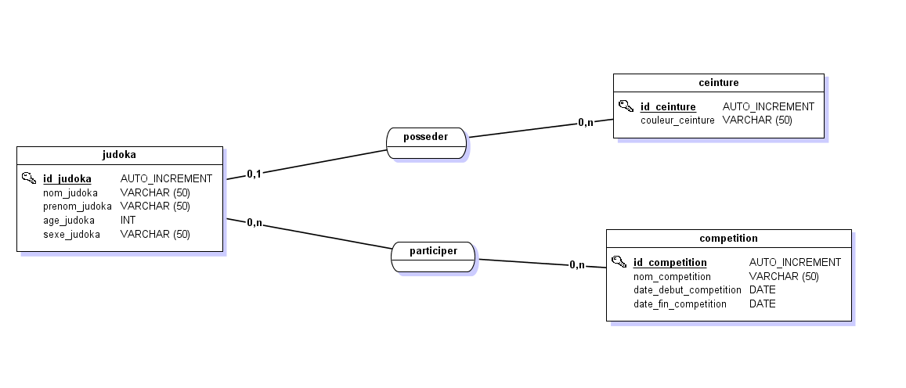

**MLD**

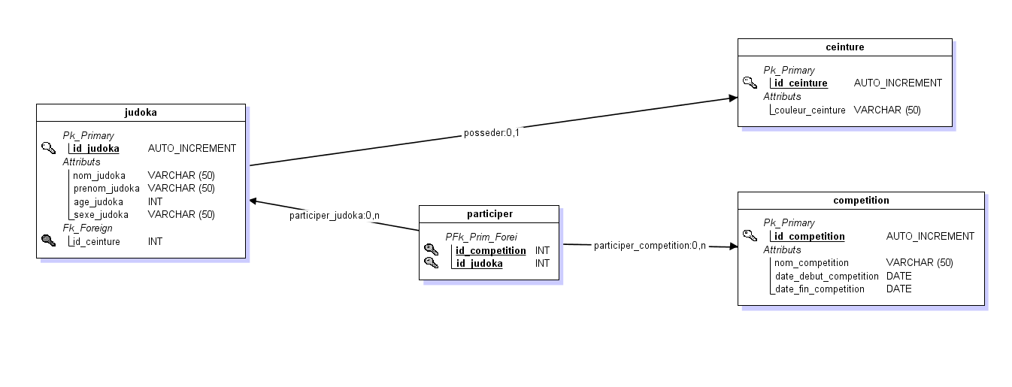

**STRUCTURE SQL**

CREATE DATABASE judo;

USE judo;

CREATE TABLE judoka(

id_judoka int primary key auto_increment not null,

nom_judoka varchar(50),

prenom_judoka varchar(50),

age_judoka int not null,

sexe_judoka varchar(50),

id_ceinture int not null

)Engine=InnoDB;

CREATE TABLE ceinture(

id_ceinture int primary key auto_increment not null,

couleur_ceinture varchar(50)

) Engine=InnoDB;

CREATE TABLE participer(

id_competition int not null,

id_judoka int not null,

primary key (id_competition, id_judoka)

) Engine=InnoDB;

CREATE TABLE competition(

id_competition int primary key auto_increment not null,

nom_competition varchar(50),

date_debut_competition date not null,

date_fin_competition date not null

)Engine=InnoDB;

ALTER TABLE judoka

add constraint fk_posseder_ceinture

foreign key (id_ceinture)

references ceinture(id_ceinture);

ALTER TABLE participer

add constraint fk_participer_judoka

foreign key (id_judoka)

references judoka(id_judoka);

ALTER TABLE participer

add constraint fk_participer_competition

foreign key (id_competition)

references competition(id_competition);

**REQUETES INSERT**

INSERT INTO ceinture (couleur_ceinture) values

('blanche'),

('jaune'),

('orange'),

('verte'),

('bleu'),

('marron'),

('noire');

INSERT INTO judoka(nom_judoka, prenom_judoka, age_judoka, sexe_judoka, id_ceinture) values

('Lachance', 'Dominique', 16, 'F', 2),

('Porter', 'Gilbert', 18, 'H', 3),

('Lemaître', 'Anne', 15, 'F', 4),

('Robert', 'Juliette', 12, 'F', 1),

('Montminy', 'Pierre', 17, 'H', 5),

('Charrette', 'Pascal', 21, 'H', 6),

('Guay', 'Émilie', 19, 'F', 6),

('Maheu', 'Louise', 14, 'F', 4),

('Poulin', 'Raymond', 26, 'H', 7),

('Dupret', 'Alain', 20, 'H', 6);

INSERT INTO competition (nom_competition, date_debut_competition, date_fin_competition) values

('judo31', '2021-02-06', '2021-02-07'),

('Judo11', '2021-02-27', '2021-02-28'),

('Judo81', '2021-03-20', '2021-03-21'),

('Judo82', '2021-04-17', '2021-04-18');

INSERT INTO participer (id_competition, id_judoka) values

(1, 1),

(1, 3),

(1, 4),

(2, 2),

(2, 5),

(2, 6),

(2, 9),

(3, 1),

(3, 9),

(4, 1),

(4, 3),

(4, 8),

(4, 4);

**REQUETE UPDATE**

UPDATE judoka SET id_ceinture = id_ceinture + 1 where id_ceinture < 5;

**REQUETE INSERT DELETE**

INSERT INTO judoka(nom_judoka, prenom_judoka, age_judoka, sexe_judoka, id_ceinture) values

('Dupont', 'Jeanne', 16, 'F', 4),

('Durant', 'Tom', 18, 'H', 2);

DELETE FROM judoka where id_judoka > 10;

**REQUETE SELECT**

SELECT nom_judoka, prenom_judoka, couleur_ceinture FROM judoka

INNER JOIN ceinture ON judoka.id_ceinture = ceinture.id_ceinture

where couleur_ceinture = 'verte';



SELECT count(id_judoka) as 'Nombre de participants' FROM participer

INNER JOIN competition ON participer.id_competition = competition.id_competition

WHERE nom_competition = 'judo31';

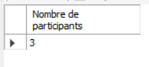

SELECT nom_judoka, prenom_judoka, age_judoka, sexe_judoka FROM judoka

INNER JOIN participer ON judoka.id_judoka = participer.id_judoka

INNER JOIN competition ON participer.id_competition = competition.id_competition

where nom_competition = 'judo81';

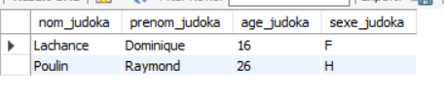

SELECT nom_judoka, prenom_judoka FROM judoka

INNER JOIN ceinture ON judoka.id_ceinture = ceinture.id_ceinture

WHERE couleur_ceinture = "marron" AND age_judoka > 19;

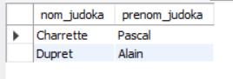

SELECT nom_judoka, prenom_judoka, couleur_ceinture FROM judoka

INNER JOIN ceinture ON judoka.id_ceinture = ceinture.id_ceinture

ORDER BY nom_judoka asc;

