HELP

BIORAISE platform integrates the biomass resources layers, environmental risks and stakeholders data.

The service evaluates the biomass resources available from agriculture and forestry, including shrublands.

From user selected locations, the platform provides on the fly the following information: biomass resources, harvesting and transport costs and energy content. The application includes diverse stakeholders related to solid bioenergy sector.

The landpage shows several tabs, from where to choose either Map or Satellite Google basemaps, the Options and Legend features.

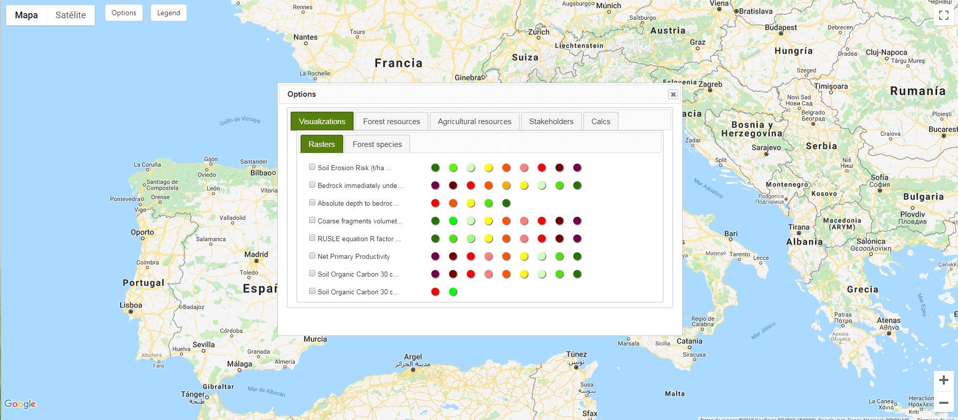

Displaying the **Options** window the following subtabs are shown: Visualizations, Forest and Agricultural resources, Stakeholders and Calcs.

**VISUALIZATIONS**

The **Visualizations** tab shows environmental maps of risks layers related to edaphology facets: Soil Erosion Risk, Bedrock immediately underlying layers of soil 0-100% of R horizon, Absolute depth to bedrock, Coarse fragments volumetric in % at 0.05 m top soils, RUSLE equation R factor and Soil Organic Carbon at 30 cm depth. In addition, the Net Primary Productivity layer is also displayed in an analogous gradient from high productivity areas (green) to lower productivity surfaces (red/purple tones).

The layers are displayed in categorized values showing a risk gradient from green (lower risk) to red/purple (higher risk).

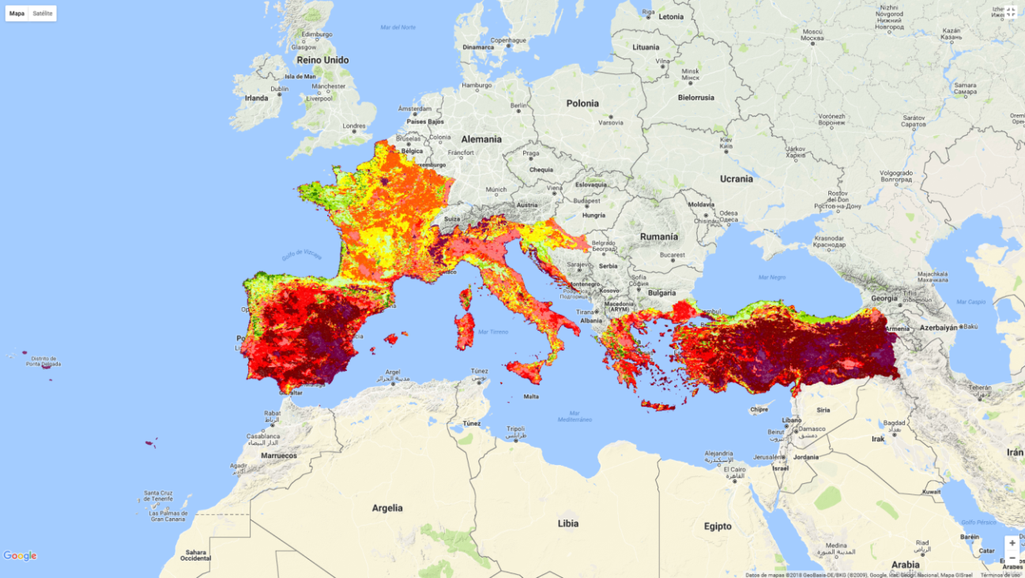

**Example of visualization layer in green-purple gradient for Net Primary Productivity: higher productivity areas are depicted in purple.**

A subtab displays dominant stands of tree specific maps selected from the JOINT RESEARCH CENTRE (<http://data.jrc.ec.europa.eu/collection/fise>) in case the user wants a more refined view of specific forest data:

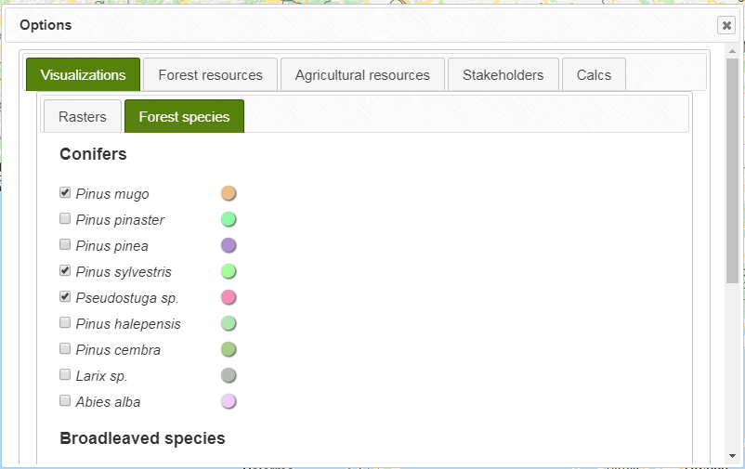

**Forest species subtab**

The **Legend** window allows for playing with the transparencies in the layer.

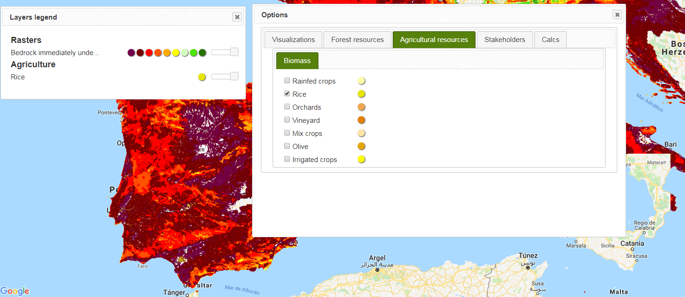

**RESOURCES**

The **Forest Resources and Agriculture Resources** tabs enable the user to select among the agriculture, forestry and shrubland land uses from CORINE LAND COVER.

Agriculture contains field resources from herbaceous crops (rainfed crops, rice, and irrigated crops), orchards, vineyards, olive trees and mix crops (agroforestry herbaceous crops).

The forestry categories include conifers, broadleaved, mixed stands, agroforestry systems (e.g., dehesas) and shrublands.

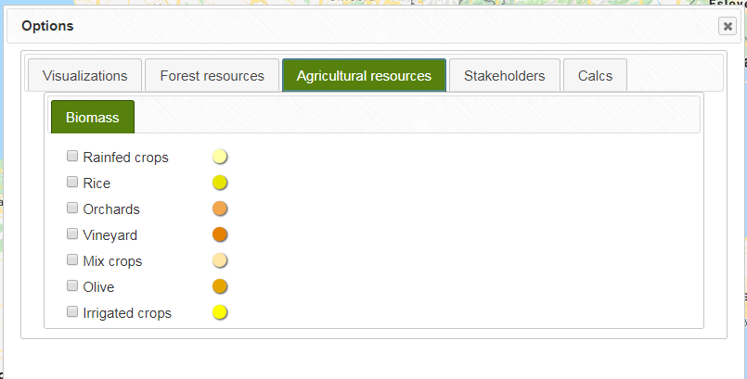

**Screenshot of the land uses available in Agriculture subtab within the Biomass choices.**

**STAKEHOLDERS**

The **STAKEHOLDERS** tab compiles data locations and details from the raw solid biomass producers: wood industry, olive oil industries, nut hulling, and wine sector –distilleries- industries, and other actors: equipment and machines for industry, services and facilities, biofuels producers, biofuel dealers, research centres, large consumers, and certified BIOMASUD PLUS biofuel producers and dealers.

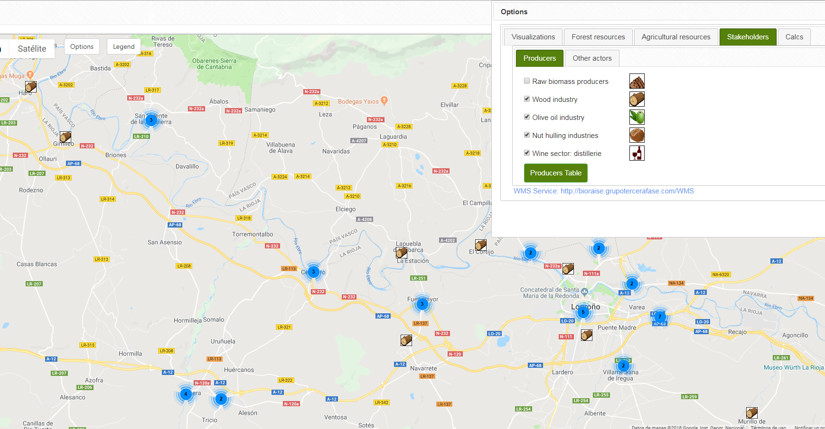

**Stakeholders tab user choices under the producers and other actors subtabs**

Note that only from detailed zooms the” Producers” and “Other Actors” Icons are visualized.

**CALCULATIONS & RESULTS**

The **Calculations** tab allows the user to choose a location for the area of interest and pick up point. For computations, either a circular radio (from 1 to 100 km) or administrative limits (NUT3 regions -e.g., province in Spanish administrative divisions- or subregion -e.g., municipality boundary-) are required.

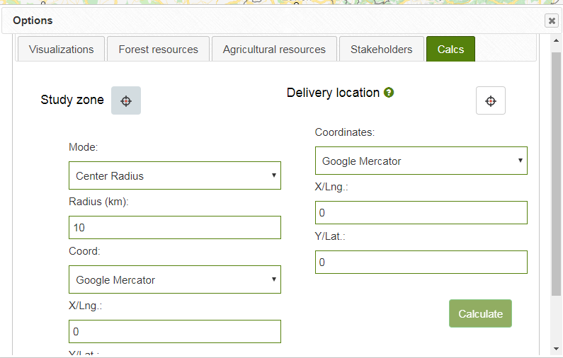

**Calculations tab: where the user selects a location in the map for on the fly computations of biomass resources, costs and energy content**

One having clicked “calculate”, a dialogue window shows the **results**:

* **Distribution maps** for potential and available field resources and **surfaces**:

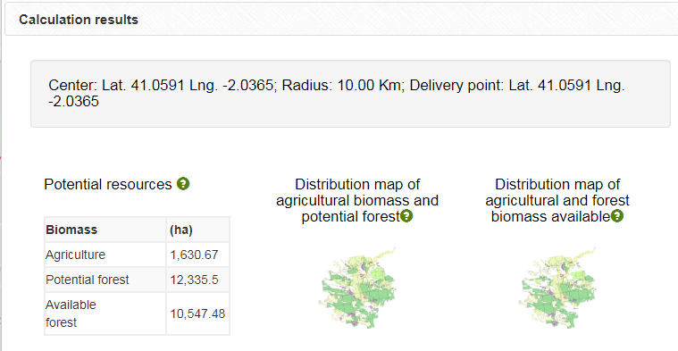

* **Resources and Costs:**

Potential biomass is provided in tonnes of dry matter per year (tDM/year). Surfaces are given in hectares and average harvesting and transport costs in €/tonne.

Regarding agriculture field resources, due to the efficiency really attainable in harvesting processes, not all the field resources reach the biomass production chain: therefore, a more realistic available biomass is also computed.

In the case of the forestry resources, soil erosion risk and top organic carbon in 30 cm depths limit the potential resources. In addition, technical constraints are applied considering a 20% percent rise slope threshold in costs computations.

Further methodological details are found in the documentation links.

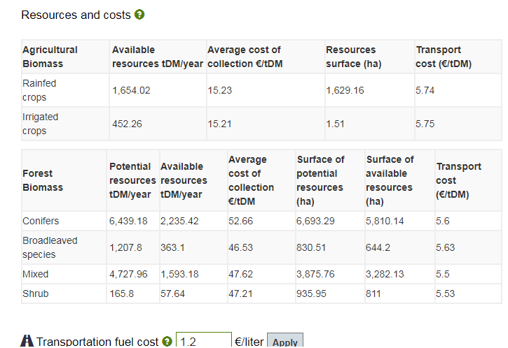

**Example of potential and available agriculture biomass resources (tDM/year), surfaces (ha), average harvesting/piling cost (€/tDM) and transport cost (€/tDM)**

Note that regarding transport costs, the user can select fuel costs “Transportation fuel cost”, which are highly variable across time and regions. The default option is 1.2 €/l.

Transport costs do not include VAT considerations (variable among countries).

* **Energetic content**



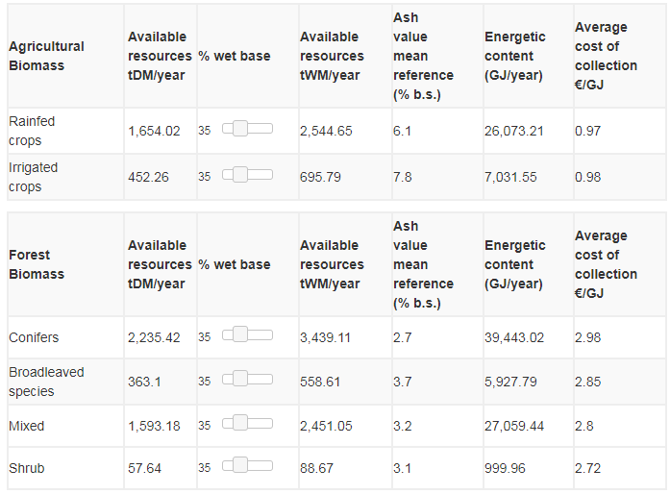

The energy contents are also computed: the user can apply different moisture contents by moving the % wet base bar.

* **Download**

At the end of the results window, the user can click the “Download results” button:

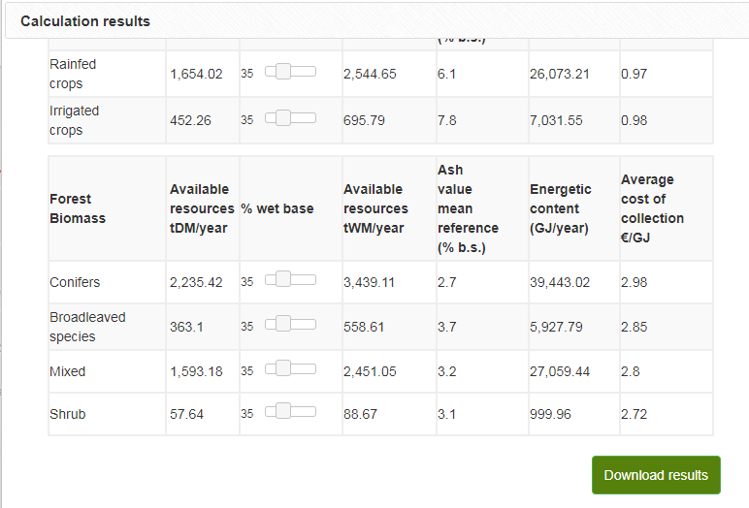

A **zip file** is provided containing a csv and a shapefile.

The corresponding attributes in the shapefile are:

-**Origin**: land use category (i.e., Agriculture or Forestry).

**-Biomass:** resource type in accordance to the Agriculture or Forestry Resources/ Biomass subcategories (e.g., Rainfed Crops, Conifers, etc.)

-**Surface**: hectares

**-BiomassPot: potential biomass (t DM/year)**

**-BiomassAvl: available biomass (t DM/year)**

**-Cost: harvesting cost and transport cost to destination (i.e., selected pick up point)**

**(€/t DM)**

**-distX**

**-distY**

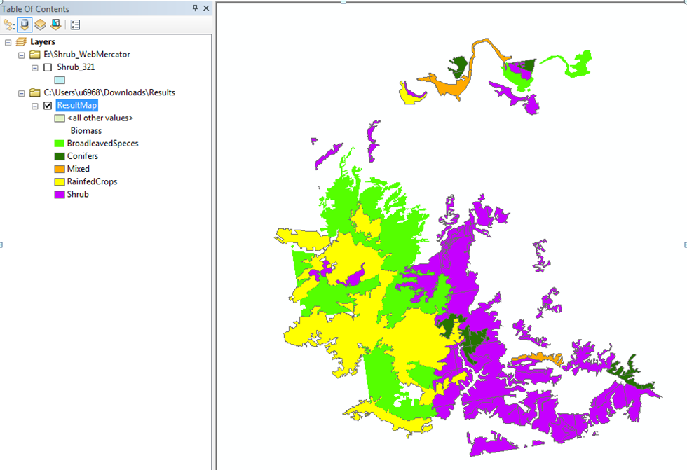

**Example of results shapefile visualization**

The CSV provides the summarized results for the area of interest:

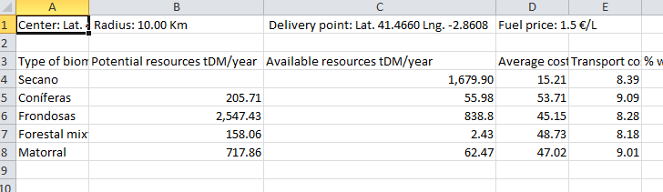

**CSV results table**

OGC SERVICES

WMS/WFS (eliminar)

