**VISUALIZATION NARRATIVE**

**Modern Dating Through Data Journalism**

Inspired by the prevalence of “dating app fatigue” highlighted by the plethora of “ghosting” and “catfishing” stories circulating on social media, I decided to embark on a data journalism project to analyse user n=behaviour and demographics on dating apps. I aimed to explore why it was deemed difficult to form meaningful romantic connections in the current dating climate.

**Audience**

I targeted my narrative towards millennials and Gen Z users of dating apps as they were deemed to be the biggest demographic of active users (insert reference)

**Data Collection**

Inspired by an online article (Fernandez, A.B, 2021) about a data journalism project on Tinder user’s data, I proceeded to acquire datasets from Swipestats.io. Tinder was also the most popular dating app (insert reference) which is why it was an appropriate dataset for my project. The dataset which included a profiles_json and profiles_csv file, was extensive with data from over 1000 profiles and required significant processing.

**Analyses**

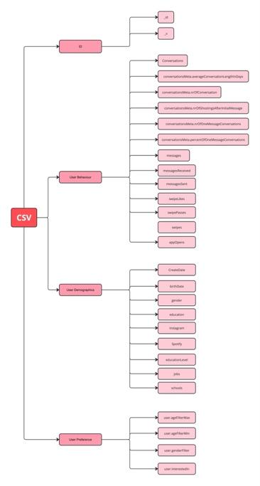With the help of Chatgpt and using Python, I extracted and listed all headers from the CSV file to understand the data structure. (refer to text file and read_python for code).

Key Guiding questions :

1. Who are the users?
2. What are they looking for?
3. What are their actions on the app?

**Data Segmentation**

I focused on user ages and genders, alongside gender and age preference, as they are the biggest determinants of which profiles appear on a user’s rotation. I also delved into user behaviour.

**Data Processing**

I used Python with the help of ChatGPT to create data frames and separate CSV files for analyses. For a time series analysis, I extracted and processed message timestamps from the JSON file, creating separate CSV files for each year and categorising message times into 6 time bins and generating a frequency table on excel.

**Visualisation**

With insights drawn form the data, I developed visualisations. Based on feedback from the tutor I created a heatmap to represent **peak conversation times** instead of looking at frequency of messages. I also refined the use of consistent graphs to improve comprehension based on feedback about the HCD component.

**Insights**

Through extensive data processing and analysis, I uncovered several trends and behaviours among dating app users. Visualising these insights helped to illustrate the challenges users face in forming meaningful connections in the modern dating era lending to the ultimate narrative of the **paradox of choice.**

**USABILITY TESTING**

**Test Objectives**

1. Evaluate the readability and comprehension of my data visualisation
2. Evaluate whether users were able to understand why dating apps are failing the modern dating
3. Users can understand what they can do to facilitate more meaningful connections through dating apps

**Tasks**

1. Identify the number of likes, passes, and matches on 1/6/2019.
2. Determine the peak conversation times in 2015 and 2021.
3. Describe the general trend of ghosting on Tinder.
4. Compare the percentage of male users to female users on the app.
5. Explain the relationship between age filters and user ages.
6. What is the user penetration rate of Tinder India

**Participants**

8 Individuals participated in the usability testing.

**Findings**

Task 1: 6/8 participants were able to easily locate the slider and navigate to 2019 and quote the right numbers. 2 participants needed additional prompts because they did not initially realise the graph included multiple years (how to address?)

Task 2: Participants generally identified the darkest shades as peak conversation times, but some remarked that higher contrast would improve clarity

Task 3: 5/8 participants needed help with understanding the axis and differentiating between the ghosting and one message scatter plots. They noticed an increasing trend but were unsure about what the number of conversations was being compared against.

Task 4: All participants accurately identified the disparity between male and female users. 1 user questioned why there were no non-binary individuals

Task 5: All participants failed to understand the relationship between age filters and users age distribution and required additional explanation.

Task 6: All participants accurately quoted user penetration rates but found the term confusing.

**Improvements**

1. Defined “user penetration rates”
2. Revised headers to reflect content more accurately, such as changing "User Demographics vs. Preferences" to "Who is the One?" and "Conversations Quality" to "Just Got Ghosted?"
3. Increased emphasis on the concept of “The Paradox of Choice”
4. Introduced background information on Tinder
5. Changed axis label for likes, passes and matches graph from “count” to “average number of likes, passes and matches”
6. Presented key statistics on the relevance of the topic and evidence that people seek meaningful connections on dating apps
7. Incorporated disclaimer stating the dataset does not include individuals who identified as non-binary.
8. Combined "number of ghostings after the initial message" with "number of one-message conversations" for a clearer narrative.
9. Superimposed age filter graph onto user age distribution graph to better illustrate the insight. Also got rid of min age filters as it did not lend to the general narrative
10. Increased the colour contrast on the heatmap to improve visibility
11. Added percentage figures on hover for better data interpretation

**REFERENCES**

Boe, K. (n.d.). Swipestats.io. <https://www.swipestats.io/>

Fernandez, A. (2021). I analyzed hundreds of user’s Tinder data — including messages — so you don’t have to. <https://towardsdatascience.com/i-analyzed-hundreds-of-users-tinder-data-including-messages-so-you-dont-have-to-14c6dc4a5fdd>

Lazzaro, S. (2015). Dating apps after midnight are the modern day ‘last call’ at a bar. <https://observer.com/2015/03/dating-apps-after-midnight-are-the-modern-day-last-call-at-a-bar/>

Lebail, M. (2021). Penetration rate – Definition, principles, and how to calculate it. <https://www.sortlist.co.uk/blog/penetration-rate/>

Llerena, K. (2024). The paradox of choice: Navigating the complex world of dating. <https://gramercypsychologicalservices.com/2024/03/18/the-paradox-of-choice-navigating-the-complex-world-of-dating/#:~:text=What%20is%20the%20Paradox%20of,has%20never%20been%20more%20relevant>

Narang, A. (2022). Can prioridating, a new dating trend, break the paradox of choice? <https://www.harpersbazaar.in/culture/story/can-prioridating-a-new-dating-trend-break-the-paradox-of-choice-564610-2022-11-07>

Pew Research Center. (2023). Key findings about online dating in the U.S. <https://www.pewresearch.org/short-reads/2023/02/02/key-findings-about-online-dating-in-the-u-s/>

Relationships Australia. (2017). Online dating. <https://www.relationships.org.au/document/november-2017-online-dating/>

Statista. (2024). Online dating – Worldwide. <https://www.statista.com/outlook/dmo/eservices/dating-services/online-dating/worldwide#global-comparison>

yuanchuan. (n.d.). Floating heart. <https://codepen.io/yuanchuan/pen/wZJqNK> ​​