**Exam Scheduling System**

**Process Report**

**Eva Nikolaeva, 293164**

**Marton Pentek,**

**Miladin Asenov,**

**Sabina Elena Baghiu,**

**Supervisors:**

**Steffen Vissing Andersen**

**Mona Wendel Andersen**

**[Number of characters]**

**Software Technologies Engineering**

**1st Semester**

**[Date]**

Version: August, 2018

Template responsible: dans@via.dk

**Table of content**

Preface iii

1 Introduction 1

2 Group Description 2

3 Project Initiation 3

4 Project Description 4

5 Project Execution 5

6 Personal Reflections 6

7 Supervision 7

8 Conclusions 8

Appendices

# Preface

Optional

# Introduction

We started this Semester Project as our first project as a group. We are first semester students at VIA and we chose the people we are in based on personal reflections, friendships and culture. For our Project we will be using our classes that we have had so far in our first year here – which are SDJ1(Software Development with Java)

, SSE(Study Skills for Engineers), RWD(Responsive Web Design) and SEP1, which is an introductory course to making our Project. Each course is used in a different way for the project and are all used equally.

In the first section of the Process Report we will include a log book of our meetings as a group, a table with the meetings and what work we have done during this period of time.

In our table we have presented a timeline of the date that we started a certain part of the Project and what we finished on the same meeting. (All dates included are in the year 2019)

Example: On 02.09.19 we started the 1st semester year and we finished summer break.

|  |  |  |  |
| --- | --- | --- | --- |
| **Date** | **Started** | **Finished** | **Duration** |
| 16.11 | Use Cases, Requirements, Use Case Diagrams, Activity Diagrams | - | 2 hours |
| 26.11 | Class Diagrams | Use Cases, Use Case Diagrams, Requirements, Activity Diagrams | 2 hours |
| 27.11 | RWD Aquarium Assignment | - | 2 hours |
| 4.12 | Start GitHub repository for SEP1, learning how to use GitKraken | RWD Aquarium Assignment | 1 hour |
| 9.12 | GUI, started work on Process Report, Implementation of Model | Class Diagram | 2 hours |
| 10.12 | Testing of some classes, Sequence Diagram | - | 4 hours |
| 13.12 | XML files for adapter, Project Report, Re-do of class diagram | Sequence diagram, GUI | 7 hours |
| 16.12 | Testing, Assemble the program |  |  |
| 18.12 |  |  |  |
| 19.12 |  |  |  |

Tasks

In this part of the Introduction, we have included what each member has worked mostly on for the period of the Project Weeks. We have included a part for tasks, which each person has contributed equally to them.

Eva Nikolaeva

* Implementation
* Process Report
* Analysis Diagrams

Sabina Elena Baghiu

* Implementation
* Testing
* Design Diagrams

Marton Pentek

* GUI
* Testing

Miladin Asenov

* Project Report

Equal Contribution:

* Analysis requirements
* Use Cases
* Project Description

# Group Description

In this part of the Process Report we will be delving into the cultural aspects, personality profiles, reflecting on group work and motivation of each group member. In order for this to be organized in the best way possible, we will separate each main point and talk about it for every person. This information is also useful to ourselves, because we may learn something we don’t know about a group member and help each other work in the best way possible by creating a safe space where we all know why we behave the way we do.

**2.1 Felder and Soloman Learning Styles**

We will first start with our learning styles based on the Feldman Test of learning styles. We will each go over our own learning style and comment on it.

2.1.1 Eva Nikolaeva

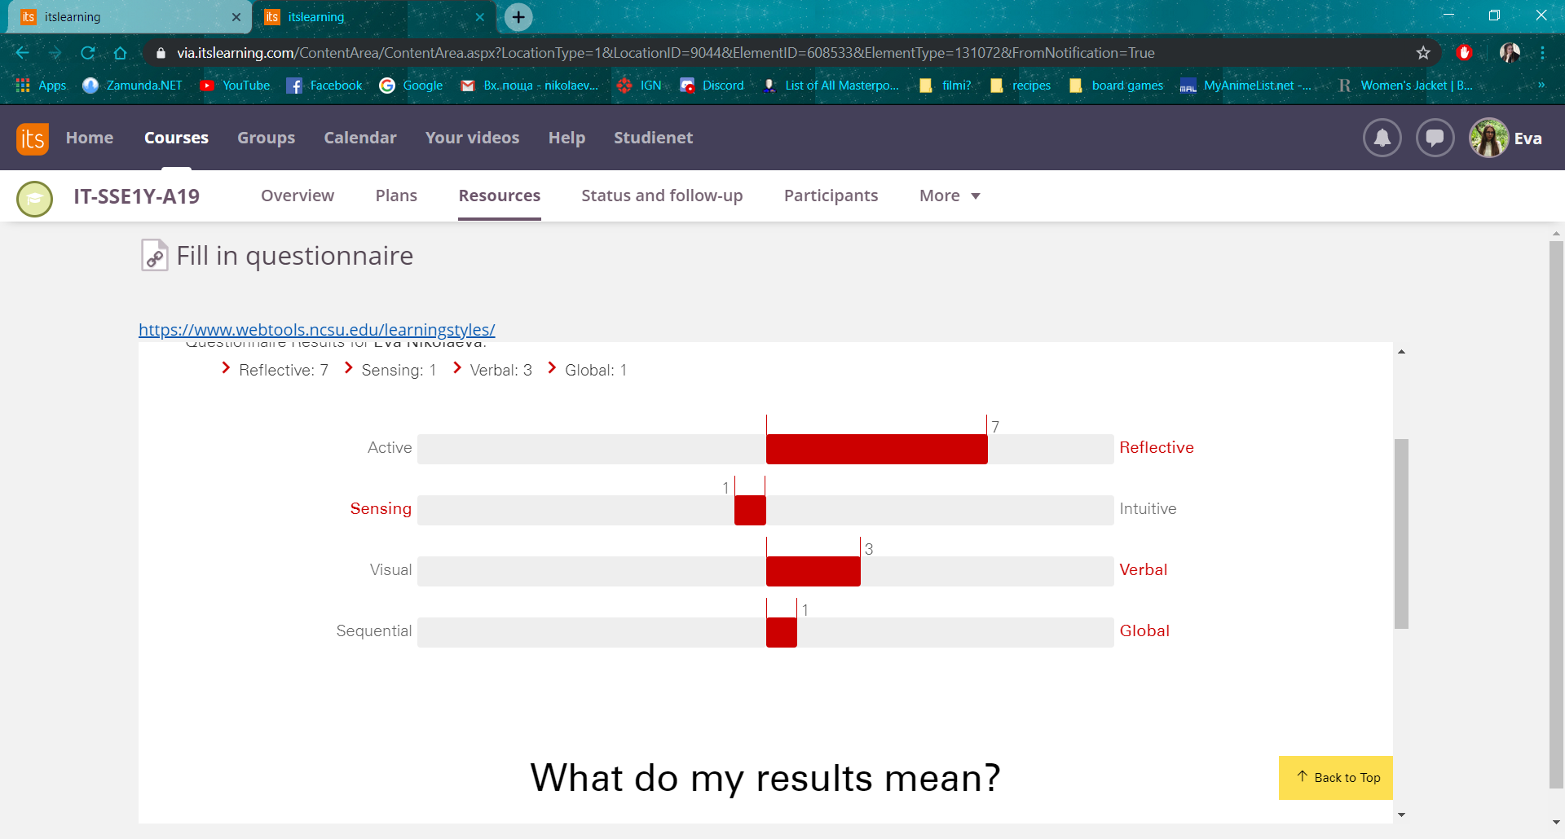

**How do I process information?**

* Reflective

This means I reflect more on the information I receive than act on it. This might include I am more reserved and do not rush into things without thinking over them beforehand, but in the learning aspect, I prefer to think about something well before I say anything. My score is 7 which means I have a preference on the way I learn and I may sometimes have a hard time in an Active environment.

**How do I perceive information?**

* Sensing

This means that in I am best at learning about concrete information, facts and something already known to be discovered. But the 1 that I scored also means that I can lean in on both sides, I can be both a sensing and an intuitive learner, where the intuitive learner prefers theoretical information and something new and innovative. I personally think I can manage with both fields of thinking, depending on the subject or matter. I like learning about theoretical stuff, but when it comes to knowing, it is much easier for me to remember facts.

**How do I prefer information to be presented to me?**

* Verbal

This means I am a verbal learner, I can better remember, understand and reflect on information which has been presented to me through words or speech. I can learn better when I read it or hear it, but the 3 also means that I can lean on the other side, which is the visual learner, learning better with pictures, graphs, diagrams and helping aims. I personally think I am more of a verbal learner, I do not need pictures and diagrams in order to learn the information given to me.

**How do I understand information?**

* Global

Global learners are people who understand information that has been presented to them first by explaining the bigger picture and then go into detail about the particular subject. I consider this to be very true about me even though it is just a 1 on the score of 1 to 10. I always need the bigger picture in order to know what is going on, then I can ask about the details or different parts of the project, for example.

2.1.2 Sabina Elena Baghiu

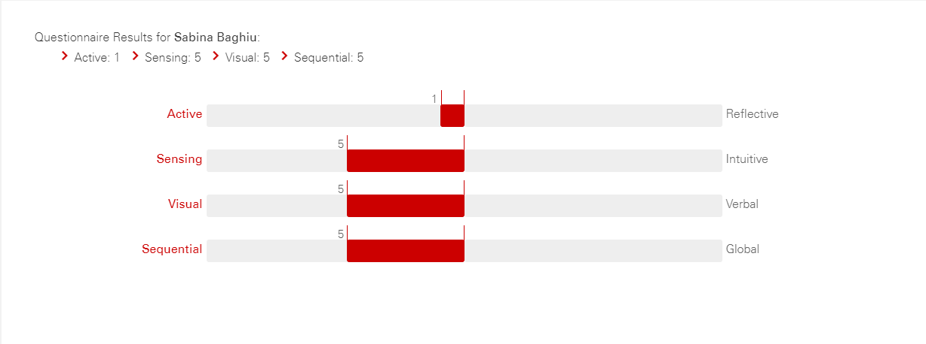

**How do I process information?**

* Active

According to the result above, I am both active and reflective, which means I can easily learn by practicing and trying things out myself, but also by analyzing things and taking my time to understand them.

**How do I perceive information?**

* Sensing

I like when information is concrete and I’m always looking for the facts, thus being more sensing.

**How do I prefer information to be presented to me?**

* Visual

I learn better if the information given to me includes pictures or diagrams, as I search for visual representations.

**How do I understand information?**

* Sequential

Because I am a sequential learner, I’m detail-oriented and I like it when the rules are being followed and information is well structured.

2.1.3 Miladin Asenov

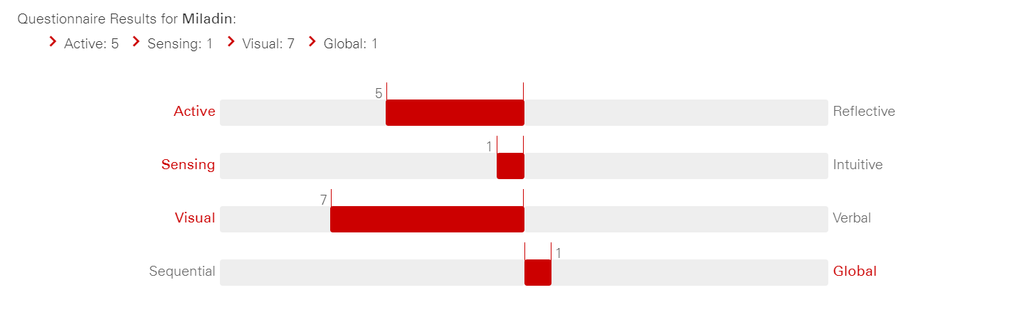

**How do I process information?**

* Active

It means that I tend to improve retention and understanding of information by discussing or explaining it to others. I benefit from group activities in which members explain topics to each other and helps finding ways to apply or use given information

**How do I perceive information?**

* Sensing

Sensing learners, such as I like to learn facts and solving problems using well-established methods; enjoy courses that have connections to the real world. I Connect information to real world applications

**How do I prefer information to be presented to me?**

* Visual

I remember what I see and implement myself. Pictures, diagrams, flow charts and demonstrations. I benefit from Finding or drawing diagrams, sketches, schematics, photographs, videos, using concept mapping to visually

arrange key points

**How do I understand information?**

* Global

I tend to Learn in large jumps, randomly absorbing material until I suddenly “get it”. I benefit from Skimming through the entire chapter to get an overview before starting to study specific information, relating the subject to things already known to see the bigger picture.

**2.2 E-Stimate Profiles**

In this segment we will explore each person’s e-stimate profile, which is a personality test, based on four colors representing different behavioral tendencies. Red is the people who are driven by status, power, knowledge and leadership. Yellow is the people who are driven by socializing, understanding and innovation. Green is the people who are driven by bonding, relationships, loyalty and friendship and lastly Blue is the people who are driven by precision, protection, detail and systematic approach.

2.2.1 Eva Nikolaeva

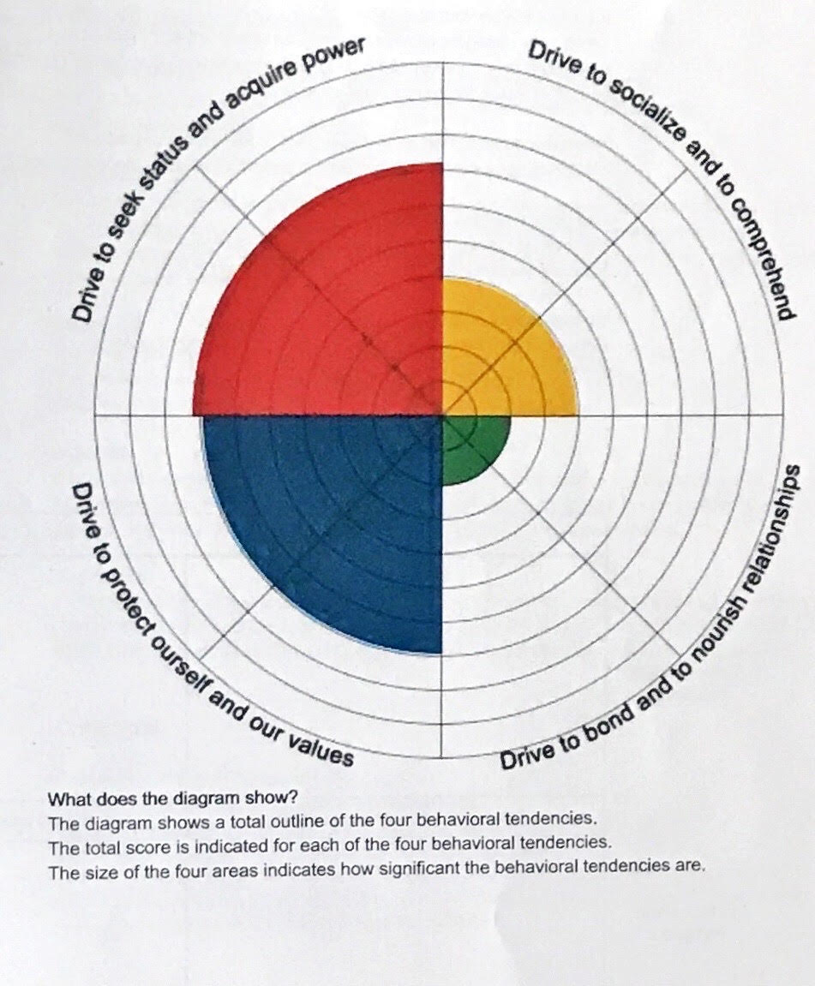

Strengths : Dynamic, Focused, Resourceful

Fears : Losing Influence, Failing, Appearing weak

Motivation: Prestige, Influence, Victories

Group Role: Initiator, Team Leader, Gets results

Judging from the image, my score can be seen to be highest in the left hemisphere of the graph. My biggest score is in red and right after the red comes blue. I can draw conclusions that I consider my environment to be unfavorable and I am both acting and reflecting, but because I have a bigger score in red, then I am also more acting. I consider this profile to be correct, because it brings out in paper my strengths, fears, motivations and also team role. In the descriptions it said that people with the red tendency are team leaders and even though this turned out to be true, I also had a very hard time being one. I was always more stressed than I had to be and I had to think about not just me, but also of my groupmates and if there is any way I can help them or motivate them.

2.2.2 Sabina Elena Baghiu

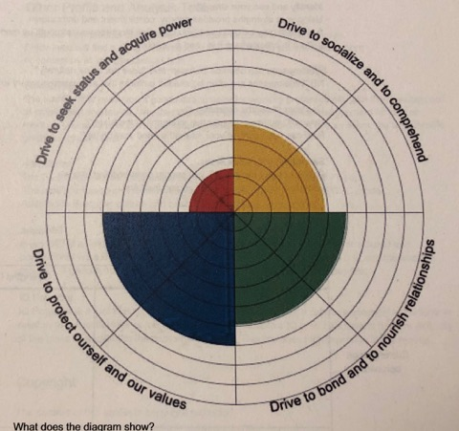

Strengths : Organized, Disciplined, Detail-oriented

Fears : Being focused on, Making mistakes, Time Pressure

Motivation: Structure, Professionalism, Clear guidelines

Group Role: Takes care of the detail, Documentation, Quality

As a result of this personality test, I discovered that I’m predominant blue, closely followed by green, with a little bit of yellow and almost no red. Being blue helped me become the one who paid more attention to the details in our team, as I was focused on the quality and the precision of our work. I was the only green person in the group, so I found myself being the mediator when it was the case, trying to solve the conflicts between us in order to work in harmony.

2.2.3 Miladin Asenov (Belbin Profile)

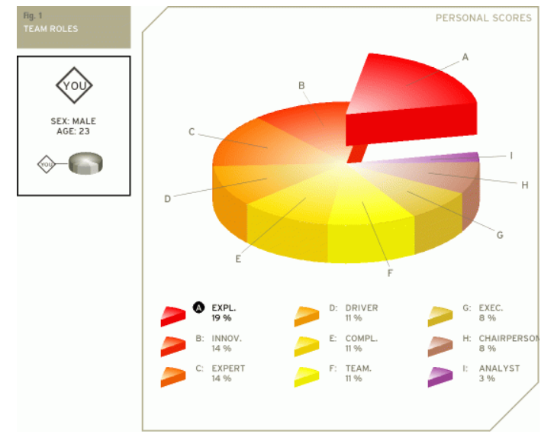

As the diagram shows, I am 19% an Explorer, which means that I am generally an extrovert by nature. I am cheerful, gregarious. The explorer is also investigative, interested and curious about things. Because explorers like to improvise and communicate with others, they will have little problem presenting ideas to the team and developing new contacts.

I am 14% Innovator, which indicates that I am the “creative generator” of the team. I have a strong imagination and a desire to be original. The innovator prefers to be independent and tends to approach tasks in a scientific way. As a creative individual the innovator may play a crucial role in the way a team approaches tasks and solves problems.

Also, I am 14% Expert, and the expert has the skills and expertise required for the specific task at hand. I have a strong focus on the task and may get defensive when others interfere work. The expert prefers to work alone, and team members often have a great deal of trust and confidence in him

**2.3 Culture**

In this segment, we will discuss the differences and similarities between our culture and since we are from three different countries, the outcomes will be filled with diversity and contrast. We will use the Six Hofstede Dimensions and we will reflect on our own country’s dimensions and whether we have been affected by it.

2.3.1 Eva Nikolaeva

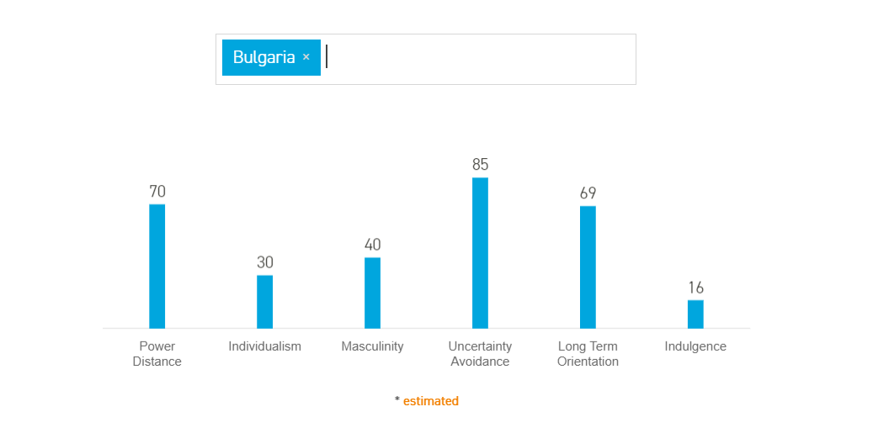

1. Power Distance High
2. Individualism Low
3. Masculinity Medium

Even though I come from a country where the context is very high and the individualism is very low, I am very much the opposite and do not agree in any way with the culture of my homecountry.

2.3.2 Sabina Elena Baghiu

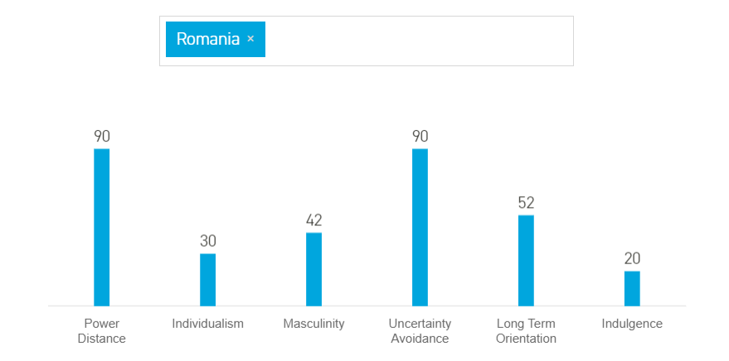

1. Power Distance High
2. Individualism Low
3. Masculinity Medium

According to the dimensions of culture that Hofstede described, Romanians are prone to having a very high power distance, therefore accepting the power being distributed unequally. I don’t think this applies to me because I believe that everyone has the same amount of power and responsibility. This fact was visible on our group, as each one of us had the chance to express their ideas and opinions freely.

Regarding individualism, I come from a society of “We”-identity and I feel like this trait reflects very well my personality, because I am more concerned about the well-being of the entire group.

When it comes to masculinity, I’m somewhere in the middle, as I care not only about achieving my goals, but also about what others want to obtain.

### 2.3.3 Miladin Asenov

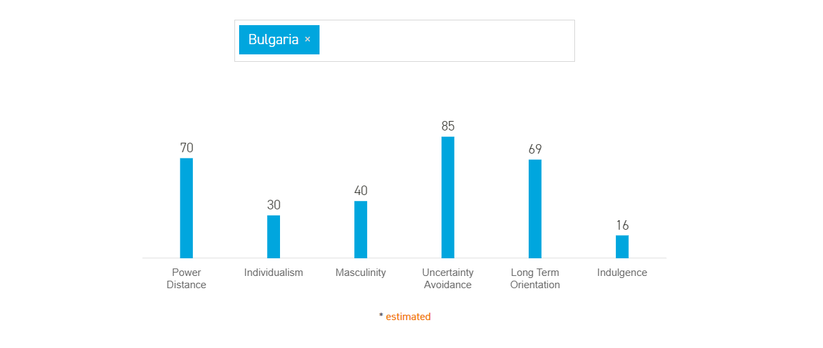

1. Power Distance High
2. Individualism Low
3. Masculinity Medium

I do not feel that I represent the exact contributable values that are shown on the diagram. The individualism is not correct, because I work the best when I work in a group, and I am comfortable to speak out. For the power distance, maybe is the only thing I really do not agree with, since I think all people should be equal, and trusted with any kind of task given to them, helping out a person who needs it, is the best thing you can do for someone. I see myself as a person who works well in a team, great with communication, and very well-going.

# Project Initiation

In this part of the Process Report, we will reflect on the first meeting we had with the VIA Representative and present an overview of how the meeting went, as well as what we learned from it.

On 18.09 all the classes of first semester were gathered in a common room, where a VIA Coordinator had a problem statement planned, where each of us was tasked with keeping notes and questions for later. She explained to us what the exam planning schedule in VIA consisted of, which was an Excel spreadsheet made by the secretaries in charge of the exam planning. She laid out the task to us, that a new system was to be made and presented as a Semester Project, followed by a lot of information, details and notetaking. After the presentation was done, a Q&A sort of session followed, which was us asking the Coordinator additional information we may need. In the following hours we worked in the so-called “PD” Groups, where we were tasked with making the Project Description of the Exam Planning System. These groups consisted of randomly chosen tables of 5 to 6 people, in which we worked on not just the Project Description, but also the SDJ and SSE courses. The task at hand was at a medium difficulty, because we were tasked with making a background description beforehand, thus helping greatly with our overall knowledge of making such document. After a week we were to also make a presentation with only the important information from the project description and present it to the Coordinator and our SDJ teacher, where we would then get reviewed by a partner PD group and the “examiners”.

When the presentation was over, we were tasked with creating our SEP group and the first members were Eva, Miladin and Sabina. The initiator of the forming of the group was Miladin, who invited both Sabina and Eva to be in a group with him. We then needed a third person and the very last day Sabina asked Marton to be in a group with us, because she was the one, who suggested we should invite him.

This project initiation was a very helpful, introducing step to our overall skills in making documentation, which we think is one, if not the most, important thing in a project. We made a lot of mistakes, but they were all in the process of learning.

In conclusion, the project initiation was a very important step in the introduction of people, who have never worked on a project of this scale and without it, we probably would not have been able to manage our time and learn as much as we know now.

# Project Description

In this part of our paper, we will include our reflections as a group on the Project Description, that we did before the project weeks started. We have answered three different questions to help understand us better formulate and present our statements.

1. How did you define the problem?

The team was presented with a problem by the customer, which was that there was no program or system to book exams (oral and written), dates, rooms and examiners. The secretary was using only an excel sheet trying to fit everything together with no errors, which of course, caused problems, such as human errors, overlapping and confusion. We defined it by laying out all the facts we received from the VIA Coordinator and together reached a conclusion that a new system was needed to be made.

1. Did you set up a realistic goal?

The goal was to create a simple but effective program, which can book an exam with no errors and save the information immediately, also with the possibility to edit and/or remove. We decided to make a GUI that is simple to use and easy to understand, make a visual User Guide with steps and explanations for everything and therefore, we think that our goal was very much realistic and not that hard to implement with the skills we had to that moment.

1. What did you want to achieve?

The team wanted to achieve a perfectly working software that will help the customer solve current problems. Having a minimalistic program, which is easy to use was the main target, which was successfully achieved.

# Project Execution

In the Project Execution part of the paper, we will talk about the methods we used in the Project making the results we expected and the results we got at the end.

After our brainstorming session, where we chose how our system is going to work and why, we were then left with the methods we should use. We were guided into using Waterfall Method by our SSE and SDJ teachers, making it a requirement to use it and we tried to make it work, but it was nearly impossible for most things. The Waterfall Method consists of a line of work, where the group works on one thing from their plan and when it is done, you go on to the next without going back, which is from where the name Waterfall comes from. You only keep going in one direction. But the problem there was that if we chose 15 requirements for our system, we then could not change any of them, which made us think whether the Waterfall Method was the best choice for our project. From then on we started going back to past documents and started changing Diagrams and code, even if we were finished with them on paper. If we could, we definitely would not choose the Waterfall Method for any future projects we have.

PROJECT RESULTS TO BE FINISHED!!!

# Personal Reflections

Eva Nikolaeva

# Supervision

In this part of the paper, we will include a “log book” of every meeting we have had with supervisors, what we went over in the meetings and a conclusion of how it went.

**Supervisor meeting 18.11 – Mona Wendel Andersen**

**Duration:** 30 minutes

**Start:** 12:30

**What we wanted to know:** How to schedule meetings comfortable for everyone, How to cooperate in a group

**What we learned:** Everything from what we wanted to know and: How to make a group contract, how to do the evaluation of each member of our group, how to communicate with each other

**Conclusion:** We needed to work on group cooperation and understanding

**Supervisor meeting 13.12 – Steffen Vissing Andersen**

**Duration:** 40 minutes

**Start:** 9:40

**What we wanted to know:** How to make the sequence diagram, Can we use Gson as a parser, What we need the Preface in the Process Report for, If we need a Student Class in the system, If we needed to use the information from the text files in the website

**What we learned:** Everything from what we wanted to know and: Insight to the structure of the SEP, how to write the Introduction to the Project Report, how to implement the class diagram in the Design segment of the Project Report, code snippets in the Project Report

**Conclusion:** Overall we are working slow, but steady. We have done a good job so far.

**Supervisor meeting 18.12 – Steffen Vissing Andersen**

**Duration:**

**Start:**

**What we wanted to know:**

**What we learned:**

**Conclusion:**

**Supervisor meeting 19.12 – Steffen Vissing Andersen**

**Duration:**

**Start:**

**What we wanted to know:**

**What we learned:**

**Conclusion:**

# Conclusions

**Appendices**

For content see Appendix 2 “Process Report – VIA Engineering Guidelines”.