Day2_20230606

Eva

6/6/23

#load libraries  
library(devtools)

Warning: package 'devtools' was built under R version 4.2.3

Loading required package: usethis

Warning: package 'usethis' was built under R version 4.2.3

library(tidyverse)

Warning: package 'tidyverse' was built under R version 4.2.3

Warning: package 'ggplot2' was built under R version 4.2.3

Warning: package 'tibble' was built under R version 4.2.3

Warning: package 'tidyr' was built under R version 4.2.3

Warning: package 'readr' was built under R version 4.2.3

Warning: package 'purrr' was built under R version 4.2.3

Warning: package 'dplyr' was built under R version 4.2.3

Warning: package 'stringr' was built under R version 4.2.3

Warning: package 'forcats' was built under R version 4.2.3

Warning: package 'lubridate' was built under R version 4.2.3

── Attaching core tidyverse packages ──────────────────────── tidyverse 2.0.0 ──  
✔ dplyr 1.1.2 ✔ readr 2.1.4  
✔ forcats 1.0.0 ✔ stringr 1.5.0  
✔ ggplot2 3.4.2 ✔ tibble 3.2.1  
✔ lubridate 1.9.2 ✔ tidyr 1.3.0  
✔ purrr 1.0.1

── Conflicts ────────────────────────────────────────── tidyverse_conflicts() ──  
✖ dplyr::filter() masks stats::filter()  
✖ dplyr::lag() masks stats::lag()  
ℹ Use the conflicted package (<http://conflicted.r-lib.org/>) to force all conflicts to become errors

library(here)

Warning: package 'here' was built under R version 4.2.3

here() starts at O:/Postdoc/Courses/Rjune23/R_course_project_day2_20230606

library(lubridate)  
library(unibeCols)

Warning: package 'unibeCols' was built under R version 4.2.3

library(ggplot2)

## Create something, this is the title

The aim of this project is to create a Quarto file that works.

## Data

something something

## Results

ebola_data <- read_csv(here("data", "raw", "ebola.csv"))

New names:  
Rows: 2484 Columns: 6  
── Column specification  
──────────────────────────────────────────────────────── Delimiter: "," chr  
(1): Country dbl (4): ...1, Cum_conf_cases, Cum_susp_cases, Cum_conf_death date  
(1): Date  
ℹ Use `spec()` to retrieve the full column specification for this data. ℹ  
Specify the column types or set `show_col_types = FALSE` to quiet this message.  
• `` -> `...1`

ebola_plot <- ebola_data %>% select(Country, Date, Cum_conf_cases) %>%  
 filter(Country == c("Sierra Leone", "Guinea", "Senegal" )) %>%  
 filter(Date <= "2015-05-31")  
  
  
plot_ebola1 <-  
 ggplot(data=ebola_plot, mapping = aes(x = Date, y = Cum_conf_cases))+  
 geom_point(aes(group=Country))  
   
 ggplot(data=ebola_plot, mapping = aes(x = Date, y = Cum_conf_cases))+  
 geom_point(alpha = 0.7, colour = "red", fill = "red",   
 shape = 17, size = 2.5, stroke = 3.5) +  
 geom_line()

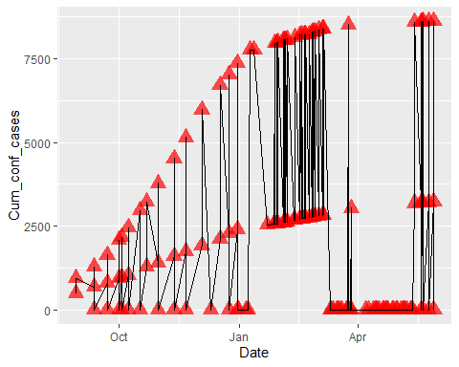

ggplot(data = ebola_plot,   
 mapping = aes(x = Date, y = Cum_conf_cases, colour = Country)) +   
 geom_point(alpha = 0.7, shape = 21, size = 2.5, stroke = 1.5) +  
 geom_line()

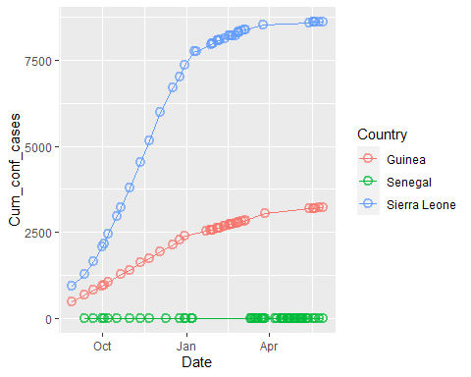

ggplot(data = ebola_plot,   
 mapping = aes(x = Date, y = Cum_conf_cases, colour = Country)) +   
 geom_line(mapping = aes(group = Country, colour = Country),   
 alpha = 0.7, linetype = "solid", linewidth = 3.5)

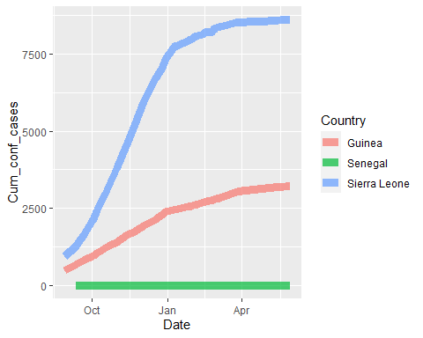

ggplot(data = ebola_plot,   
 mapping = aes(x = Date, y = Cum_conf_cases, colour = Country)) +   
 geom_point(alpha = 0.7, shape = 21, size = 5.5, stroke = 0.5) +  
 geom_line()+  
 ggtitle(label = "Confirmed Ebola cases in 3 countries") +  
 xlab(label = "Time") +  
 ylab(label = "Cum. # of confirmed cases")

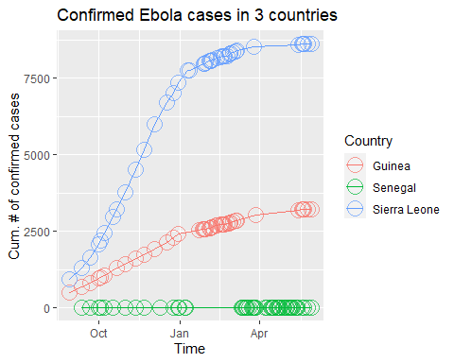

You can add options to executable code like this

[1] 4

The echo: false option disables the printing of code (only output is displayed).