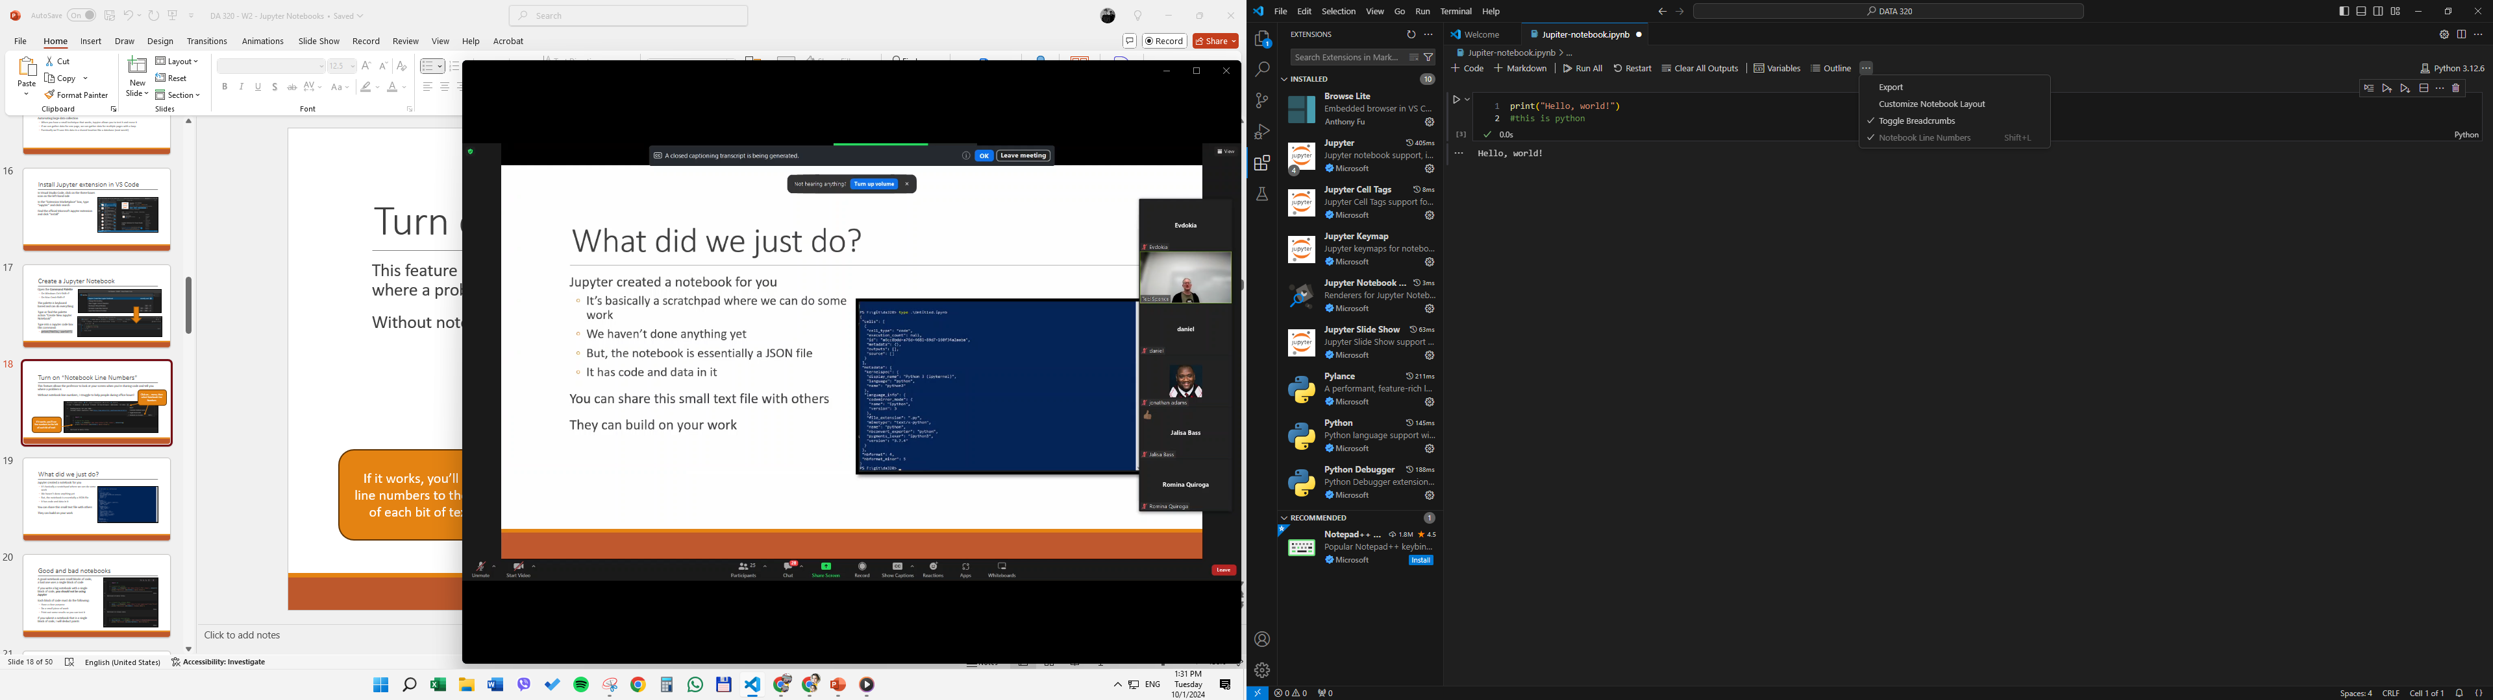

import requests
import re

# URL of the webpage for movies in 2010 on Metacritic
url = 'https://www.metacritic.com/browse/movie/all/all/2010/new/?page=1'

# Headers to mimic a browser visit
headers = {'User-Agent': 'Mozilla/5.0'}

# Send a GET request to the webpage
response = requests.get(url, headers=headers)

# Check if the request was successful
if response.status_code == 200:
# Extract the webpage content
webpage_content = response.text

# Regular expression to find movie titles within the <div data-title="...">
movie_titles = re.findall(r'<div data-title="(.*?)"', webpage_content)

# Print the movie titles
for title in movie_titles:
print(title)

