‘health’: previously PCIP51; Log transformation helped? (very similar results to non-transformed, based on normal probability plots)
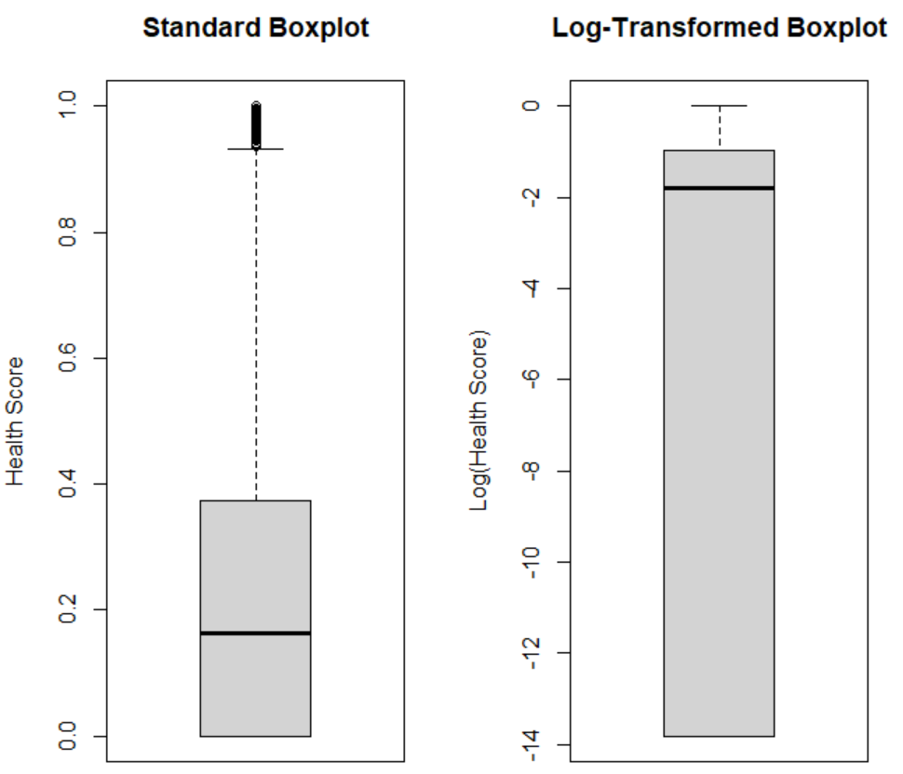
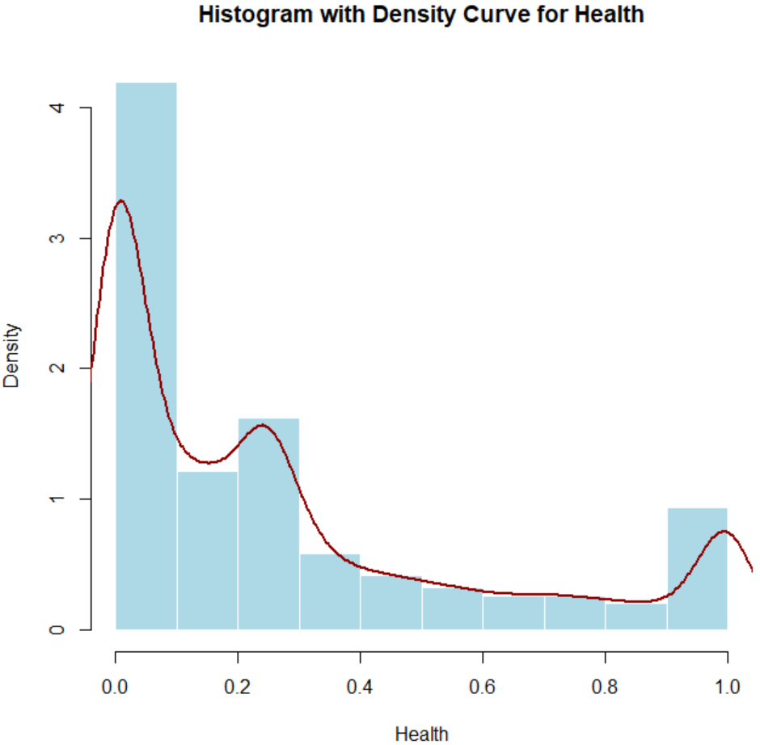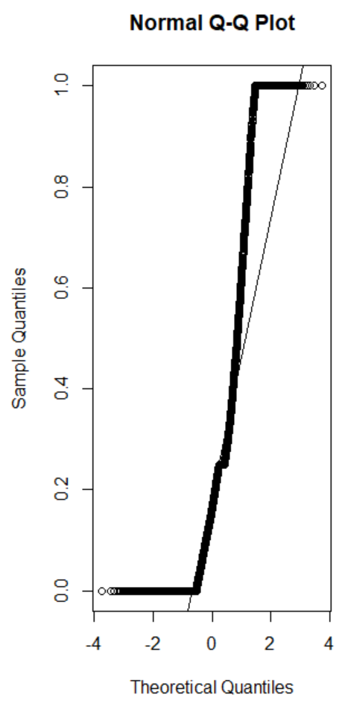

Log transformed histogram and normal probability plot. Similar to non-transformed.
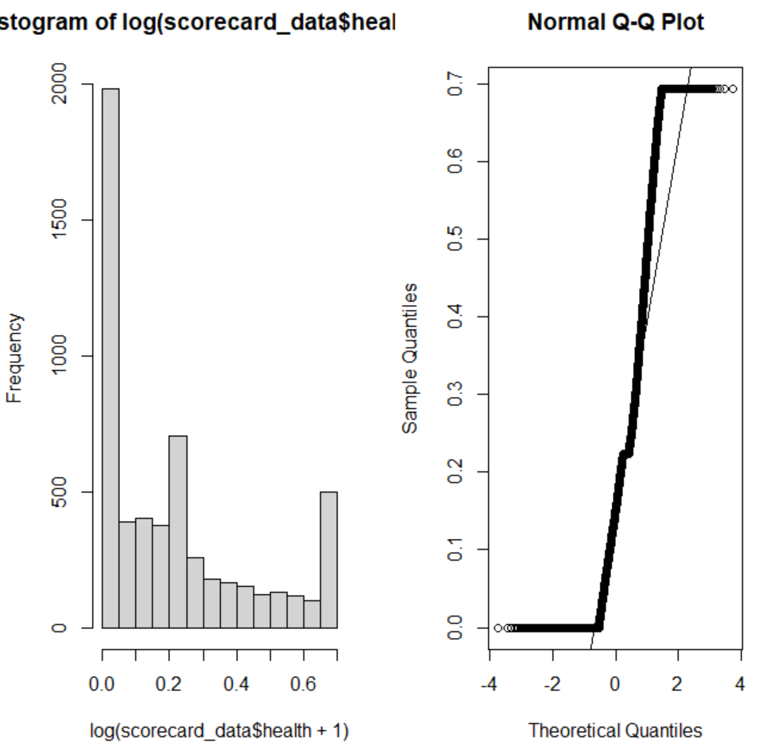

‘business’: previously PCIP52; Log transformation helped? (Log transformation boxplot looks good, but log transformation QQ plots appear slightly better)
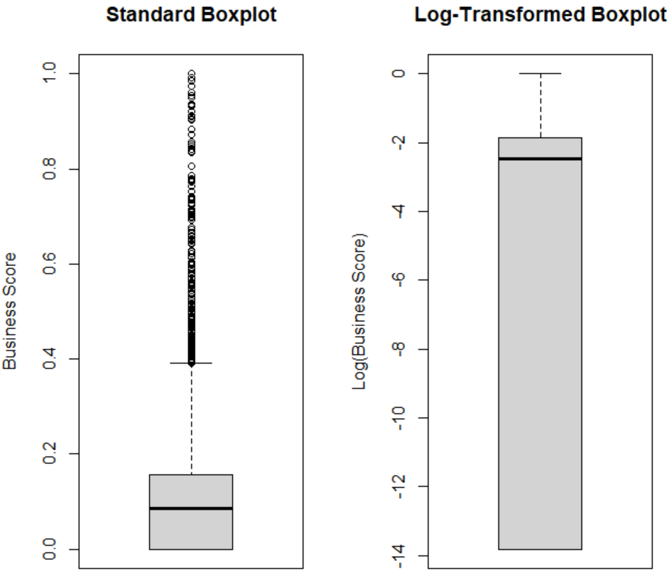
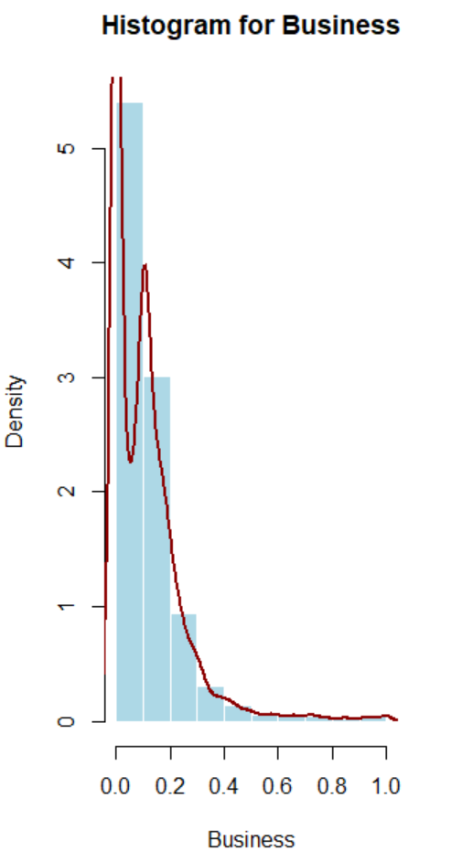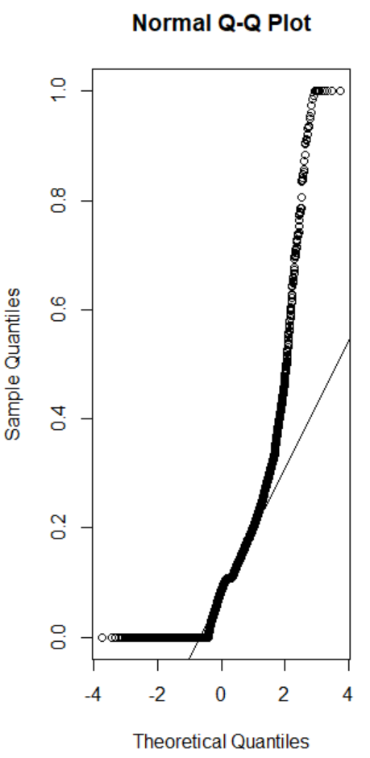
Log-transformed histogram and normal probability plot
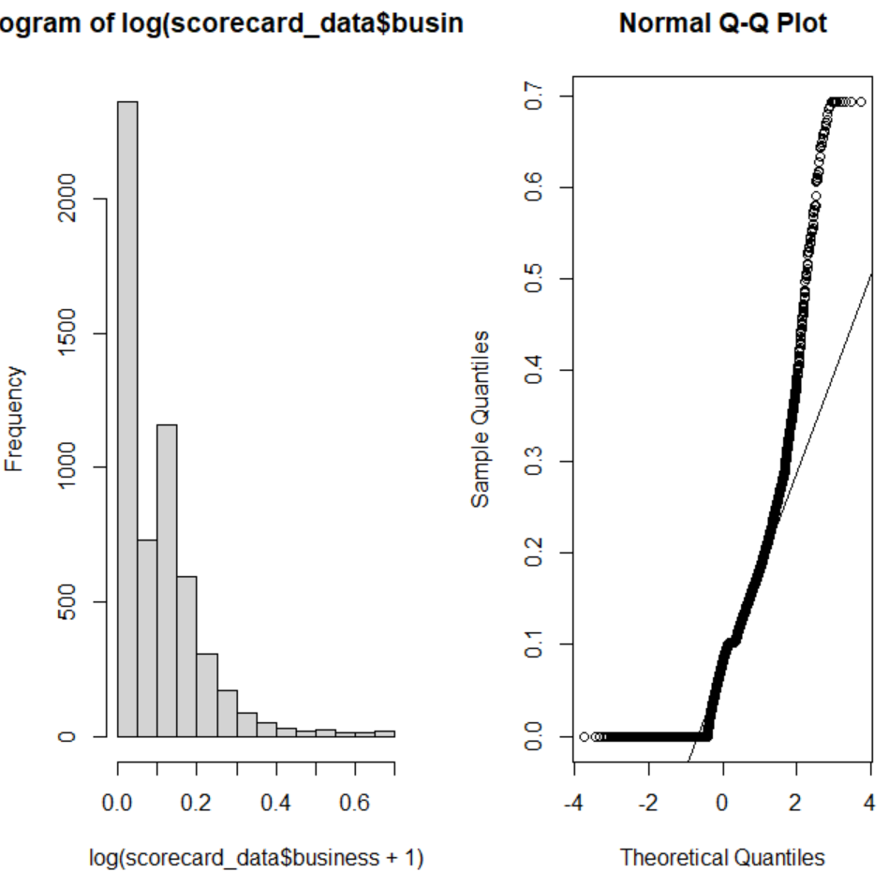

‘pell_grant’: previously PCTPELL; log transformation not necessary
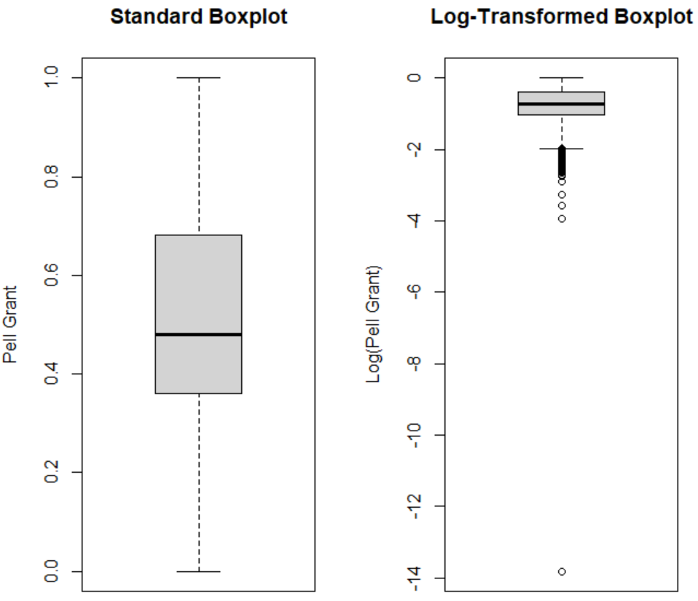
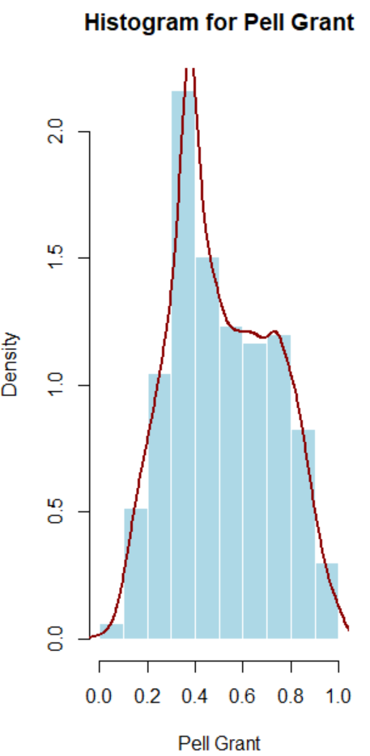

‘student_loan’: previously PCTFLOAN; log transformation not necessary
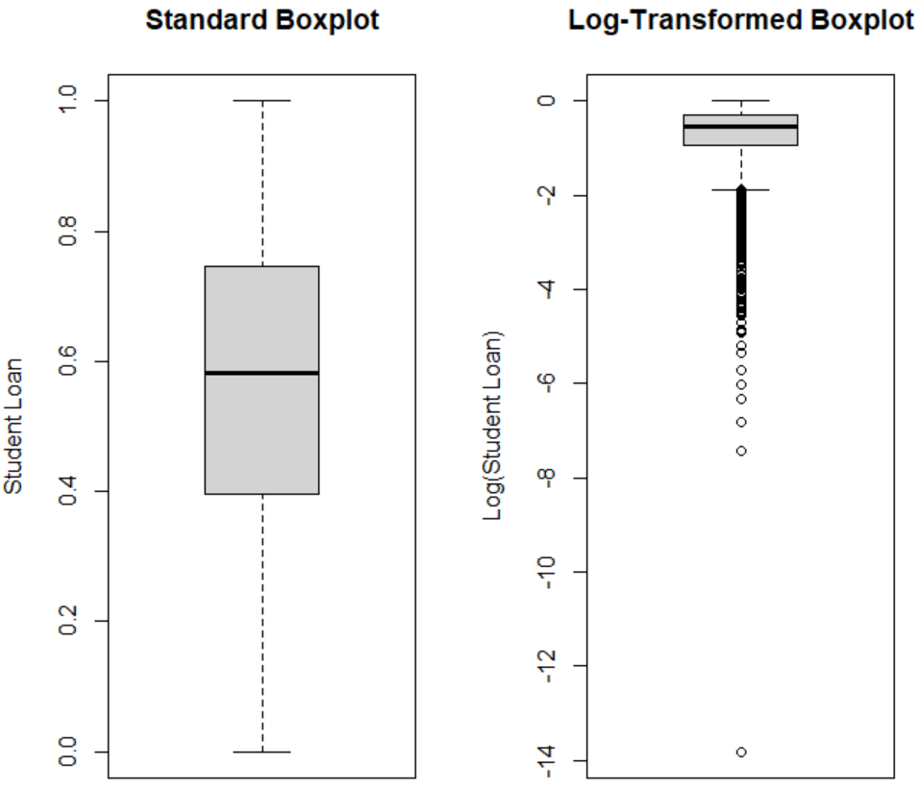
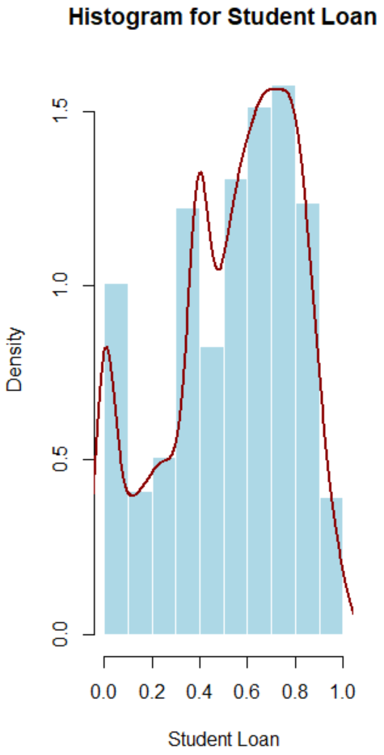

‘10yr_salary’: previously MD_EARN_WNE_P10; log transformation helped
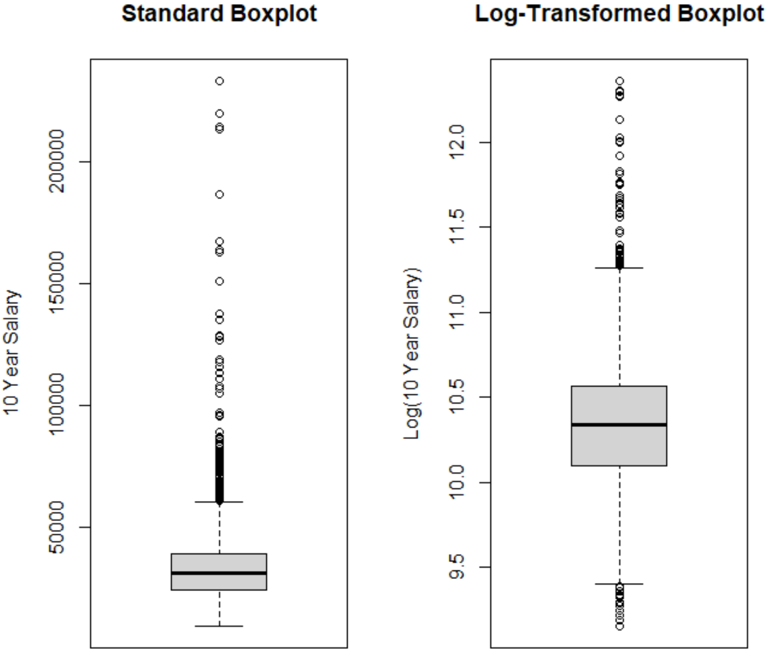
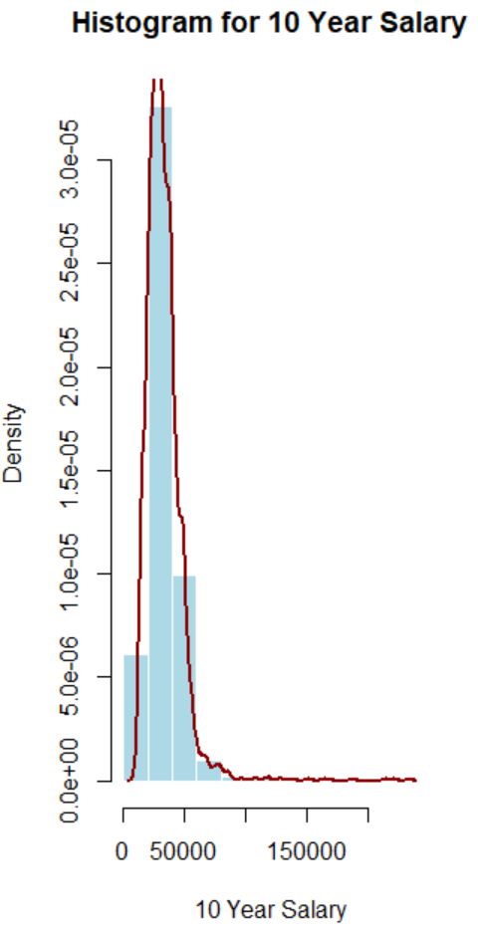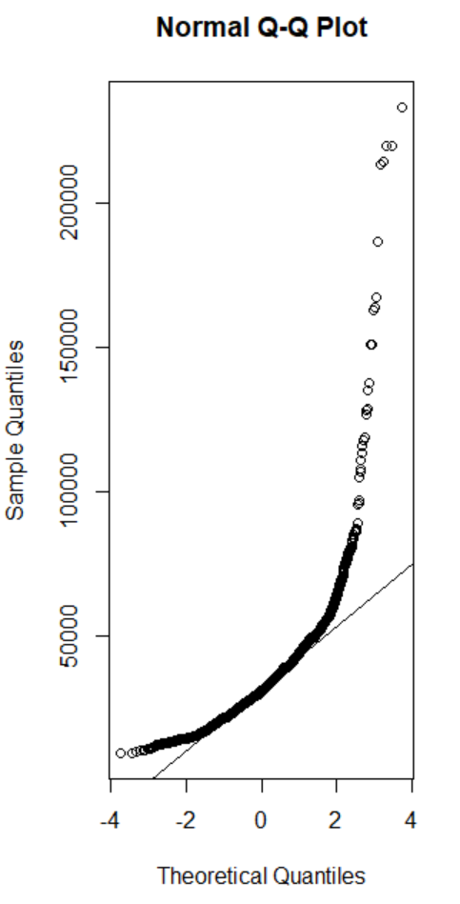
Log-transformation plots for ‘10yr_salary’; log-transformation helped
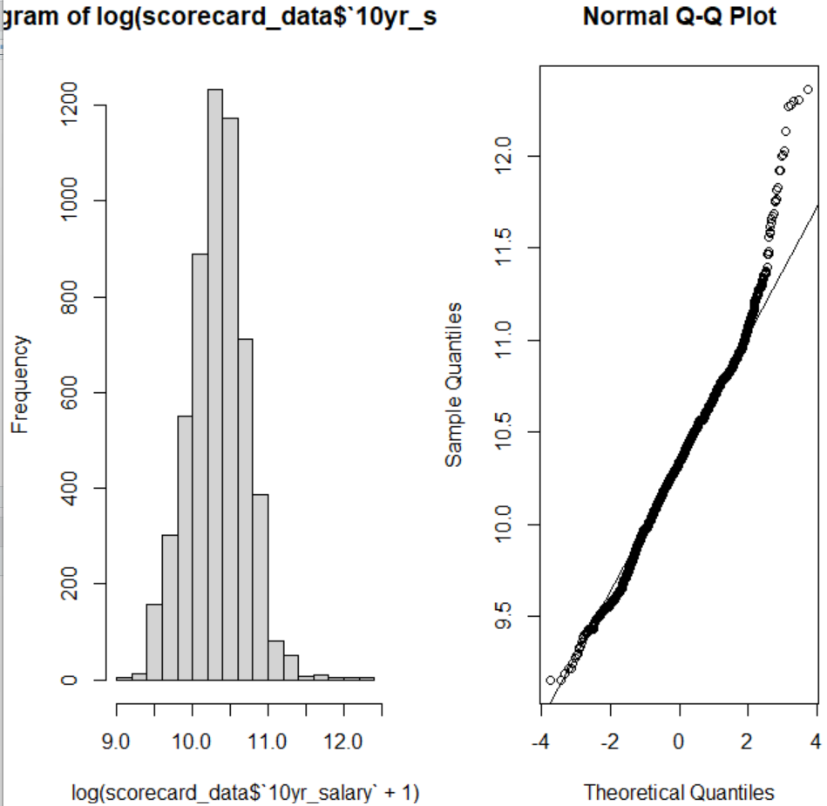

‘6yr_25k’: previously GT_25K_P6; log transformation not necessary
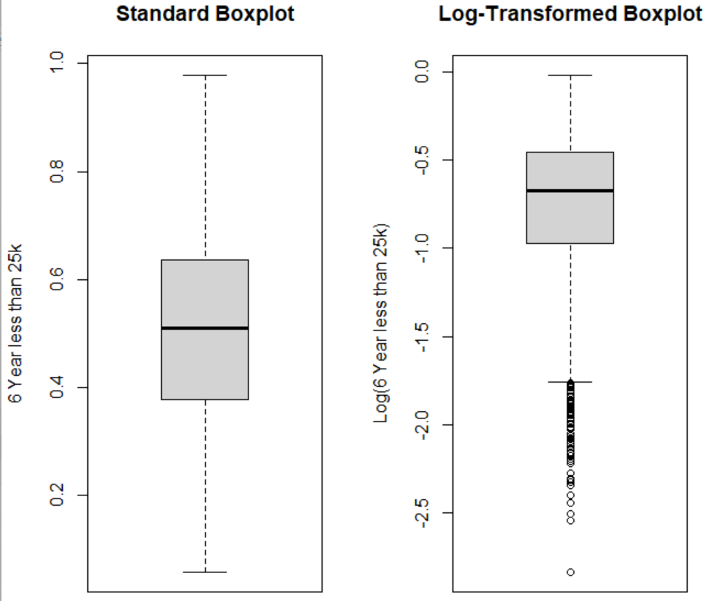
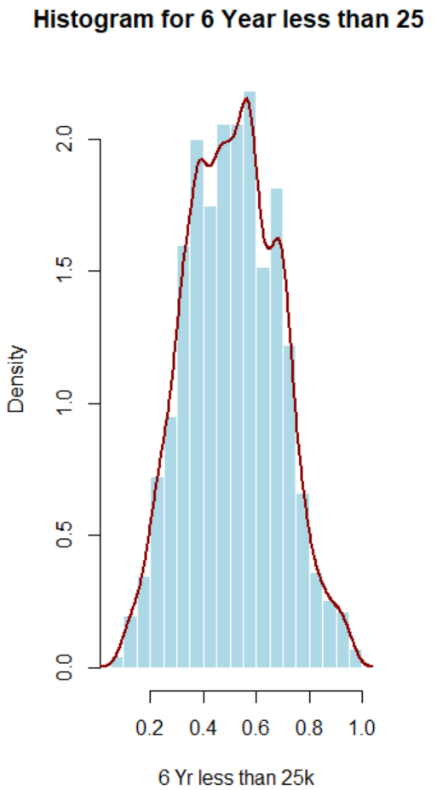

‘grad_debt’: previously GRAD_DEBT_MDN_SUPP; log-transformation did not help
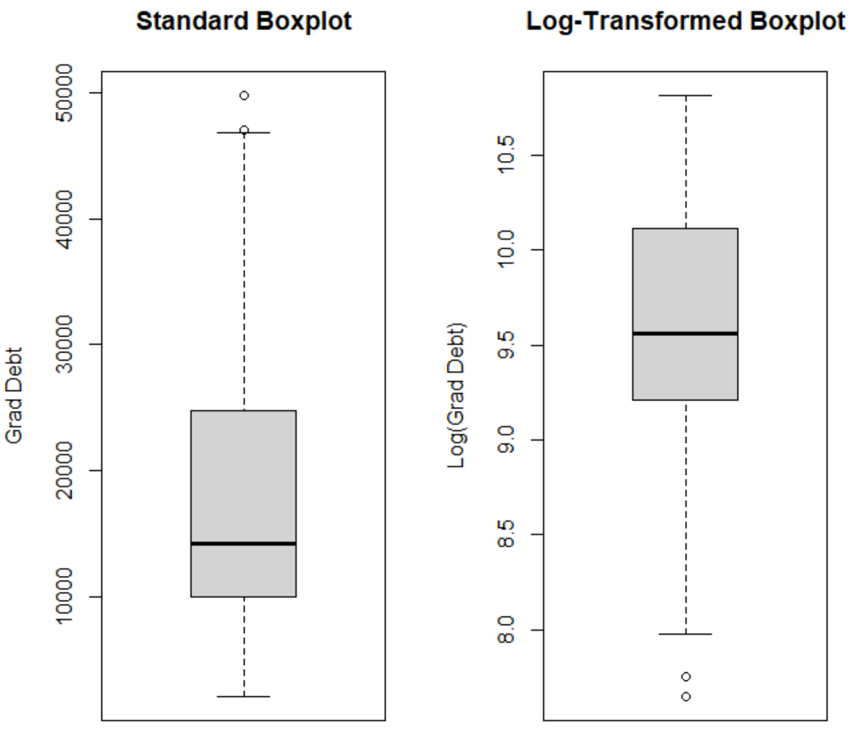
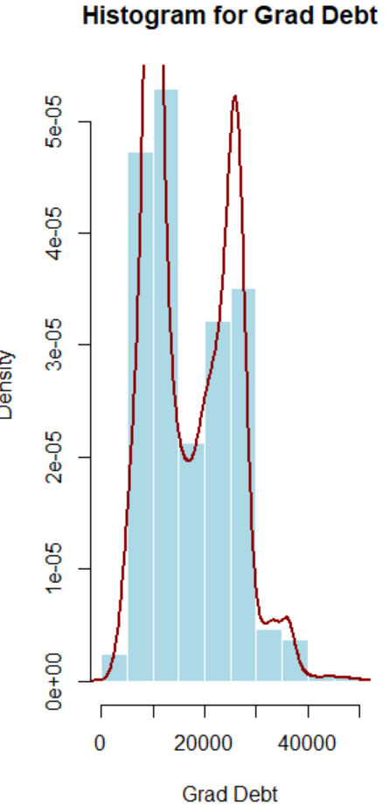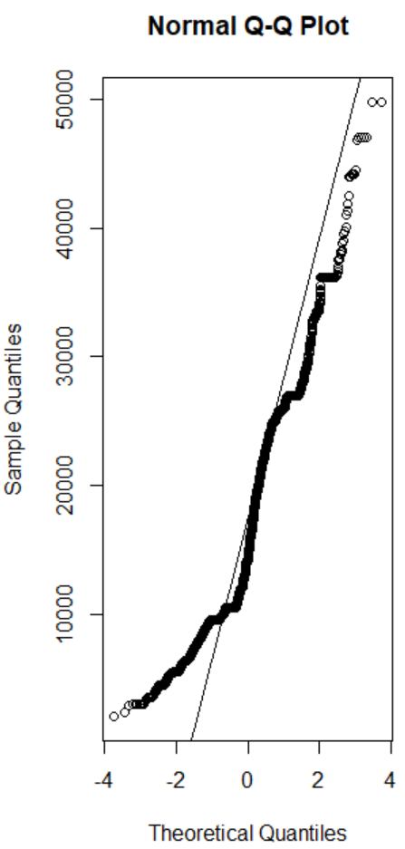

Log-transformed histogram and normal probability plot
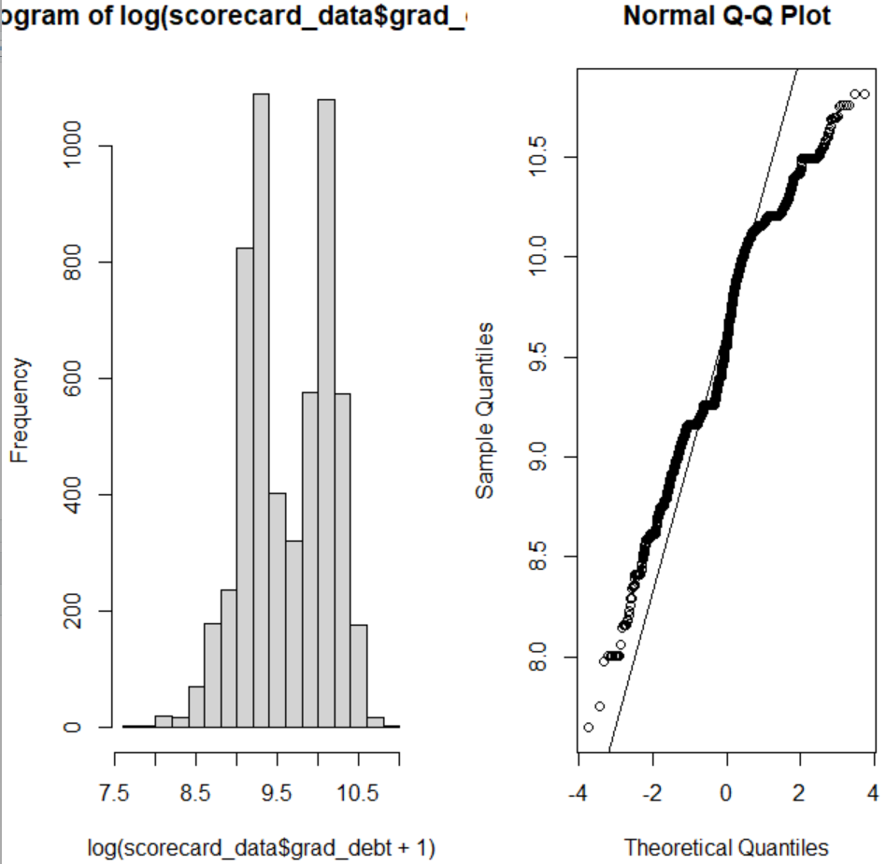

‘repay’: previously RPY_3YR_RT_SUPP; log transformation not necessary
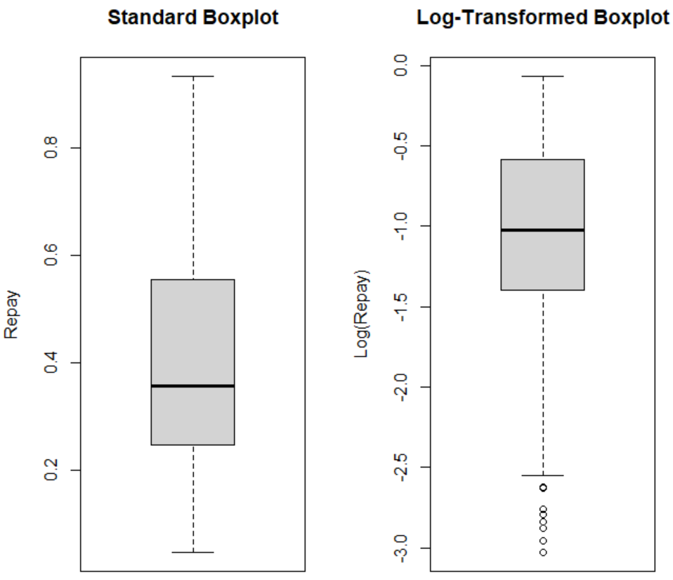
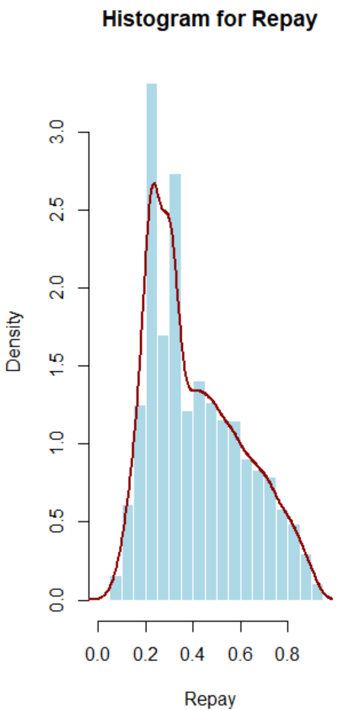

‘net_price’: previously NET_PRICE2; log-transformation does not help
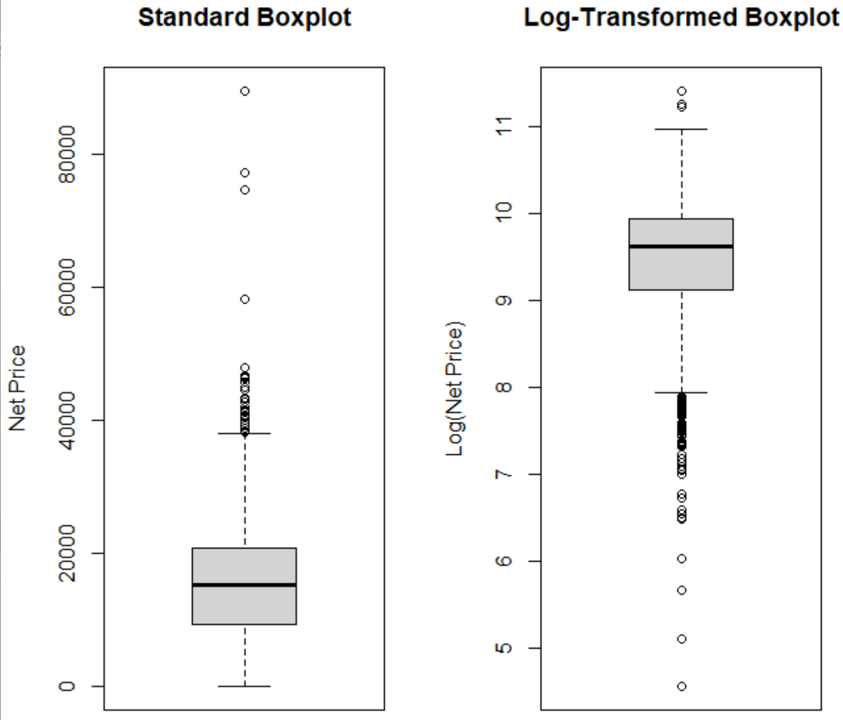
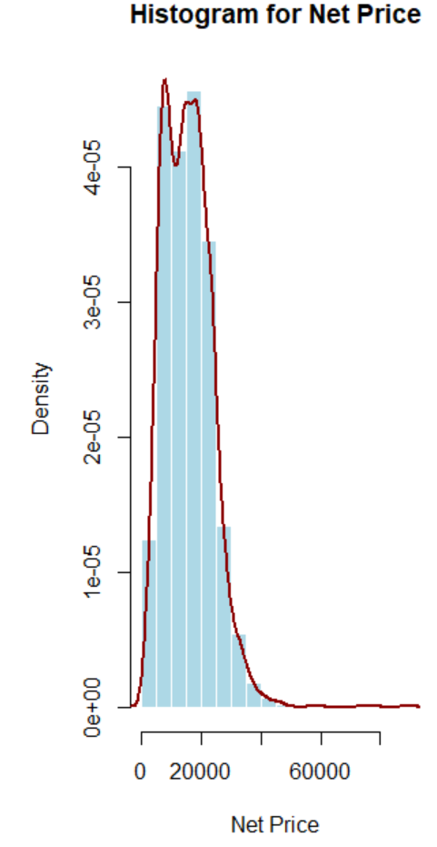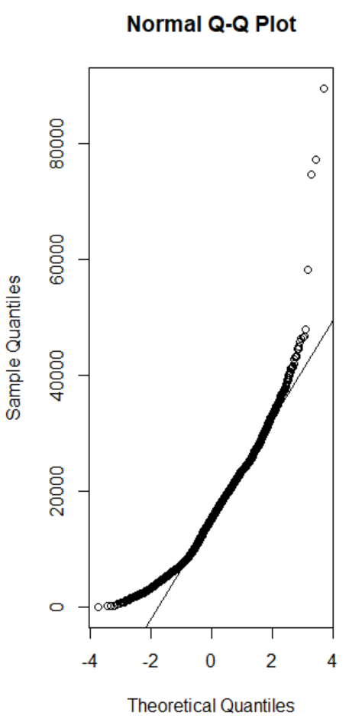

Log-transformed histogram and normal probability plot
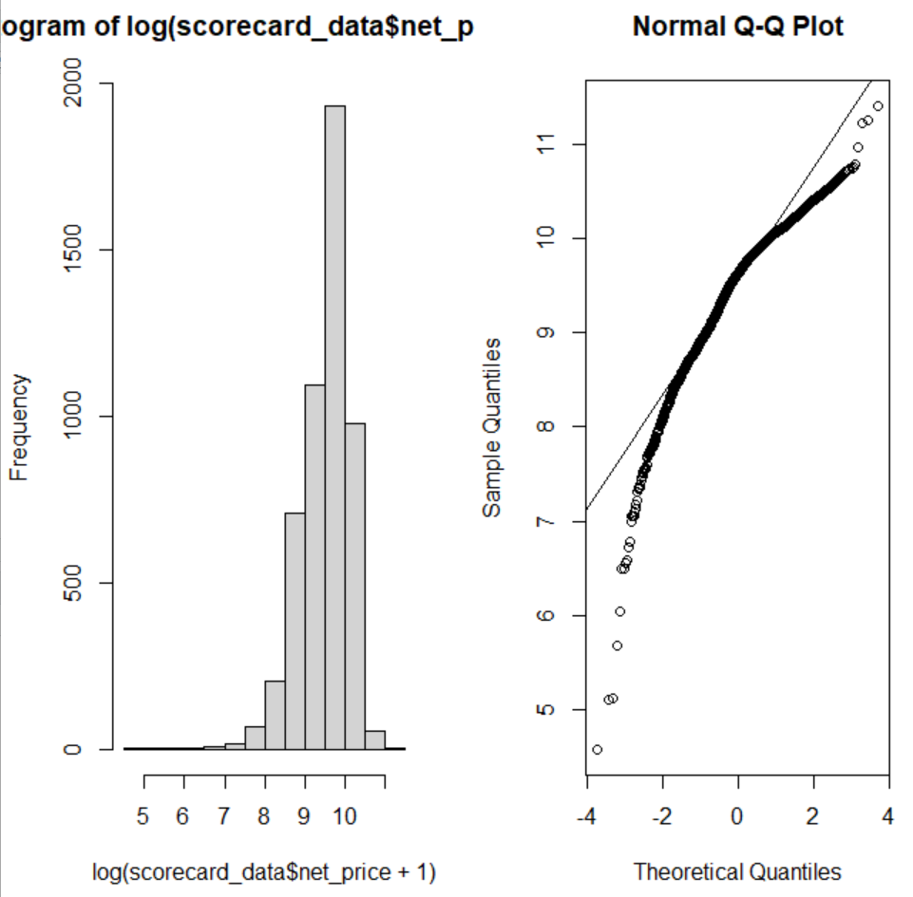

‘avg_sat’: previously SAT_AVG2; log transformation slightly better
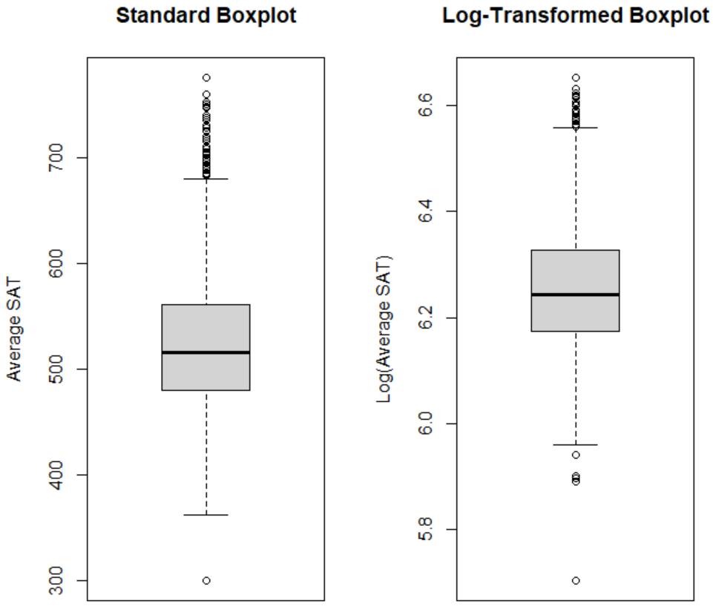
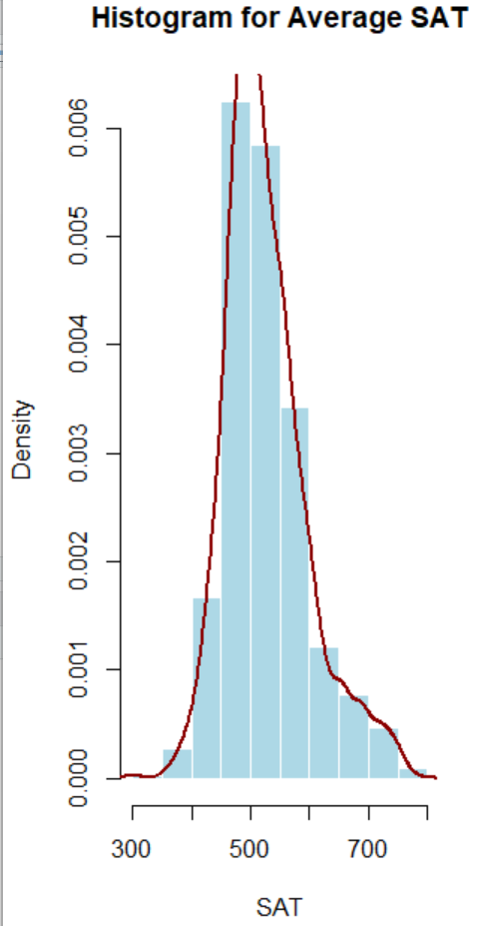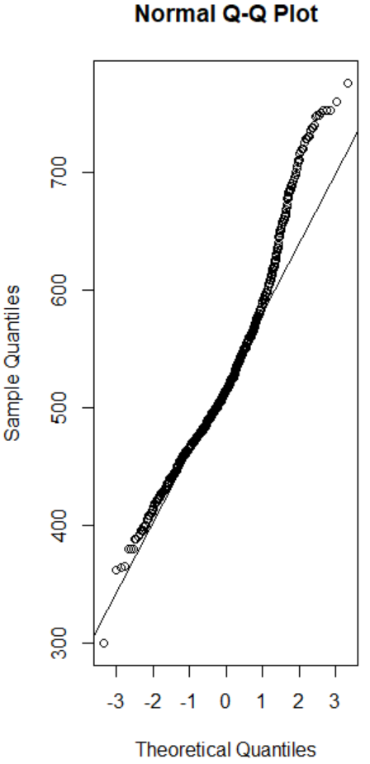
Log-transformed histogram and normal probability plot
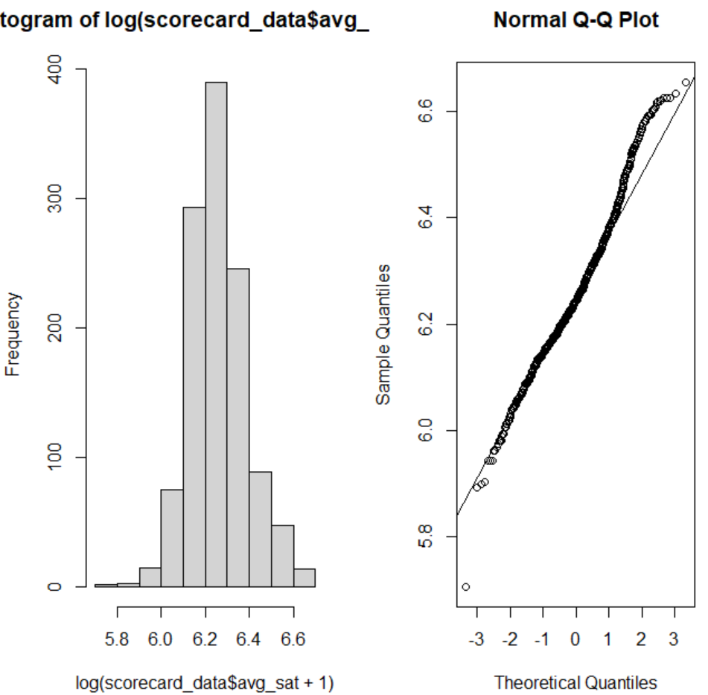

‘retention’: previously RETENTION_RATE2; log transformation does not help
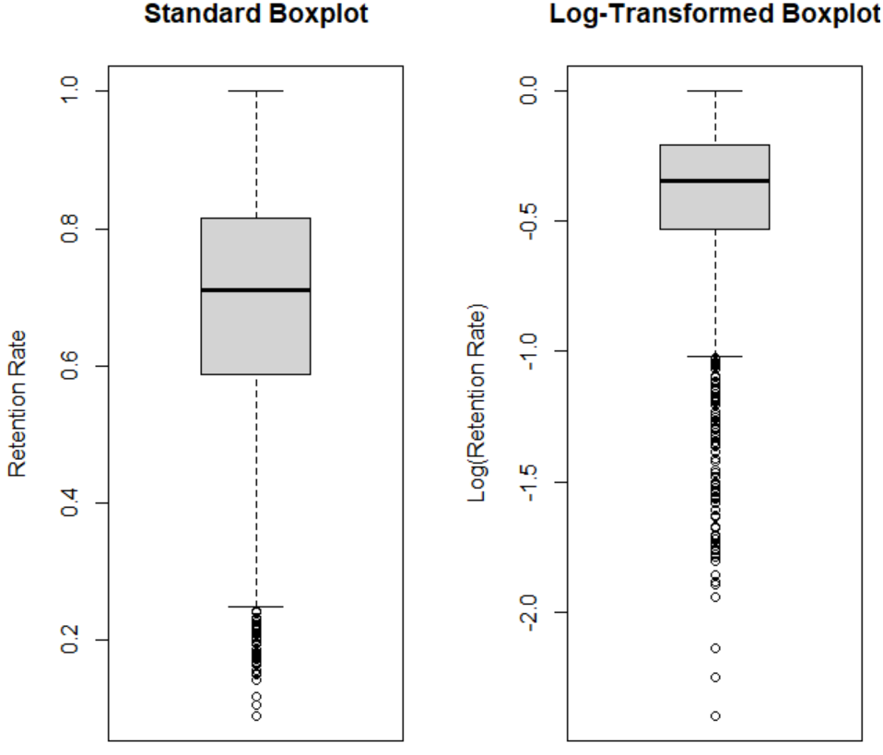
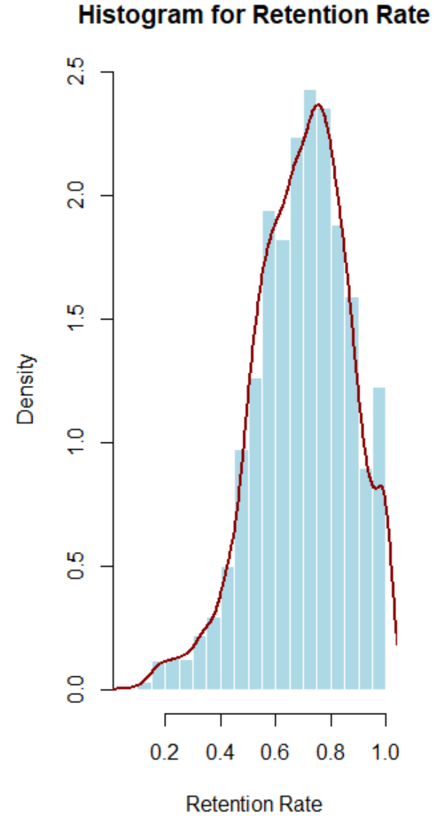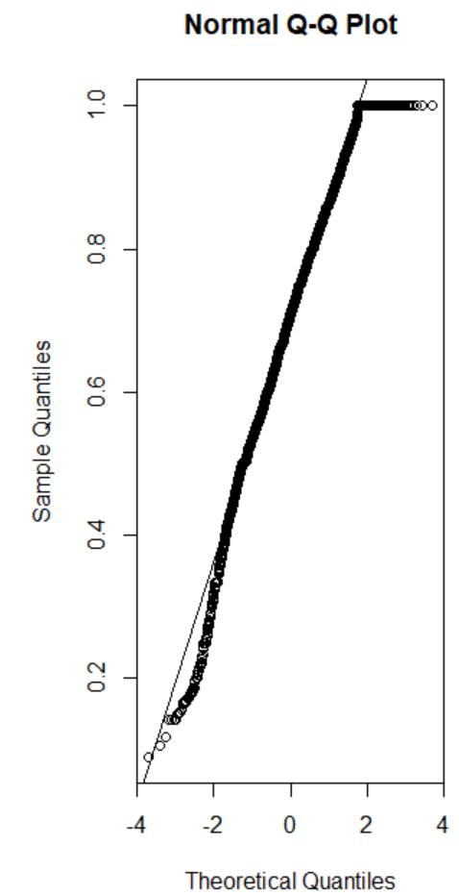
Log-transformed histogram and normal probability plot
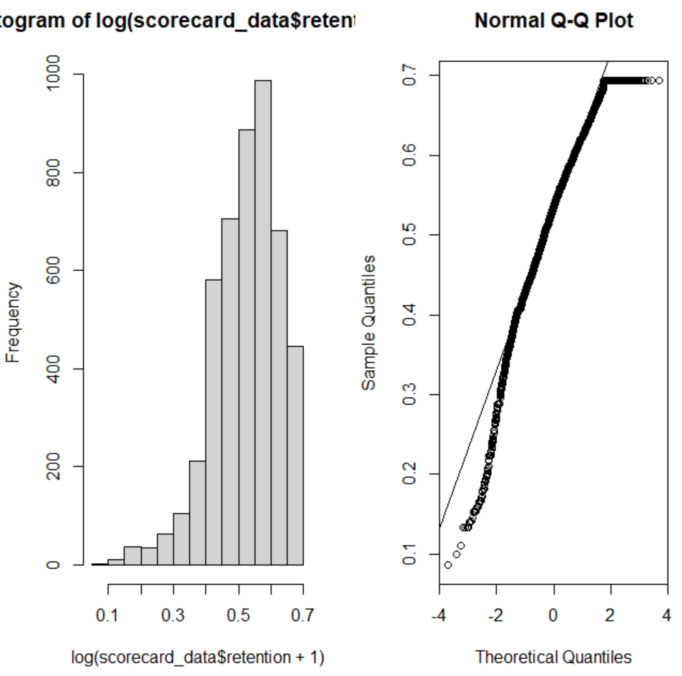

‘grad_rate’: previously GRAD_RATE2; log-transformation not necessary
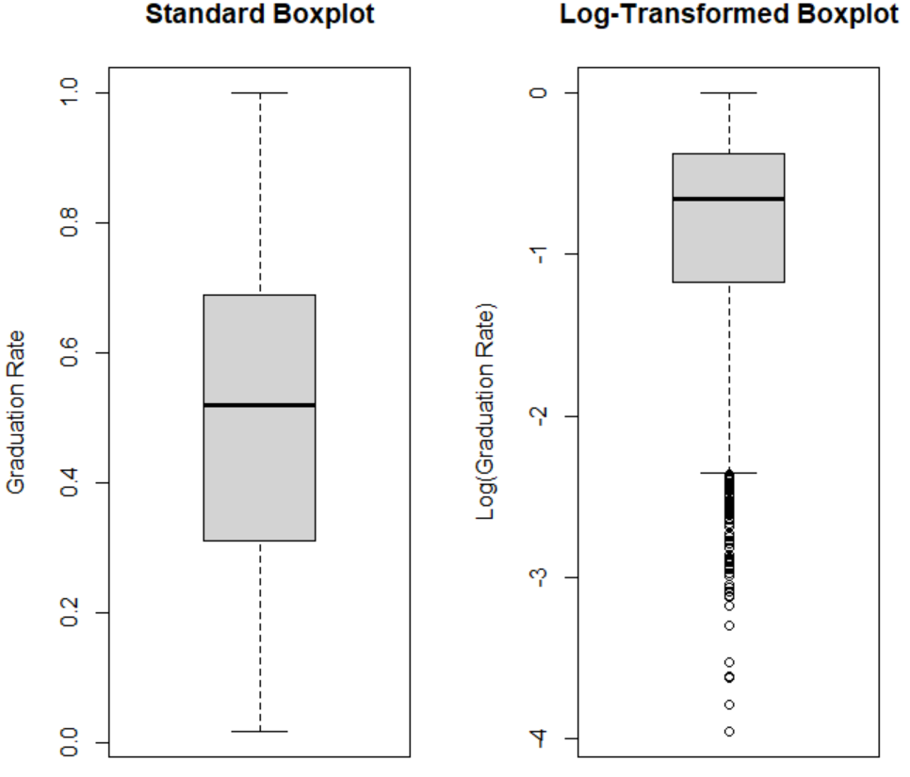
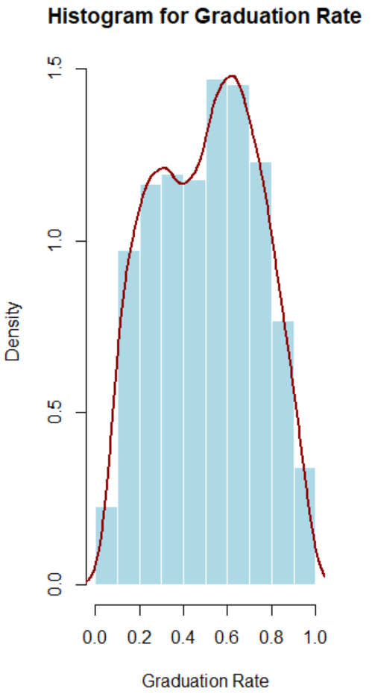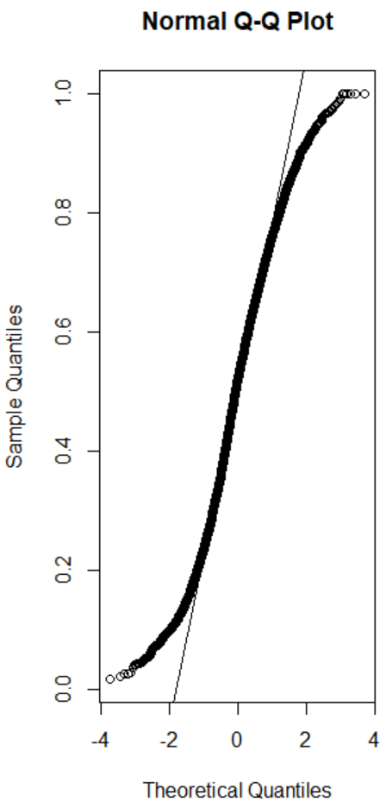

Correlation:
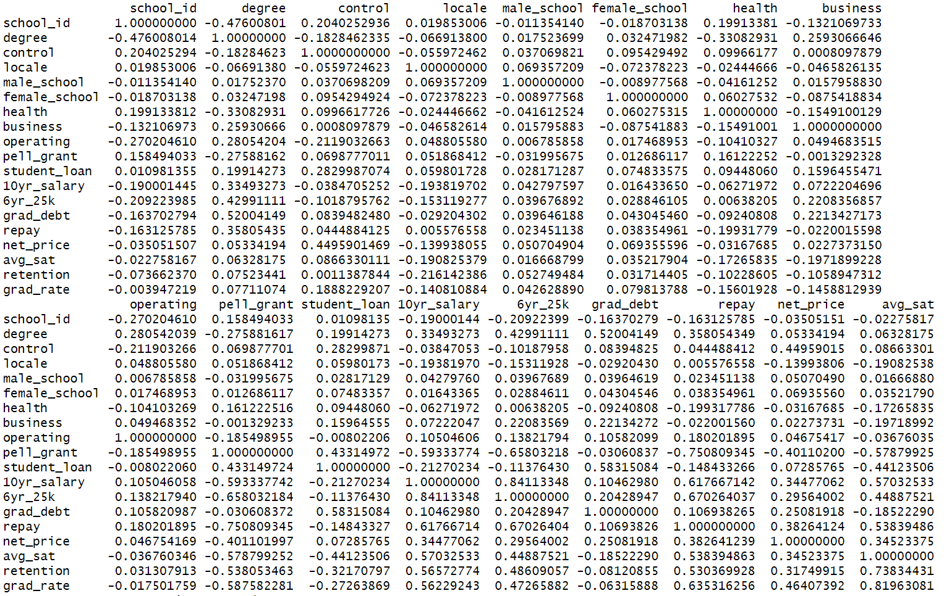
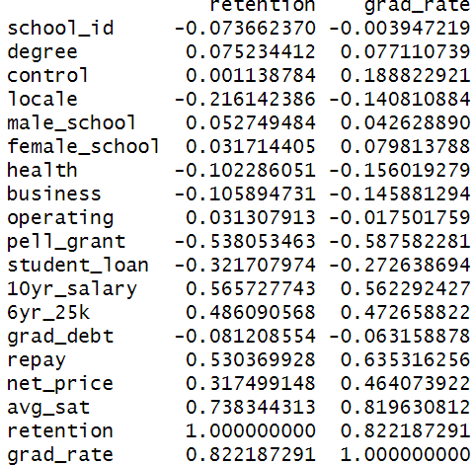
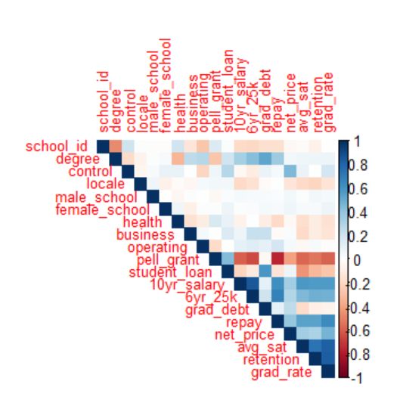
Red = strong positive correlation
Blue = strong negative correlation
White/light = weak or no correlation

Key Relationships:
Avg_sat ↔ grad_rate: Moderate positive correlation → Higher SAT scores tend to align with higher graduation rates.
Retention ↔ 10yr_salary & grad_rate : Positive correlation → Schools with better retention tend to produce better long-term outcomes.
Pell_grant ↔ student_loan & grad_debt: Positive correlation → Students receiving Pell Grants often also take on more debt.
Pell_grant ↔ avg_sat, retention, grad_rate : Negative correlation → Institutions with more Pell recipients may have lower SAT scores and graduation rates—possibly reflecting socioeconomic disparities.
10yr_salary ↔ grad_debt, repay, net_price: Negative correlation → Higher debt and cost may not always translate to higher earnings.
Repay ↔ grad_rate & retention : Positive correlation → Better academic outcomes align with stronger loan repayment

Modeling implications:
Avg_sat, retention, grad_rate, pell_grant, grad_debt, net_price → These show meaningful relationships with salary and repayment.

Multicollinearity:
Student_loan, grad_debt, and pell_grant are interrelated → Consider using PCA, variance inflation factor (VIF), or regularization to handle redundancy.

Possible interaction terms:
Pell_grant x avg_sat
Grad_debt x retention

