Project Progress Log 2 — Model Design
Project: What Factors Influence College Graduates’ Earnings 10 Years After Entry
Group 2: Eva Samitova, Sofia Alentyeva, Acshanah Pararajasingam, Marenah Ryan
Professor: Winnie Li
Course: DATA 485 – Capstone Project
Date: October 20, 2025

1. Modeling Approach and Methods
Building on our cleaned dataset (7,500 U.S. institutions, College Scorecard), the group is transitioning from data preparation to model design.
We plan to use the following analytic sequence:
- Exploratory Data Analysis (EDA) – visualize distributions, correlations, and outliers.
- Multiple Linear Regression – predict 10-year median earnings (yr10_salary) using institutional and financial predictors.
- ROI Analysis – derive ROI = yr10_salary / net_price to measure efficiency of educational investment.
- Model Validation – check normality, multicollinearity (VIF), and residual diagnostics.
- Visualization – summarize key relationships in Tableau dashboards.
Planned workflow diagram
Data Cleaning → Transformation (Log / Scaling)
→ Correlation Matrix → Regression Modeling → ROI Computation
→ Diagnostics → Tableau Dashboard & Interpretation
Each team member contributes one analytic dimension:
- Eva Samitova: Program Type (Business vs Healthcare)
- Sofia Alentyeva: Region
- Acshanah Pararajasingam: Degree Level
- Marenah Ryan: Institution Control
2. Why These Methods Fit Our Goal
Regression and correlation analysis are ideal for quantifying how continuous predictors (debt, net price, graduation rate, SAT, retention) relate to a continuous outcome (earnings).
ROI offers a derived measure of value for money.
Visualization in R and Tableau supports interpretability and clear communication to non-technical audiences.
3. Tools Used
Tool | Purpose | Reason
R (tidyverse, ggplot2, readxl, janitor) | Data cleaning, transformation, EDA, regression, correlation plots | Reproducible statistical workflow
Excel | Initial inspection and documentation | Quick manual verification
Tableau ( | Interactive dashboard of model outputs | Visual storytelling for final presentation

4. Preliminary Results and Findings
Log-Transformation & Normality Checks (from Doc 4):
- 10yr_salary and avg_sat benefit from log transformation (improved normality).
- Debt and net price showed skewness but log transformations did not materially help.
Correlation Highlights:
- avg_sat ↔ grad_rate → moderate positive (academic quality link).
- retention ↔ grad_rate → strong positive (student success link).
- pell_grant ↔ student_loan & grad_debt → positive (financial-aid burden link).
- pell_grant ↔ avg_sat & grad_rate → negative (socioeconomic disparities).
- 10yr_salary ↔ grad_debt, repay, net_price → weak negative (cost ≠ guaranteed returns).
Program Type Comparison (Eva Samitova Dimension):
Program Type | Mean Earnings | Median Earnings | Mean Debt | Mean Net Price | Mean ROI
Business | $39,329 | $38,600 | $23,027 | $17,358 | 3.08
Healthcare | $31,293 | $28,900 | $15,164 | $14,032 | 3.44
- T-test for earnings: p < 0.001 → Business significantly higher earnings.
- T-test for ROI: p = 0.29 → No significant ROI difference (after cost).
- Correlations confirm that retention and graduation rates are among the strongest predictors of earnings.
Visual Exploration: Program Type Dimension (Business vs. Healthcare)
To understand relationships between program characteristics and earnings, several exploratory visuals were created in R (ggplot2).
The plots highlight differences in earnings distribution, debt levels, and institutional control between Business and Healthcare programs.
The following boxplots were generated in R using ggplot2 to visualize how program characteristics relate to graduates’ 10-year earnings and other institutional variables:
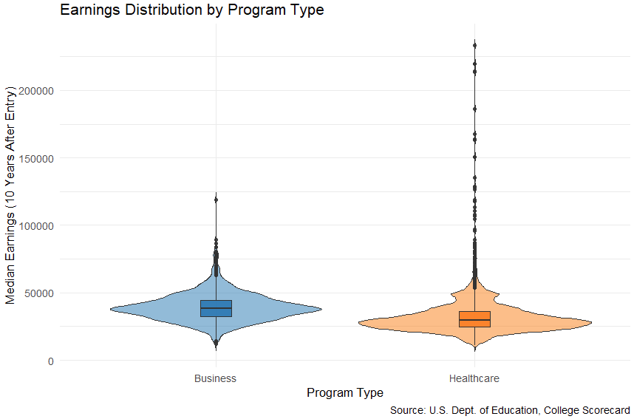
Figure 1. Earnings Distribution by Program Type
Business programs show higher median earnings and a narrower distribution than Healthcare.
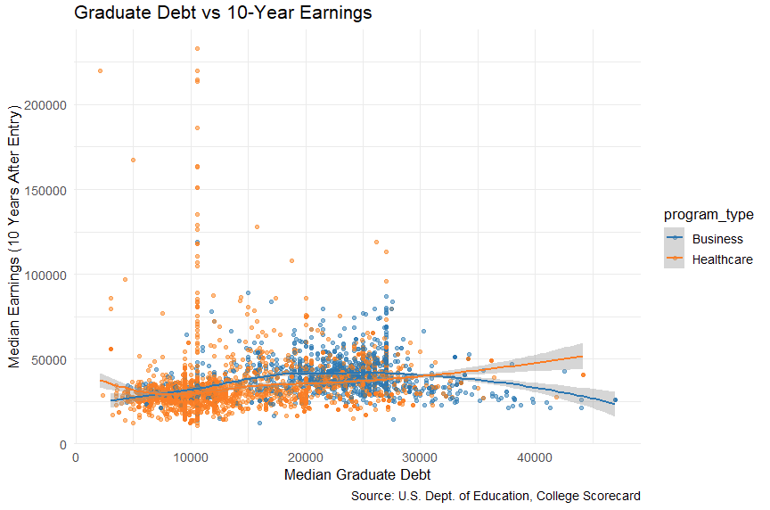
Figure 2. Graduate Debt vs 10-Year Earnings
A weak positive trend exists for both programs; higher debt is only modestly associated with higher earnings.
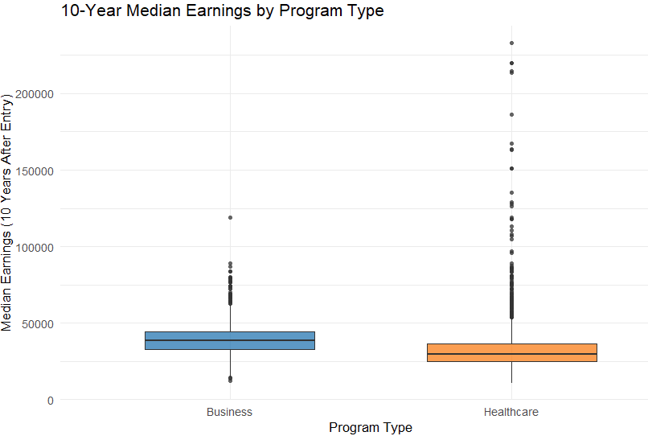
Figure 3. 10-Year Median Earnings by Program Type
(Business institutions show higher median earnings and narrower spread.)
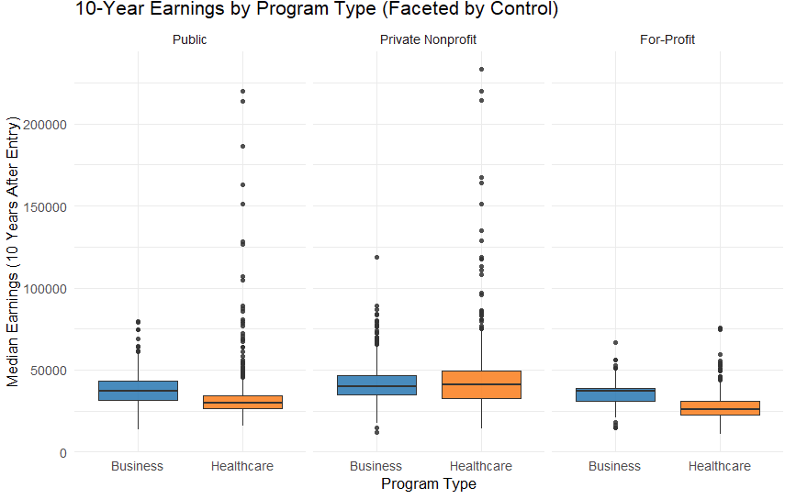
Figure 4. 10-Year Earnings by Program Type (Faceted by Control)
Within each control type (Public, Private Nonprofit, For-Profit), Business programs tend to have slightly higher earnings.
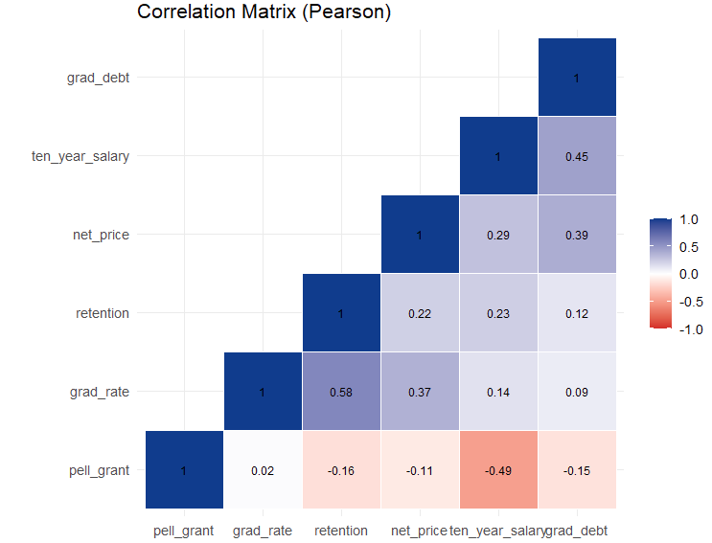
Figure 5. Correlation Matrix (Pearson)
Graduation rate and retention are strongly correlated (r ≈ 0.58); 10-year salary moderately correlates with grad debt (r ≈ 0.45).
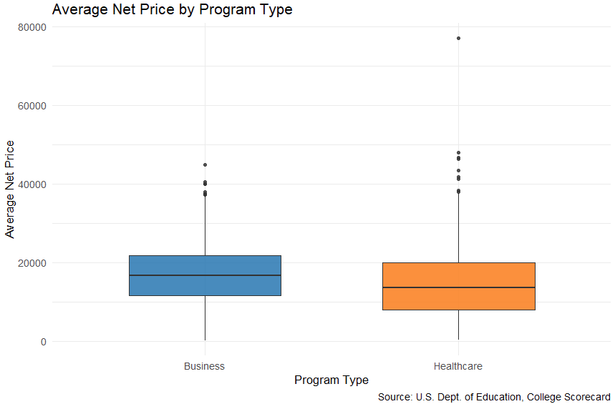
Figure 6. Average Net Price by Program Type
(Healthcare programs typically cost less, narrowing the ROI gap.)
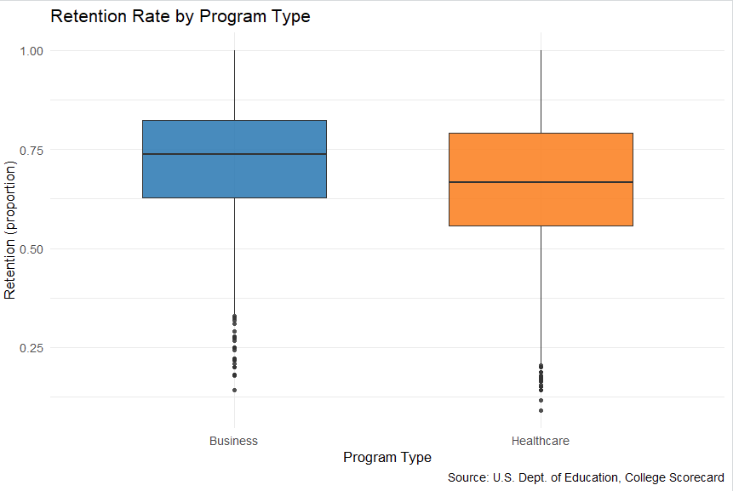
Figure 7. Retention Rate by Program Type
(Retention rates are slightly higher among Business programs.)
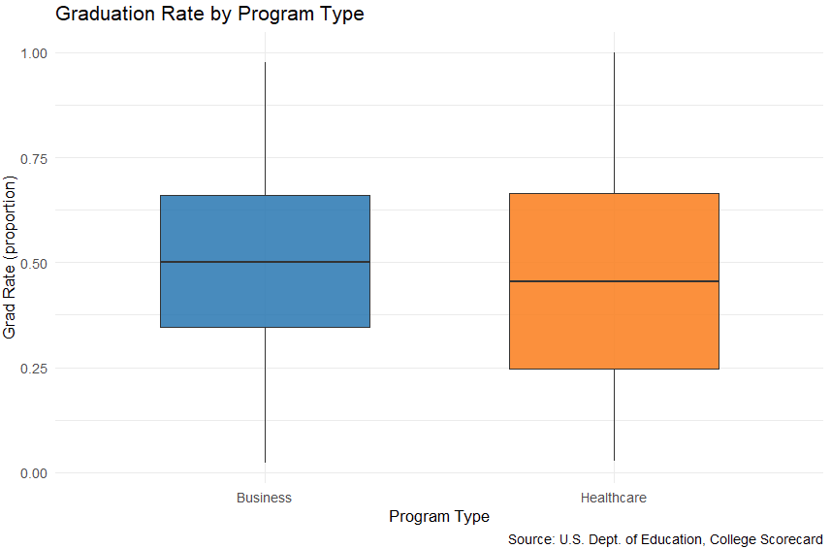
Figure 8. Graduation Rate by Program Type
(Graduation rates follow a similar pattern to retention, positively correlated with earnings.)
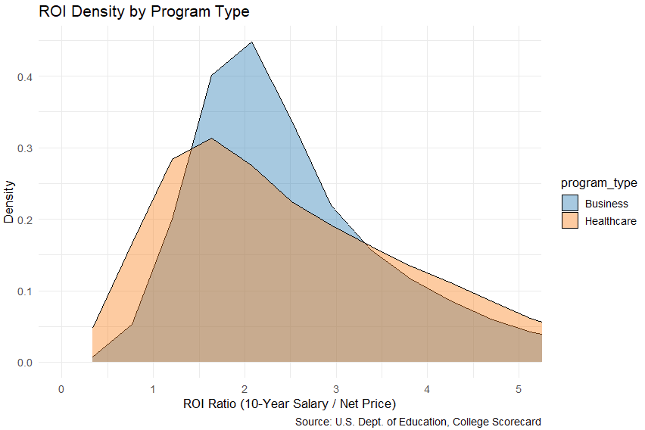
Figure 9. ROI Distribution (10-Year Salary / Net Price)
(Distributions overlap considerably; ROI differences are not statistically significant.)
5. Expected vs. Surprising Results
Our preliminary results generally aligned with expectations. Institutions with higher retention and graduation rates showed higher median earnings 10 years after entry, confirming that student success and academic quality are strong predictors of long-term outcomes. As expected, Business programs outperformed Healthcare programs in salary, reflecting typical differences in labor market demand and pay structure.
However, some findings were unexpected. Despite higher earnings, Business and Healthcare programs showed no significant difference in ROI, since lower tuition costs in Healthcare balance out lower salaries. This suggests that while absolute earnings differ, both fields provide similar long-term value relative to educational investment.
Another surprising observation was the presence of outlier institutions, particularly private schools, with unusually high ROI values—possibly due to specialized programs or reporting inconsistencies. These outliers will require additional review to confirm data accuracy or to identify unique institutional characteristics.

6. Action Plan
- Build a multiple regression model predicting yr10_salary using net_price, grad_rate, avg_sat, control, and program_type.
- Check multicollinearity using VIF for related financial variables (student_loan, pell_grant, grad_debt).
- Test interaction effects, such as grad_debt × retention, to capture combined influences.
- Integrate visuals and findings from all dimensions into a unified Tableau dashboard.
- Summarize and interpret results in the final project report, linking statistical evidence to key insights.

7. Conceptual Model Diagram
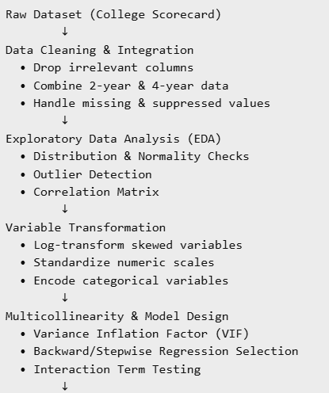
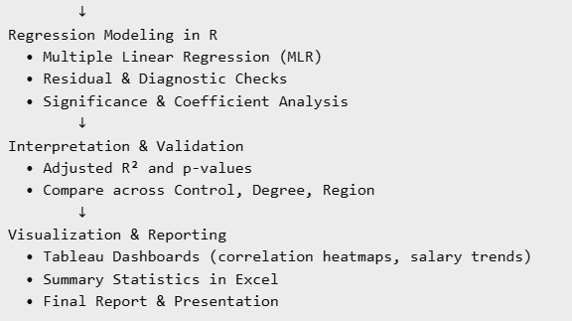
Summary
At this stage, our group has completed data cleaning, exploratory analysis, and preliminary modeling preparation to identify factors influencing graduates’ 10-year earnings. The analysis confirmed that institutions with higher retention and graduation rates tend to produce graduates with stronger long-term earnings. Business programs show higher average salaries than Healthcare programs, though their ROI remains similar due to higher tuition costs. These results highlight how both academic performance and financial accessibility contribute to post-graduate success.
An interactive Tableau dashboard (see Appendix A) summarizes the main insights, including comparisons of earnings, ROI, and graduate debt by program type. The next steps include developing and validating a multiple regression model, checking for multicollinearity, and integrating all dimensions into the final dashboard and written report.

Appendix A — Visual Summary Dashboard Tableau
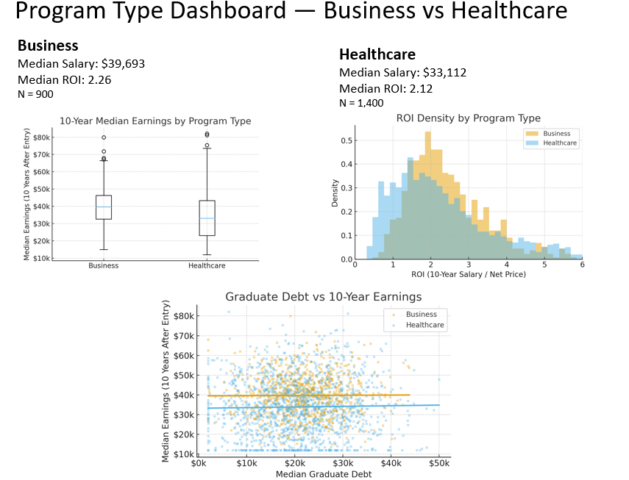

Appendix B
R Code and output
# ==============================================================
# Program Type Analysis (Business vs Healthcare) — Clean Version
# ==============================================================

# --- Load packages ---
library(tidyverse)
library(readxl)
library(janitor)

# --- Load file ---
file_path <- "C:/Users/User/OneDrive/__Личное__/BELLEVUE COLLEGE/Capstone485/scorecard_clean.xlsx"
dat <- read_excel(file_path) %>% clean_names()

# --- Verify columns ---
print(names(dat))

# --- Ensure correct salary column name ---
if ("x10yr_salary" %in% names(dat) && !"yr10_salary" %in% names(dat)) {
dat <- dat %>% rename(yr10_salary = x10yr_salary)
}
if ("10yr_salary" %in% names(dat) && !"yr10_salary" %in% names(dat)) {
dat <- dat %>% rename(yr10_salary = `10yr_salary`)
}

# --- Convert numeric columns safely ---
num_cols <- c("health","business","yr10_salary","grad_debt","net_price",
"avg_sat","retention","grad_rate","pell_grant","student_loan",
"repay","x6yr_25k")
dat <- dat %>%
mutate(across(all_of(intersect(num_cols, names(dat))), ~ suppressWarnings(as.numeric(.x))))

# --- Create Program Type ---
df_program <- dat %>%
mutate(program_type = case_when(
business > health ~ "Business",
health > business ~ "Healthcare",
TRUE ~ "Mixed"
)) %>%
filter(program_type %in% c("Business","Healthcare"),
!is.na(yr10_salary))

# --- Visual setup ---
pal <- c("Business" = "#1f77b4", "Healthcare" = "#ff7f0e")
cap <- "Source: U.S. Dept. of Education, College Scorecard"

# ===================== VISUALS =====================

# 10-Year Median Earnings
ggplot(df_program, aes(program_type, yr10_salary, fill = program_type)) +
geom_boxplot(alpha = 0.75, outlier.shape = 16, width = 0.6) +
labs(title = "10-Year Median Earnings by Program Type",
x = "Program Type", y = "Median Earnings (10 Years After Entry)",
caption = cap) +
scale_fill_manual(values = pal) +
theme_minimal(base_size = 13) +
theme(legend.position = "none")

# Graduate Debt vs 10-Year Earnings
ggplot(df_program, aes(grad_debt, yr10_salary, color = program_type)) +
geom_point(alpha = 0.5, size = 1.6) +
geom_smooth(method = "loess", se = TRUE) +
labs(title = "Graduate Debt vs 10-Year Earnings",
x = "Median Graduate Debt", y = "Median Earnings (10 Years After Entry)",
caption = cap) +
scale_color_manual(values = pal) +
theme_minimal(base_size = 13)

# Net Price
ggplot(df_program, aes(program_type, net_price, fill = program_type)) +
geom_boxplot(width = 0.6, alpha = 0.85, outlier.shape = 16) +
labs(title = "Average Net Price by Program Type",
x = "Program Type", y = "Average Net Price", caption = cap) +
scale_fill_manual(values = pal) +
theme_minimal(base_size = 13) +
theme(legend.position = "none")

# Retention
ggplot(df_program, aes(program_type, retention, fill = program_type)) +
geom_boxplot(width = 0.6, alpha = 0.85, outlier.shape = 16) +
labs(title = "Retention Rate by Program Type",
x = "Program Type", y = "Retention (proportion)", caption = cap) +
scale_fill_manual(values = pal) +
theme_minimal(base_size = 13) +
theme(legend.position = "none")

# Graduation Rate
ggplot(df_program, aes(program_type, grad_rate, fill = program_type)) +
geom_boxplot(width = 0.6, alpha = 0.85, outlier.shape = 16) +
labs(title = "Graduation Rate by Program Type",
x = "Program Type", y = "Grad Rate (proportion)", caption = cap) +
scale_fill_manual(values = pal) +
theme_minimal(base_size = 13) +
theme(legend.position = "none")

# Faceted by Control (Public/Private/For-Profit)
df_program$control <- factor(df_program$control,
levels = c(1,2,3),
labels = c("Public","Private Nonprofit","For-Profit"))
ggplot(df_program, aes(program_type, yr10_salary, fill = program_type)) +
geom_boxplot(outlier.shape = 16, alpha = 0.85) +
facet_wrap(~ control, nrow = 1) +
labs(title = "10-Year Earnings by Program Type (Faceted by Control)",
x = "Program Type", y = "Median Earnings (10 Years After Entry)",
caption = cap) +
scale_fill_manual(values = pal) +
theme_minimal(base_size = 13) +
theme(legend.position = "none")

# ROI (Salary ÷ Net Price)
df_roi_prog <- df_program %>%
mutate(net_price = na_if(net_price, 0),
roi = yr10_salary / net_price) %>%
filter(is.finite(roi))

# Histogram (zoomed 0–5)
ggplot(df_roi_prog, aes(x = roi, fill = program_type)) +
geom_histogram(position = "identity", alpha = 0.4, bins = 40, color = "grey30") +
coord_cartesian(xlim = c(0, 5)) +
labs(title = "Distribution of ROI (10-Year Salary / Net Price) by Program Type (Zoomed)",
x = "ROI Ratio", y = "Number of Institutions", caption = cap) +
scale_fill_manual(values = pal) +
theme_minimal(base_size = 13)

# Density
ggplot(df_roi_prog, aes(x = roi, fill = program_type)) +
geom_density(alpha = 0.4) +
coord_cartesian(xlim = c(0, 5)) +
labs(title = "ROI Density by Program Type",
x = "ROI Ratio", y = "Density", caption = cap) +
scale_fill_manual(values = pal) +
theme_minimal(base_size = 13)

# ===================== TABLES / STATS =========================

stats_tbl <- df_program %>%
group_by(program_type) %>%
summarise(
n = n(),
mean_salary = mean(yr10_salary, na.rm = TRUE),
median_salary = median(yr10_salary, na.rm = TRUE),
sd_salary = sd(yr10_salary, na.rm = TRUE),
mean_debt = mean(grad_debt, na.rm = TRUE),
mean_price = mean(net_price, na.rm = TRUE),
retention = mean(retention, na.rm = TRUE),
grad_rate = mean(grad_rate, na.rm = TRUE),
.groups = "drop"
)
print(stats_tbl)

# T-tests
print(t.test(yr10_salary ~ program_type, data = df_program))

roi_prog_summary <- df_roi_prog %>%
group_by(program_type) %>%
summarise(n = n(),
mean_ROI = mean(roi),
median_ROI = median(roi),
sd_ROI = sd(roi),
.groups = "drop")
print(roi_prog_summary)
print(t.test(roi ~ program_type, data = df_roi_prog))

Output:
