**ENROLLMENT LETTER**

2025-May-22

**Student Name:** Chen, Yanhong

**Date of Birth:** 2007-JUN-08

**Ontario Education Number**: 913-750-170

**Enrollment Date:** 2024-SEP-03

**Expected Graduation Date:** 2025-JUN-30

This letter is to certify that the above student is enrolled as a full-time student at Emerald Valley Academy (BSID: 887678). The students of Emerald Valley Academy receive face-to-face instruction through their local school, and complete OSSD course work through our advanced learning platform. The medium of instruction is English, and student assessments are centrally evaluated by Ontario Certified Teachers in Canada. Upon successful completion of the Ontario Secondary School Program, the student will graduate with an Ontario Secondary School Diploma (OSSD) issued by the Ontario Ministry of Education.

Please feel free to contact me if you require any addition information or clarification.

Sincerely,

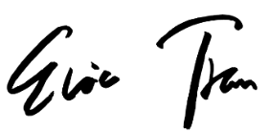

Eric Tran

Principal

Emerald Valley Academy