Data Preparation
Import Data and Initial Data Inspection
- The Skip Comments (#) option was disabled during data import because one startup name contained the # character (e.g., #waywire), which caused the record to be incorrectly treated as a comment. (By disabling the Skip Comments filter, this valid record was successfully recovered without affecting other rows.)
- After importing the dataset, we checked whether the automatically assigned data types (e.g., polynominal, integer, date) were consistent with the actual values in each column.
- The funding_total_usd variable was automatically detected as polynominal due to inconsistent numeric formatting, such as comma-separated values (e.g., 17,50,000) and non-numeric placeholders (e.g., -).
- Conceptually, the funding amount represents a continuous numeric value and would ideally be treated as a real-valued attribute rather than an integer.
- However, directly converting this attribute to a numeric type resulted in a large number of missing values (?), as non-numeric entries could not be parsed.
- To avoid unnecessary information loss during the import stage, the attribute type was intentionally left unchanged, with the plan to resolve formatting issues later using a Replace operation before numeric parsing.
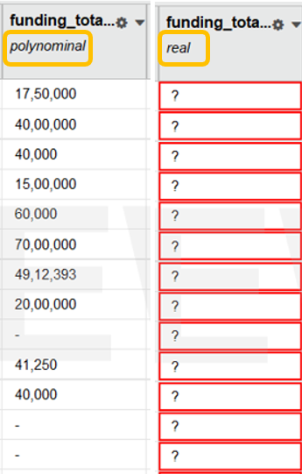
Filter Examples and Rationale
- status is not missing
Observations with missing status were removed because this variable serves as the label of the model and represents a core indicator of startup outcomes.
- country_code contains USA
The analysis was restricted to U.S.-based startups to reduce cross-country differences in regulatory environments, funding systems, and market maturity, allowing for clearer comparisons across firms operating under similar conditions.
- market is not missing
Startups without market information were excluded because meaningful industry-level analysis and results were considered important, particularly for stakeholders who may use the model outputs for interpretation or decision-making.
- funding_rounds is not missing
Startups with missing funding round information were excluded because the number of funding rounds reflects investment activity, growth signals, and survival prospects.
- funding_total_usd does not contain "-"
Non-numeric placeholders were removed to support accurate numeric parsing and analysis of funding amounts.
- founded_at ≥ 01/01/1992
The dataset was restricted to startups founded from 1992 onward to focus on firms operating within a more comparable startup and venture capital environment, which expanded significantly during the early 1990s.
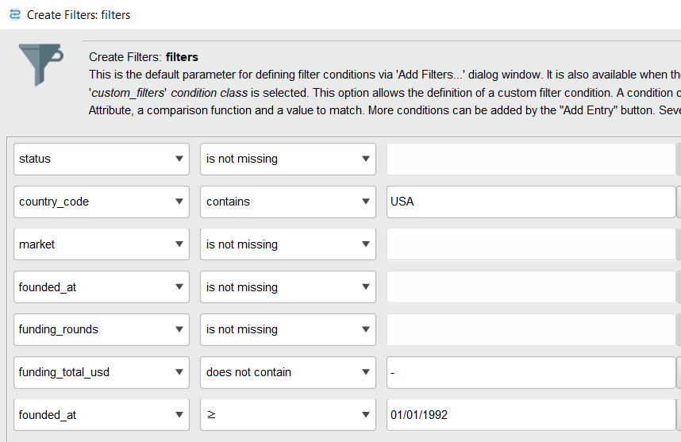
Excluded Funding-Type Variables
- The original dataset contains several funding-type–specific attributes (e.g., seed, venture, angel, Series A–H).
- These variables could potentially provide detailed insights into startup growth stages and financing structure.
- However, they were excluded from the analysis due to a high proportion of missing values, which could introduce bias and reduce model stability.
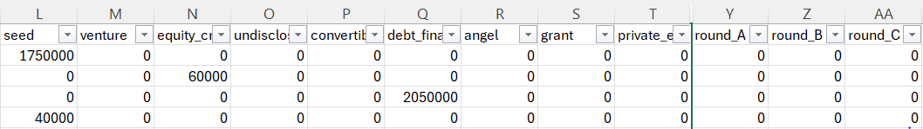

Generate Attributes
- A new binary attribute, outcome, was created to serve as the label for the classification task.
- The outcome variable was defined using the expression
if(status == "closed", 0, 1)
where startups with a status of closed were assigned a value of 0, and all other statuses (e.g., operating or acquired) were assigned a value of 1 to represent a positive investment outcome.
- The firm_age attribute was generated using the expression
2025 - founded_year
to represent the age of each startup and capture temporal information relevant for modeling.
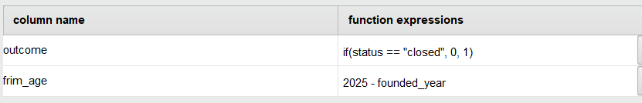

Select Attributes
- After generating the target variable, the original status attribute was excluded from the feature set because it was used to construct outcome.
- This step was taken to prevent data leakage and ensure that the model does not have access to information directly related to the target label.
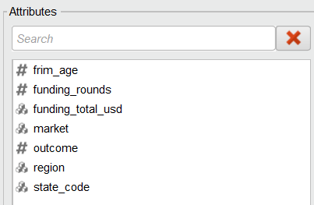

Replace
- The funding_total_usd attribute was initially interpreted as polynominal because the numeric values contained formatting characters such as commas and spaces.
- A first Replace operator was applied to remove comma characters (,) from the values.
- An additional Replace operator was applied to remove whitespace (spaces) from the values to ensure clean numeric formatting.
- After these replacements, the attribute was properly prepared for conversion into a numeric data type in subsequent processing steps.
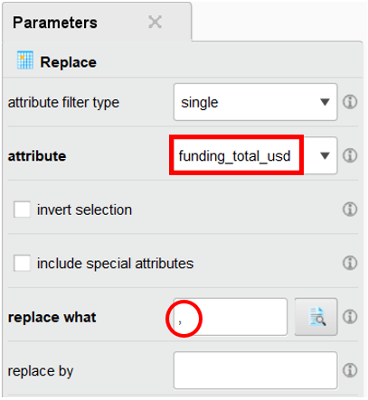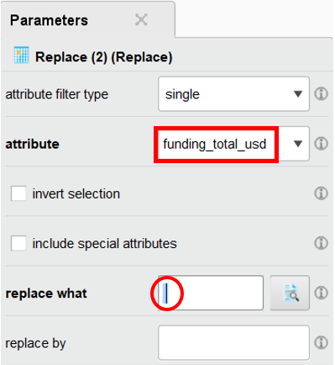
Parse Number
After standardizing the numeric format of the funding_total_usd attribute using a Replace operation, a Parse Numbers operator was applied.
- This step converted the attribute from polynominal to a numeric data type, enabling quantitative analysis and use in downstream modeling.
- Parsing was performed only after filtering out non-numeric placeholders to prevent the introduction of unnecessary missing values.

Numerical to Binominal
- The outcome variable was converted from a numeric format (0/1) to a binominal attribute to ensure compatibility with classification algorithms and performance evaluation metrics.
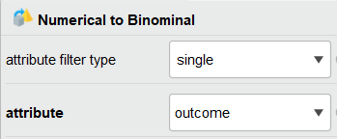

Set Role
- The binominal outcome attribute was explicitly assigned the label role, clearly defining the target variable for the supervised learning task
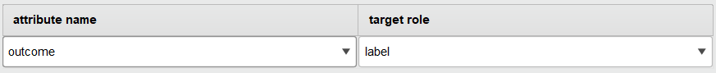

Split Data
- The dataset was split into 70% training data and 30% testing data using a ratio of 0.7 / 0.3
- This ratio was chosen as a common practice to provide sufficient data for model training while reserving an adequate portion for reliable performance evaluation on unseen data
- The automatic sampling option was used to let RapidMiner select an appropriate sampling strategy based on the data characteristics, reducing the risk of introducing unintended sampling bias
SMOTE Upsampling
- SMOTE Upsampling was applied to address class imbalance in the target variable by generating synthetic examples for the minority class.
- The number of neighbours was set to 3, allowing new samples to be generated based on nearby minority instances while limiting excessive smoothing.
- The auto detect minority class option was enabled so that the minority class was identified automatically based on the class distribution.
- The equalize classes option was selected to balance the class distribution and reduce bias toward the majority class during model training.
- Normalization was applied to ensure that distance-based calculations within SMOTE were not dominated by features with larger scales.
- The nominal change rate was set to 0.5 to control the degree of variation introduced when handling nominal attributes.
- The nominal change rate was set to 0.5 to allow some variation in nominal attributes while avoiding overly random changes when generating synthetic samples.

