Data Preparation
Import Data and Initial Data Inspection
- The Skip Comments (#) option was disabled during data import because some startup names contained the # character (e.g., #waywire), which would otherwise cause those records to be incorrectly ignored.
- The funding_total_usd attribute was initially detected as polynominal due to inconsistent formatting, such as comma-separated values and embedded spaces. Converting it directly to a numeric type at import would have produced many missing values, so it was cleaned first and parsed later.
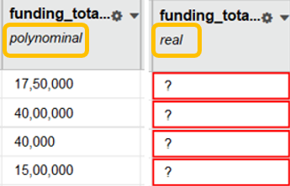
Filter Examples and Rationale
- founded at ≥ 01/01/1992
Startups founded from 1992 onward were included to improve comparability, as firms founded earlier often operated under different market and financing conditions. In the early 1990s, venture capital practices became more standardized and structured funding stages became more common.
- Status does not contain operating
Startups with an operating status were excluded to align the dataset with the business objective of distinguishing clear outcomes. The analysis focuses on acquired versus closed firms, where acquisition indicates an exit and closure indicates failure, while operating firms remain unresolved at the time of observation.

Replace and Parse Number
- The funding_total_usd attribute was cleaned using Replace operators to remove commas and spaces and then converted from polynominal to numeric using Parse Numbers, enabling quantitative analysis.

Generate Attributes
- Outcome was defined as 0 for closed and 1 for acquired, treating acquisition as a completed exit; operating firms were excluded in the filtering step to avoid unresolved outcomes.
- The firm_age attribute was generated to capture startup maturity. Firm age is a relevant factor in modeling startup outcomes, as firms that have existed for longer periods have moved beyond early stages of uncertainty and are more likely to reach stable states or achieve successful exits.

Select Attributes
- After generating the outcome variable, the original status attribute was removed from the feature set to prevent data leakage, ensuring that the model does not use information directly related to the target label during training or evaluation.

Split Data
- The dataset was split into 70% training and 30% testing data using a 0.7 / 0.3 ratio to evaluate model performance on unseen data while retaining sufficient observations for training.

SMOTE Upsampling
- SMOTE Upsampling was applied after data splitting and only to the training set to address class imbalance between acquired and closed startups and to avoid inflated test performance.
- The number of neighbours was set to 3 to generate synthetic samples based on nearby minority instances while avoiding excessive smoothing.
- The minority class was detected automatically using the auto detect minority class option.
- The equalize classes option was enabled to balance the target classes during model training.
- Normalization was applied to support distance-based calculations during the upsampling process.

