 | 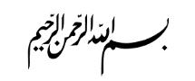
 | 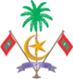
MINISTRY OF HEALTH  MALE’  REPUBLIC OF MALDIVES |  | 
Requested Political Appointees Details

- How many political appointees work in this ministry?
30
- How many political directors work in this ministry? What is their job scope and their pay. Please share a table with details.
6 Political Directors
Main Job scope | Salary
1. Coordination with provincial hospitals and health centers.  2. Performing the duties of various departments and divisions of the assigned Ministry  3. Perform special duties assigned by the Minister of Health and State Ministers under the direction of the Minister  4. Political activities  5. Performing the duties of Governing Board of Male’ City Group of Hospitals.  6. Support the Media Unit to develop content related to the government manifesto and policies | Range of MVR 20,000 - 20,500 MVR

- How many deputy ministers work in this ministry? What is their job scope and what is their pay? Please share a table with details.
7 Deputy Ministers.
Main Job scope | Salary
1. Monitor the progress of various departments and divisions assigned  2. Perform special duties assigned by the Minister of Health under the direction of the Minister.  3. Coordination with provincial hospitals and health centers.  4. Implementation of government public health policies and preparation of public health related policies and plans.  5. Assist in the formulation and implementation of assigned departmental policies.  6. Participate in senior staff meetings and various meetings held in connection with official work of the office and give necessary advice. | 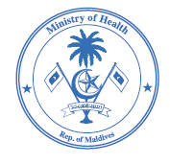  Range of MVR 31,000 - 31,500 MVR

