PH 250B Week 3, Tab 1 Practice Problems
Topic: Measures of Disease

Problem 1. (Source: Fall 2017 250B Exam 1 Practice Exam Problem Set)

Mortality from liver cirrhosis declined in all adult age groups in the early 1920s due to decreased alcohol consumption resulting from U.S. Prohibition laws. This is an example of a(n): [Circle only one answer]

- Period effect
- Age effect
- Cohort effect
- Period effect and cohort effect
- Age effect and period effect

Problem 2. (Source: Fall 2017 250B Exam 1 Practice Exam Problem Set)

The three lines in the graph below represent rates of a hypothetical disease in different birth cohorts. What time-scale effect(s) appear(s) to be operating in this example? Please circle the best answer from the choices below.
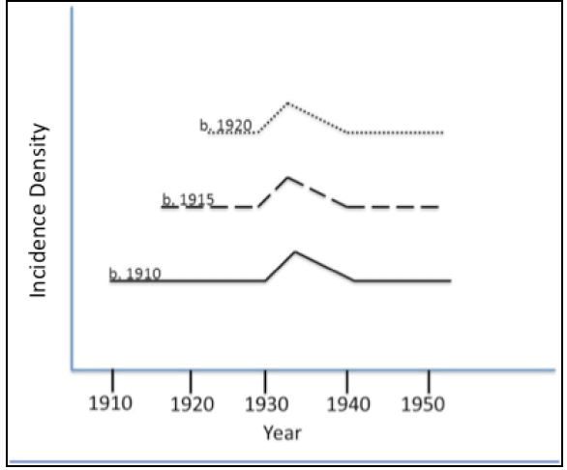
- Age effect
- Period effect
- Cohort effect
- Period and cohort effect
- Age, period, and cohort effect

Problem 3. (Source: 250B Problem Set)
In the graph and scenarios below, state whether there are age, period, and/or cohort effects.
- In this graph:
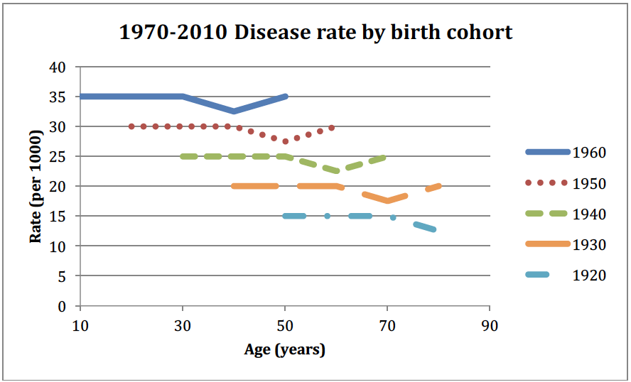

- An epidemiologist analyzes retrospective data on pancreatic cancer in a Norwegian population born between 1920 and 1960. She finds that the individuals born during World War II had a reduced incidence of pancreatic cancer.

- A study follows a cohort of nurses aged 20-40 years old for 30 years and records incident cases of osteoarthritis. The cumulative incidence is calculated for each year of the study, and investigators find that the incidence increases each year.

- A study of Native Americans found that the rate of type II diabetes was higher during the 1960s across a range of ages than during the rest of the 20th century.

