PH 250B Week 3, Tab 2 Practice Problems
Topic: Measures of Disease

The first five problems in this set are practice calculating cumulative incidence using the different techniques that we’ve learned and these five problems build on each other. We’d recommend doing them in order. In the answer key, we give a summary that compares and contrasts the different calculation methods in each of these scenarios. Our advice is that after you do each set of calculations you compare your results from the different methods and consider how and why they are different before looking at the answer summary.

The subsequent problems provide additional practice.

Cumulative Incidence Problems

Problem 1: Closed population, follow-up time for non-cases is equal, interval risk is not rare
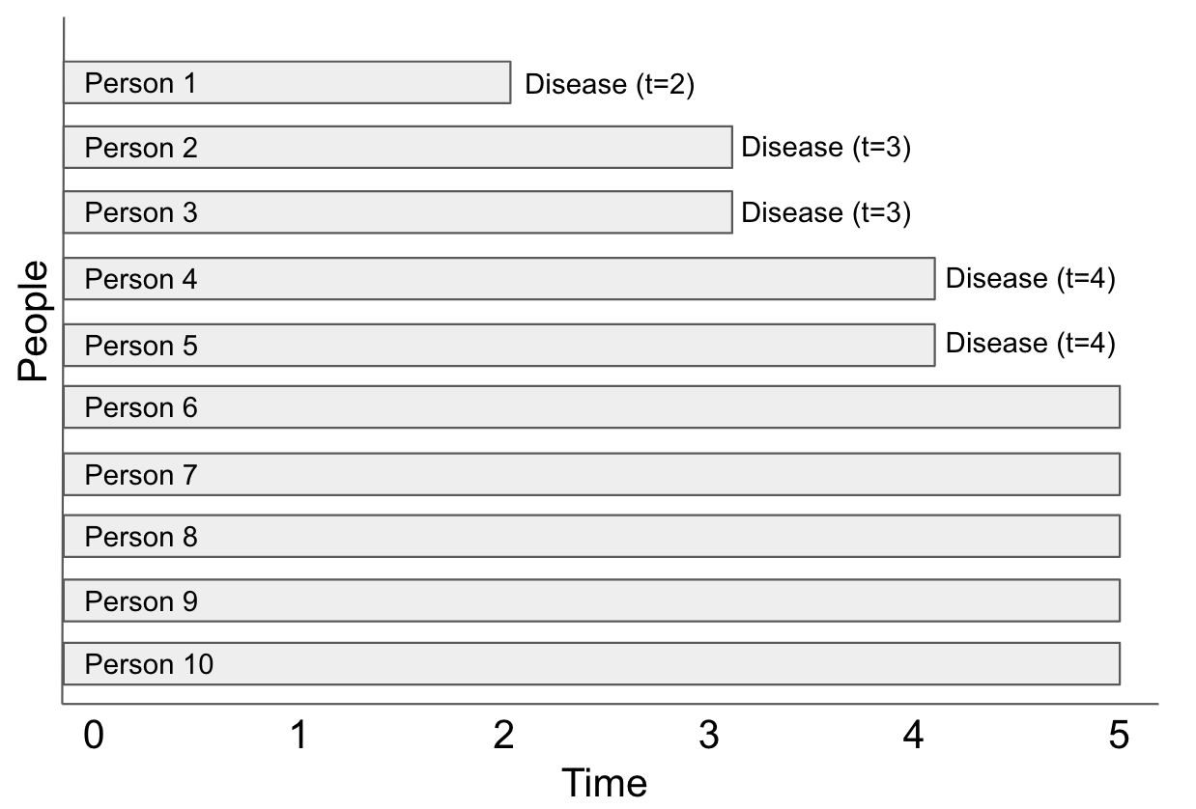
Simple cumulative method
CI = I / N₀
CI =

Actuarial method
Interval  j | time period  t_{j-1}, t_{j} | pop. at risk  N’_{0j} | incident disease  I_{j} | Withdrawals  W_{j} | interval risk (conditional risk)  R_{j} | Interval survival  S_{j}
1
2
3
4
5

CI =

Kaplan Meier method
Time  j | pop. at risk  N’_{j} | incident disease  I_{j} | interval risk  R_{j} | interval survival  S_{j}

CI_{t0, tj} =

Density method
Interval  j | time period  t_{j-1}, t_{j} | pop. at risk  N’_{0j} | incident disease  I_{j} | Interval duration  △t | Interval incidence density  ID_{j} | Interval risk  ID_{j}△t_{j}
1
2
3
4
5

CI_{t0, tj} =

Problem 2: Closed population, follow-up time for non-cases is equal, interval risk is rare
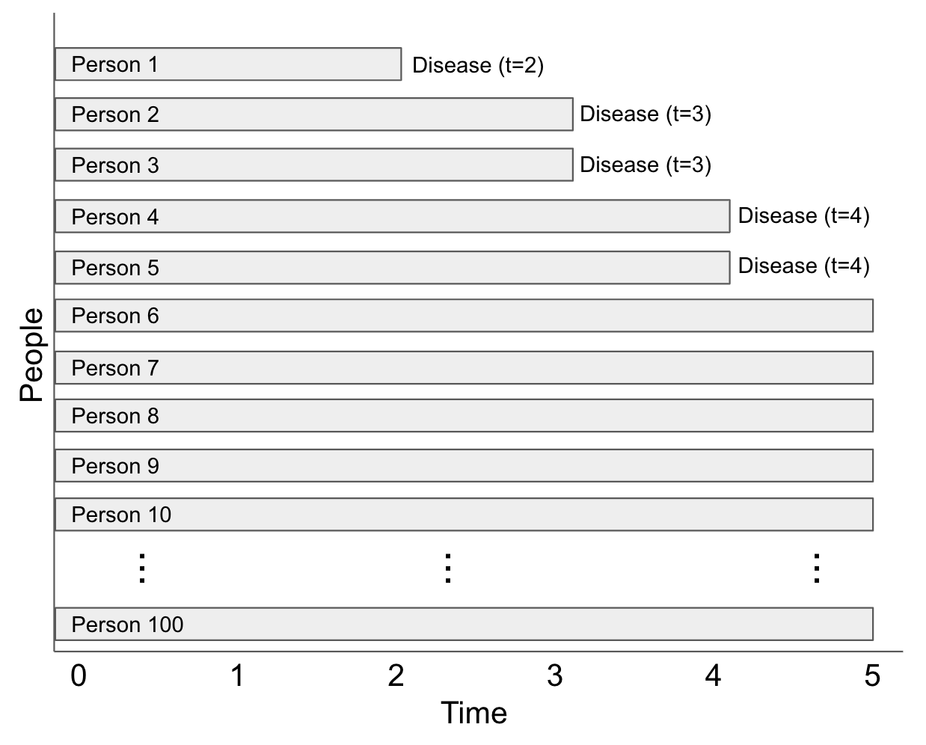
Simple cumulative method
CI = I / N₀
CI =

Actuarial method
Interval  j | time period  t_{j-1}, t_{j} | pop. at risk  N’_{0j} | incident disease  I_{j} | Withdrawals  W_{j} | interval risk (conditional risk)  R_{j} | Interval survival  S_{j}
1
2
3
4
5

CI_{t0, tj} =

Kaplan Meier method
Time  j | pop. at risk  N’_{j} | incident disease  I_{j} | interval risk  R_{j} | interval survival  S_{j}

CI_{t0, tj} =

Density method
Interval  j | time period  t_{j-1}, t_{j} | pop. at risk  N’_{0j} | incident disease  I_{j} | Interval duration  △t | Interval incidence density  ID_{j} | Interval risk  ID_{j}△t_{j}
1
2
3
4
5

CI_{t0, tj} =

Problem 3: Closed population, follow-up time for non-cases is not equal, no interval has both withdrawal and disease, interval risk is not rare
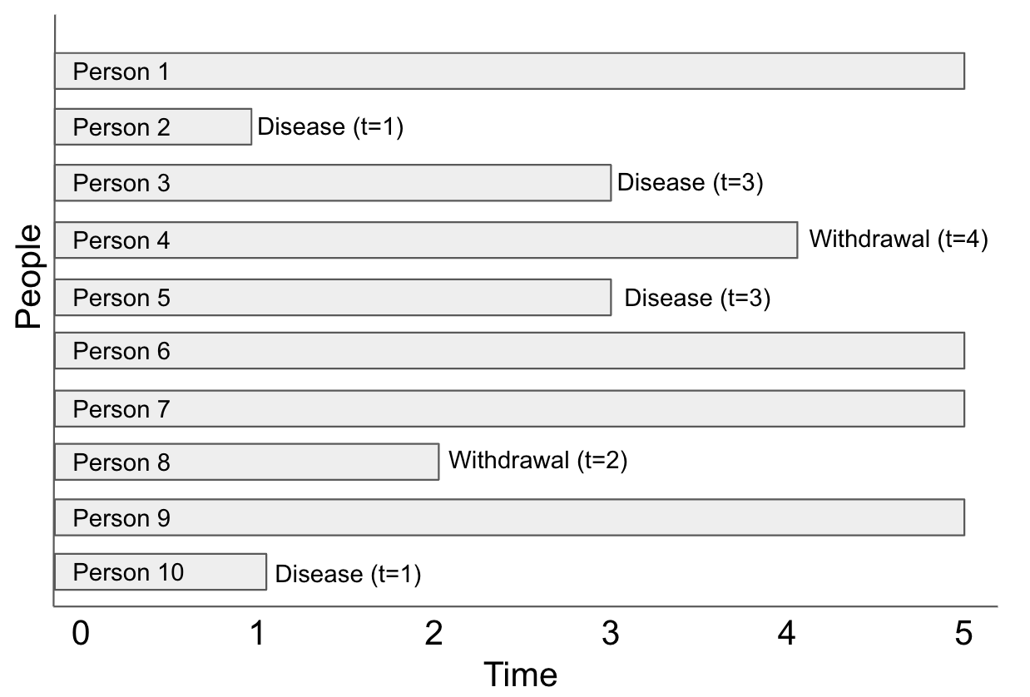
Simple cumulative method

Actuarial method
Interval  j | time period  t_{j-1}, t_{j} | pop. at risk  N’_{0j} | incident disease  I_{j} | Withdrawals  W_{j} | interval risk (conditional risk)  R_{j} | Interval survival  S_{j}
1
2
3
4
5

CI_{t0, tj} =

Kaplan Meier method
Time  j | pop. at risk  N’_{j} | incident disease  I_{j} | interval risk  R_{j} | interval survival  S_{j}

CI_{t0, tj} =

Density method
Interval  j | time period  t_{j-1}, t_{j} | pop. at risk  N’_{0j} | incident disease  I_{j} | Interval duration  △t | Interval incidence density  ID_{j} | Interval risk  ID_{j}△t_{j}

CI_{t0, tj} =

Problem 4: Closed population, follow-up time for non-cases is not equal, one interval has both withdrawal and disease, interval risk is not rare
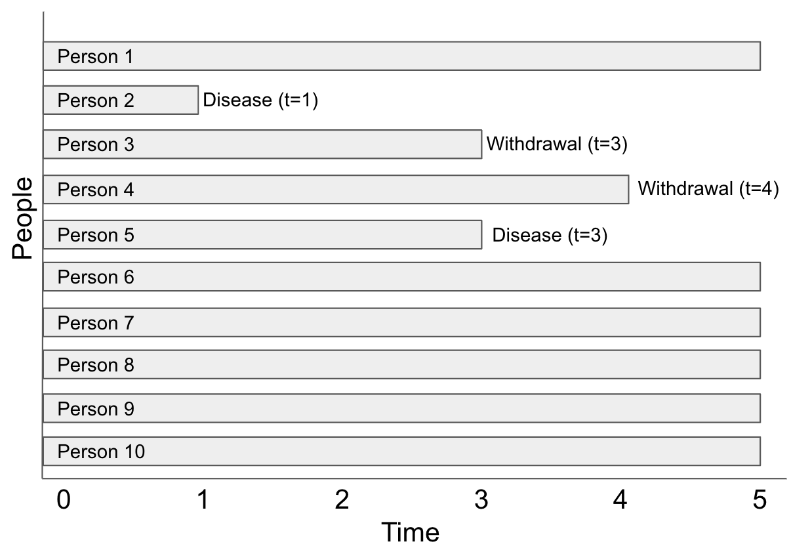
Simple cumulative method

Actuarial method
Interval  j | time period  t_{j-1}, t_{j} | pop. at risk  N’_{0j} | incident disease  I_{j} | Withdrawals  W_{j} | interval risk (conditional risk)  R_{j} | Interval survival  S_{j}
1
2
3
4
5

CI_{t0, tj} =

Kaplan Meier method
Time  j | pop. at risk  N’_{j} | incident disease  I_{j} | interval risk  R_{j} | interval survival  S_{j}

CI_{t0, tj} =

Density method (note: assume withdrawals were followed through the end of the interval in which they withdrew)
Interval  j | time period  t_{j-1}, t_{j} | pop. at risk  N’_{0j} | incident disease  I_{j} | Interval duration  △t | Interval incidence density  ID_{j} | Interval risk  ID_{j}△t_{j}

CI_{t0, tj} =

Problem 5: Open population, follow-up time for non-cases is not equal, at least one interval has both withdrawal and disease, and interval risk is not rare

In this example, “Time” on the x-axis is in months.
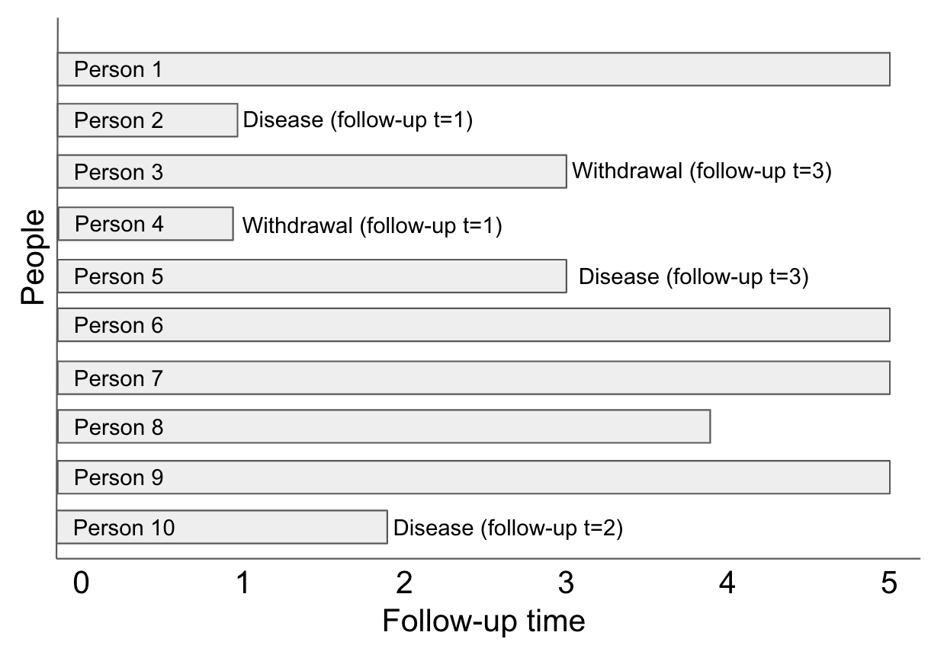
Calculate the incidence density

Person | Person- months of followup
1
2
3
4
5
6
7
8
9
10
Total

Incidence density:

Cumulative incidence using the simple cumulative method

Cumulative incidence using the Actuarial method
Interval  j | time period  t_{j-1}, t_{j} | pop. at risk  N’_{0j} | incident disease  I_{j} | Withdrawals  W_{j} | interval risk (conditional risk)  R_{j} | Interval survival  S_{j}
1
2
3
4
5

CI_{t0, tj} =

Cumulative incidence using the Kaplan Meier method
Time  j | pop. at risk  N’_{j} | incident disease  I_{j} | interval risk  R_{j} | interval survival  S_{j}

CI_{t0, tj} =

Cumulative incidence using the density method (note: assume withdrawals were followed through the end of the interval in which they withdrew)
Interval  j | time period  t_{j-1}, t_{j} | pop. at risk  N’_{0j} | incident disease  I_{j} | Interval duration  △t | Interval incidence density  ID_{j} | Interval risk  ID_{j}△t_{j}

CI_{t0, tj} =

Additional Practice Problems
Problem 6. (Fall 2017 250B Practice Exam Problem Set)

You have been hired by the Chinese CDC to investigate rates of chronic lung disease (CLD) among coal mine workers in China. You are given the following information about CLD cases, drawn from studies collecting data among miners all over the country.

Age group | No. of CLD cases | Person-time accrued (years) | Incidence density
16-25 | 1,500 | 750,000
26-30 | 2,500 | 862,000
31-35 | 3,000 | 811,000
36-40 | 3,000 | 1,250,000
Total | 10,000

- Calculate and interpret the relevant overall (crude) measure of disease. What is this measure?

- Calculate the relevant measure of disease for each age group, and transcribe your results to the space provided in the table above.

Problem 7. (Fall 2017 250B Practice Exam problem set)

Incidence density is: (circle all that apply)
- A proportion
- The fundamental measure of disease occurrence
- The same as the hazard
- Best interpreted at the individual level
- None of the above

Problem 8. (Fall 2017 250B problem set)

Time to disease in populations
The figure below summarizes the disease status of 10 individuals followed over a period of one year. THe blue shaded bars represent time from the beginning of disease until death.

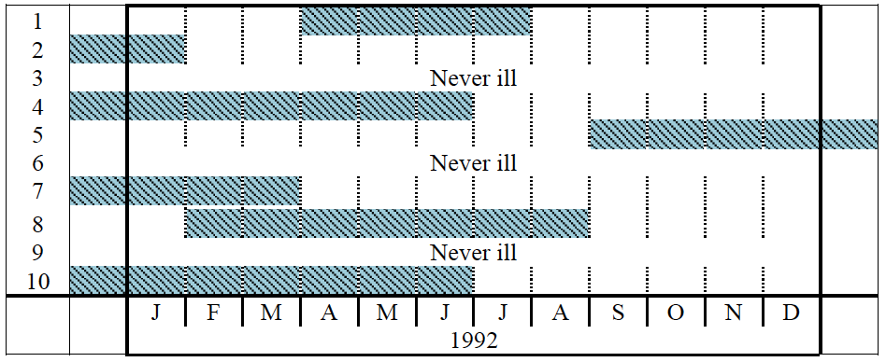

- What is the point prevalence on May 1, 1992?

- What is the cumulative incidence for March 1, 1992 to December 31, 1992? Interpret this measure.

- What is the incidence density from March 1, 1992 to December 31, 1992? Interpret this measure.

- Which of the measures from parts b and c estimate risk and which estimate rate? What is the difference? Which measure can be applied to individuals?

Problem 9. (Fall 2017 250B problem set)
The following hypothetical data represent the 5-year follow-up experience of 1,000 newly diagnosed cases of ovarian cancer.

- To use the actuarial method to calculate the cumulative incidence of mortality due to ovarian cancer in each interval, what assumption(s) do you need to make?

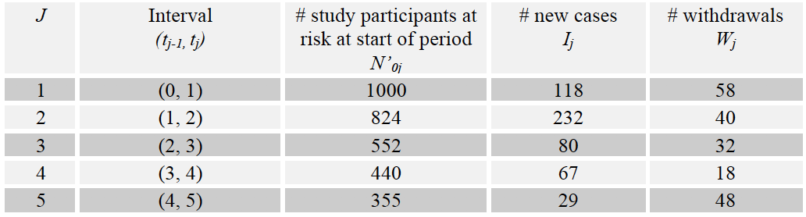

- Use the actuarial method to calculate the cumulative incidence of ovarian cancer mortality in each interval. Interpret the cumulative incidence for interval five.

J | N’_{0j} | I_{j} | W_{j} | Interval Risk  R_{j}
1 | 1000 | 118 | 58
2 | 824 | 232 | 40
3 | 552 | 80 | 32
4 | 440 | 67 | 18
5 | 355 | 29 | 48

- Calculate the 5-year cumulative incidence. Interpret this measure.

J | N’_{0j} | I_{j} | W_{j} | Interval risk  R_{j} | Interval survival  S_{j} | Cumulative incidence  R_{(t0,tj)}
1 | 1000 | 118 | 58
2 | 824 | 232 | 40
3 | 552 | 80 | 32
4 | 440 | 67 | 18
5 | 355 | 29 | 48

- Calculate the 5-year cumulative survival. Interpret this measure.

J | N’_{0j} | I_{j} | W_{j} | Interval risk  R_{j} | Interval survival  S_{j} | Cumulative incidence  CI_{(t0,tj)} | Cumulative survival  S_{(t0,tj)}
1 | 1000 | 118 | 58
2 | 824 | 232 | 40
3 | 552 | 80 | 32
4 | 440 | 67 | 18
5 | 355 | 29 | 48

- Using the density method (using incidence density), estimate the interval risk (CI), cumulative 5-year risk, and cumulative 5-year survival for new cases of ovarian cancer. What assumptions must you make to calculate person-time (PT) using this data? What assumptions must you make to use ID (rate) to calculate CI (risk)?

J | N’_{0j} | I_{j} | △t | Incidence density  ID_{j} | Interval risk  ID_{j}△t_{j}
1 | 1000 | 118 | 1
2 | 824 | 232 | 1
3 | 552 | 80 | 1
4 | 440 | 67 | 1
5 | 355 | 29 | 1

- Imagine you are conducting a study to measure the incidence of mortality following acute myocardial infarction. You want to use the actuarial method to calculate cumulative incidence. The probability of mortality is greatest in the period when the symptoms first show and decreases over time. Given this information, how would you construct the time intervals for data collection so that you could use the actuarial method to calculate cumulative incidence?

Problem 10. (Fall 2017 250B Practice Exam problem set)
Smoking and all-cause mortality
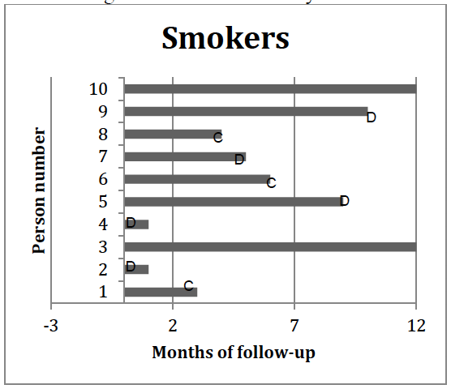
- In this study of smoking and mortality, data were collected continuously for 12 months or until event (mortality). D indicates death, and C indicates last known contact with censored individuals. Note that 2 individuals were alive and uncensored at the end of the study. Use the Kaplan-Meier method to estimate the cumulative incidence by filling in the table below (use as many rows as necessary).
Cumulative incidence among smokers

Time_{J} | N_{J} | I_{J} | Interval risk (R_{J}) | Interval survival (1-R_{J}) | Cumulative incidence | Cumulative survival

- The cumulative incidence among 10 non-smokers during the same period was 0.260. Calculate an absolute measure of association between smoking and cumulative incidence of death. Name this measure. Interpret this measure.

- The following issues arose during this study. Which of the following violates an assumption needed in using the Kaplan-Meier method to estimate cumulative incidence? Multiple answers may be selected.
i. Smokers were more likely to be lost to follow-up than non-smokers.
Ii. People who were lost to follow-up did not withdraw from the study at the midpoint of intervals of observation.
Iii. the rate of smoking (cigarettes smokers per person-day) in the study population increased starting in the 7th month of follow up.

