PH 250B Week 6, Tab 1 Ungraded quiz - ANSWERS
Topic: Trials

Problem 1. (Fall 2017 250B Practice exam problem set)
The figure below shows the results of five non-inferiority studies comparing an old and a new treatment. We are concerned with an adverse outcome, meaning that the new treatment is inferior if it exceeds delta in the positive direction. For each letter, label whether they are superior, inferior, noninferior, or inconclusive. The pre-specified delta for these studies is 2. (5 points)

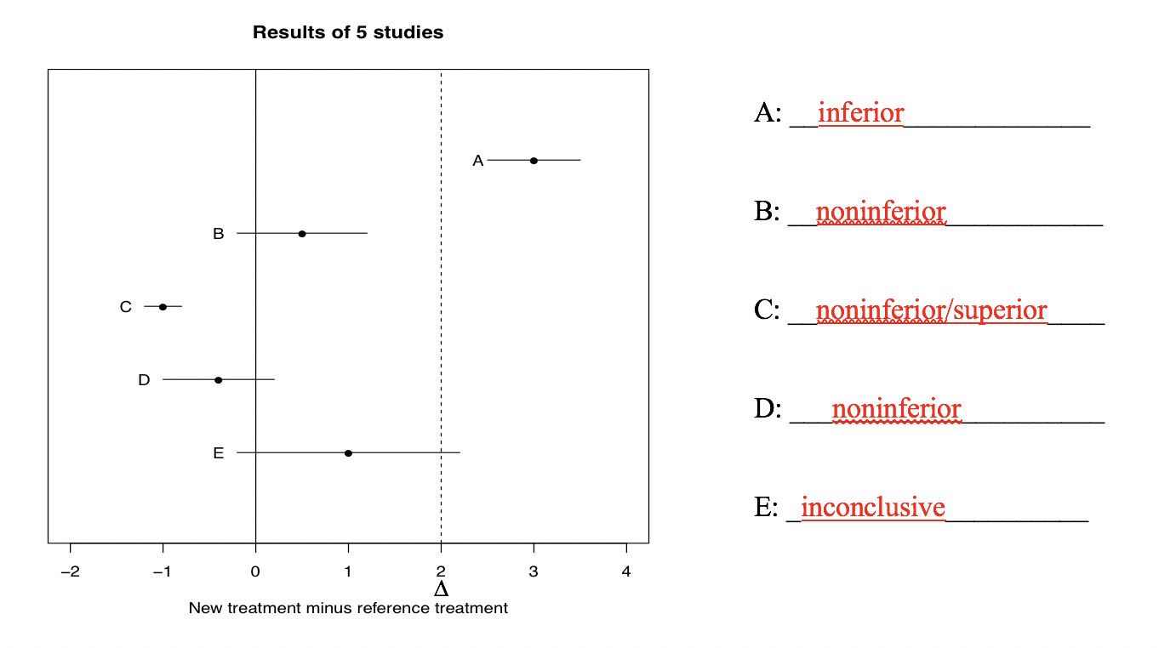
A is inferior because the entire confidence interval exceeds delta (margin). Just a note that if
the Confidence Interval (CI) crosses the threshold (delta/margin), the trial has failed to
establish non-inferiority.
B is non-inferior because the CI lies entirely below the chosen non-inferiority threshold (delta).
C is non-inferior because the point estimate and CI did not cross the non-inferiority
delta/margin. This can also be considered superior because the confidence interval is less
than 0 (the null hypothesis) and does not include the null.
D is non-inferior because the CI did not cross the non-inferiority delta/margin
E is inconclusive because the CI crosses the non-inferiority delta/margin

Problem 2. (Fall 2016 250B Problem set)
“The standard brand-name version of chronic obstructive pulmonary disease (COPD)
treatment increases forced expiratory volume 1 (FEV1, a measure of respiration) by 15%
on average. The newly developed generic version of this treatment will increase FEV1 by
at least 12% on average.”

This statement is the alternative hypothesis for which type of clinical trial?
a. Superiority trial
b. Phase IV trial
c. Equivalence trial
d. Non-inferiority trial
e. Phase I trial

D, this is a non-inferiority hypothesis that the alternative treatment is not worse than
existing treatment within a certain margin (new treatment < current treatment by no more
than 3% points).

Some read this as the results of a trial, but it’s the alternative hypothesis. When read as
the alternative hypothesis, the only option is d.

Problem 3. (Fall 2017 252C Midterm)
What is the null hypothesis in a superiority trial?
- There is no difference between groups.
- Treatment outcome is greater than control outcome
- Control outcome is greater than treatment outcome

Problem 4. (Fall 2016 250B problem set)
Observational evidence has indicated that increasing access to playgrounds (building new playgrounds or renovating existing ones) for young children can reduce the risk of childhood obesity. In addition, data suggest that mass media campaigns can influence norms around gender roles, leading fathers to spend more time playing with their young children. You want to test whether these interventions (increasing playgrounds and mass media campaign) can improve children’s physical activity. You hypothesize that the two interventions combined will have a synergistic impact of childhood obesity.

a. Name the type of trial that is best suited to addressing these research questions. List the study arms in this trial.

Factorial trial
Four study arms – one receives neither intervention, one gets just media campaign, one gets just playground improvements, one gets both interventions
+1 point for naming the design. +0.25 for identifying each study arm.
b. Would you randomize exposures at an individual or a cluster level? Justify your choice in one sentence.

Cluster. Both exposures are group-level exposures that could not be effectively randomized to individuals.

c. You would like to ensure that each arm of the study is balanced in terms of a key
confounder of local sports league availability, which differs between urban and rural settings. You also hope to ensure that each arm of the study is approximately the same size even if it’s a small study. Identify and justify a randomization strategy that addresses both of these concerns (1-2 sentences).

Blocked, stratified randomization. Blocking ensures equal numbers in each study arm; stratification by urban-rural setting prior to randomization guarantees that the distribution of urban to rural settings is even across study arms.
+0.5 for naming each strategy. +1 point for each explanation of the strategy.

d. As the study progresses, study personnel raise a concern that information from the
media campaigns is being reposted on social media platforms that all study participants have a chance to see. What potential problem is this? If it is occurring, how might it affect the effect you estimate?

Spillover or contamination. It would bias results towards the null by making all groups more similar to each other. Also accepted is non-adherence as this would lead to contamination.

Problem 5. (Fall 2016 250B problem set)
A clinical trial of a drug to reduce hyperactivity in teenagers included 400 subjects, of which 324 took the complete course of medication (either active drug or placebo depending on assigned treatment arm). What analysis should they use to quantify effectiveness? How many subjects would be included?

The investigators should conduct an intent-to-treat analysis. For this analysis, the investigators should use all 400 subjects.

Problem 6. (Fall 2016 252C Midterm question)
Which phase of a trial is most often designed as an RCT?
- I
- II
- III
- IV
Remember that typically Phase I trials are not really trials, they are usually done on a few healthy volunteers immediately after animal testing. They are neither randomized nor trials even though they are called trials. Similarly, Phase II trials are not RCTs, the trials are done on people with a particular disease that is being treated by the new regimen. The purpose of a Phase II trials are to establish the relative efficacy of different doses of the new therapy or medication, and again, it's often not randomized or controlled.

Phase III is most often designed as an RCT and after Phase III trials, FDA can approve the drug for marketing.
Phase IV trials are even larger studies that monitor potential adverse events in very large populations, since often these adverse events are rare and would be difficult to detect in a Phase III trial. These are studies that are done after marketing is approved, and these are also not truly trials. They're often not randomized or controlled.

Problem 7. (Fall 2016 252C Midterm question)
What is the ICC of the following data set? Provide an interpretation of this ICC
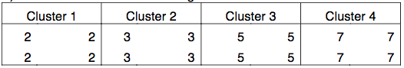
1
The ICC is 1 in such scenarios because there is no within-cluster variance or in other words, there is perfect within-cluster correlation. Cluster membership tells us everything.

Problem 8. (Fall 2017 252C Midterm question)
Compared to individually-randomized study, a cluster-randomized study almost always requires a sample size with _______________ individuals.
- More
- Fewer
- The same number of
Cluster-randomized studies always require a larger sample size because having more people in a cluster with high rho adds little unique information.

Problem 9. (Fall 2017 252C Midterm)
Fill in the blank.
In a clustered study design, cluster membership is not at all informative when the intraclass correlation coefficient (ICC) is equal to __ZERO__________.

