PH 250B Week 8, Refresher Ungraded quiz - ANSWERS
Topic: Cross-sectional and ecological studies

Problem 1. (Fall 2017 250A Problem Set)
Read the following abstract (adapted from Pettifor AE, Rees HV, Kleinschmidt I, Steffenson AE, Macphail C, Hlongwa-Madikizela L, Vermaak K, Padian NS. Young people's sexual health in South Africa: HIV prevalence and sexual behaviors from a nationally representative household survey. AIDS 2005;19(14):1525-34) and answer the following questions:

Objectives. To determine the prevalence of HIV infection and exposure to national HIV prevention programs in South African youth aged 15–24 years.
Methods. From March to August 2003 we conducted a national survey of HIV prevalence and sexual behavior among 11,904 15–24 year olds.
Results. Young women were significantly more likely to be infected with HIV in comparison with young men (15.5 versus 4.8%). Males and females who reported participation in at least one national HIV prevention program were less likely to be infected with HIV (adjusted OR=0.60; 95% CI, 0.40–0.89; adjusted OR=0.61; 95% CI, 0.43–0.85, respectively).

- Is the study described in this paper an example of an observational or experimental study? How do you know this?

This is an observational study design because the investigators had no control over the subjects’ exposure status.

- What is the name of this type of study design?

This is a cross-sectional study.

- When did assessment of the exposure and outcome occur? Given your answer, do you have any concerns about the directionality of the association between HIV infection status and participation in a HIV prevention program?

Assessment of the exposures and outcome occurred simultaneously. At times, this may lead to uncertainty about the directionality of the association between the exposure and outcome in a cross-sectional study. In this example, it’s possible that some people learned they had HIV before they had the opportunity to join the prevention program, which may have negatively influenced their future willingness to participate in the program. In this case, HIV status influences participation in the program, not vice versa.

- Calculate and interpret a ratio of disease prevalence among females compared to males (i.e., a prevalence ratio).

Prev ratio = Prev_{females} / Prev_{males} = 15.5% / 4.8% = 3.23

The prevalence of HIV infection among young women in South Africa in 2003 is 3.23 times the prevalence of HIV infection among young men.

E. Explain why the authors of this study chose to use this study design to answer their research question. What are the advantages of using such a study design for this research question?

Potential explanations include:

- Cross-sectional study designs are efficient when the exposures and outcomes of interest are relatively common and for outcomes that have long duration. These criteria are met in this study setting where the outcome and exposures of interest are not uncommon among young people.
- Cross-sectional studies are quick and often cost less than other study designs.
- Since this study is nationally representative, it serves to document the nation-national prevalence of HIV and risk factors in South Africa.

Problem 2. (Fall 2017 250A Problem Set)
Please examine figures 1 and 2 from Pickett KE, et al. Wider income gaps, wider waistbands? An ecological study of obesity and income inequality. J Epidemiol Community Health 2005;59(8):670-4.

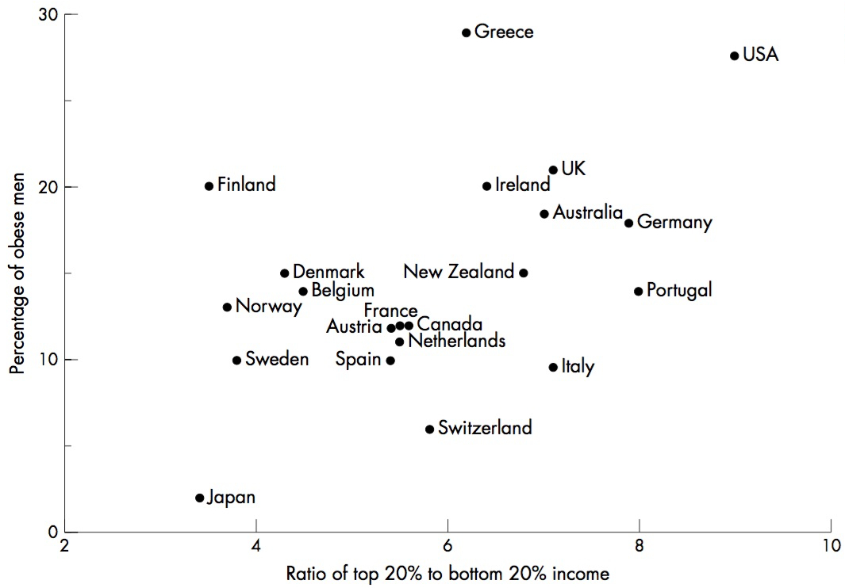

Figure 1. The relation between male obesity and inequality in 21 developed countries.
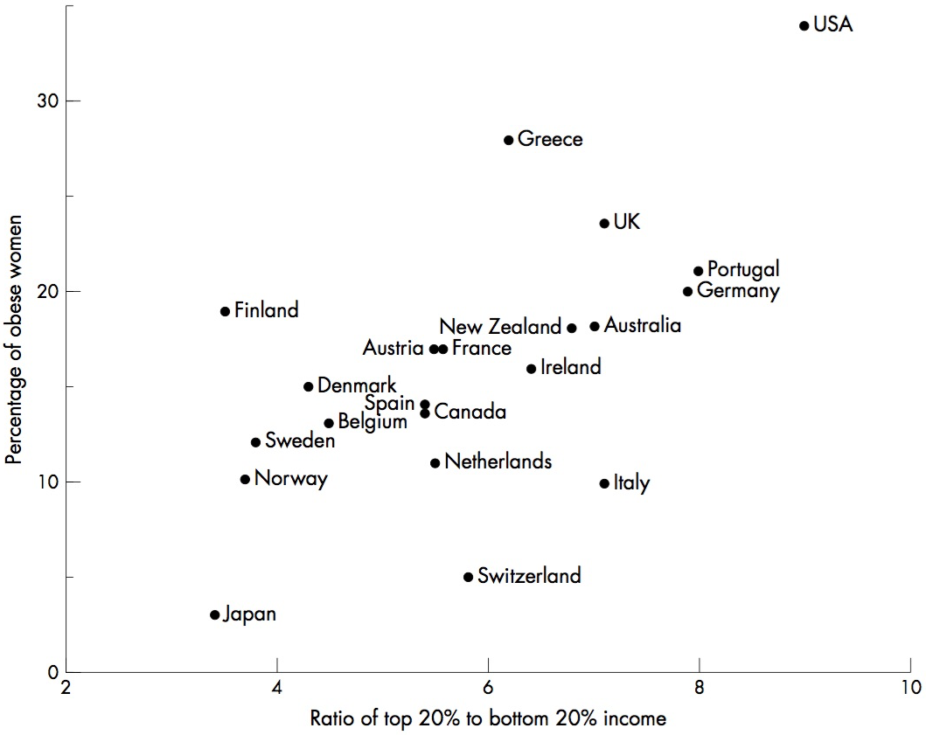

Figure 2. The relation between male obesity and inequality in 21 developed countries.

- Provide an interpretation of the data shown in the figures. Hint: The ratio on the horizontal axis is the mean income of the richest 20% of the population divided by the mean income of the poorest 20% of the population. It is a measure of income inequality.

Developed countries with greater levels of income inequality have a higher percentage of obesity in the adult populations.

- Would this be considered an ecologic study? Why or why not?

Yes. The exposure (ratio of a country’s top 20% to bottom 20% income) is a group-level characteristic. The outcome (percentage of obese men/woman in the adult population) is also a group-level characteristic. The unit of analysis for these data is the country’s population. These analyses do not examine the relationship between an individual’s income and his/her risk of being obese.

- What is different about an ecologic study compared to other study designs?

Ecologic studies are observational studies in which the units of analysis are populations or groups of people. The “group” is often defined by a geographic area (census tract, state, community, etc.) or it can be a population without reference to location (ethnic group, SES group, etc.).They differ from other kinds of studies because they do not measure outcomes in individuals.

- Discuss the advantages and disadvantages of ecologic studies.

Advantages

- Useful tool for generation of hypotheses that can subsequently be tested with individual-level data
- Sometimes the grouped outcome may be principal outcome of interest (e.g., smoking termination for an entire community)
- Conducting ecological studies may be inexpensive and relatively easy if large datasets with relevant information are available (e.g., US Vital statistics, NHANES, hospital-level data)
- Sometimes exposures can only be measured at a group level in the absence of personal exposure metrics, e.g., water hardness, pollution in a city, exposure to an intervention
- When risk factor measurement at the individual level is particularly prone to error; in this situation we may only be able to see a true association at the ecological level (e.g., self reporting of alcohol consumption vs. with county alcohol sales)
- Can evaluate a wide range of exposure levels that could not be done with a typical individual-level study

Disadvantages

- Imprecision in the measurement of exposure and disease makes accurate quantification of exposure-disease associations difficult
- Ability to adjust for the influence of extraneous variables is limited by the availability of such data and analytic approaches for incorporating them
- Data on many variables of interest may not be recorded at a group level (behavior, attitudes, etc.)
- Ecologic fallacy: Erroneously making inferences about individuals based on aggregate data for the group to which those individuals belong. The fallacy assumes that all members of a group exhibit characteristics of the group at large. For example, in the melanoma study in Question 1, we might hypothesize from the data that exposure to stronger sunlight at equatorial latitudes is causing melanoma, but the individuals who experience increased sun exposure may not be those who are developing melanoma. Note that the “ecologic fallacy” is a potential issue with interpreting an ecologic study’s results, not a problem with the study design per se.

Problem 3. (Fall 2017 250B Problem Set)

- What is the ecologic fallacy?
“The failure of expected ecologic effect estimates to reflect the biological effect at the individual level.” (Rothman)
“A logical fallacy inherent in making causal inferences from group data to individual behaviors…a problem of confusing the group with the members of the group, of assuming that because a group has a certain characteristic the members of that group must also have that characteristic.” (Schwartz)
“The ecological fallacy (or aggregation bias) has been defined as ‘the bias that may occur because an association observed between variables on an aggregate level does not necessarily represent the association that exists at an individual level.’” (Szklo)

Problem 4. (Fall 2017 250B Practice Exam)
Use the following graph to answer the related questions below.
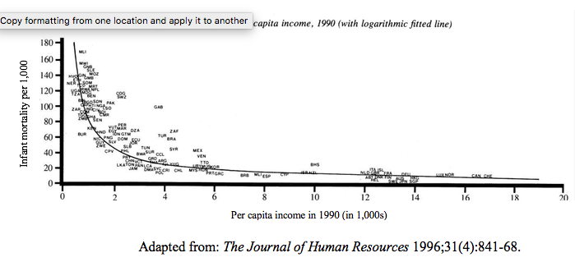

The small writing on the graph are abbreviations of countries. For example, at the far right of the graph are LUX (Luxembourg), NOR (Norway), and CAN (Canada). You do not need to be able to read these to interpret the graph.

a) What type of study design does the graph above illustrate? (1 point)

Ecologic study design.

b) Interpret the findings illustrated in the graph in one sentence. (1 point)

Countries with higher per capita income had lower infant mortality rates. Countries are the unit of analysis, and ½ point was taken off if this was not clear from your answer.

