We PH 250B Week 9 Bias
Topic 1: Information Bias, Selection bias, and generalizability
Practice Problems - ANSWERS

Note: It is often useful to use a 2 x 2 table as an aid for thinking about how cell sizes change with various bias scenarios. For example, because the OR = (AD)/(BC), you can figure out whether the OR will be overestimated or underestimated once you’ve figured out which cells are inflated and which are deflated as a result of the bias.

Problem 1. (Fall 2017 250B Problem set)
An investigator decides to conduct a study examining the relationship between Facebook usage and anxiety among undergraduate students. She wants to enroll 75 participants from the largest undergraduate dorm on campus. She will measure their “Facebooking” behavior over a 2-week period and then test them for signs of anxiety. Two hundred students respond to her recruitment flyers. Fifteen are excluded because they do not use Facebook or are not undergrads. She randomly selects 75 students from those who responded and were eligible.
a. Who comprises the study sample, study population, and target populations?

Study sample: The 75 students who satisfied the inclusion criteria and actually participated in the study.

Study population: The 185 students who responded to the flyers and satisfied the inclusion criteria. (This includes everyone who was eligible and willing to participate in the study if chosen.)

Target population: Students who live in the selected undergraduate dorm. This definition of the study’s target population could be different – remember that the target population may depend on the investigator’s aims!

NOTE: Some books call the “study population” the “actual population” and the “study sample” the “study population”.

b. What are two examples of potential external populations to whom the investigator may wish to generalize her results?

Possibilities: All Berkeley undergrads, all 18-22-year-olds in California, all 18-22-year-olds in the U.S. This would really depend on the investigator’s goals and the generalizability of the study population.

c. The investigator realizes after the study is over that the study participants were students who had, on average, come from much wealthier families than the dorm residents as a whole. What sort of validity (internal or external) should she be worried about?
The internal validity of her study. The study population was not representative of the target population (selection bias). Additionally, she should be worried about external validity because internal validity is a prerequisite for external validity.

c. The investigator presents results that are very imprecise (the confidence interval is very wide). What kind of error affects the precision of a study?
Random error

Problem 2. (Fall 2017 250B Problem set)
An investigator does a cohort study looking at public transit use and risk of strep throat. She gets a small grant and decides to assess strep throat based on participant report of symptoms. She then gets a larger grant and does the same study on the same people, this time assessing strep throat based on a throat culture (using swabs collected during the first study), which perfectly measures strep throat. She wants to determine how well using participant report of symptoms worked.

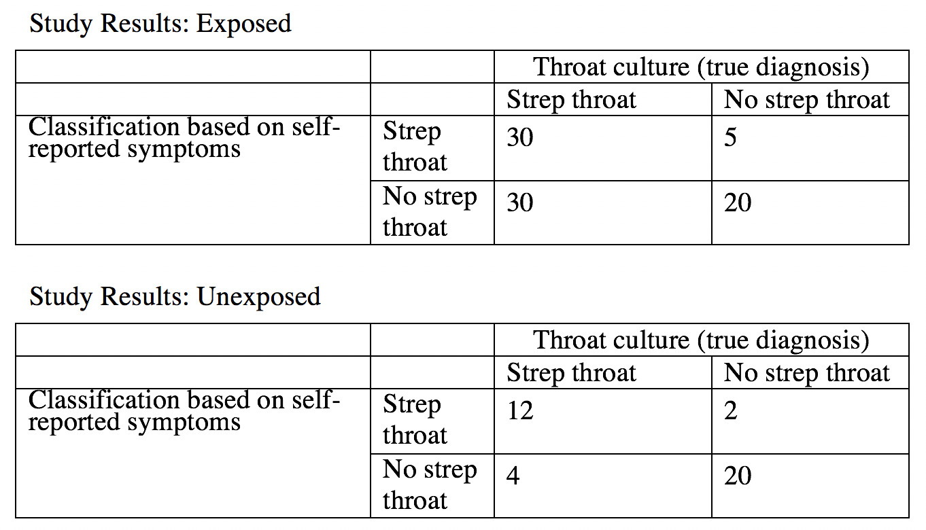
A. Is this differential or non-differential misclassification?
Differential – the misclassification of disease is different for exposed and unexposed.
30/35 (exposed) = 0.8571429
12/14 (unexposed) = 0.8571429
20/50 = .4 (exposed)
20/24 = .83 (unexposed)

Sensitivity: P(testing + | disease +)
30/60 - exposed = .5
12/16 - unexposed .75
Specificity: P(testing - | disease -)
20/25 - exposed
20/22 - unexposed
B. Calculate and compare the CIRs the investigator got using participant report and the throat culture.
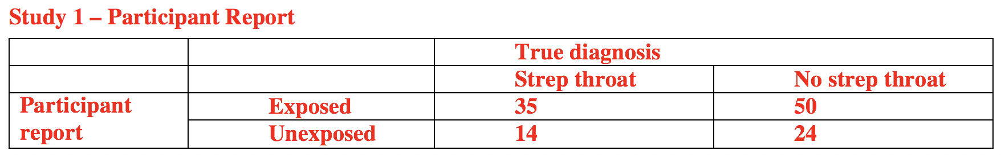
Misclassified CIR = (35/(35+50))/(14/(14+24)) =1.12
The risk of strep throat was 12% higher among those riding public transportation compared to those who did not ride transportation during the study period.
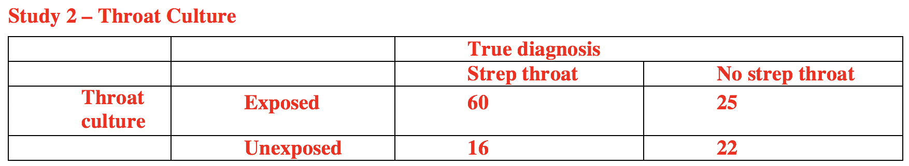
True CIR = (60/(60+25))/(16/(16+22)) = 1.68
The risk of strep throat was 68% higher among those riding public transportation compared to those who did not ride transportation during the study period.

Using participant report of symptoms the investigator received a much smaller CIR than the “true” CIR. The differential misclassification biased her results toward the null.

Problem 3. (Fall 2017 250B Practice exam problem set)
Researchers wish to investigate a potential association between use of in-ear headphones to listen to music and hearing damage among Berkeley students (25,885 undergraduates). They ask for your assistance in thinking through their approach. They have a list of all students in University housing (18,000). They plan to draw a random sample from the housing list and send a survey to invite participants to take a survey assessing in-ear headphone use (binary exposure) and be screened for hearing loss (binary outcome). Based on prior studies, they know ahead of time that 10% of the students in University housing never respond to surveys when invited to participate.

a. The investigators collect the study data and calculate an adjusted odds ratio of 2.3 between in-ear headphone use and hearing loss. Then they find out that one of the two screening devices for hearing loss was experiencing technical difficulties and incorrectly over-diagnosed hearing loss among subjects at random intervals during the screening. They ask for your help deciding if the study is too flawed to publish. What do you need to know to determine if there was non-differential misclassification? (2 points)

We are told that classification of disease status was erroneously leading to over-diagnosis. To determine if the overall bias is non-differential, we need to know if misclassification was also differential by exposure status. In other words, did the exposed and unexposed subjects have equal probability of being tested by either machine? If by some quirk only exposed subjects were tested on the malfunctioning machine, that would result in differential misclassification.

2 points: clearly state that it can only be non-differential misclassification if the error is similarly distributed by exposure status, or words to that effect.

Partial credit: mentioning sensitivity and specificity but not noting exposure, mentioning random distribution of subjects.

b. The manuscript draft you review states: “1620 of 1800 (90%) of students contacted responded to the survey. The adjusted odds ratio of 2.3 (95% CI 1.5 – 4.0) suggests an internally valid and statistically significant association between headphone use and hearing loss.” Given the information provided in all of the above, define internal validity in the context of this study, state one concern with the validity of this study, and indicate whether the results reported in the draft manuscript address this concern. (3 points)

1 point: definition of internal validity must include similarity between target population and study population
1 point: any of the following – systematic difference due to:
Study population excludes non-residential students
Study population excludes non-respondents / respondents may have self-selected
Non-differential misclassification in measurement
Unmeasured confounding
1 point for stating that the manuscript does not address internal validity [confidence intervals only tell us about random error]
OR: if clearly defined selection bias due to non-response or confounding as the major concern with validity and linked that to high response rate or adjusted odds ratio in the draft, that earned 1 point.

Problem 4. (Fall 2017 250B Practice exam problem set)
Read the following abstract and answer the related questions below:
OBJECTIVE: To investigate whether diabetes is associated with an increased risk of subsequent depression. (diabetes —> depression)
PARTICIPANTS: Claims data were randomly selected from 23 million people covered by the Taiwan National Health Insurance program. Using these data, we identified patients aged ≥20 years who were newly diagnosed with diabetes between 2000-2002. We then randomly selected non-diabetic subjects from 2000-2002 for comparison. Both groups were followed up through the end of 2007 and incident cases of diagnosed depression were identified in each group. Risks were compared between the two groups.
RESULTS: The adjusted cumulative incidence ratio [CIR] for the diabetes and depression association, which controlled for gender, income, and occupation, was 1.46 (95% CI: 1.24-1.71).
CONCLUSIONS: In this population-based study, diabetic patients were at a higher risk for subsequent depression.
Adapted from: Hsu YM, Su LT, Chang HM, Sung FC, Lyu SY, Chen PC. Diabetes mellitus and risk of depression. Int J Nurs Stud. 2011 Oct 7.

A. An investigator in this study later tells you that 5% of those classified as not depressed in the unexposed group were actually truly depressed, while every case in the diabetic group was correctly diagnosed. (This happened because the diabetic group’s physicians were monitoring that group’s health more carefully.) The study data are below.

 | Depression | No depression
Diabetic | 240 | 1350
Not diabetic | 150 | 1460

Draw a new 2x2 table and calculate (1) the cumulative incidence ratio from the misclassified data above, and (2) the CIR that would have been obtained if depression had been correctly diagnosed in both exposure groups. (6 Points)

5% of those classified as unexposed non-diseased (cell D) are false negatives and should be moved to unexposed diseased (cell C). This would yield the following table:

 | Depression | No depression
Diabetic | 240 | 1350
Not diabetic | 150+(1460*.05)=  223 | 1460-(1460*.05)=  1387
CIR_{biased} = (240/(240+1350)) / (150/(150+1460)) = 0.151/0.093 = 1.62
CIR_{unbiased} = (240/(240+1350)) / (223/(223+1387) = 0.151/0.1385 = 1.09

Many people failed to calculate the CIR and calculated the OR instead (despite being explicitly instructed to calculate the CIR). These answers were not given credit.

B. Describe the direction of the bias due to this misclassification. (2 Points)

The bias was away from the null.

Problem 5. (Fall 2017 250B Practice exam problem set)
The following questions use data and situations adapted from: Nickson C, Mason KE, English DR, Kavanagh AM. Mammographic screening and breast cancer mortality: a case-control study and meta-analysis. Cancer Epidemiol Biomarkers Prev. 2012 Sep;21(9):1479-88.

This study was designed to investigate the association between mammograms and breast cancer mortality among women over the age of 50. “Cases” were breast cancer patients who had died as a result of their cancer, and “controls” were women who were still living at the time of the study, regardless of their breast cancer diagnosis. Participants were categorized as “exposed” if they had received at least one mammogram any time after their 50th birthday. The investigators collected the following data:

 | Cases (death from bc) | Controls (living)
Exposed (1 mam) | 167 (WOULD BE BIGGER) | 2051
Unexposed (0 mam) | 264 | 1599

a. The investigators excluded from their study any breast cancer patient who had had a mammogram before the age of 50. However, they note that this excluded women who were screened earlier in their lives because they have a particularly high risk of developing a rapidly fatal form of breast cancer. What type of bias might this introduce, and how would you expect it to affect your OR? (2 points)

Selection bias. In this case, we’re missing people who belong in our A cell (those who were exposed to mammograms and died (became “cases”)). This would mean that our OR is lower (farther from the null) than it should be.

1 point for correct bias, 1 point for correctly identifying direction.

b. The authors note that family history of breast cancer might be a confounder, but they did not have the data necessary to control for this. If family history makes women more likely to receive a mammogram, and more likely to die from breast cancer, in which direction would you expect this unmeasured confounding to bias the results? (2 points)

In this case, we would expect our cell A (exposed and died) to be larger. If we are calculating the OR = ad/bc, we would expect that our biased OR would be larger and be biased towards the null.

Problem 6. (Fall 2017 250B Problem set)

The effect of sexually transmitted human papillomavirus (HPV) infection on the risk of cervical cancer was investigated in a study. A gynecological screening program in Sydney, Australia, identified 1,347 women free from cervical cancer who had abnormal epithelial cells suggestive of HPV infection. These exposed women were asked to return repeatedly for follow-up examinations (Pap smears) to identify cases of cervical cancer during an 8-year period following the initial examination. However, 311 women did not return for any follow- up visits despite reminders. The remaining 1,036 women, returning for one or more follow-up visits, contributed a total of 4,222 woman-years among the exposed. A total of 36 cases were identified in the exposed, all at the end of the 8 years. NOTE: You are only given information about the exposed people in this cohort.
Additional information about the unexposed is not necessary to do the problem. Assume the unexposed numbers are unaffected by any bias.

a. Among the exposed, how many woman-years were lost to follow-up during this study?

If we had complete follow-up on all 1,347 women, we would have a total of 1347 * 8 = 10,776 woman-years for the exposed. The total possible woman-years of follow-up is 10,776. Since we actually have only 4,222 woman-years of follow-up, we know that 10776 - 4222 = 6554 woman-years were lost to follow-up. You could also calculate this as (311*8) + (1036*8)-4222=6554 if you want to consider those completely lost and those partially lost separately.

b. Women could be more likely to return for follow-up visits if they developed minor bleeding from a cervical cancer. If so, in what direction would the IDR be biased by the loss of women to follow-up?

If symptoms of disease increase follow-up visits, then the incidence density ratio would be over- estimated (away from the null). Those exposed women lost to follow-up were likely to have been disease-free and because their person-time is missing the incidence density would be artificially increased among the exposed.

c. Assume that the 36 identified cases were all the cases that occurred in the 1,347 exposed women during the 8 years. By how much could the loss to follow-up of exposed women, according to B (above), have biased the incidence density ratio?
We observed an ID of 36/4222 = .0085. In the most extreme case, where there was no disease among those lost to follow-up, the incidence density would be ID = 36/10776 = .0033.

We can compare the observed IDR to the IDR assuming no disease among those lost to follow-up by examining the ratio of the observed ID in the exposed to the ID in the exposed assuming no disease among those lost to follow-up. Comparing IDs is equivalent to comparing IDRs, since the ID in the unexposed is in the denominator of each of these measures. The ID in the unexposed cancels out, because we assume it is unchanged in both scenarios; it has no direct impact on the calculations.
In the case of the data observed in this study: IDR_{observed} = ID_{observed_exposed} / ID_{unexposed}
In the case where we assume no disease among those lost to follow-up: IDR_{assumed} = ID_{assumd_exposed} / ID_{unexposed}
So we can compare: IDR_{observed} / IDR_{assumed}
= (ID_{observed_exposed} / ID_{unexposed}) / (ID_{assumed_exposed} / ID_{unexposed})

= ID_{observed_exposed} / ID_{assumed_exposed}

Comparing this to the ID we observed, we have .0085/.0033 = 2.55. The ratio indicates that the IDR could be overestimated by as much as 155% (ratio of 2.55 implies 155% higher).
We can also use the Kleinbaum formula to estimate the impact of bias: (ϑbiased- ϑtrue)/
ϑtrue=(0.0085-0.0033)/0.0033=1.58, so again our estimate based on the above loss to follow-up, is considerably overestimated.

Problem 7. (Fall 2017 250B Problem set)
These data are from a case-control study on biomass cooking fuel exposure and tuberculosis [Perez-Padilla et al. Int J Tuberc Lung Dis 2001;5:1-7.]. Cases were 288 patients with an active smear or culture positive tuberculosis, and controls were 545 patients with ear, nose and throat ailments from the same hospital, seen at the same time. Past or present exposure to biomass smoke was obtained by interview.
The table gives the data for the association between current exposure to biomass smoke and TB:
 | TB
Biomass Smoke  Exposure Status | Cases | Controls | Total
Exposed | 50 | 21 | 71
Unexposed | 238 | 524 | 762
Total | 288 | 545 | 833

The authors found a significant association between indoor smoke and TB (OR = 5.2). After adjusting for several confounders, a significant association remained (adjusted OR = 2.2).

A. In this study, exposure assessment was made by interviews. If tuberculosis patients provide more accurate histories about past exposure to biomass smoke compared to controls, what bias can occur? Would it be differential or non-differential?

This bias is called recall bias (a form of information bias). To be considered recall bias, assessment of past exposure must affect cases and controls differently – i.e., differential.

B. If tuberculosis patients changed their cooking fuel to cleaner fuels like gas after developing the disease, how could it affect the odds ratio for current use of a biomass stove?

In this example, it will bias the OR toward the null because some cases are reported as not exposed but were actually exposed prior to developing the disease. This is misclassification error (a form of information bias) and in this example it is differential by disease status (individuals from cell A move to cell C).

C. In this study, patients with ear, nose and throat (ENT) conditions were chosen as controls. If some ENT conditions are associated with biomass smoke (like allergic rhinitis), could this affect the odds ratio? What would this type of bias represent?

In this case, the controls are also likely to have high levels of biomass exposure. This would bias the OR towards the null. The study includes more exposed (potential) controls than unexposed (potential) controls relative to the target population. This is a form of selection bias—specifically, Berkson’s bias—and it would be differential by disease status.

D. If cases and controls had similar problems in remembering the cooking fuels they used in the past, what type of misclassification could have occurred? How will that affect the odds ratio?

Since both cases and controls have similar problems in recall, the misclassification will be non- differential by disease status and on average it would bias the OR towards the null. This is NOT a form of recall bias, which would require that recall be differential between cases and controls.
Contrast this with 4.A (above).

E. If the interviewers who did the exposure assessment had known the disease status of the cases and controls, how could this have affected the odds ratio? What type of bias would this be?

If the interviewers knew the disease status, they could probe for better exposure data from the TB patients and this could bias the OR away from the null, assuming that this caused TB patients to report more exposure than they would have otherwise. This bias is called interviewer bias (a form of information bias) and it would be differential by disease status.

F. Biomass smoke is known to contain many toxic chemicals. If exposure to biomass smoke is one cause of tuberculosis, and if it leads to rapid progression of disease and death among these patients, how would it affect the odds ratio in a case-control study examining biomass smoke as a risk factor for TB?

Assuming a cumulative case-control design, if exposure leads to rapid death among TB patients, then the cases who end up being recruited into the study may have contracted TB due to other exposures, since they are still alive and well enough to take part in a study. This would result in a form of selection bias, as the exposure distribution among the cases does not reflect that in the target population – those exposed to biomass smoke are less likely to have been selected. The OR would likely be biased towards the null because the measured effect would likely be smaller than the true effect. People would be missing from the A cell. Remember, selection bias can be towards or away from the null, depending on what’s happening!

G. The authors could have improved the measurement of exposures in this study by actually quantifying indoor air pollution levels due to biomass smoke using instruments. If they had done that, how would it have affected the precision of their OR estimates?

More refined measurement of the exposure status would increase the validity of those measurements (and therefore the OR), but it would not necessarily have any effect on the precision of the OR.

H. Suppose instead of interviews, biomass smoke exposure was assessed using air monitors worn by individuals in the study. You classify exposure to biomass smoke as high, medium and low using the monitor results. After you finish your study, the monitor company calls to tell you their monitors have been acting strangely. A random set of monitors in your study malfunctioned such that some over-estimated smoke exposure while others under-estimated smoke exposure (malfunctions affected cases and controls equally). What, if anything, can you say about the odds ratios you calculated in your study?

We cannot be sure if our OR is biased toward or away from the null. Non-differential misclassification when there are more than two categories of the exposure or disease that is misclassified does not necessarily result in bias towards the null. We have three levels of biomass smoke exposure. Note - this nuance was not taught in lecture and you will not be tested on it. However, it is very useful to know, and will likely be added to the course for the next time it’s taught.

Problem 8. (Fall 2017 250A Problem set)
Name 5 ways to reduce bias during the design and implementation of a study.
- Use objective, accurate sources of information (e.g., ask women to bring one of their unused tampons from home so the brand and absorbency can be recorded)
- Use standardized data collection forms, methods, etc.
- Use recall cues & techniques (e.g., calendars, photos of brand logos)
- Increase privacy to facilitate truthful answering of sensitive questions on questionnaires. This might include audio- or computer-assisted interviewing methods
- Obtain high levels of participation. When this is not possible, collect all possible information on non-responders to determine whether and how participants and non-participants are different
- Maintain high adherence rates / low levels of loss-to-follow-up (keep high quality and updated contact information on participants)
- Masking those collecting data and those providing data

Problem 9. (Fall 2017 250A Problem set)
The association between Reye’s syndrome and aspirin is being investigated. Reye’s syndrome occurs in children due to consumption of aspirin medication. It leads to a condition called hepatic encephalopathy where the liver and brain are affected. If the true odds ratio (OR) for Reye’s syndrome and aspirin is significantly greater than one, what will be the effect of the following scenarios? In each instance, indicate if the odds ratio would be:

- Biased away from null (overestimated)
- Biased towards null (underestimated)
- Unbiased

 |  | Reye’s Syndrome |  | Total
 |  | Yes | No
Aspirin Use | Yes | A | B | A + B
 | No | C | D | C + D
 | Total | A + C | B + D

- For some of cases, aspirin use followed the onset of the earliest manifestation of Reye’s syndrome rather than preceded it.

OR is biased away from the null because cell A is erroneously inflated and cell C is deflated.

- Parents tended to incorrectly report Tylenol use as aspirin use, non-differentially with respect to case or control status.

OR is biased towards the null because non-differential misclassification of the exposure will bias results towards the null.

- The retrospective nature of the case-control study led to some problems with recall. Parents of both cases and controls under-reported aspirin use by 10%.

OR is biased towards the null because non-differential misclassification of the exposure will bias results towards the null.

- Parents of children with Reye’s syndrome recalled aspirin use with greater accuracy than the parents of children without the syndrome, who tended to underreport aspirin use.

OR is biased away from the null because B is deflated.

- Due to the increased publicity about possible consequences associated with aspirin, parents of cases were more likely to report Tylenol use as aspirin use.

OR is biased away from the null because cell A is inflated (differential misclassification).

- Cases were selected from physician reports, and physicians were more likely to diagnose Reye’s syndrome if the child had used aspirin.

OR is biased away from the null because cell A is inflated (differential misclassification).

Problem 10. (Fall 2017 250A Problem set)
Public health practitioners wanted to evaluate the impact of a community-wide bicycle safety intervention on the incidence of head concussions. Community A was exposed to an intensive bicycle helmet use campaign, and community B, which did not receive the intervention, was chosen as a comparison population. Rates of injury associated with bicycle accidents and the use of helmets were measured in both communities.

Table 1 presents data on the “true” injury status of study participants. Although generally the extent of misclassification is unknown to the investigators, in this example we know both the “true” injury classification status and the proportions of injured and not injured individuals that are misclassified with respect to head injury status.

Table 1. True injury status (injured vs. not injured)
 | Injured | Not Injured | Total
Community A | 40 | 60 | 100
Community B | 20 | 80 | 100

- Calculate the relative risk of injured participants in Community A vs. Community B

RR = (40/100) / (20/100) = 2.0

- Suppose that 20% of participants with head injuries are incorrectly classified as not injured, and that 5% of participants without head injuries were incorrectly classified as injured. This misclassification of injury occurs irrespective of community of residence (the “exposure”).

Fill in the cells for the “observed” data in Table 2, below and calculate the relative risk based on the data in Table 2 (as if misclassification of injury had occurred

Table 2. “Observed” injury status (injured vs. not injured)

 | Injured | Not injured | Total
Community A | [(0.8*40)+(0.05*60)] = 35 | [(0.2*40)+(0.95*60)] = 65 | 100
Community B | [(0.8*20)+(0.05*80)] = 20 | [(0.2*20)+(0.95*80)] = 80 | 100

RR = (35/100) / (20/100) = 1.75

- What type of misclassification is apparent?

This is non-differential misclassification, which biases our estimates of association towards the null value (which is 1). This problem presents an example of how misclassification of disease could affect the observed RR. When we are conducting studies, we never know the “truth” about how many of our participants have been misclassified. Knowing whether misclassification is likely to be differential or non-differential comes from knowledge of the measurement tools and intuition about the direction of bias (e.g., over or under reporting). If we believe that there is no reason for diagnosis of head injury to differ by Community, then we assume that misclassification is likely the same between Community A and B.

- Compare this “observed” relative risk to the true relative risk that we found with no misclassification present (calculated in part A above).

True RR = 2.0 versus the observed RR when misclassification occurs = 1.75

- Describe what particular concerns in regards to selection bias are associated with case-control studies and cohort studies.

In any study, when the probability of selection is associated with both the exposure and the outcome, selection bias can occur. In case-control studies, participants are selected on disease status. Selection bias is likely when either cases or controls are not selected independently of their exposure status. For instance, this can happen if exposed cases are more likely to participate than those who are unexposed. In cohort studies, participants can be selected based on exposure status such as in the case of workplace exposure studies of exposed and unexposed workers. In order to avoid selection bias, exposed and unexposed participants need to be selected independent of their outcome status. A major concern with cohort studies is loss to follow up. If participants who are lost to follow up are different from those who remain in the study due to a factor associated with both, exposure and outcome, selection bias can occur.

