PH 250B Week 9 Bias
Topic 2: Diagnosing Bias using DAGs
Practice Problems - ANSWERS

Problem 1. (Fall 2017 250B Practice exam problem set)
Researchers are conducting a placebo-controlled randomized trial to test whether anti-inflammatory medication can prevent preeclampsia (preeclampsia = gestational hypertension = high blood pressure during pregnancy). (5 points)

a. Draw a DAG to show the causal structure underlying the trial data; include the exposure, outcome, and pre-pregnancy blood pressure.

A is exposure, Y outcome, and W pre-pregnancy BP in the graph below.

Grading: 2 points, ½ each for line A to Y and W to Y, 1 for no line W to A

There is no line between A and W because A is randomized.

b. During the trial, participants report minor side effects of the medication; these reports are more common in the treatment arm than the placebo arm. 80% of the cohort remains in the trial throughout while 20% withdraw. Researchers believe side effects contributed to retention in the study. The researchers also know that those showing early signs of preeclampsia were more likely to stay in the study. Update your DAG above or re-draw it to include retention in the study and how loss to follow up impacts the existing variables in the DAG.
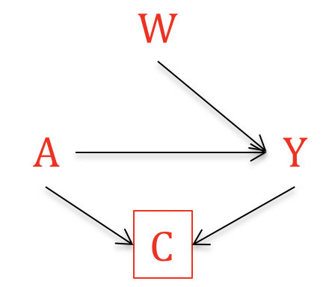
Grading: 2 points, 1 for arrows from A to C and Y to C, 1 for box around C (addition of line between A and Y maybe ½ point if no box). Points were given if this DAG was written in part a and it was correct for both a and b.

