PH 250B Week 10 Confounding
Refresher
Practice Problems- ANSWERS

Problem 1. (Fall 2017 250B Problem set)
The following data are from a hypothetical study on the risk of hepatitis C (HCV) among people who smoke crack cocaine with a pipe. The data are stratified by injection drug use, which you believe is a potential confounder. Hepatitis C is a blood-borne infection; smoking crack cocaine can lead to oral abrasions that plausibly increase infection risk.

a. Use the three-criteria approach to assess potential confounding by injection drug use in this study.

1. The factor causes (or is a surrogate for) the outcome in the source population: We believe injection drug use increases risk of HCV.
2. Factor must be associated with the exposure in the source population: We believe people who inject drugs are more likely to also smoke crack cocaine.
3. Factor must not be caused by exposure or disease: We believe injection drug use is not caused by HCV or smoking crack cocaine.

In sum, injection drug use is a potential confounder in this study.

Problem 2. (Fall 2017 250B Practice exam problem set)- UPDATED 11/12/19
Researchers wish to investigate a potential association between use of in-ear headphones to listen to music and hearing damage among Berkeley students (25,885 undergraduates). They ask for your assistance in thinking through their approach. They have a list of all students in University housing (18,000). They plan to draw a random sample from the housing list and send a survey to invite participants to take a survey assessing in-ear headphone use (binary exposure) and be screened for hearing loss (binary outcome). Based on prior studies, they know ahead of time that 10% of the students in University housing never respond to surveys when invited to participate.

a. Define the study population and study sample in this context. What is the maximum number of people in the study population? (3 points)

1 point: study population is the list of housed students who would respond if contacted. Minus ½ if housing list but didn’t include some form of ‘would respond’.
1 point: Given 10% fixed non-response, maximum size is 18,000-0.10*18000=16,200.
1 point: Study sample is those contacted who participate in the study.
Minus ½ for including exposure status in definition of either but getting the rest right.

b. The investigators are interested in the net amount of hearing loss created through both harmful and preventive effects of in-ear headphone use. What type of measure do you recommend to isolate the overall causal impact of in-ear headphone use, assuming for the moment an unbiased study design with minimal random error? Hint: think about which of the four causal types (doomed, immune, etc.) the investigators are interested in. (1 point)

1 point for any of: absolute measure, attributable risk, AR, AR%, excess risk, CID, IDD, risk difference, rate difference, PAR, PAR%
No credit if also or only mentioned relative measures

c. A research assistant points out that attendance at rock concerts might affect the study question. Consider the role of this third variable according to the three criteria for confounding. Based on these criteria, do you think the study should collect data on concert attendance? Use the three criteria to justify your answer. (3 points)

Full credit: identify the three criteria and conclude whether or not to collect data so that it is clear how your assessment of the criteria relates to determining confounding.
1 point: Third variable must be causally related to outcome (-½ if stated associated with outcome)
1 point: third variable must be associated with exposure
1 point: Third variable must not be on causal pathway / not be a mediator. (–½ for moderator instead of mediator)
Minus 1 for providing criteria but not stating how that informs yes/no on confounding.

Most people determined that concert attendance could cause hearing loss, might be associated with headphone use due to a common cause such as love of music, and was unlikely to lie on the causal pathway, so it should be collected. Others thought the association between concert and attendance and headphone use was unlikely or that headphone use could increase the likelihood of concert attendance and so concert attendance was not a confounder. So long as the definitions of criteria were correct and the decision on data collection matched the evaluation of the criteria, full credit was possible.
Partial credit for drawing a diagram instead of words since hard to assess full understanding of criteria.

Problem 3. (Fall 2017 250B Practice exam problem set)
A cumulative case-control study was conducted to determine whether maternal exposure to a chemical used in paper processing during pregnancy is associated with preterm delivery. The study population was women working at a paper plant who delivered between January 2000 and December 2003. Women with a preterm delivery were enrolled as cases and then controls were sampled from the population of women with a term delivery. Women who worked with the chemical at any time during pregnancy were classified as exposed, and women who did not work with the chemical were classified as unexposed. The Principal Investigator (PI) of the study is concerned that maternal age might be a confounder in this analysis, so she gives you the data divided into two age groups.

 | Age 20-29 |  |  |  | Age 30-40
 | Preterm | Term |  |  | Preterm | Term
Exposed | 20 | 60 |  | Exposed | 30 | 40
Unexposed | 6 | 36 |  | Unexposed | 4 | 54

a) Before the investigator started the study, what three criteria should she have considered to assess whether age is a confounder? (3 points)
1. Age must cause preterm delivery in the source population
2. Age must be associated with the exposure in the source population
3. Age must not be caused by exposure or disease
[1 point for each correct answer]

Problem 4. (Fall 2017 250B Practice exam problem set)
The following questions use data and situations adapted from: Nickson C, Mason KE, English DR, Kavanagh AM. Mammographic screening and breast cancer mortality: a case-control study and meta-analysis. Cancer Epidemiol Biomarkers Prev. 2012 Sep;21(9):1479-88.

This study was designed to investigate the association between mammograms and breast cancer mortality among women over the age of 50. “Cases” were breast cancer patients who had died as a result of their cancer, and “controls” were women who were still living at the time of the study, regardless of their breast cancer diagnosis. Participants were categorized as “exposed” if they had received at least one mammogram any time after their 50th birthday. The investigators collected the following data:

 | Cases | Controls
Exposed | 167 | 2051
Unexposed | 264 | 1599

a. Name two options the investigators would have had to account for family history of breast cancer in the design phase of the study. (2 points)

Restriction: could restrict the study just to women with (or without) a family history of breast cancer.
Matching: could match cases and controls based on their family history.
Randomization: could randomly assign some women to get mammograms and others never to receive a mammogram. This doesn’t seem very ethical or feasible, but it is a commonly used approach to avoid confounding.

1 point for each correct option.

Problem 5. (Fall 2017 250B Practice exam problem set)
Read the following abstract and answer the question below:

Study Objective: This study was designed to evaluate whether immediate (versus delayed) use of Anti Retroviral Treatment (ART) by HIV-infected individuals would reduce transmission of HIV to their HIV-uninfected partners.
Methods: 1,763 HIV-serodiscordant couples (couples with one member who is HIV-infected and one member who is HIV-uninfected) were enrolled. The HIV-infected person was required to have a CD4 cell count that did not require ARV treatment for his/her own health at the time the study began. Couples were randomized to one of two groups. In one group, the HIV-infected person immediately began taking ART (immediate ART group). In the other group, the HIV-infected person began ART only when his or her CD4 cell count fell below the requirement for treatment (delayed ART group).
Results: Among the 877 couples in the delayed ART group, 27 HIV transmissions occurred in one year. This was in contrast to only one (1) transmission that occurred among the 866 couples in the immediate ART group in one year. This difference was highly statistically significant.
Adapted from: HIV Treatment for Prevention Trial (modified from original: www.hptn.org)

A. What was the unit of randomization in this study? Explain how randomization relates to counterfactuals in 1-3 sentences. (3 Points)

The unit of randomization for this study was “couples”. Sero-discordant couples were randomized to receive “immediate ART” in the intervention group or “delayed ART” in the control group.
The goal of randomization is to create two groups that are as similar to each other as possible at baseline in terms of measured and unmeasured covariates. These groups represent the closest approximation to the true counterfactual populations as we can get. The ideal counterfactual would be to have a group take the intervention (e.g., immediate ART) and assess their outcomes, rewind time, have them take the control (e.g., delayed ART) and assess their outcomes, and then compare the two sets of outcomes

Problem 6. (Fall 2017 250B Problem set)
An investigator conducted a one-year case-control study of the relationship between gender and coronary heart disease (CHD) (both categorized as binary variables). Because of prior work, the investigator believed that the role of a subject’s level of serum ferritin (an iron-binding protein) must also be evaluated in any analyses. The stratified results are below.
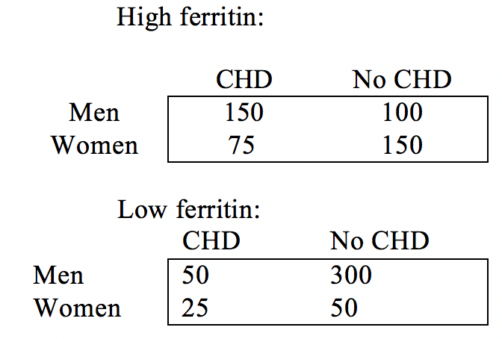
- Calculate and interpret the OR for each table (low and high ferritin).
OR_{high} = 150*150 / 75*100 = 3.0
OR_{low} = 50*50 / 25*300 = 0.33
Among people with high ferritin levels, men have 3 times the odds of having CHD compared to women, over the course of a year.
Among people with low ferritin levels, men have 0.33 times the odds of CHD compared to women (i.e., men have one third the odds of women of having CHD), over the course of a year.

- Calculate and interpret the crude OR_{pooled} for the combined data.
OR_{pooled} = 200*200 /400*100 = 1.0
Men and women have equal odds of having CHD, over the course of a year. The unadjusted (for ferritin) OR indicates that gender does not affect odds of CHD.

- Calculate and interpret the adjusted OR for ferritin levels.
Mantel Haenszel OR_{MH}:
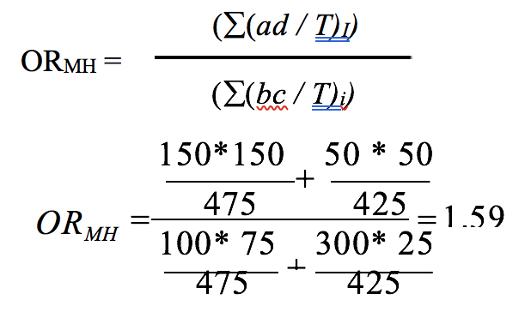
Men have 1.59 times the odds of having CHD compared to women, over the course of a year after adjusting for ferritin levels.


Problem 7. (Fall 2017 250B Problem set)
The following data are from a hypothetical study on the risk of hepatitis C (HCV) among people who smoke crack cocaine with a pipe. The data are stratified by injection drug use, which you believe is a potential confounder. Hepatitis C is a blood-borne infection; smoking crack cocaine can lead to oral abrasions that plausibly increase infection risk.
- Proceeding as if injection drug use is a plausible confounder, you collect the following data:
Injection drug use

Table 1. Injection Drug Use | HCV | Person-months
Crack pipe use | 90 | 1200
No crack pipe use | 47 | 800

No injection drug use

Table 2. No Injection Drug Use | HCV | Person-months
Crack pipe use | 12 | 500
No crack pipe use | 9 | 1200

Calculate and interpret the rate difference for HCV comparing crack pipe use to no crack pipe use separately for people who use injection drugs and people who do not use injection drugs.

IDD among people who inject drugs: 90/1200-47/800 = 0.0163

IDD among people who do not inject drugs: 12/500-9/1200 = 0.0165

Among people who used injection drugs, there was an excess of 0.0163 HCV cases per person- month (16.3 per 1,000 person-months) among people who used crack pipes compared to people who did not use crack pipes, over the course of the study.

Among people who did not use injection drugs, there was an excess of 0.0165 HCV cases per person-month (16.5 cases per 1,000 person-months) among people who used crack pipes compared to people who did not use crack pipes, over the course of the study.

- Calculate and interpret the crude IDD_{pooled} for crack pipe use using the combined data.
102/1700-56/2000=0.032

There were an excess of 0.032 HCV cases per person-month (32 per 1,000 person-months) among people who used crack pipes compared to people who did not use crack pipes, over the course of the study.

- Calculate and interpret the adjusted IDD_{MH}.
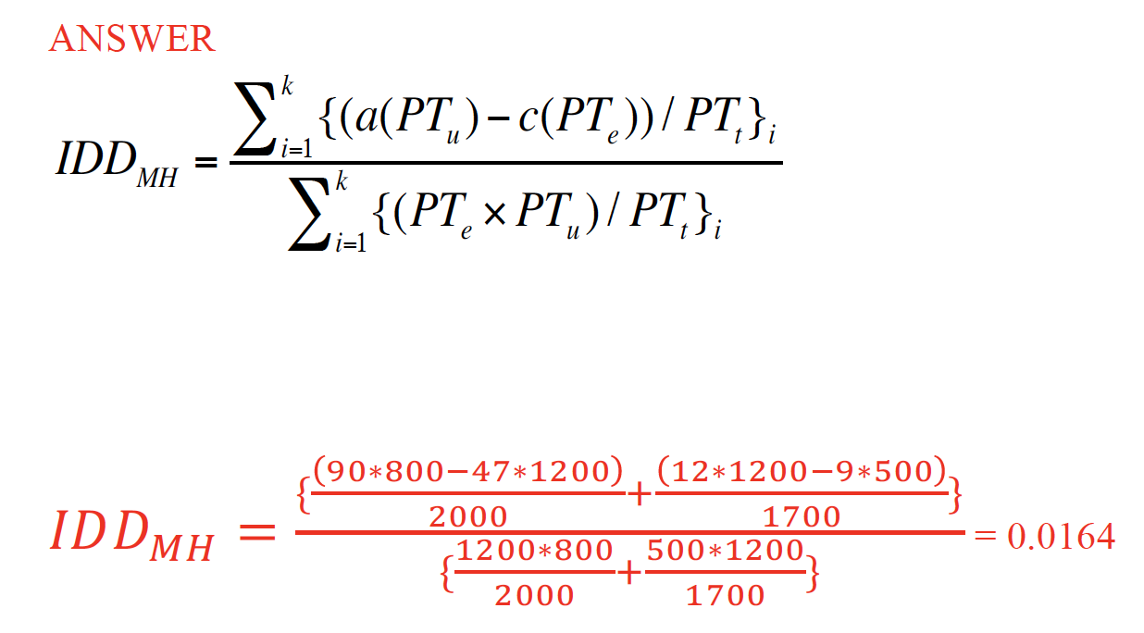
There were an excess of 0.0164 HCV cases per person-month (16.4 cases per 1,000 person- months) among people who used crack pipes compared to people that did not use crack pipes, after adjusting for injection drug use, over the study period.

Problem 8. (Fall 2017 250A Problem set)
What methods are available to control confounding in the design phase of the study?

- Randomization
- Matching
- Restriction

Problem 9. (Fall 2017 250A Problem set)
What methods are available to control confounding in the analysis phase?

- Stratification
- Standardization
- Multivariable Analysis

