PH 250B Week 10 Confounding
Topic 2: Using DAGs to identify confounding
Practice Problems - ANSWERS

Problem 1. (Source: Fall 2017 250B problem set)
Use the directed acyclic graph (DAG) below to answer the following questions. The investigator is interested in the relationship between chocolate consumption and colon cancer.

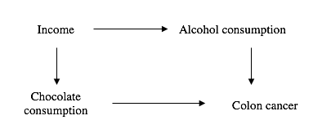

- Practice using the DAG rules: Assume that chocolate consumption does not actually cause colon cancer (i.e., remove the arrow from chocolate to cancer). Are there any open pathways between chocolate consumption and colon cancer?
Yes, chocolate consumption→→→income→→→ alcohol→→→ cancer

Note: the effects can appear to flow up arrows, e.g. from chocolate consumption to income. This is called a “backdoor” pathway. This is not a DAG; it is a depiction of a backdoor pathway created by the DAG above. In a study of chocolate and cancer, the existence of this pathway would indicate that chocolate and cancer might be statistically associated due to having a common ancestor (income) rather than due to a causal effect.

Problem 2. (Fall 2017 250B Problem set)
List the variables, if any, that act as confounders in the A (exposure of interest) -> Y (outcome) relationship. Mark (using boxes) how you would adjust for any identified confounders.
- Answer: W is a confounder
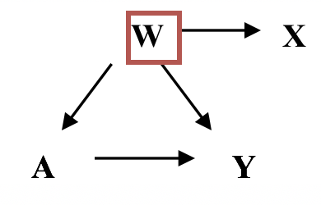
- Answer: None of the variables are confounders
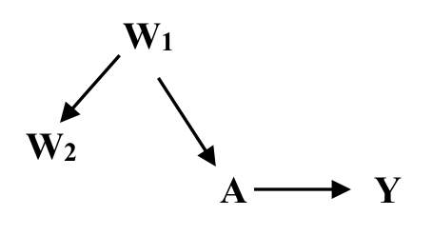
- Answer: Controlling for W3 is sufficient to control confounding because the DAG shows that W1 only affects Y through W3; there is no direct arrow from W1 to Y nor is there a shared parent of W1 and Y. There is no need to control for W2, because controlling for W1 blocks the backdoor path from A to Y.
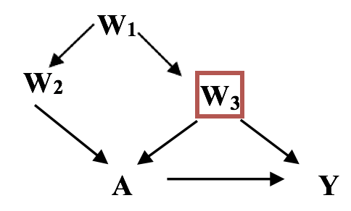
- Answer: Need to control for W₁ or W₂ because unmeasured variables (U) confound the relationship between A and Y through the Ws.
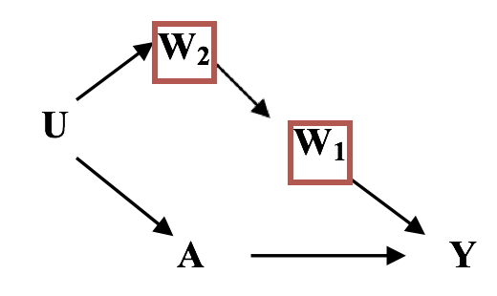

X
Problem 3. (Fall 2017 250B Practice exam problem set)
Read the following abstract and answer the related questions below.

Background. Individuals born with certain birth outcomes – including low birth weight and pre- term birth – have increased risk of ischemic heart disease (IHD) in adulthood. One hypothesis to explain this is that common genetic factors predispose individuals to both pregnancies resulting in these outcomes and IHD. If this hypothesis is true, mothers who deliver babies with these birth outcomes should themselves be at increased risk of developing IHD. We investigated whether low birth weight or pre-term pregnancy outcomes were related to risk of subsequent IHD in the mother. Methods. Routine maternity hospital discharge data were used to identify all singleton first births that occurred in Scotland between 1981 and 1985. These birth data were subsequently linked to hospital and mortality records for later admissions and deaths (1981-1999), providing
15–19 years of follow-up on all mothers. Risk ratios were adjusted for socioeconomic deprivation, maternal height and age at the time of the birth, and hypertension. Findings. Complete data were available on 129,920 (95.6%) eligible deliveries. Maternal risk of IHD admission or death was associated with previously delivering a baby in the lowest birth weight quintile (adjusted risk ratio 1.9 [95% CI 1.5–2.4]), and preterm delivery (adjusted risk ratio 1.8 [1.3–2.5]). Interpretation. Low birth weight and preterm delivery are associated with an increased risk of subsequent IHD in the mother. Common genetic risk factors might explain the link between these pregnancy complications and risk of IHD in both the individual and the mother.
Adapted from: Smith G, Pell J, Walsh D. The Lancet 2001;357(9273):2002-2006.

Draw a DAG representing the relationships between the study’s exposure and outcome of interest and the potentially confounding variables identified in the abstract. Represent in the DAG how you would indicate controlling for the potential confounders. (5 points)

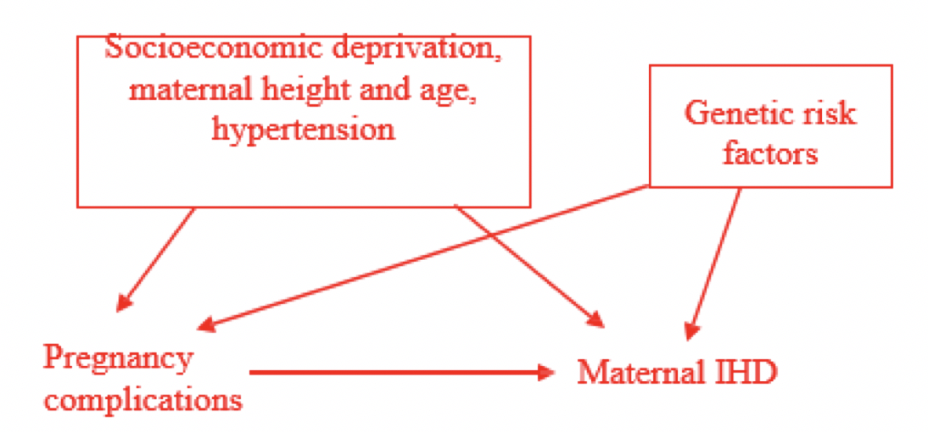

[Correct if they put a box around either socioeconomic deprivation, etc. and genetic risk factors or just socioeconomic deprivation, etc. since genetic risk factors were not explicitly mentioned in the study. Many different DAGs were accepted as answers to this question].

Problem 4. (Fall 2017 250A Practice exam problem set)
For each of the following statements, please draw the directed acyclic graph (DAG) and state whether the variable of interest could be a confounder.

- Smoking is a risk factor for pancreatic cancer. Assume that people who smoke are less health-conscious and consume lower amounts of fruits and vegetables than non-smokers. Is smoking a confounding variable when analyzing the association between consumption of fruits and vegetables and pancreatic cancer?

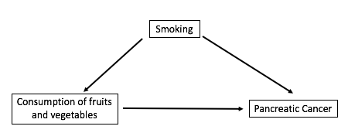
Yes. Smoking satisfies all criteria of a confounder.

- Alcohol is known to raise HDL levels, and high levels of HDL are associated with a reduced risk of heart disease. Is HDL level a confounder in the association between alcohol consumption and heart disease? Under what situation would HDL levels be considered a confounder?

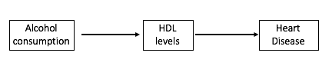
Based on the description above, HDL level is not a confounder because it is on the causal pathway (see diagram above). HDL would be considered a confounder if it were associated with both alcohol consumption and heart disease but not an intermediate on the causal pathway.

- Gender is a known risk factor for heart disease. A gene (gene B) is associated with a lower risk of heart disease. Is gene B a confounder? If not, under what situation(s) would gene B be a confounder in the relationship between gender and heart disease?
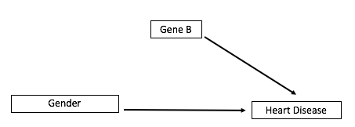

Besides being associated with the outcome, a confounder must also be associated with exposure. In this case, if gene B is distributed equally between the two genders (i.e., gene b is not associated with gender), then gene B cannot be a confounder (see diagram). If gene B were related to gender, gene B can be considered a confounder.
Problem 5. For each of the following DAGs, decide which, if any, covariates (C_{x}) should be controlled for in order to remove confounding of the relationship between E and D. (Note: Drawing an arrow between two nodes is technically an assertion that a relationship exists between them; we study E and D because we aren’t sure if there’s a relationship between them, and thus it’d be valid to not draw an arrow between them. An arrow is drawn for the sake of consistency with the lecture slides).

E
C₁
C₂
D
E
C₁
C₂
D

Answer: adjust for C2. The existing paths from E-->D besides the direct path are:
- E-->C1-->D; this is a directed path and thus is of interest - we should keep this path intact and not adjust for C1
- E-->C1<--C2-->D; C1 is a collider (has arrows going into it from E and C2), and therefore this path is naturally blocked (remember that when not adjusted for, colliders naturally block any paths on which they lie; adjusting for them, however, induces a relationship between their parents)
- E<--C2-->C1-->D; this backdoor path needs to be blocked! We can adjust for C1 or C2. Since C1 is an intermediate in the first path we considered, we shouldn’t adjust for it, and therefore should adjust for C2
- E<--C2-->D; this backdoor path also needs to be blocked. We’ve already decided to adjust for C2, which makes this path blocked as well.

E
C₁
C₂
D
C₃

E
C₁
C₂
D
C₃

or...
E
C₁
C₂
D
C₃

Answer: adjust for C1 and C2; the paths to consider are:
- E<--C2-->C1<--C3-->D; C1 is a collider so this path is automatically blocked
- E<--C1-->D; this path needs to be blocked, and there is no way to do this other than by adjusting for C1; NOTE: C1 is a collider of C2 and C3, so adjusting for C1 opens a backdoor path between C2 and C3! This means we have another path to consider...
- E<--C2---C3-->D; we need to adjust for either C2 or C3 to block this path. Usually we aim to control just enough confounders (i.e. the “minimally sufficient” adjustment set) to eliminate all non-directed paths, as controlling for more than is needed is redundant and reduces precision in our estimates (you don’t need to know why this is, but if you’re curious, it’s because adjusting for variables can be thought of as stratifying on them, and the more variable we stratify on, the sparser the cells of our 2x2 tables)
- E<--C1<--C3-->D; we adjusted for C1 so this is blocked
- E<--C2-->C1-->D; we adjusted for C1 so this is blocked

E
C₁
U
D
C₃
E
C₁
U
D
C₃

NOTE: “U” denotes an unmeasured variable; unmeasured variables cannot be controlled for because we lack data on them. Therefore, the covariates available for us to control for are C1 and C3
Answer: adjust for both C1 and C3. The paths to consider are:
- E<--U-->C1<--C3-->D; this path is blocked because C1 is a collider of U and C3
- E<--U-->C1-->D; this is a non-directed path that must be blocked, which we can only do by adjusting for C1, since U is unmeasured; C1 is a collider of U and C3, so an association between them is induced! We therefore also need to consider the following path we induced...
- E<--U---C3-->D; this is a backdoor path that needs to be blocked, which we can only do by adjusting for C3
- E<--U---C3-->C1-->D; we already decided to adjust for both C1 and C3, so this path is blocked
E
C₁
C₂
D
C₃
E
C₁
C₂
D
C₃

Answer: adjust for C1. The paths to consider are:
- E<--C1-->D; we have to adjust for C1 to block this path
- E<--C1-->C3-->D; we already adjusted for C1 so this path is blocked
- E-->C2<--C3-->D; C2 is a collider so this path is blocked
- E-->C2<--C3<--C1-->D; again, C2 is a collider so this path is blocked
E
C₁
C₂
D
C₃

