PH 250B Week 11 Effect Modification
Topic 1: Biologic interaction, statistical interaction, effect modification
Practice Problems - ANSWERS

Problem 1. (Fall 2017 250B Problem set)
An investigator conducted a one-year case-control study of the relationship between gender and coronary heart disease (CHD). Because of prior work, the investigator believed that the role of a subject’s level of serum ferritin (an iron-binding protein) must also be evaluated in any analyses. The stratified results are below.
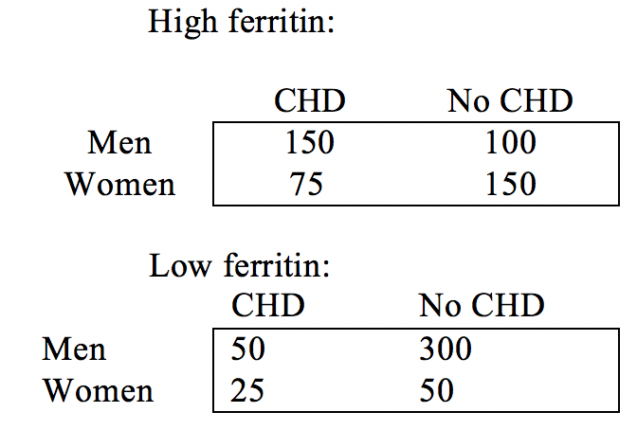
- Calculate and interpret the OR for each table (low and high ferritin).
OR_{high} = 150*150 / 75*100 = 3.0
OR_{low} = 50*50 / 25*300 = 0.33
Among people with high ferritin levels, men have 3 times the odds of having CHD compared to women, over the course of a year.
Among people with low ferritin levels, men have 0.33 times the odds of CHD compared to women (i.e., men have one third the odds of women of having CHD), over the course of a year.

- Calculate and interpret the crude OR_{pooled} for the combined data.
OR_{pooled} = 200*200 /400*100 = 1.0
Men and women have equal odds of having CHD, over the course of a year. The unadjusted (for ferritin) OR indicates that gender does not affect odds of CHD.

- Calculate and interpret the OR adjusted for ferritin levels.
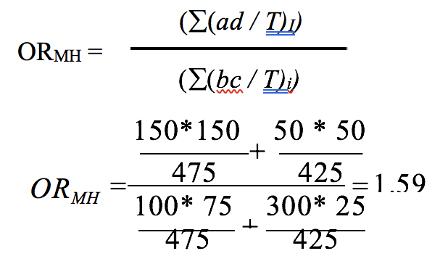
Men have 1.59 times the odds of having CHD compared to women, over the course of a year after adjusting for ferritin levels.

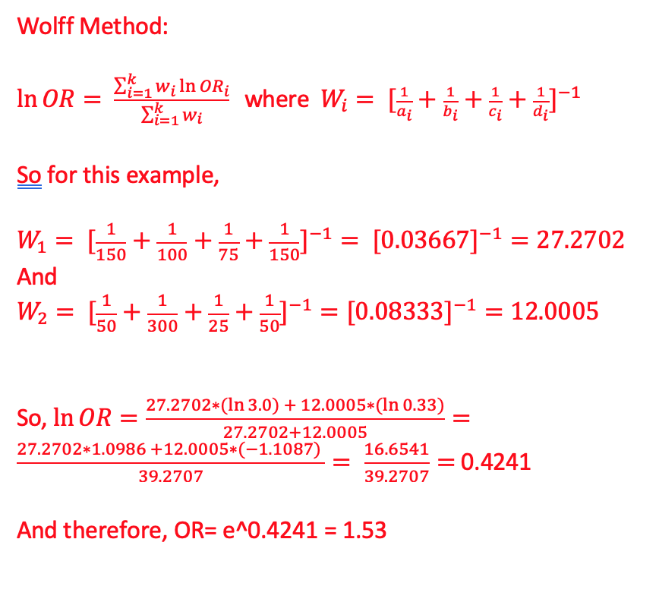
d. Is there statistical evidence of heterogeneity? Calculate the X² test of homogeneity and use this information to describe the role of ferritin in the relationship between gender and CHD.

Formula for chi-square test of homogeneity
NOTE: We will show the solution using both methods of pooling the odds ratio (Mantel-Haenszel and the Woolf method).
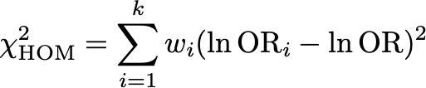
H₀: The measure of association is the same across strata.
H_{A}: The measure of association is different across strata.

Step 1: Calculate weights
w₁ = 1/ (1/150 + 1/100 + 1/75 + 1/150) = 27.270
w₂ = 1/ (1/50 + 1/300 + 1/25 + 1/50) = 12.000

Step 2: pool odds ratio using Mantel-Haenszel method

(completed above)

Step 3: calculate chi-square statistic

Step 4: obtain p-value
We have two strata, so degrees of freedom = k-1 = 1. We compare 40.661 to the first row of the table below and see that it is > 5.02 so the p-value < 0.025.
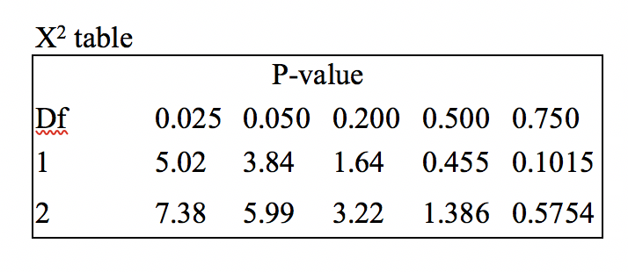

The p-value is less than 0.2, therefore, we reject the null hypothesis and conclude that the stratified estimates differ significantly from each other. Clinically, the stratified estimates are also meaningfully different from the MH estimate. Ferritin is an effect modifier; in other words, the relationship between gender and CHD varies by ferritin level.

Note: There will be some rounding error depending on how many decimals you include in your ORs.

Alternative approach using Woolf method to pool the odds ratio, starting at Step 2:

Step 2: pool odds ratio using Woolf method

Step 3: calculate chi-square statistic

Step 4: obtain p-value
We have two strata, so degrees of freedom = k-1 = 1. We compare 40.599 to the first row of the table below and see that it is > 5.02 so the p-value < 0.025.

e. Is the adjusted measure of association (the OR_{MH}) useful in this situation? Why or why not?

Generally, when there is evidence of effect modification it is more useful to present stratified estimates. However, if you are only interested in the net association, you could present an adjusted measure. This would hide the nuance of the relationship between gender and risk of CHD across levels of ferritin but would give you an idea of the net association between CHD and gender in the total population. In this case, since one measure of association is protective and the other harmful, you would likely still present stratified estimates as the net effect may be misleading.

f. How should the investigator present these findings? Write a one or two sentence abstract of the results.

Among individuals with high ferritin levels, male gender appears to be a strong risk factor for coronary heart disease (OR: 3.0). Among individuals with low ferritin levels, male gender appears to be a strong protective factor for coronary heart disease (OR: 0.33).

(SPECULATION FOLLOWS:) We hypothesize that differences in iron metabolism between men and women affect the stability of plaque formation in the lumen of the coronary arteries. Further study is called for to determine if intervention to reduce ferritin levels in men will reduce the incidence of coronary artery disease in men. Please fund our grant.

Problem 2. (Fall 2017 250B Practice exam problem set)

The following questions use data and situations adapted from: Nickson C, Mason KE, English DR, Kavanagh AM. Mammographic screening and breast cancer mortality: a case-control study and meta-analysis. Cancer Epidemiol Biomarkers Prev. 2012 Sep;21(9):1479-88.

This study was designed to investigate the association between mammograms and breast cancer mortality among women over the age of 50. “Cases” were breast cancer patients who had died as a result of their cancer, and “controls” were women who were still living at the time of the study, regardless of their breast cancer diagnosis. Participants were categorized as “exposed” if they had received at least one mammogram any time after their 50th birthday. The investigators collected the following data:

 | Cases | Controls
Exposed | 167 | 2051
Unexposed | 264 | 1599

The investigators were also concerned that socioeconomic disadvantage might be a potential confounder or effect modifier. They measured SES and found the following:

Low SES:
 | Cases | Controls | Total
Exposed | 56 | 1095
Unexposed | 131 | 1107
Total |  |  | 2389

High SES:
 | Cases | Controls | Total
Exposed | 111 | 956
Unexposed | 133 | 492
Total |  |  | 1680

a. Calculate the crude OR and the stratum-specific ORs for those with low and high SES. (3 points)

Crude OR: (167*1599) / (2051*264) = 0.493.
Low SES: (56*1107)/(131*1095)=0.432.
High SES: (111*492)/(133*956)=0.430.

1 point for each calculation, ½ point off if calculation was set up correctly the number was wrong.

b. Calculate and interpret the adjusted OR. (3 points)
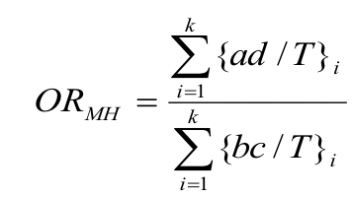

= [((56*1107)/2389) + ((111*492)/1680)] / [((131*1095)/2389) + ((133*956)/1680)]

= 0.431. Women who died of breast cancer had 0.431 times the odds of having a mammogram than those who did not die, adjusting for SES.

1.5 points for calculation, 1.5 points for interpretation. Interpretations using disease odds or exposure odds were both acceptable, but ½ point was lost for use of “risk” instead of “odds” and ½ point was lost if adjustment for SES was not mentioned.

c. The p-value on the chi-squared test for homogeneity is 0.98. State the null hypothesis being tested. Given these results, what do you conclude about the role of SES? Is it a confounder, effect modifier, or neither? Justify your answer in 1-2 sentences. (3 points)

The null hypothesis is that the stratum-specific ORs are not different from one another.

AND

The results of the above questions show that the adjusted OR appears to be meaningfully different from the crude OR, which suggests confounding is present. Furthermore, the results of part C show that the stratum-specific ORs are not statistically different from one another, which means that effect modification is not present. Based on all of this, we’d conclude that SES is a confounder.

OR

The results of parts B-C show that the adjusted OR does not appear to be meaningfully different from the crude OR, which suggests confounding is not present. Furthermore, the results of part D show that the stratum-specific ORs are not statistically different from one another, which means that effect modification is not present. Based on all of this, we’d conclude that SES is neither a confounder or an effect modifier.

1 point for correct null hypothesis. 1 point for correctly assessing that no EM is present. 1 point for reasonably justified decision about confounding.

Problem 3. (Fall 2017 250B Practice exam problem set)
Investigators of a cohort study examining the relation between vegetarian diet and incident myocardial infarction (MI) drew a DAG at the beginning of their study, consulted the existing literature, and identified height as a confounder and also potentially an effect modifier of this relation.

The investigators calculated an overall CIR of 0.45 for the relation between vegetarian diet and incident MI. They then stratified by height, and found a CIR=0.82 for people less than 5’6” and a CIR=0.83 for people 5’6” and taller.

Answer the following questions.

A. In the relationship between vegetarian diet and incident MI, height appears to be (circle one) (2 Points):

a) neither a confounder nor an effect modifier.
b) a confounder but not an effect modifier.
c) an effect modifier (confounding is irrelevant).

B. What measure(s) of association would you recommend that the investigators report given the role of height you identified in A) in the relation between vegetarian diet and MI, and why? (3 Points)

Confounding by height appears to be present, so the investigators should calculate the MH CIR (or CIR adjusted some other way – e.g., regression model) and present the results for the relationship between vegetarian diet and incident MI adjusted for height.

Problem 4. (Fall 2017 250B Practice exam problem set)
You are given some data on work stress and cardiovascular disease (CVD) and told to analyze the relationship between these two variables. You think that rural residence might be an effect measure modifier of this relationship. Below are the actual data.

 | Rural |  |  |  |  | Non-rural
 | CVD | No CVD |  |  |  | CVD | No CVD
Stressed | 154 | 618 | 772 |  | Stressed | 151 | 470 | 621
Non-stressed | 360 | 2409 | 2769 |  | Non-  stressed | 418 | 2372 | 2790
 |  |  | 3541 |  |  |  |  | 3411

A. Calculate the crude CIR. (1 Point)

Crude CIR = (154 + 151) / (772+621) = 0.2190 = 1.56
(360 + 418) / (2769 + 2790) 0.1400

B. Calculate the CIR for each group (rural and non-rural separately). (2 Points)

CIR_{rural} = (154/772) / (360/2769) = 1.53
CIR_{non-rural} = (151/621) / (418/2790) = 1.62

C. Calculate the chi square test of homogeneity to assess whether rural residence is an effect modifier of the work stress -> CVD relationship. (4 Points)

Useful information: (use these as the weights for each stratum)
var(ln(CIR_{rural}))=0.00761
var(ln(CIR_{non-rural}))=0.00705

Step 1: Calculate weights
w₁ = 0.00761
w₂ = 0.00705

Step 2: pool cumulative incidence ratio using Mantel-Haenszel method
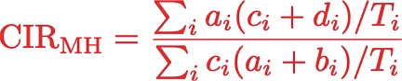

154 * (360+2409) / 3541 + 151 * (418+2372) / 3411
___________________________________________
360*(154+618) / 3541 + 418*(151+470)/3411
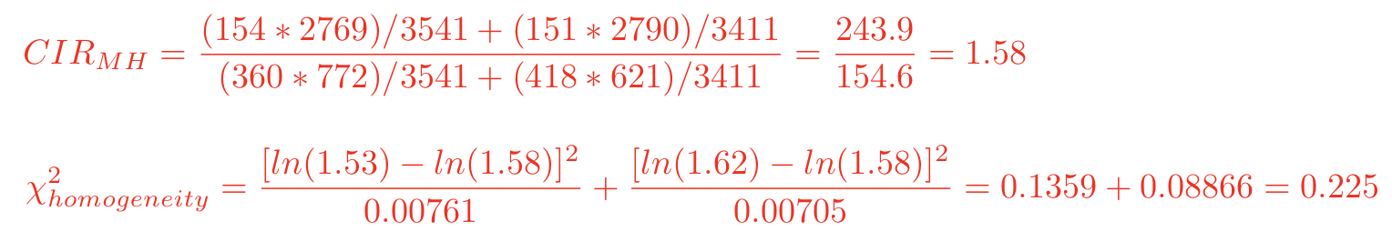

Step 3: calculate chi-square statistic

X² = 0.225

D. Use the p value table below to determine an approximate p value based on your test statistic.

X² table
P-value
Df | 0.025 | 0.050 | 0.200 | 0.500 | 0.750
1 | 5.02 | 3.84 | 1.64 | 0.455 | 0.1015
2 | 7.38 | 5.99 | 3.22 | 1.386 | 0.5754
The test statistic of 0.225 with one degree of freedom lies between 0.1015 and 0.455, indicating that the p value lies between 0.500 and 0.750.

E. State the null hypothesis for this X² test, and interpret your finding in relation to this null hypothesis. (3 Points)

The null hypothesis is that there is no heterogeneity/there is homogeneity of the effect of work stress on CVD between rural and non-rural residents; in other words, CIR_{rural} = CIR_{non-rural}. Given that the p-value for the chi-square test of homogeneity is larger than the standard alpha level of 0.2, we accept the null hypothesis and conclude that there is no statistically significant difference in the effect of stress on risk of CVD between rural and non-rural residents in this population.

F. Do these results reveal anything about causal interaction? Why or why not?
Assume that your results are unbiased. (3 Points)

Even if results are unbiased, we cannot make statements about interaction as a causal concept based on multiplicative interaction – these results show there is an absence of effect modification on the multiplicative scale (measure of association modification).

Note: We also accepted responses that said that the absence of interaction on the multiplicative scale indicates that there is interaction on the absolute scale. Assuming that there were no other sources of bias (as we did here), you could therefore say that there was evidence of causal interaction. As long as the reasoning was correct for either scenario, we gave you full credit.

