PH 250B Week 12 Matching and Screening
Topic 2: Overmatching and Matched Analysis
Ungraded quiz - ANSWERS

Problem 1. (Szklo and Nieto, Epidemiology: Beyond the Basics, 4th ed.)
In planning an individually-matched case-based case-control study to test the hypothesis that air pollution (measured by individually placed monitors) is related to a certain type of respiratory cancer, the investigators decide to match cases and controls on age, gender, ethnic background, and smoking (yes or no).
- In addition to general logistical difficulties usually associated with matching, what is the main undesirable consequence that may result from matching cases and controls in this study?
By matching on ethnic background, the investigators would also match on variables related to ethnic background, which may include residence area. As a result, cases and controls may be overmatched; that is, they may be matched on the exposure of interest.

- Because the disease of interest is rare, the investigators decide to individually match 10 controls for each case. Is this a reasonable strategy considering the additional costs involved and the tight budget to conduct this study?
Probably not. Little additional efficiency (statistical power) is achieved when the ratio of controls to cases is greater than 4:1 or 5:1.

Problem 2. (Fall 2017 250B Problem set)
To investigate the association between childhood sleeping patterns and adolescent obesity, you decide to conduct a case-cohort study using a cohort of 14,881 adolescents. You match controls to cases on gender with a 1:1 ratio.
a. What analytic technique would you use to calculate the odds ratio?

Since we can treat the data as frequency matched on gender, the appropriate analytic technique is logistic regression with gender as a covariate, or calculating a MH or Wolff adjusted OR (adjusting for gender).

b. Could you assess the association between gender and adolescent obesity? Why or why not?

No, you have matched on gender, so you have set the distribution of gender. Therefore, you cannot analyze the association between gender and adolescent obesity.

c. If you had not matched on gender, how could you control for confounding by gender in the design and analytic phases of the study?

During the design of the study, you could have restricted your investigation to only one gender. During the data analysis, you could use stratification or multivariable modeling.

d. Should you additionally match on how energetic adolescents feel at baseline? Why or why not?

It could be possible to make a case for energy level as a confounder or a mediator depending on which you think comes first / is measured first, energy level or sleep patterns. Matching on a mediator would irreversibly bias your study, so it is not safe to match on energy level unless you have a strong causal structure and temporal ordering in the data that would support it as a confounder rather than a mediator.

Problem 3. (Fall 2017 250B Problem set)

In a small pilot study, mothers of 20 children with attention deficit hyperactivity disorder (ADHD) and mothers of 20 healthy children without signs of ADHD were asked questions about their child’s prenatal exposure to pesticides. The DAG below represents the causal structure the investigators hypothesize.
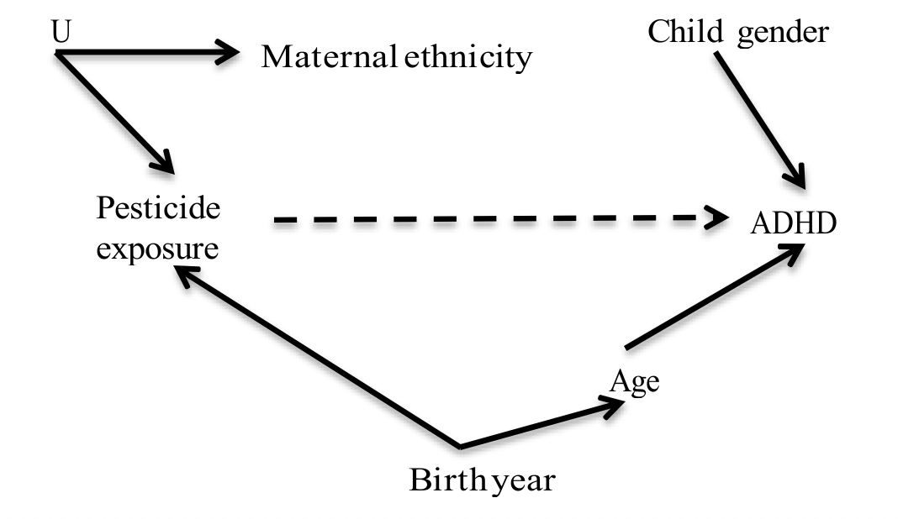
a. Assess gender, year of birth, and maternal ethnicity as third variables: which should you match on and why?
Birth year is the only variable that appears to be a confounder based on this DAG, so it is the best choice for matching. Maternal ethnicity is associated with exposure alone (through the unmeasured common cause U) so matching on ethnicity will reduce study efficiency. Gender is not a confounder: child gender is independent of maternal pesticide exposure. Thus, there is no reason to match on this variable.

Assume matching was implemented as you recommend. The study data are shown below.

Pair Number | With ADHD | Without ADHD
1 | exposed | exposed
2 | exposed | unexposed
3 | exposed | unexposed
4 | exposed | unexposed
5 | unexposed | exposed
6 | unexposed | exposed
7 | exposed | exposed
8 | exposed | unexposed
9 | exposed | exposed
10 | unexposed | unexposed
11 | exposed | exposed
12 | exposed | unexposed
13 | unexposed | unexposed
14 | unexposed | unexposed

15 | exposed | exposed
16 | unexposed | unexposed
17 | unexposed | unexposed
18 | exposed | unexposed
19 | exposed | unexposed
20 | exposed | unexposed

b. Calculate the appropriate measure of association.

 | Controls
Cases | Exposed | Unexposed
Exposed | 5 | 8
Unexposed | 2 | 5

Matched OR = B/C = 8/2 = 4.0

c. If you had broken the match and calculated the same measure of association, what would have been different about your answer?

The unmatched OR would have been biased. In general, matching in case-control studies makes controls more similar to cases on the matching factors, which should be associated with exposure. This reduces the difference in exposure distribution and tends to bias the unmatched OR towards the null, although this is not always the case for individually matched data.

[Although we did not ask you to calculate it, for these data, the unmatched OR = ad/bc = (13*13)/(7*7) = 3.4, which is biased towards the null in this instance.]

Problem 4. (Fall 2017 250B Practice exam problem set)
Read the abstract and answer the questions below.
Background. It is unclear whether respiratory viruses are associated with chronic obstructive pulmonary disease (COPD) exacerbation in COPD patients. (Note: An exacerbation is defined as an acute worsening of symptoms.)
Methods. We performed a matched case-control study using data from an ongoing cohort study to determine whether viral respiratory infections are associated with COPD exacerbation. Cases were all COPD subjects who experienced an exacerbation (n=92). Each case was matched 1-to-1 with a control. Each control was a randomly selected COPD patient from the same cohort who had not experienced an exacerbation at the time of the case’s exacerbation. Cases and controls were matched on time, age, and gender.
Results. There were 92 case-control pairs. In 31 pairs, only the case had a respiratory virus, and in 3 pairs only the control had a virus. In 20 pairs, both case and control had no virus.
Source: Adapted from Hutchinson et al. Respiratory Medicine 2007; 101 (12): 2472-
2481.

- Construct a 2-by-2 table using the data provided in the abstract.

 |  | Control
 |  | Exposed to virus | Unexposed
Cases | Exposed to virus | 38 | 31
Cases | Unexposed | 3 | 20

- Calculate the appropriate measure of association for these data.
Matched-pairs OR: B/C = 31/3 = 10.33

- The investigators had considered also matching cases and controls on their wheezing symptoms. Wheezing can be caused by both viral respiratory infections and COPD exacerbations. State in one sentence why you think the investigators decided not to match on wheezing.

Since wheezing is caused by both viral respiratory infections and COPD exacerbations, it is a collider, and matching on it would have introduced bias (this is one form of overmatching).

- The measure of association in (b) had a wide confidence interval due to small cells. The investigators considered the possibility of breaking the match and conducting an unmatched analysis. State in one sentence whether you think the investigators should conduct an unmatched analysis, and why (or why not).
The authors should not conduct an unmatched analysis because if you break the match in a pair matched case-control study the measure of association will be biased. (Note: Also accepted answers that discussed breaking the individual match and converting to frequency matching.)

Problem 5. (Fall 2017 250B Practice exam problem set)

(True/False) In a case-control study, stratification on a matching factor and calculation of an adjusted OR achieves unbiased estimation.

(True/False) Since case-control studies tend to be very large, there is usually no reason to match on confounding factors

Problem 6. (Fall 2017 250B Practice exam problem set)
You have conducted a matched cohort study to investigate whether elective induction of labor increases the risk of infant mortality compared to labor of spontaneous onset. You use individual matching to match women with induced labor (“exposed”) to women with spontaneous labor (“unexposed”) on a variety of factors, including parity, gestational age, and age of the mother.

You collect data on 20 pairs of women and find the following:
- In 5 matched pairs, both the exposed and unexposed women had infants who died.
- In 5 matched pairs, both the exposed and unexposed women had infants who survived.
- In 6 matched pairs, the exposed woman’s infant died and the unexposed woman’s infant survived.
- In 4 matched pairs, the exposed woman’s infant survived and the unexposed woman’s infant died.

A. Set up the appropriate table and calculate the matched CIR. (4 points)

 |  | Unexposed
 |  | Died | Survived
Exposed | Died | 5 | 6
Exposed | Survived | 4 | 5

Matched RR = (A+B)/(A+C) = (5+6)/(5+4) = 1.222

1 points for setting up the table correctly
2 points for calculating the matched CIR correctly. The most common error was calculating a matched OR instead of the CIR.

B. How would you expect the CIR using the unmatched table to differ from your answer in part A? (Note: you do NOT need to calculate the unmatched CIR.) (1 points)

The unmatched RR would not differ from the matched RR calculated in part A because this is a cohort. The unmatched estimate differs in case-control studies, not in cohort studies.

(If you did calculate it, you would get: [11/(11+9)] / [9/(9+11)] = 1.222) Bonus ½ point for mentioning the change in variance

Problem 7. (Fall 2017 250B Exam 3)

Adapted from Yiu-hong Leung et al. Risk factors for community-associated methicillin-resistant Staphylococcus aureus infection in Hong Kong. Journal of Infection. 2012.

Background: The objective of this study was to identify risk factors for community-associated methicillin-resistant Staphylococcus aureus (CA-MRSA) infection in Hong Kong.
Methods: We carried out a matched case-control study. Cases and controls were pair matched based on sex and age. A total of 127 cases and 127 controls participated in the study.
Results: In 10 pairs, only the case practiced frequent handwashing, and in 26 pairs only the control practiced frequent handwashing. In 50 pairs, both the case and control practiced frequent handwashing.

A. Which of the following matching strategies did the investigators use for this study?
Select the one best option. (1 point)
a. Individual matching
b. Frequency matching
c. Distance matching
d. None of the above

B. Using the data provided in the abstract, fill in the 2-by-2 table below with the appropriate information for assessing the relationship between frequent hand washing and MRSA infection in this study. (3 points)
 |  | Control (at risk)
 |  | Exposed (frequent handwashing) | Unexposed (infrequent handwashing)
Case (MRSA)  C | Exposed (frequent handwashing) | 50 | 10
Case (MRSA)  C | Unexposed (infrequent handwashing) | 26 | 41

Grading:
½ point per correct cell

C. Calculate the appropriate measure of association for these data. (2 points) Matched OR = B/C = 10/26 = 0.385

Grading:
+½ point for identifying the MoA as the matched OR
+½ point for correct formula
+1 point for correct answer
-½ point for new math error

D. Calculate the unmatched measure of association. (2 points)

 | Case | Control
Exposed | 50+10 = 60 | 76
Unexposed | 26+41 = 67 | 51

ad/bc = (60*51)/(76*67)
= 3060/5092
= 0.601

Grading:
+½ point for identifying MoA as the OR
+½ point for correct formula where a, b, c, d are individuals rather than pairs
+1 point for correct answer
-½ point for new math error

E. Compare the measures of association you calculated in parts C and D. Briefly explain the reason for any similarity or difference you observe. (2 points)

The measures of association differ. This is because in a matched case-control study, breaking the match will induce bias.

Grading:
+½ point for stating they differ
+1.5 points for stating correct justification

F. The investigators had considered also matching cases and controls on sharing of personal items such as nail clippers or razors with other persons. Had they decided to do so, how would this affect their ability to examine sharing of personal items as a risk factor for MRSA infection? (1 point)
Matching on this factor prevents you from examining its association with the outcome.

Grading:
+1 point for correct answer

