PH 250B Week 12 Matching and Screening
Topic 3: Screening
Ungraded quiz - ANSWERS

Problem 1. (Fall 2017 250B Problem set)
A patient in the UK tests positive for malaria on a test with sensitivity of 98% and specificity of 99%. Based on their recent travel, their prior probability of disease is estimated to be 5%. Calculate the probability they have malaria following the positive test.
LR+=sensitivity/(1-specificity)=98
Pre-test prob=0.05
Pre-test odds = .05/.95 = 0.0526
(LR+)*pre-test odds = 5.16 post-test odds
Post-test probability = post-test odds/(post-test odds+1)=0.838

Problem 2. (Fall 2017 250B Problem set)
The following data were obtained from a study where a new test measuring lead burden in the body was evaluated against bone lead level as the gold standard. The investigators classified those with bone lead levels more than 20μg/dL as positive, and less than that level as negative. The investigators wanted to determine the optimal cut-off level for the new test. Investigators evaluated four different cut-off levels, which yielded the following table:

 | True positive | False positive | False negative | True negative | Total
Cutoff A | 168 | 6 | 232 | 594 | 1,000
Cutoff B | 224 | 24 | 176 | 576 | 1,000
Cutoff C | 340 | 114 | 60 | 486 | 1,000
Cutoff D | 364 | 348 | 36 | 252 | 1,000

A. Calculate the sensitivity and specificity of the test at each of the cut-off levels.

 | True positive | False positive | False negative | True negative | Total | Sensitivity | Specificity
Cutoff A | 168 | 6 | 232 | 594 | 1,000 | 168/ (168+232) = 0.42 | 594 / (594+6) = 0.99
Cutoff B | 224 | 24 | 176 | 576 | 1,000 | 0.56 | 0.96
Cutoff C | 340 | 114 | 60 | 486 | 1,000 | 0.85 | 0.81
Cutoff D | 364 | 348 | 36 | 252 | 1,000 | 0.91 | 0.42

B. Based on the sensitivity and specificity values, construct a ROC curve (either in a computer or by hand) and identify the best cut-off for the test.
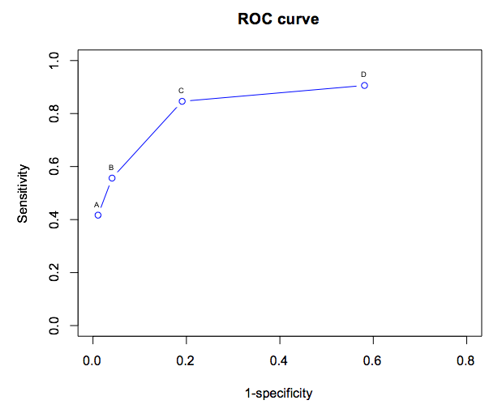
Cut-off C would be the best cut-off based on the ROC curve. This point optimizes the sensitivity and specificity of the test.

Note: in practice, the optimal cut-off level may also depend on the implications of false positives and false negatives, not just the sensitivity and specificity of a cut-off.

Problem 3. (Fall 2017 250B Problem set)
Refer to Nelson HD, Tyne K, Naik A, Bougatsos C, Chan BK, Humphrey L. Screening for Breast Cancer: an Update for the U.S. Preventive Services Task Force. Annals of Internal Medicine. 2009; 151: 727-737.

Required sections: Abstract, Methods: Study Selection, Results: False-Positive and False- Negative Mammography Results, Table 2, Discussion

Using Szklo 4.4.3 and/or the Grimes and Schulz article as a reference, consider the studies included and excluded from the meta-analysis of benefits of mammography.

a. What bias(es) did the investigators hope to address by including randomized trials only? How does randomization address such bias?

Randomization of screening reduces self-selection bias. Self-selection bias occurs when individuals choose to get screened or not, which may be related to perceived risk, health care status, and other differences between the screened and non-screened. This is considered a type of confounding because individuals choose to get screened (exposed) based on some third variable that may also be related to the outcome of interest.

Randomization also addresses length bias, which occurs when cases identified through screening programs, which are likely to be cases with a longer detectable pre-clinical phase, are compared to cases detected by subsequent screening or clinical diagnosis.
Randomizing screening enables equal distribution of cases with short and long DPCP between the screened and unscreened, so comparison of overall prognosis between these two groups is not likely to be affected by length bias.

b. What bias(es) did the investigators hope to address by excluding studies using survival time or other non-mortality outcomes? Explain briefly.

Calculating survival (or disease-free survival time) after screening compared to survival after clinical diagnosis results in lead-time bias, where the earlier detection is combined with any actual increase in survival. Assessing age-specific mortality rates among screened and unscreened is the best way to eliminate lead-time bias, unless the average lead-time can be well estimated.

c. What are the implications of their inclusion and exclusion criteria for internal validity? For external validity?

Including high quality randomized trials increases internal validity by reducing selection bias and two types of information bias (length and lead time). However, it may reduce external validity since participants in RCTs are not necessarily representative of the full population of women to whom the investigators wish to generalize (women 40+ in the U.S.)

D. Look at the results presented in Table 3. If women of all ages had the same prevalence of breast cancer, for which age group would mammography have the lowest positive predictive value (PPV)?
PPV is true positives (cell a) divided by total testing positive (cell a plus b). Table 3 indicates that false negatives (cell c) stay relatively constant over age groups but that false positives (cell b) decrease with increasing age. If we hold prevalence constant across age groups, that is the same as holding the total diseased (a+c)/N constant, and we further know based on the false negative data that cell c does not vary significantly over age. Cell a, true positives, remain relatively constant across age groups. False positives (cell b) are highest for the youngest women; this increases the denominator of PPV for the youngest women and decreases PPV. Therefore, PPV would be lowest for women ages 40 – 49 in a setting of constant prevalence.

E. How does the specificity of breast self-exam (BSE) compare to mammography based on the results presented in the Discussion section?

The discussion indicates that two trials showed an increased number of benign biopsy results (false positives of BSE), suggesting that it is less specific than mammography.

Problem 4. (Fall 2017 250B Problem set)
Newborns are tested for phenylketonuria (PKU). If a newborn does not have the enzyme necessary to change phenylalanine to tyrosine, she or he can experience brain damage and seizures. The test can be done either with a heel prick to collect several drops of blood or a urine test. Once detected, PKU can be treated effectively. Should the test for PKU aim to have higher sensitivity or higher specificity?

PKU is treatable but missing a case can have severe consequences for the newborn and its family. Therefore, screening for PKU aims for high sensitivity rather than specificity. Many false positives and further testing can cause anxiety, but the danger of missing a case of PKU is thought to outweigh these concerns.

Problem 5. (Fall 2017 250B Practice exam problem set)
Earlier this year, researchers published results from a multicenter Randomized Control Trial, concluding that screening with low-dose CT scans reduces mortality from lung cancer by increasing early detection of lung cancer. Low-dose CT scans are available in most large, private hospitals and some public hospitals, and cost around $2500 per scan. Some scientists in the field are advocating that these low-dose CT scans be used in a new, national screening program for lung cancer. Without calculating any measures of test validity, provide 2 reasons why this might not be a good idea. Assume you are not concerned about the role of bias or random error. (2 points)

There are several potential answers to this question, each of which would have received one point. Full credit was given for any two of the following answers:
• CT scans are very expensive, making the screening test not very economical, especially for a rare outcome like lung cancer
• Not everyone is near to/has access to a CT scan
• It is not clear from the evidence provided that early detection of lung cancer would necessarily improve outcomes.
• The cost of false positives must be considered – could result in invasive diagnostics, certainly could create worry and uncertainty, particularly if policy for the appropriate course of action after diagnosis is not generally agreed upon
• The effects of regular exposure to CT scans on health outcomes is unknown

Problem 6. (Fall 2017 250B Practice exam problem set)
Imagine that the CT scan was then tested in a pulmonary clinic (a clinic for patients with lung-related diseases). During the test period 141 patients participated, and of these, 40 had lung cancer. The performance of the CT scan as a screening test for lung cancer in this population was:

Sensitivity: 72.5%
Specificity: 99.3%
PPV: 96.7%
NPV: 90.0%

Calculate the prevalence of lung cancer observed among patients coming into the pulmonary clinic. (1 point)

Prev= 40/141 = 0.284 = 28.4%

Problem 7. (Fall 2017 250B Practice exam problem set)
An elderly patient comes in to the clinic with a terrible recurrent cough, is screened for lung cancer using the CT scan, and receives a negative test result. Using the prevalence of lung cancer in the pulmonary clinic as the prior probability, calculate the post-test probability of lung cancer in this patient, and provide a one- sentence interpretation of your results. (4 points)

One point was awarded for calculating the correct likelihood ratio (negative). 2 points were awarded for correct calculations (which could include the alternative calculation: P(D|-) = 11/111 = 10%). One point was awarded for the correct interpretation of the likelihood ratio negative.

Pre-test probability: 0.284

Likelihood ratio (-): 1 – Sensitivity = 0.275 = 0.277
Specificity 0.99

Pre-test odds: P/(1-P) = 0.284/0.716 = 0.396
Post-test odds: LR(-) x Pre-test odds = (0.277)*(0.396) = 0.109
Post-test probability: 0.109 / (1 + 0.109) = 0.098
The probability of this patient having lung cancer based on the prior probability and negative test result is ~9.8%.

Problem 8. (Fall 2017 250B Practice exam problem set)
Suppose you were preparing to implement a screening program for an infectious, potentially life- threatening disease that can be cured with antibiotic treatment. Would you prefer to have a test with high specificity or high sensitivity? Explain your answer in one sentence.

You would want a test with high sensitivity so that a maximum proportion of true cases would be identified, treated and cured to reduce spread of the disease and to reduce morbidity and mortality from the disease.

Problem 9. (Fall 2017 250B Practice exam problem set)
Below you are given a range of sensitivity and specificity values for two tests. Plot the ROC curves for these two tests, and label the X and Y axes. Which test performs better?

Test 1 Test 2
Sensitivity Specificity Sensitivity Specificity
1 0.43 0.92 0.34 0.99
2 0.65 0.87 0.69 0.90
3 0.80 0.80 0.82 0.86
4 0.90 0.65 0.93 0.78
5 0.95 0.55 0.99 0.65
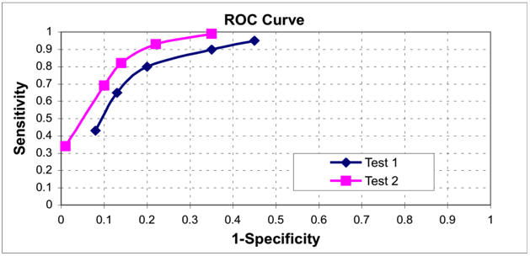
Test 2 is a better test because for any one given value of specificity it has higher sensitivity, so the area under the curve is larger.
[0.5 points for labeling each axis, 1 point for drawing the curves, 1 point for identifying the test that performs better].

Problem 10. (Fall 2017 250B Practice exam problem set)
Valid diagnostic tests of tuberculosis are expensive and rarely used in low-resource settings where TB burden is the highest. You help develop a cheaper diagnostic tool. You have access to samples from a population-based case control study in San Francisco that relied on the gold standard, microbiologic culture, for diagnosis. (15 points total)
a. What measures can you calculate based on these data to provide evidence that your new test will be valid in a range of settings?
Sensitivity and specificity.
Predictive values depend on prevalence and prevalence is fixed by design in a case-control study, so they will not be generalizable measures of validity.
Grading: 2 total. + 1 each for sensitivity & specificity, -1 for also mentioning either or both predictive values.

b. Use the data below to calculate and interpret the measures you named in part a.

 | Case | Control
Test + | 165 | 72 | 237
Test - | 35 | 128 | 163
 | 200 | 200 | 400

Sensitivity = a/(a+c) = 165/200 = 0.825. Of those truly diseased, 82.5% will test positive using the new diagnostic.
Specificity = d/(b+d)=128/200 = 0.64. Of those truly not diseased, 64% will test negative using the new diagnostic.
Grading: 4 total. 1 point for each calculation (1/2 point for formula correct but bad math), 1 point for each interpretation – must be clear it is among those truly diseased / not diseased. Full credit possible if the wrong answers from part A were carried through here but were correctly calculated and interpreted.

c. The preliminary findings are strong enough to support a pilot test among a random sample of primary care patients in Kampala, Uganda. The Minister of Health will approve the test for broader use if at least 67% of those testing positive are truly diseased and no more than 40% of those testing negative are truly diseased. Given the data below, does the test meet these standards? Name and calculate the appropriate measures of validity.

 | TB | No TB
Test + | 88 | 135 | 223
Test - | 22 | 255 | 277
 | 110 | 390 | 500

The Minister wants a PPV of .67 and an NPV of .6 (1-.4). PPV = a/(a+b) = 88 / 223 = 0.395
NPV=d/(c+d)=255/277 = 0.921
No, the test does not meet the Minister’s threshold for PPV, though it does for NPV.

Grading: 4 total. 1 point for naming both tests, 1 point each for calculations (1/2 point each for correct formula but bad math), 1 point for correct conclusion (matching the math)
Also OK to name and calculate false positive rate (b/(1+b)) and false negative rate (c/(c+d)), grade as above based on correct math and conclusions
If incorrectly answered specificity and sensitivity here and calculated correctly, but did not list them in the questions above, 1 point for each formula and math.

b. Without changing the test, explain one change to the implementation described above you could make to improve test performance relative to the Minister’s standards. Justify this change.

You could restrict use of the test to patients showing symptoms of TB or to high-prevalence areas. PPV will increase in a higher prevalence setting while NPV will decrease; the test is performing well above the threshold for NPV, so limiting it to higher prevalence areas will improve predictive performance.

Grading: 2 points. 1 for understanding prevalence drives NPV / PPV, 1 for recognizing higher prevalence required to change test in right direction.
1 point if measures are calculated above to suggest lower prevalence better and that logic is carried forward here.
Partial credit of 1 point for stating that an additional test could be used
½ point for suggesting changing the test positivity cutpoint

c. A patient presents to the clinic in Kampala reporting sustained cough, weight loss, and night sweats. The clinicians estimate a 60% probability of TB, but your test comes back with a negative result. What is the probability this patient has TB after the test?

Pre-test probability: 0.60
Pre-test odds: 0.60/0.40 = 1.5
Note we can use the calculation of sens and spec from either part b or part c; results will be very similar.
LR-=(1-sens)/spec = (1-.80)/.64 = 0.313
Post-test odds: LR- * pre-test odds: 0.313*1.5 = 0.470
Post-test probability: .470/1.459 = 0.322
(repeated using data from part b instead, LR = 0.273, odds = 0.4095, post-test prob = 0.291)

There is a 32.2% (29.1%) probability the patient has TB in light of the test results.

Grading: 3 points. 1 point for choosing correct LR and formula. 2 points for correct calculations, including translating back to probability at last step. Can get full credit for this answer if use incorrect values of sensitivity and specificity above, so long as the math within this answer is correct

Problem 11. (Fall 2017 250B Practice exam problem set)
The graph below compares the validity of two screening tests across a number of cut-points for distinguishing negative from positive results. (6 points)
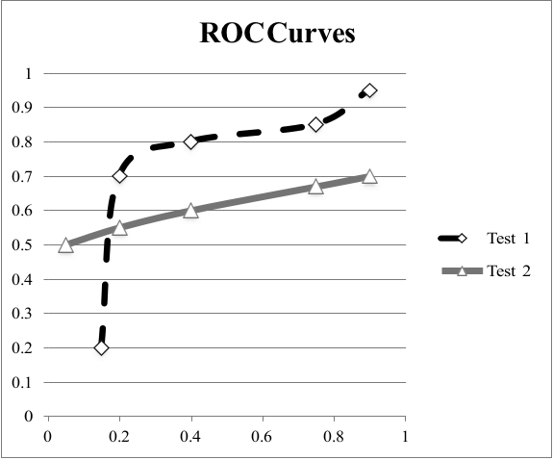
a. Label the X axis and the Y axis
X: 1-specificity
Y: Sensitivity

Grading: 1 point, ½ per label.

b. Overall, which test would you say is more accurate?
Test 1, as it is closer to the ideal (top left corner) / area under the curve is greater.
Grading: 1 point.
c. The SF Department of Public Health (SFPDH) has quantified the public health impact of false positives and false negatives (on a cost and quality-adjusted life year basis). If the cost of a false positive is 100 times higher than the cost of a false negative, what test and what cut- point do you choose?

To minimize false positives, we want to maximize specificity. We choose the point closest to 0 on the X axis (X=0 means specificity=1). This is Test 2, cut-point at around (0.05, .5). There will be roughly 10 false negatives for each false positive.

Grading: 1 point. ½ for identifying specificity as key quantity to maximize but choosing a different cut point. Full credit possible if axes are wrong but answer would minimize false positives however that is portrayed given incorrect axes. Full credit possible if selected different cut-point with appropriate justification for choice.

Problem 12. (Fall 2017 250B Practice exam problem set)
An observational study on the impact of screening returned the following results: the median time of mortality is 7 months in the unscreened group and 9.5 months among the screened, although by the end of 1 year the simple cumulative incidence of death is ~0.75 in both groups. A statistical test comparing the two survival curves suggests that the survival experience of the unscreened is significantly different from the survival in the screened group.
The curves below show the data in graphical form. (8 points)

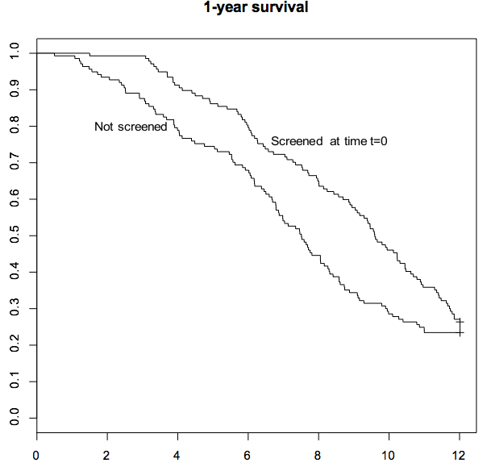

a. Define the exposure and outcome of interest.

Exposure: screening
Outcome: mortality within 1 year 1 point

b. Provide one explanation for the results assuming a causal relationship.
The most straightforward option is that screening enables early diagnosis and treatment of disease, leading to better patient prognosis. The fact that simple cumulative incidence doesn’t look very different may be due to random chance; simple cumulative incidence is a crude measure that doesn’t reflect the increased time of survival. [second sentence not required for full credit]

Grading: 2 points. Partial credit possible for explaining a link but not suggesting a mechanism, or for suggesting there is a causal relationship that is obscured by confounding.

c. Provide one explanation for the results that does not assume a causal relationship. Several answers possible:
Bias: length-bias – screening is more likely to detect cases with long detectable pre-clinical phases than shorter, more aggressive cases. The shorter cases also lead to higher mortality, hence the apparent increased survival among the screened group.
Lead-time bias: screening may have accelerated the diagnosis of disease among those screened at baseline compared with diagnoses for the unscreened group, but not actually improved survival time.
Self-selection bias: individuals chose to get screened in this case. Those who did may have been younger, healthier or with better access to health care than the unscreened.
Random error: there may be no true difference in the survival distributions of the screened and the unscreened. The positive result may be a Type I error.

Grading: 2 points. Full credit for both naming a possible explanation (a bias or random error) and explaining how it applied in this case.

Problem 13. (Fall 2017 250B Practice exam problem set)
The following scenario is adapted from Aikou et al., Tests for Serum Levels of Trefoil Factor Family Proteins Can Improve Gastric Cancer Screening. Gastroenterology 2011.

Improving methods for early detection of gastric cancer may reduce morbidity and mortality. A group of researchers studied the potential utility of trefoil factor family (TFF) proteins (TFF1, TFF2 and TFF3) as markers for gastric cancer screening. Serum was collected from 183 patients with gastric cancer and 280 healthy individuals without cancer, and serum levels of TFF1, TFF2, and TFF3 were measured using an enzyme-linked immunosorbent assay (ELISA), a relatively cost-effective, fast, and noninvasive tool.

Using the ROC curve provided below, answer the following questions.

ROC Curve

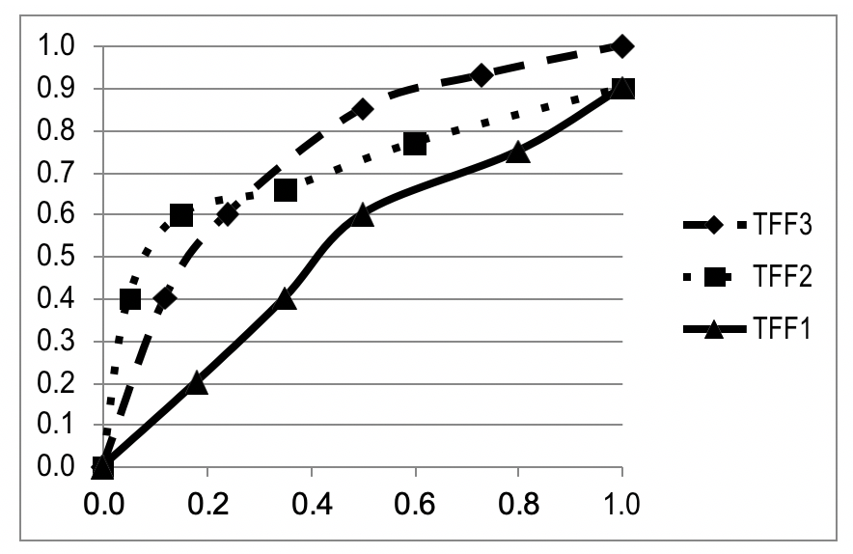
A. Label the x- and y-axes. (1 point)
X-axis: 1-specificity
Y-axis: Sensitivity

Grading:
½ point per correct axis label

B. An established screening program wants to incorporate TFF as the first step for screening for gastric cancer. They are concerned about false positives; they want to minimize false positives as long as the screening tool correctly identifies at least 60% of those who truly have the disease. Which TFF marker (TFF1, TFF2, or TFF3) would serve as the most valid screening tool for detecting gastric cancer? Explain why in 1-2 sentences. (2 points)

They should incorporate TFF2 into their screening program. At a sensitivity of 0.60 (or 60%), TFF2 has the lowest probability of false positives (i.e., lowest value along the x- axis for 1-specificity) / highest probability of capturing true negatives.

Grading:
1 point for choosing correct TFF marker 1 point for correct explanation
-½ if accidentally put it has the "lowest specificity" instead of lowest 1-specificity or highest specificity
-Errors from 8A did not carry forward (i.e., credit was given in Part B for answers that were technically incorrect but correctly matched up with how axes in part A were labeled)

C. Below is a schematic depicting the distributions of TFF3 levels among those with and without true gastric cancer. Using this schematic, explain how moving the TFF3 marker cut-point (the vertical dashed line) to the right will affect its sensitivity and specificity for detecting gastric cancer. Why is this the case? Limit your answer to 2-3 sentences. (2 points)

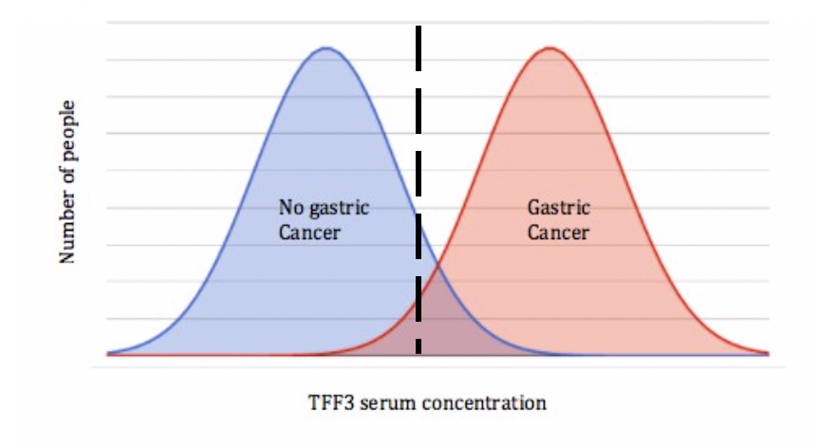
How: moving the TFF3 concentration cut-point to the right will result in a diagnostic tool that has higher specificity and lowered sensitivity (illustrating the trade-off between sensitivity and sensitivity).
Why: there will be a tradeoff between sensitivity and specificity because the distributions of TFF3 serum concentration among diseased and non-diseased overlap to a certain extent.

Grading:
1 point for indicating correct "how" (increase in specificity, decrease in sensitivity) 1 point for correct explanation as to why: Full credit was given for why if answer included something correct about the areas under the distributions changing; about
changes in false positives/false negatives; or about not detecting cases with low TFF3 levels – referring to the overlap of the distributions
-½ if why for how both sensitivity and specificity change not included

D. An observational study is conducted to examine the relationship between gastric cancer screening using TFF markers and survival time. In this study, would you be concerned about lead time bias? Provide a 1-2 sentence explanation as to why or why not. (2 points)

Yes, gastric cancer cases identified by TFF marker screening will on average appear to have longer survival than cases not identified by screening (e.g., those clinically diagnosed after symptoms develop), regardless of whether screening actually improves survival. This is because disease among those screened will be detected earlier in the disease process, and this time between screening and when disease would have been clinically diagnosed is included when calculating survival.

½ point for correctly answering yes you would be concerned
1.5 points for correct explanation (1. disease detected earlier among those screened compared to those not screened; 2. this time between when disease is identified via screening and when it would have been identified clinically due to symptom development – i.e., lead time – is included when calculating survival; 3. so those screened will appear to have longer survival regardless of whether screening actually improved survival)

